Valuing the voice of the customer
SPSS Statistical Analysis Report
Introduction
This report summarizes a sample of data related to customer satisfaction survey analysis via IBM SPSS Statistics. The data consists of 120 customers with details regarding demographics, buying patterns, customer service interactions, customer loyalty and satisfaction ratings. Independent Samples T Tests and Chi Square tests were used for 4 business questions.
Dataset Overview
There are 120 cases and the following variables: Customer_ID, Group (A/B), Satisfaction_Score (1 to 10), Age, Gender, Location, Purchase_History (Yes/No), Support_Contacted (Yes/No), Loyalty_Level (Low/Medium/High), and Satisfaction_Factor.
The Variable View setup should look like this.
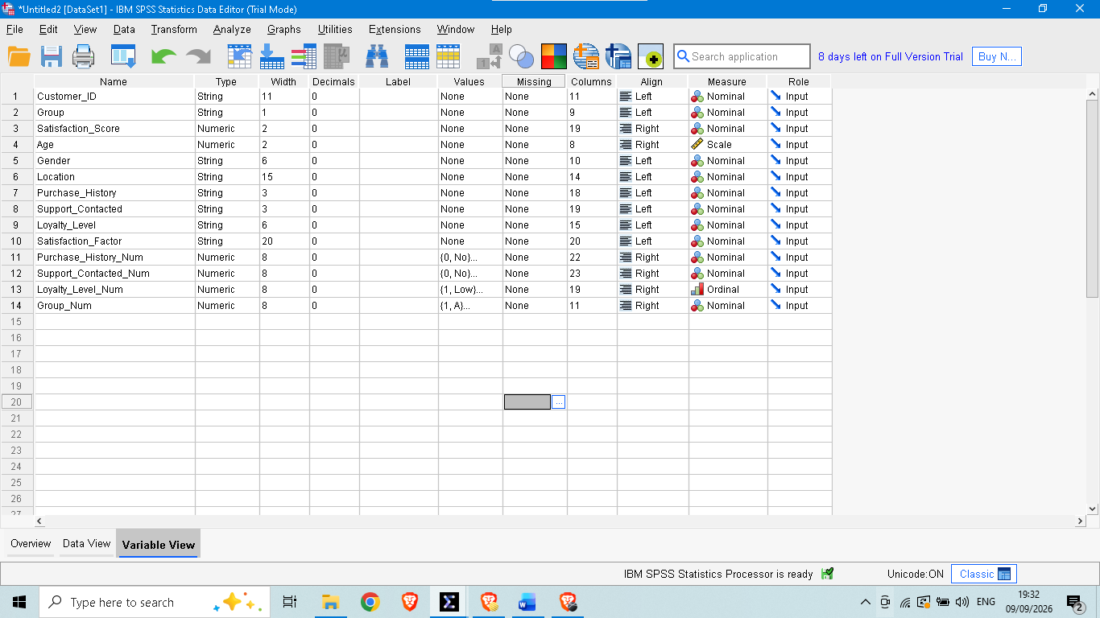
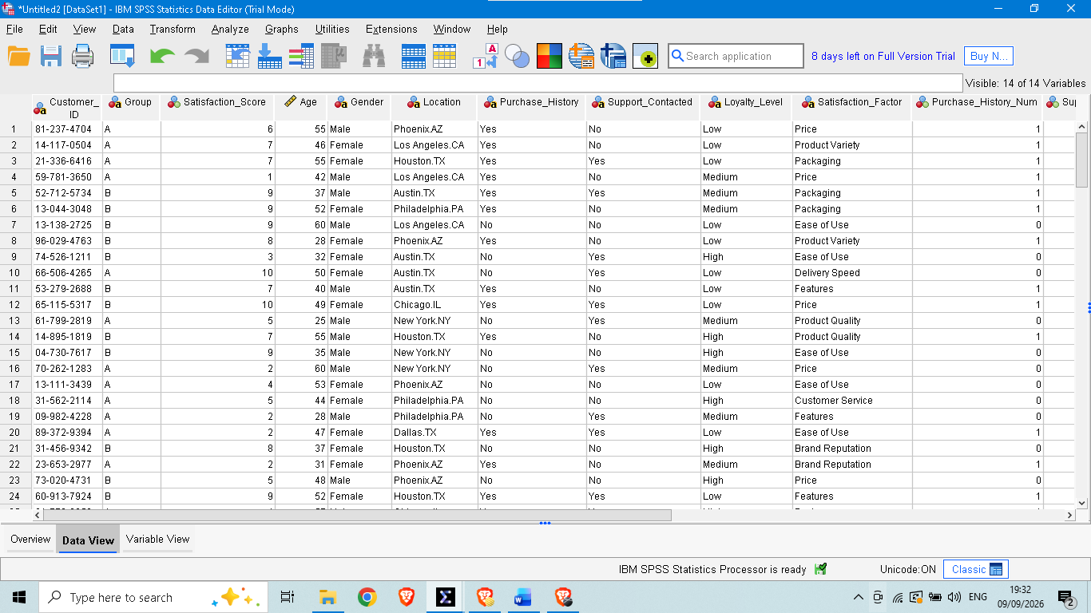
Question One: Are Group A or B more satisfied?
Independent Samples T Test was performed on Satisfaction_Score between group A and group B.
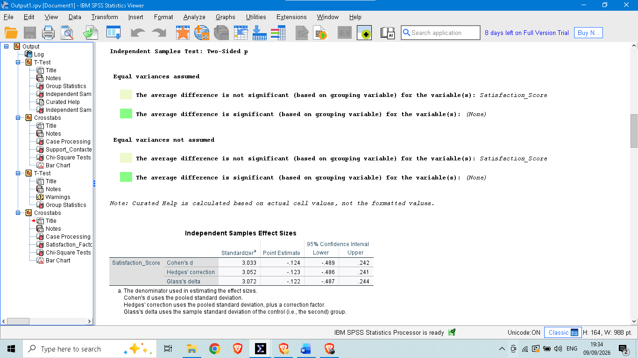
Group A (n = 48) had a mean satisfaction score of 5.13 (SD = 2.97) and Group B (n = 72) had a mean of 5.50 (SD = 3.07). The Independent Samples T Test showed t(118) = -0.66, p = .508. As p>0.05, it is not statistically significant that there is a difference between the satisfaction of Group A and Group B. The average scores were slightly higher for Group B, but this might have been caused by chance.
Question Two: does the interaction with support result in changing loyalty level?
A Chi Square test was performed with a cross tabulation of Support_Contacted and Loyalty_Level.
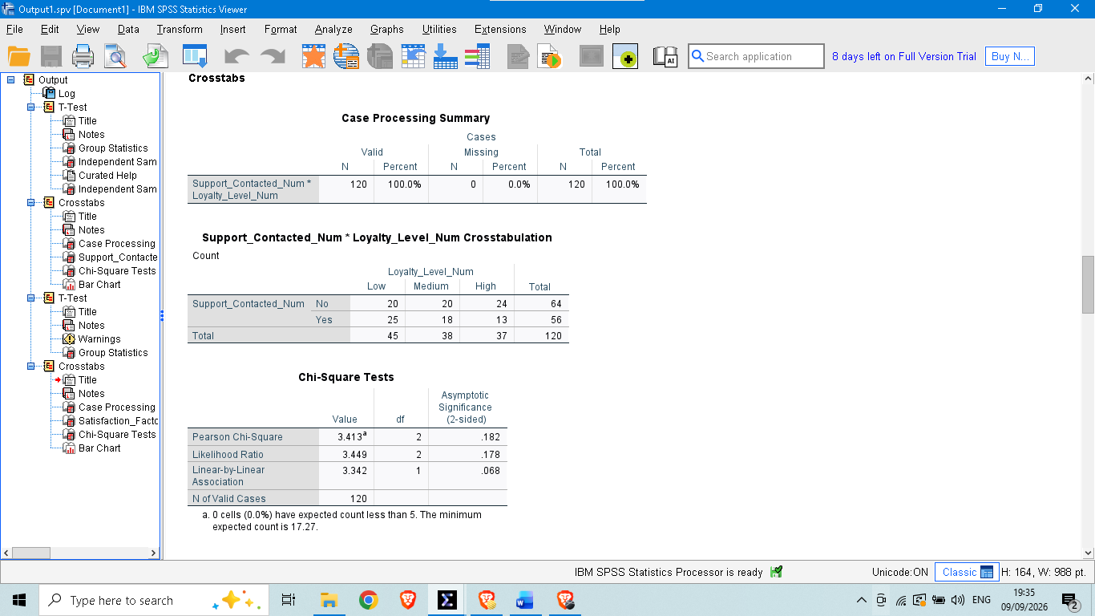
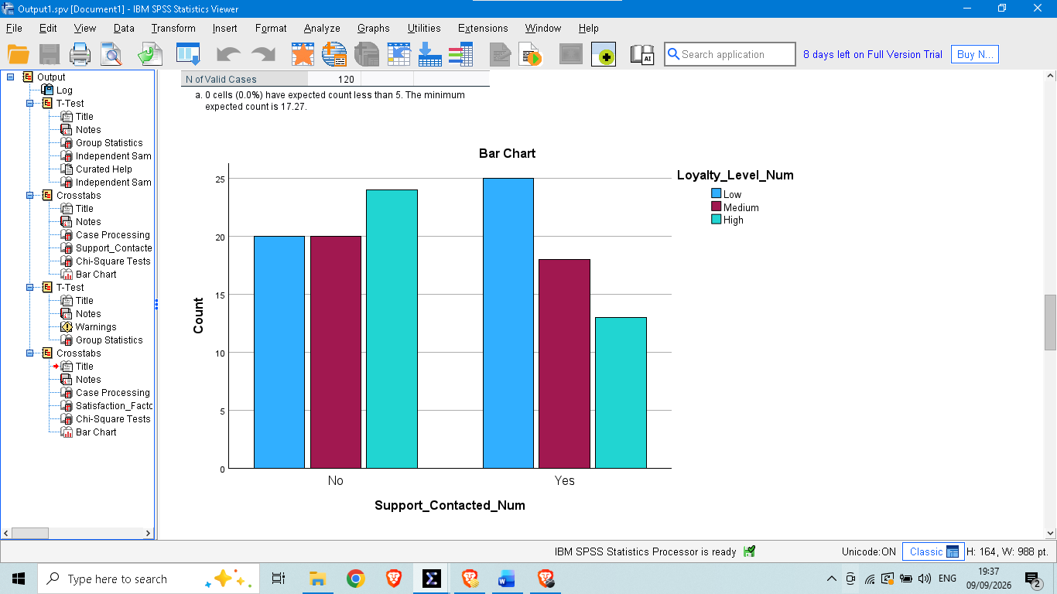

Customers (55.6 percent) reached out to support of the 45 that identified as having Low loyalty. The 38 customers who had Medium loyalty had 18 (47.4 percent) contact with support. Only 13 (35.1 percent) of the 37 customers who had High loyalty had reached out to support. Results of the Chi Square test showed there was no significant difference between the two groups, with a Pearson value of 3.41 and 2 degrees of freedom, p = .182. The correlation between contact with support and loyalty level is not statistically significant at the 5 percent level because the p value is greater than 0.05. But the pattern is consistent in direction, customers who call customer service more frequently are less loyal, and others may have a similar sample size where this relationship would become statistically significant.
Question Three: Is satisfaction related to purchase history?
An Independent Samples T Test was designed to compare Satisfaction_Score between customers that had a purchase history and customers that did not have a purchase history.
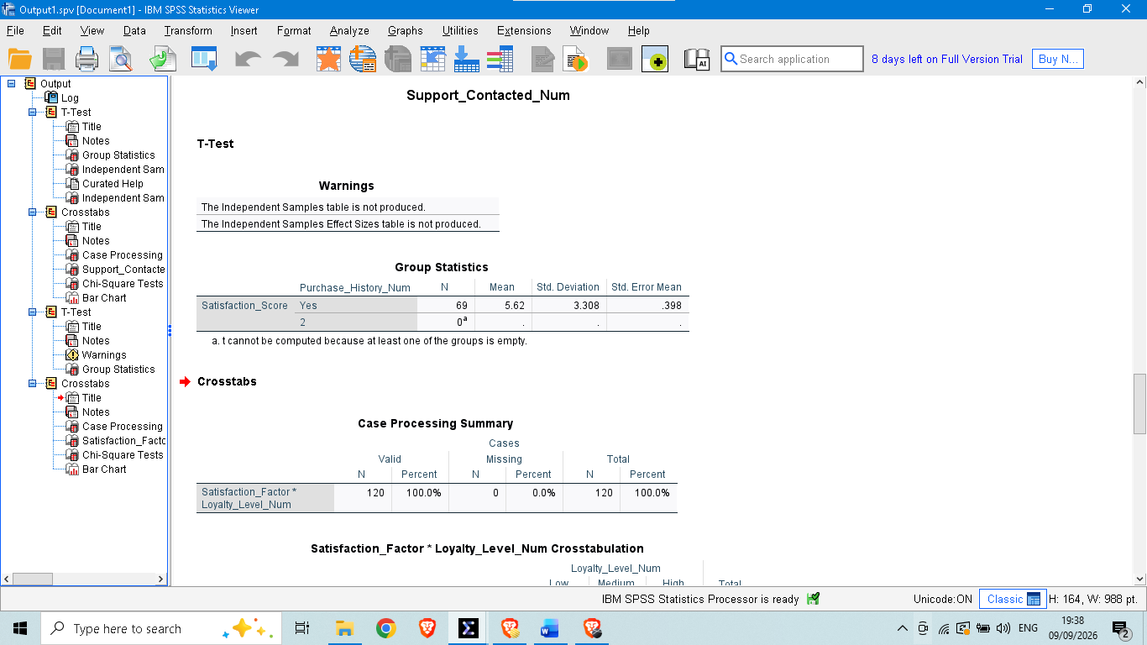
SPSS only returned one group in the Group Statistics table with n = 69, mean = 5.62 and SD = 3.31, and marked that the Independent Samples Test table was not producible. This occurs if the grouping variable Purchase_History_Num does not have 2 valid groups in the data, such as when there are no cases in one of the categories, or when the variable was not re-coded properly. To complete this comparison, first check and confirm that the Purchase_History_Num variable has Yes (1) and No (0) values in it, and that these values are coded correctly in Variable View, then repeat the test.
Question Four: What is the relationship between the satisfaction factor and loyalty in Q6, Q4?
A Chi Square test was performed on a crosstabulation of Satisfaction_Factor and Loyalty_Level.
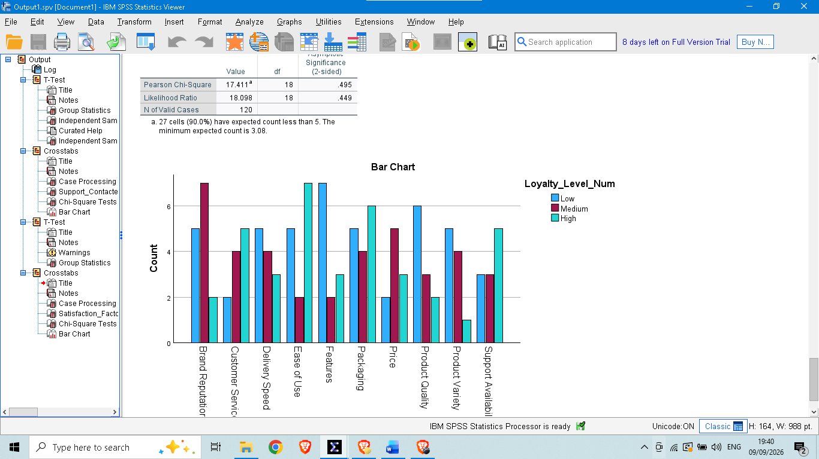
The Satisfaction_Factor x Loyalty_Level Crosstabulation table is an inserted screenshot.The Satisfaction_Factor x Loyalty_Level
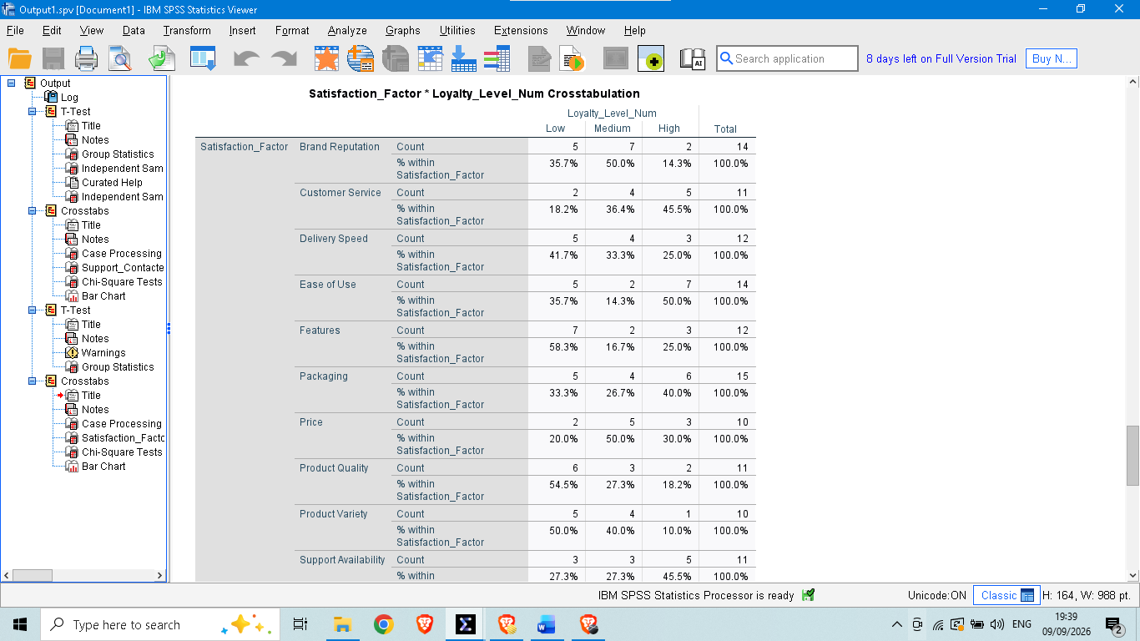

As with Question 2, the crosstabulation spanned 10 satisfaction factor categories and 120 customers, and results were consistent with the totals seen in Question 2 – 45 Low loyalty customers, 38 Medium, and 37 High. The Chi Square test results were Pearson Chi-Square = 17.41, df = 18, p = .495. As p is far greater than 0.05, this dataset does not significantly relate to satisfaction factor and loyalty level. None of the three product attributes (Price, Packaging, Ease of Use) was significantly correlated with higher loyalty.
Summary of Findings
Group (A vs B): There was no significant difference in satisfaction level, p = .508.
Support Contacted vs Loyalty: There was no significant relationship, p = .182, however, the non-loyal customers contacted support more often.
Purchase History vs Satisfaction: Test could not be completed, Purchase_History_Num has coding error, needs correction and rerun.
The correlations between the Satisfaction Factor and Loyalty were not significant (p = .495).
Conclusion
However, none of the tests completed were statistically significant for the sample at the 5 percent level, indicating that group membership, support contact and satisfaction factor did not display strong measurable relationships with customer satisfaction or loyalty. The findings indicate that for this sample, satisfaction and loyalty might be related to some of the other omitted variables or that the effects may be smaller than the sample size of this data set can detect. Prior to answering that question, the Purchase_History comparison should be fixed and re-run.

