Group Project Documentation   
Basic Cross-Platform Application Programming with .NET

Hotel Management

**Prepared by ABKL**

**Nguyễn Đặng Trường Anh**

**Phạm Trần Lê Bảo**

**Thái Tùng Khương**

**Nguyễn Khánh Linh**

**Ho Chi Minh City, 2022**

**Table of Contents**

**Table of Contents ii**

**Revision History ii**

**1.** **Project Introduction 1**

1.1 Product Perspective

1.2 User Classes and Characteristics 1

**2.** **Database Design 1**

**3.** **System Architecture 1**

**4.** **Implementation 2**

Screenshots and explanations 2

**5.** **References 2**

**Revision History**

|  |  |  |  |
| --- | --- | --- | --- |
| **Name** | **Date** | **Reason For Changes** | **Version** |
| Lê Bảo  Trường Anh  Khánh Linh  Tùng Khương | 27/02/2022 | Initial draft, choose a topic, discuss and present the business function of winform | *1.0 draft 1* |
| Lê Bảo  Trường Anh | 06/03/2022 | *Draw ERD, class diagram and write database* | *1.0 draft 2* |
| Lê Bảo  Trường Anh | 07/03/2022 | Design UI for App  Complete Feature Login | *2.0 stage 1* |
| Lê Bảo  Trường Anh | 09/03/2022 – 15/03/2022 | Complete Feature Employee Management  Complete Feture Customer Management  Fix bug | *2.0 stage 2* |
| Khánh Linh | 09/03/2022 -16/03/2022 | Complete Function Load Room in Feature Room Management  Fix bug | *2.0 stage 3* |
| Tùng Khương | 09/03/2022 -17/03/2022 | Complete Function load and add in Feature Service Management  Fix bug | *2.0 stage 4* |
| Lê Bảo  Trường Anh | 17/03/2022 | Complete Feature Service Management  Complete Feature RoomType  Fix bug | *2.0 stage 5* |
| Lê Bảo  Trường Anh | 18/03/2022 | Complete Feature Main  Complete Feature Room Details  Fix bug | *2.0 stage 6* |
| Lê Bảo  Trường Anh | 19/03/2022 | Fix bug and Complete All Feature  Write Report | *2.0 stage 7* |

# Project Introduction

## Product Perspective

This project is about building a software to support the management in the hotel in order to help the manager to manage his hotel effectively. The software can manage a list of rooms, convenient for customer's booking when customers arrive.

In today's era, people's lives are increasingly enhanced and developed, leading to the development of a system of services for people's lives. Not only outside of that rule, the hotel and motel service system is also growing

In Vietnam, the State is going into service development, and investing in tourism. Therefore, the hotel business is also being focused to attract domestic and foreign tourists to visit. Large hotels all have clear management software, but small hotels still use traditional methods. The management efficiency of these small hotels is still not high.

That's why building a hotel management software, to improve the current management level in the stores, to make the management simpler and most effective, and to reduce costs when manage. Help simplify and implement management in the best way.

## User Classes and Characteristics

Business Rules

- Build a software to support the management of tasks in the hotel to help the receptionists manage their hotel well and be effective in the following tasks:

• Manage the list of rooms when booked for convenient management.

• Check the facilities for easy repair when the room has a dozen problems.

• Convenient for customer's booking when customers arrive.

• Solve, support work related to daily activities of customers, receive and handle booking requests from customers.

• Applying Information Technology to reduce effort and save time for business requirements at hotels.

- The software must meet the basic tasks, and at the same time must operate stably and with high performance, ensuring efficiency when the amount of data is large.

- In particular, the website must be suitable for the profession of a number of employees in different departments in the hotel to help reduce the time and effort spent compared to recording through books as before. At the same time has the ability to expand and upgrade when needed.

Class Diagram

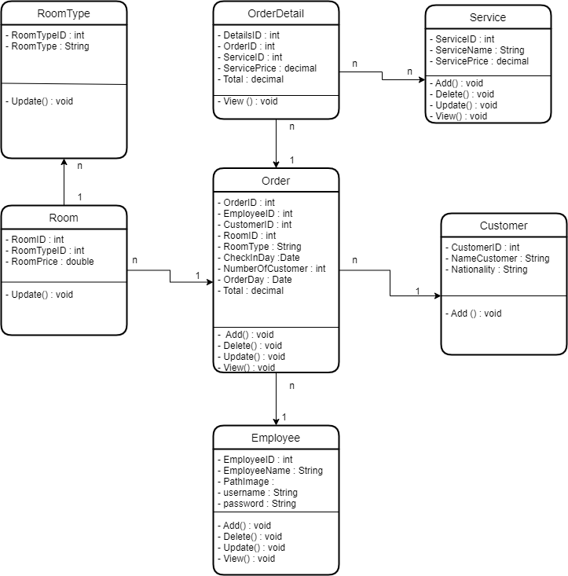

# Database Design

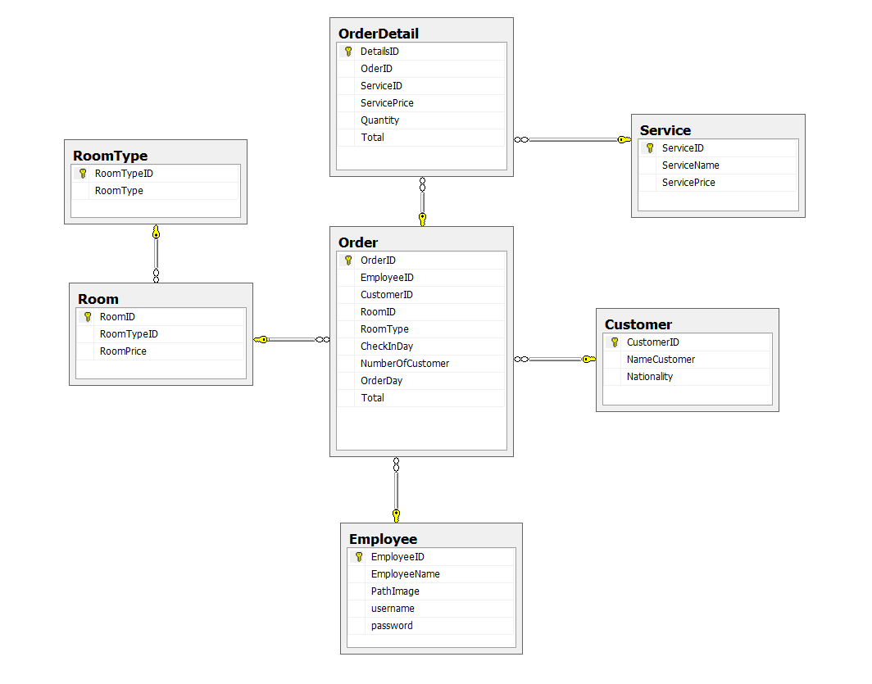

# System Architecture

▪ Apply 3-layers architecture to develop an application

▪ Apply MPV (Model-Presenter-View) pattern in WinForms application

▪ Apply Repository pattern and Singleton pattern in a project

▪ The system operating the software should have .NET Core 5.0 of higher installed.

# Implementation

## Screenshots and explanations

## ScreenFlow

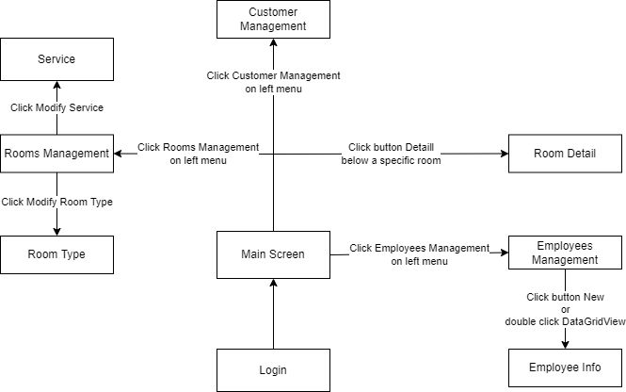

**The ScreenShots**

Login

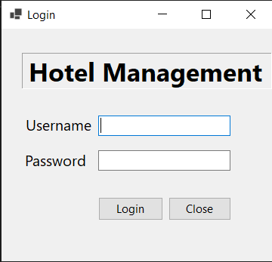

Home View

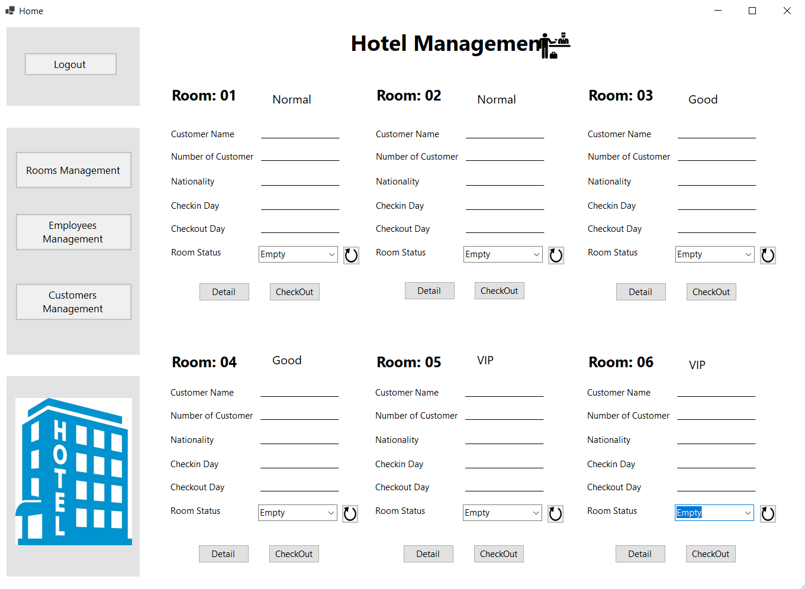

Description: Display all details of existing hotel rooms and 3 main management functions of the hotel including Rooms Management, Employees Management, Customers Management, Detail, CheckOut.

Rooms Management

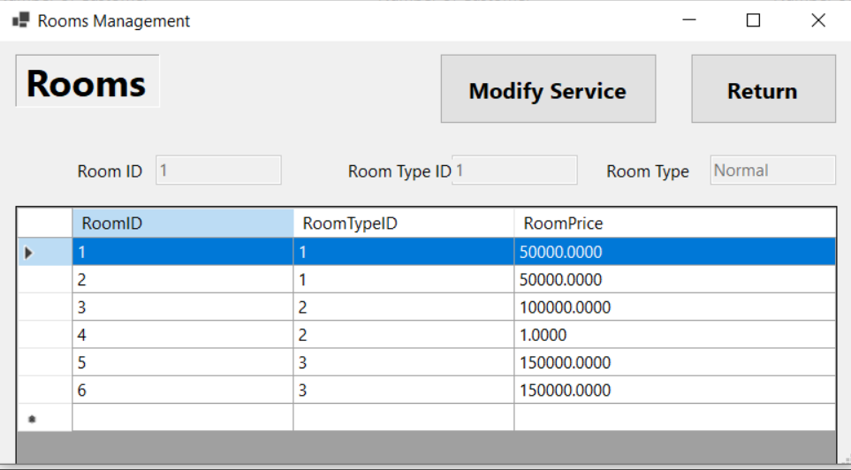

Description: When clicking on Rooms Management, it will display all available room numbers of the hotel including Room Number, Room Type and Room Rate on it. The user only has the right to modify the room's information including RoomType and RoomPrice. On the right corner of the screen, there are 2 buttons that are 2 functions: Service Update and Back to Home.

Modify Service

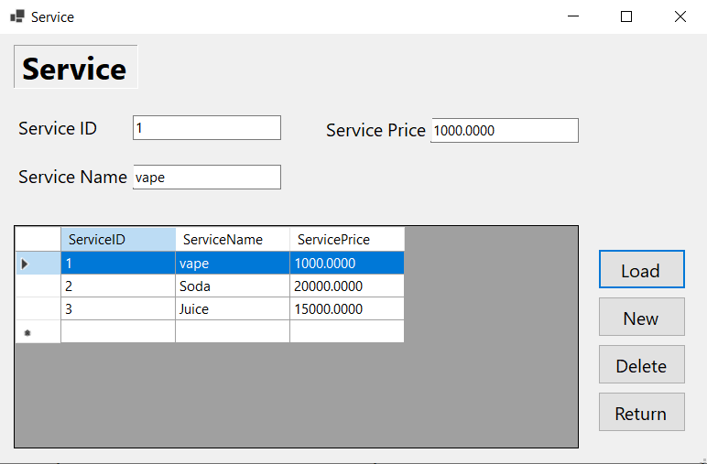

Description: When clicking on the Modify Service app button, we will display all the services that our hotel currently has such as: Soda, Juice...

There are function buttons such as: Load service from database to datagridView , add service, delete service, update service based on user's selection of rows from datagridview. Each operation will be updated back to the database. Clicking Return will return to the Rooms Management page.

Employees Management

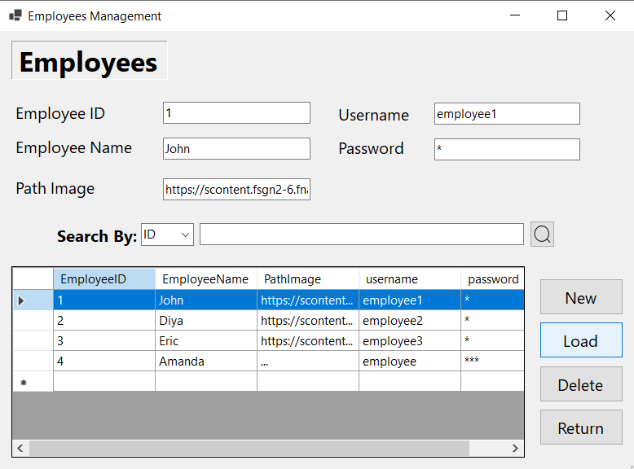

Description: When clicking on Employees Management, it will display all information of hotel employees including ID, name, avatar, username, password. Above the datagirdView table is the function to search employees by ID and Name . The right side of the screen includes the functions of creating new employees, loading employee information, deleting employees and returning to Home. Users can update employee information by double clicking on the employee to be updated in the datagridView.

Employee Info

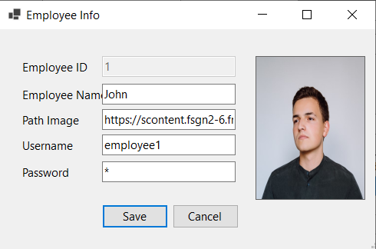

Description: User can change all employee information except Employee ID then click Save to save it to Database. Click cancel to exit Employee Info and return to Employees Management.

Customers Management

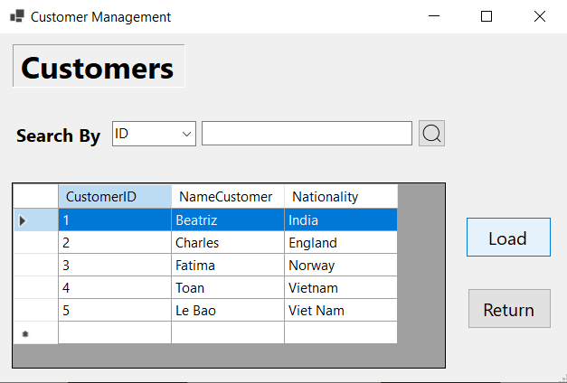

Description: Displays all information of customers who have ever rented a room at the hotel, including Id, name, nationality. Above the datagridView table is the function to search for customers by ID, Name, and Nationality. On the right side are two functions Load customer information from the database and return to Home.

Room Detail

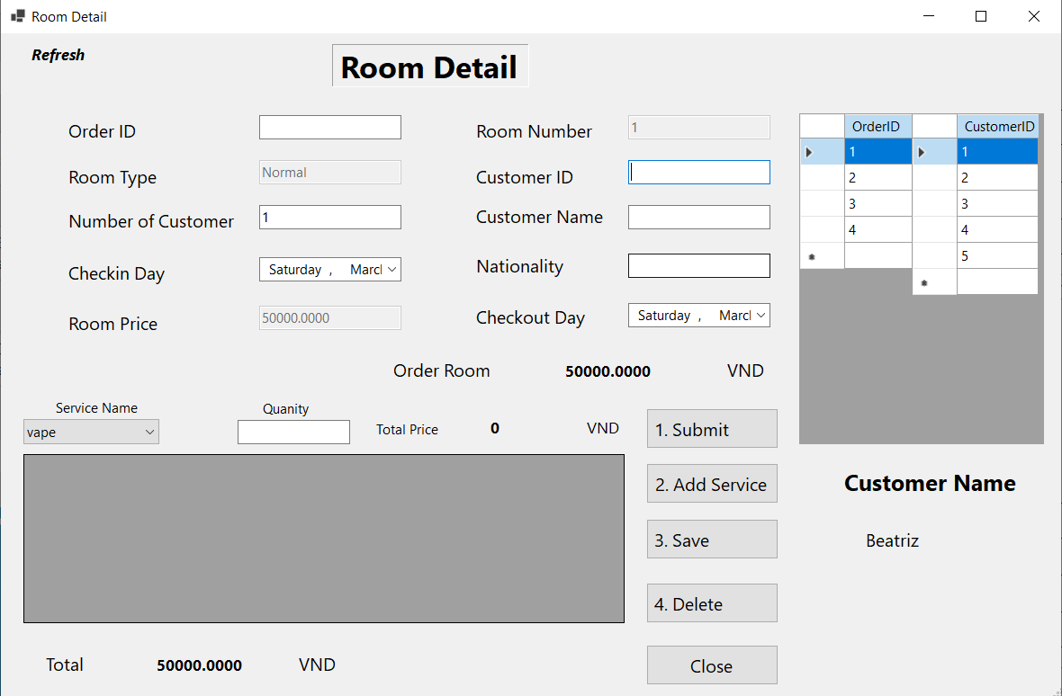

- Description:

+ Display customer invoice information such as: room type, number of guests, date of entry, room rate, number of nights, room number, guest name, nationality, departure date, amount, service name, service price Service, Quantity,, Date of Invoice, OrderID, CustomerID, CustomerName already exist for employee to know.

+ Includes buttons with functions such as: Summit, add service, delete service, save when modified.

+ After the user presses the Summit button, the information will be saved in the customer, invoice, and invoice details table in each table in the database.

+ When the user presses the add button, the service name selected from the combobox and the quantity filled from the textbox will be inserted into the datagridview of the service details below.

+ When the user clicks on the row on the datagridview and presses the delete button, the service will be deleted on that datagridview.

+ The service name will be loaded from the dump database and combobox.

+ When you press the save button, all selected customer and service information will be saved to the database and will return to the main screen and display on the labels of that room, the information has been filled in and the room status will change from empty to have guests.