

**OJT MANAGEMENT SYSTEM**

**Software Design Document**

– Ho Chi Minh, January 2022 –

**Table of Contents**

I. Overview 3

1. Code Packages 3

2. Database Schema 3

II. Code Designs 4

1. <Feature/Function Name1> 4

a. Class Diagram 4

b. Class Specifications 4

c. Sequence Diagram(s) 4

d. Database queries 5

2. <Feature/Function Name2> 5

III. Database Tables 5

1. <Table name 1> 5

2. <Table name 2…> 5

# I. Overview

## 1. Code Packages/Namespaces

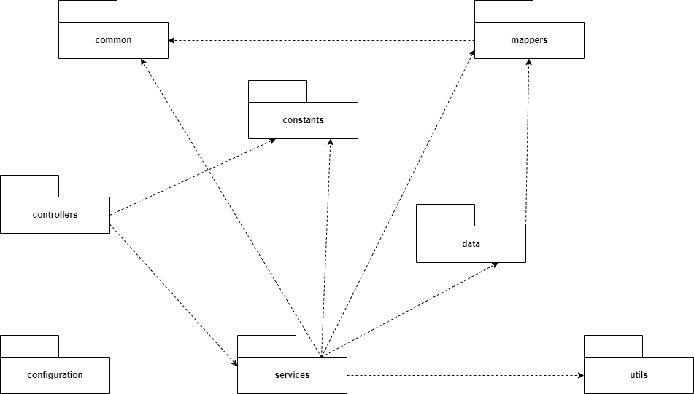

***Package descriptions & package class naming conventions***

|  |  |  |
| --- | --- | --- |
| **No** | **Package** | **Description** |
| 01 | common | Description: Contains commons methods and objects classes. Ie: exceptions handler, enums, payloads, response dtos, ... Naming convention: Upper camel case naming convention |
| 02 | data | Description: Contains database entities and repositories Naming convention: Upper camel case naming convention |
| 03 | services | Description: Contains the services classes to process business logic of data.  Naming convention: Upper camel case naming convention |
| 04 | utils | Description: Contains project Utilities. Ie: SortUtil, JwtUtils, …  Naming convention: Upper camel case naming convention |
| 05 | controller | Description: Contains routing controllers of project.  Naming convention: Upper camel case naming convention |
| 06 | constants | Description: contains constants of the project. Ie: Security constants Naming convention: Upper camel case naming convention |
| 07 | configuration | Description: contains configuration of projects. Ie: cors, security, jwt Naming convention: Upper camel case naming convention |
| 08 | mapper | Description: contains data mappers.  Naming convention: Upper camel case naming convention |

## 2. Database Schema

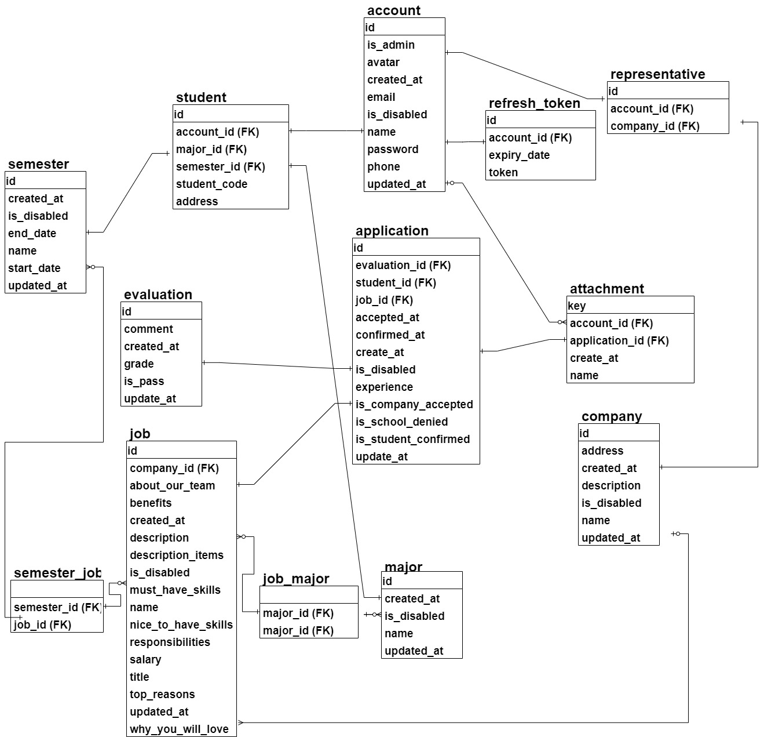

***Table descriptions & package class naming conventions are as below***

|  |  |  |
| --- | --- | --- |
| **No** | **Table** | **Description** |
| 1 | account | - This table includes common fields of all users as avatar, create_at, email, is_disabled, name, password, phone, update_at. The is_admin field to identify the type account sign in to system is admin or not.  - Primary key: id - Foreign keys: None |
| 2 | attachment | - This table is used to store attachment in an application of a student. An attachment has an application and an account  - Primary key: key  - Foreign keys: account_id, application_id |
| 3 | refresh_token | - This table is used to store the token to authorization and keep log in in their web browser. Every user has log in to system all have a token  - Priamary key: id  - Foreign key: account_id |
| 4 | student | -This table is used to store information of student with some own field of student. And a student has an account, a major and a semester  - Primary key: id  - Foreign keys: student_id, semester_id, account_id |
| 5 | representative | -This table is used to store information of company representative with their own fields that the account does not have. Representative has an account and a company  - Primary key: id  - Foreign key: account_id, company_id |
| 6 | company | - This table is used to store information of company that link with school. A company has many jobs and a company representative  - Primary key: id  - Foreign keys: None |
| 7 | job | - This table is used to store information of job. A company have many jobs. A have many applications.  - Primary key: id  - Foreign key: company_id |
| 8 | major | - This table is used to store information of major. A student has a major and a major has many jobs  - Primary key: id  - Foreign key: None |
| 9 | semester | - This table is used to store information of student semester. A student has a semester and a semester has many jobs  - Primary key: id  - Foreign key: None |
| 10 | semester_job | - This table is used to separate relation many-to-many between semester and job. A semester has many jobs and a job in many semesters  - Primary key: None  - Foreign keys: semester_id, job_id |
| 11 | application | - This table is used to store information of application of student for a position. A student can apply many applications and an application has an evaluation, job and attachment.  - Primary key: id  - Foreign keys: evaluation_id, job_id and student_id |
| 12 | job_major | - This table is used to separate relation many-to-many between job and major. A major has many jobs and a job can in many major  - Primary key: None  - Foreign keys: job_id, major_id |
| 13 | evaluation | - This table is used to store information of evaluation of a student application for a job. An application have an evaluation.  - Primary key: id  - Foreign key: None |

# II. Code Designs

## 1. Signin/Signout

### a. Class Diagram

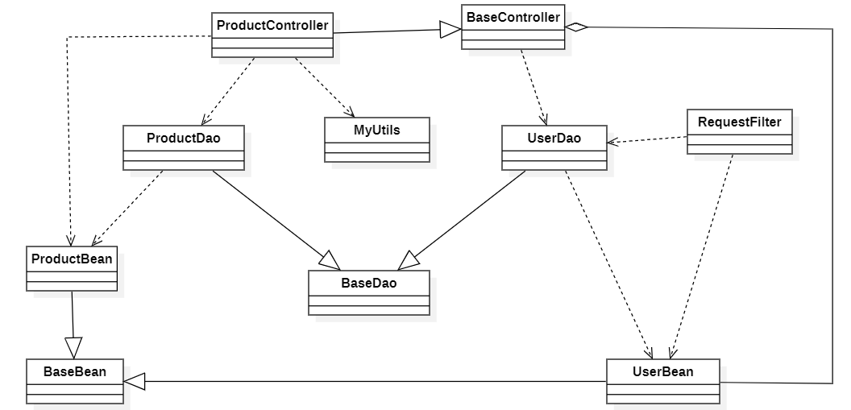

### b. Class Specifications

#### XYZ Class

*[Provide the detailed description for the class methods]*

|  |  |  |
| --- | --- | --- |
| **No** | **Method** | **Description** |
| *01* | *<method name>* | *<Description of the method, including the inputs, outputs & internal method processing>* |
|  |  |  |

#### ABC Class

***Class Methods***

*[Provide the detailed description for the class methods]*

|  |  |  |
| --- | --- | --- |
| **No** | **Method** | **Description** |
| *01* | *<method name>* | *<Description of the method, including the inputs, outputs & internal method processing>* |
|  |  |  |

### c. Sequence Diagram(s)

*[Provide the sequence diagram(s) for the feature, see the sample below]*

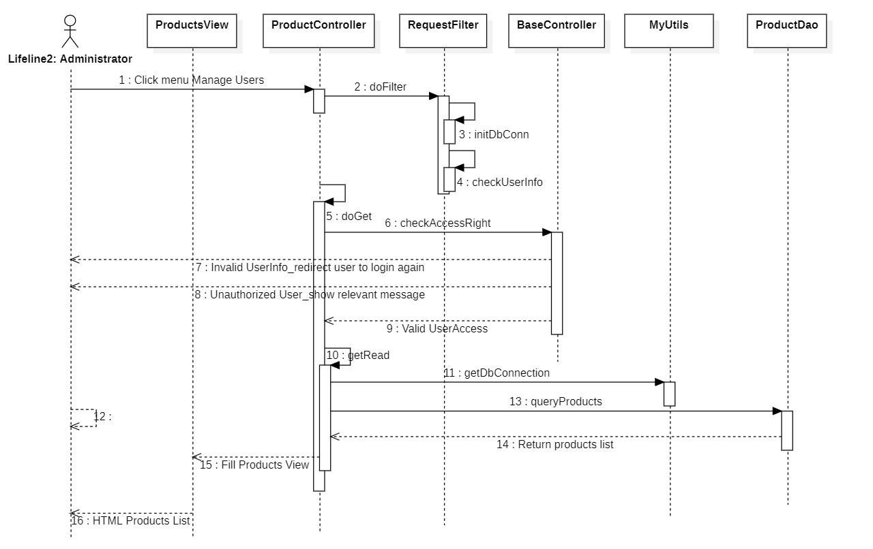

### d. Database queries

*[Provide the detailed SQL (select, insert, update...) which are used in implementing the function/screen]*

## 2. <Feature/Function Name2>

### a. Class Diagram

*[This part presents the class diagram for the relevant feature]*



### b. Class Specifications

*[Provide the description for each class and the methods in each class, following the table format as below]*

#### XYZ Class

*[Provide the detailed description for the class methods]*

|  |  |  |
| --- | --- | --- |
| **No** | **Method** | **Description** |
| *01* | *<method name>* | *<Description of the method, including the inputs, outputs & internal method processing>* |
|  |  |  |

#### ABC Class

***Class Methods***

*[Provide the detailed description for the class methods]*

|  |  |  |
| --- | --- | --- |
| **No** | **Method** | **Description** |
| *01* | *<method name>* | *<Description of the method, including the inputs, outputs & internal method processing>* |
|  |  |  |

### c. Sequence Diagram(s)

*[Provide the sequence diagram(s) for the feature, see the sample below]*



### d. Database queries

*[Provide the detailed SQL (select, insert, update...) which are used in implementing the function/screen]*

# III. Database Tables

## Account

|  |  |  |  |  |  |  |  |
| --- | --- | --- | --- | --- | --- | --- | --- |
| **#** | **Field name** | **Type** | **Size** | **Unique** | **Not Null** | **PK/FK** | **Notes** |
| 1 | id | bigint | 8bytes | x | x | PK |  |
| 2 | Is_admin | boolean | 1bytes |  | x |  |  |
| 3 | avatar | Varchar(2048) | 6144bytes |  | x |  |  |
| 4 | created_at | timestamp | 8bytes |  | x |  |  |
| 5 | email | Varchar(320) | 960bytes |  | x |  |  |
| 6 | is.disabled | Boolean | 1bytes |  | x |  |  |
| 7 | name | Varchar(255) | 765bytes |  | x |  |  |
| 8 | password | Varchar(1024) | 3072bytes |  | x |  |  |
| 9 | phone | Varchar(13) | 39bytes |  | x |  |  |
| 10 | updated_at | timestamp | 8bytes |  | x |  |  |

## 2. Attachment

|  |  |  |  |  |  |  |  |
| --- | --- | --- | --- | --- | --- | --- | --- |
| **#** | **Field name** | **Type** | **Size** | **Unique** | **Not Null** | **PK/FK** | **Notes** |
| 1 | key | Varchar(255) | 765bytes | x | x | PK |  |
| 2 | Account_id | bigint | 8bytes |  | x |  |  |
| 3 | Created_at | timestamp | 8bytes |  | x |  |  |
| 4 | name | Varchar(255) | 765bytes |  | x |  |  |
| 5 | Application_id | bigint | 8bytes | x | x | FK |  |

## 3.Refresh token

|  |  |  |  |  |  |  |  |
| --- | --- | --- | --- | --- | --- | --- | --- |
| **#** | **Field name** | **Type** | **Size** | **Unique** | **Not Null** | **PK/FK** | **Notes** |
| 1 | id | brigint | 8bytes | x | x | PK |  |
| 2 | Expiry_date | timestamp | 8bytes |  |  |  |  |
| 3 | token | Varchar(255) | 765bytes |  | x |  |  |
| 4 | Account_id | bigint | 8bytes |  | x | FK |  |

## 4. Student

|  |  |  |  |  |  |  |  |
| --- | --- | --- | --- | --- | --- | --- | --- |
| **#** | **Field name** | **Type** | **Size** | **Unique** | **Not Null** | **PK/FK** | **Notes** |
| 1 | id | bigint | 8 bytes | x | x | PK |  |
| 2 | address | varchar(500) | 1500 bytes |  |  |  |  |
| 3 | student_code | varchar(10) | 30 bytes |  | x |  |  |
| 4 | account_id | bigint | 8 bytes |  | x | FK |  |
| 5 | major_id | bigint | 8 bytes |  | x | FK |  |
| 6 | semester_id | bigint | 8 bytes |  | x | FK |  |

## 5. Representative

|  |  |  |  |  |  |  |  |
| --- | --- | --- | --- | --- | --- | --- | --- |
| **#** | **Field name** | **Type** | **Size** | **Unique** | **Not Null** | **PK/FK** | **Notes** |
| 1 | id | bigint | 8 bytes | x | x | PK |  |
| 2 | account_id | bigint | 8 bytes |  | x | FK |  |
| 3 | company_id | bigint | 8 bytes |  | x | FK |  |

## 6. Company

|  |  |  |  |  |  |  |  |
| --- | --- | --- | --- | --- | --- | --- | --- |
| **#** | **Field name** | **Type** | **Size** | **Unique** | **Not Null** | **PK/FK** | **Notes** |
| 1 | id | bigint | 8 bytes | x | x | PK |  |
| 2 | address | varchar(500) | 1500 bytes |  |  |  |  |
| 3 | create_ad | bigint | 8 bytes |  | x |  |  |
| 4 | description | varchar(2000) | 6000 bytes |  |  |  |  |
| 5 | is_disabled | boolean | 1 byte |  | x |  |  |
| 6 | name | varchar(255) | 765 bytes |  | x |  |  |
| 7 | updated_at | timestamp | 8 bytes |  | x |  |  |

## 7. Job

|  |  |  |  |  |  |  |  |
| --- | --- | --- | --- | --- | --- | --- | --- |
| **#** | **Field name** | **Type** | **Size** | **Unique** | **Not Null** | **PK/FK** | **Notes** |
| 1 | id | bigint | 8 bytes | x | x | PK |  |
| 2 | about_our_team | varchar(2000) | 6000 bytes |  | x |  |  |
| 4 | benefit | jsonb |  |  | x |  |  |
| 5 | created_at | timestamp | 8 bytes |  | x |  |  |
| 6 | description | varchar(2000) | 6000 bytes |  |  |  |  |
| 7 | description_items | jsonb |  |  | x |  |  |
| 8 | is_disabled | boolean | 1 bytes |  | x |  |  |
| 9 | must_have_skils | jsonb |  |  | x |  |  |
| 10 | name | varchar(255) | 765 bytes |  | x |  |  |
| 11 | nice_to_have_skill | jsonb |  |  | x |  |  |
| 12 | responsibilities | jsonb |  |  | x |  |  |
| 13 | salary | varchar(255) | 765 bytes |  | x |  |  |
| 14 | title | varchar(255) | 765 bytes |  | x |  |  |
| 15 | top_reasons | jsonb |  |  | x |  |  |
| 16 | updated_at | timestamp | 8 bytes |  | x |  |  |
| 17 | why_you_will_love | varchar(2000) | 6000 bytes |  | x |  |  |
| 18 | company_id | bigint | 8 bytes | x | x | FK |  |

## 8. Major

|  |  |  |  |  |  |  |  |
| --- | --- | --- | --- | --- | --- | --- | --- |
| **#** | **Field name** | **Type** | **Size** | **Unique** | **Not Null** | **PK/FK** | **Notes** |
| 1 | id | bigInt | 8 bytes | x | x | PK |  |
| 2 | created_at | timestamp | 8 bytes |  | x |  |  |
| 3 | is_disabled | boolean | 1 bytes |  | x |  |  |
| 4 | name | varchar(255) | 765 bytes |  | x |  |  |
| 5 | updated_at | timestamp | 8 bytes |  | x |  |  |

## 9. Semester

|  |  |  |  |  |  |  |  |
| --- | --- | --- | --- | --- | --- | --- | --- |
| **#** | **Field name** | **Type** | **Size** | **Unique** | **Not Null** | **PK/FK** | **Notes** |
| 1 | id | bigInt | 8 bytes | x | x | PK |  |
| 2 | created_at | timestamp | 8 bytes |  | x |  |  |
| 3 | is_disabled | boolean | 1 bytes |  | x |  |  |
| 4 | end_date | timestamp | 8 bytes |  | x |  |  |
| 5 | name | varchar(255) | 765 bytes |  | x |  |  |
| 6 | start_date | timestamp | 8 bytes |  | x |  |  |
| 7 | updated_at | timestamp | 8 bytes |  | x |  |  |

## 10. Semester_job

|  |  |  |  |  |  |  |  |
| --- | --- | --- | --- | --- | --- | --- | --- |
| **#** | **Field name** | **Type** | **Size** | **Unique** | **Not Null** | **PK/FK** | **Notes** |
| 1 | semester_id | bigint | 8 bytes |  | X | FK |  |
| 2 | job_id | bigint | 8 bytes |  | X | FK |  |

## 11. Application

|  |  |  |  |  |  |  |  |
| --- | --- | --- | --- | --- | --- | --- | --- |
| **#** | **Field name** | **Type** | **Size** | **Unique** | **Not Null** | **PK/FK** | **Notes** |
| 1 | id | bigint | 8bytes | X | X | PK |  |
| 2 | accpeted_at | timestamp |  |  |  |  |  |
| 3 | confirmed_at | timestamp |  |  |  |  |  |
| 4 | Create_at | timestamp |  |  |  |  |  |
| 5 | is_disabled | boolean | 1 byte |  |  |  |  |
| 6 | experience | Varchar(1000) |  |  |  |  |  |
| 7 | is_company_accepted | boolean | 1byte |  |  |  |  |
| 8 | is_school_denied | boolean | 1 byte |  |  |  |  |
| 9 | is_student_confirmed | boolean | 1 byte |  |  |  |  |
| 10 | updated_at | timestamp |  |  |  |  |  |
| 11 | evaluation_id | bigint | 8 bytes |  |  | FK |  |
| 12 | job_id | bigint | 8 bytes |  |  | FK |  |
| 13 | student_id | bigint | 8bytes |  |  | FK |  |

## 12. Job_Major

|  |  |  |  |  |  |  |  |
| --- | --- | --- | --- | --- | --- | --- | --- |
| **#** | **Field name** | **Type** | **Size** | **Unique** | **Not Null** | **PK/FK** | **Notes** |
| 1 | Major_id | bigint | 8 bytes |  | x | FK |  |
| 2 | Job_id | bigint | 8 bytes |  | x | FK |  |

## 13. Evaluation

|  |  |  |  |  |  |  |  |
| --- | --- | --- | --- | --- | --- | --- | --- |
| **#** | **Field name** | **Type** | **Size** | **Unique** | **Not Null** | **PK/FK** | **Notes** |
| 1 | id | bigint | 8bytes | x | x | PK |  |
| 2 | comment | Varchar(500) | 1500bytes |  |  |  |  |
| 3 | Create_at | timestamp | 8bytes |  |  |  |  |
| 4 | grade | bigint | 8bytes |  |  |  |  |
| 5 | Is_pass | boolean | 1 byte |  |  |  |  |
| 6 | Updated_at | timestamp | 8 bytes |  |  |  |  |