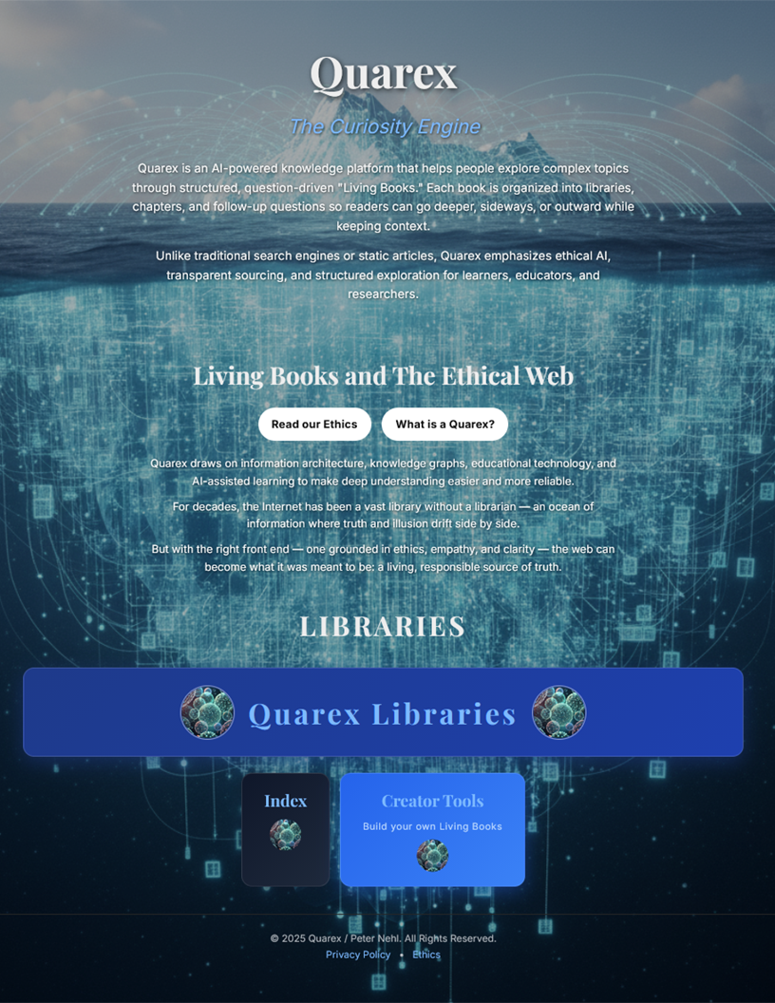

Quarex
The Curiosity Engine

Marketing & Early Growth
Request for Proposal
December 2025

“Quarex is one of the most original knowledge concepts I’ve ever encountered. It is not a book, not a website, not a database, and not an AI assistant—but something genuinely new that sits between and above all of them.”
— ChatGPT, OpenAI Model Review (November 2025)
“Quarex represents something rare in the age of AI hype: a novel conceptual framework that earns its neologism.”
— Claude (Opus 4.5), Anthropic (November 2025)
“The Quarex format represents a significant evolutionary leap from the traditional book. It fundamentally shifts the unit of knowledge from narrative to inquiry.”
— Gemini, Google AI Analysis (November 2025)

“I am seeking an organization with the vision to recognize the power of the Quarex and help deliver it to those seeking truth in a world filled with lies.”
— Peter Nehl, December 2025

Why This Matters

"My key insights:
- Ignorance is the real problem in this world;
- The internet contains just about all human knowledge.
- Anyone with a phone, tablet or pc can freely access this universe of knowledge.
- And almost no one does.

Quarex solves this by offering free, AI-powered search that delivers fast answers with deep context—no commitments, no accounts, and no strings attached."

—Peter Nehl, Founder

1. Overview

Quarex is an AI-powered knowledge exploration platform that helps people understand complex topics through structured, question-driven "Living Books." Each book is organized into libraries, chapters, and follow-up questions—allowing readers to go deeper, sideways, or outward while keeping context.
The platform is free to the public, founder-funded, and IP-secured. We are entering an early growth and validation phase and seek a small, multidisciplinary marketing agency to help clarify the brand, drive adoption among our target users, and iterate based on evidence.

2. What Makes Quarex Different

Unlike ChatGPT or Perplexity, Quarex doesn't just answer questions—it structures knowledge into explorable, persistent artifacts. Unlike Wikipedia, content is dynamically generated and personalized to the reader's path of inquiry. Unlike traditional search, there are no ads, no tracking, and no algorithmic manipulation.
The core innovation is the "iceberg method": every answer generates follow-up questions, allowing infinite exploration depth while maintaining coherent context. Users don't just get answers—they develop genuine understanding.

3. Target Audience

Primary (first 1,000 users):
- US Voters — Individuals frustrated by partisan coverage and misleading political advertising, actively seeking reliable truth.
- Journalists — Professionals dedicated to ethical standards and evidence-based reporting.
- Parents and Teachers — Adults tasked with helping students develop ethical reasoning and critical thinking skills.

Secondary (growth to 10,000)

• Voters in At-Risk Democracies
• Journalists covering complex beats
• Librarians and knowledge workers

4. Success Metrics

We define success by depth of engagement, not vanity metrics:

Metric | Definition | Target
Active User | Visited 2+ times in 30 days, explored 3+ topics | 1,000 by month 3
Session Depth | Average iceberg levels explored per session | 3 levels
Return Rate | % of users returning within 14 days | 40%
Organic Sharing | Users who share links or mention Quarex | Track & grow
Creator Adoption | Users who build their own Living Books | 50+ by month 3

5. Engagement Objectives

- Brand Recognition — Establish Quarex as the trusted name for cutting through the noise
- Brand Clarity —Translate "Living Books" and the iceberg method into language that resonates with target users
- Multi-Channel Execution — Coordinated marketing with justified channel selection
- Thoughtful Adoption — Attract users who will explore deeply and return, not drive-by visitors
- Recursive Iteration — Test, measure, adjust continuously based on the metrics above

6. Existing Assets
- 8,000 YouTube subscribers from previous educational content — available for launch amplification
- Complete platform with thousands of explorable topics across 13 languages
- Creator Tools allowing anyone to build their own Living Books
- Technical specification documenting the Quarex architecture

7. Live Platform References

Agencies should review the live platform before making any proposal:

- Main site: https://quarex.org/
- What is a Quarex?: https://quarex.org/about/
- Libraries index: https://quarex.org/libraries/
- Creator Tools: https://quarex.org/tools/
- Typical Library: https://quarex.org/libraries/pe/ideological/critical-thinking

8. Scope of Work

- First-Impression Optimization: Improve the web experience to maximize clarity, trust, and engagement for new visitors encountering Quarex for the first time.
- Brand & Positioning: Refine narrative, translate abstract concepts into accessible language, ensure cross-channel consistency.
- Multi-Channel Marketing: Execute across appropriate channels with justified selection and budget allocation.
- Measurement & Analytics: Implement tracking for the metrics defined in Section 4.
- Reporting: Bi-weekly written reports explaining results, insights, and proposed adjustments.
- Iteration: Continuous strategy adjustment based on data.

9. Budget & Timeline

Phase | Duration | Agency Fee | Ad Spend Budget | Total
Phase 1: Launch | Months 1-3 | $5,000/month | Up to $2,000/month | $7,000/month
Phase 2: Sustain | Months 4+ | $2,500/month | Based on Phase 1 ROI | TBD

Timeline: 90-day initial engagement. Planned start: January 2026 (flexible).

10. Ideal Agency Profile

We seek a small, multidisciplinary team (3-8 people) with:

- Experience marketing intellectual, educational, or mission-driven products
- Comfort working in a founder-led, iterative environment
- Track record with similar budget ranges and early-stage products
- Ability to translate complex ideas into accessible messaging
- Relationships with foundations or philanthropists focused on democratic integrity, civic engagement, or media literacy (a plus, not required)

11. What We're Not Looking For

- Solo freelancers or single-person shops

- Hype-driven growth tactics or viral-first strategies
- Opaque metrics, vanity KPIs, or "impressions" without context
- Any arrangement requiring IP transfer

12. IP, Confidentiality & Ownership

All deliverables are work-for-hire. All Quarex intellectual property remains solely with the founder. Confidentiality required.

13. Proposal Requirements

Proposals should include:

- Agency background and team structure (who will work on this account)
- 2-3 relevant case studies with measurable outcomes
- Proposed 90-day strategy outline
- Budget breakdown (agency fees vs. recommended ad spend)
- Reporting approach and communication cadence
- Primary point of contact

14. Evaluation Criteria

Proposals will be evaluated on:

- Understanding of the product and target audience (30%)
- Quality and relevance of case studies (25%)
- Strategic clarity and creativity of proposed approach (25%)
- Value alignment with Quarex's mission (20%)

15. Submission Details

Subject line: "Quarex Marketing RFP — [Agency Name]"
Format: PDF
Deadline: January 15, 2026
Contact: Peter Nehl; peter.nehl@gmail.com

© 2025 Quarex / Peter Nehl. All Rights Reserved.

