**GPST redesign report**

I used a template found on HTML5 UP. I chose this template because of its dynamic nature and flexibility. I primarily used green for my website to match the requested GPST color. I aimed to use as much green as possible while keeping the design simple and minimal, to give off a more modern feel. I also selected a font that isn't too technical but also not overly cursive.

I started with a template and then added text, images, and logos, adjusting alignments, sizing, colors, and layout. The provided CSS was extremely long and complicated, so I had to read through everything and make sense of the classes and IDs to make the relevant adjustments in the correct locations.

One of the most detailed parts was when I tried to change the hover effect on a link. The default color was blue, which I didn't particularly like, so I switched it to the golden GPST color. I ensured that everything was changed and coherent

I created three main pages: home (index), training, and board. I changed the contact page into a section in the footer so that it doesn't take up as much space but is still functional. However, I still included it and created a clickable link in the navigation section:

I also added the logo as requested. I used an editing tool built into my photo app to remove the background, then added the photo to the title in HTML and set the height and width to visually appealing sizes.

I also added the events sections in the homepage.

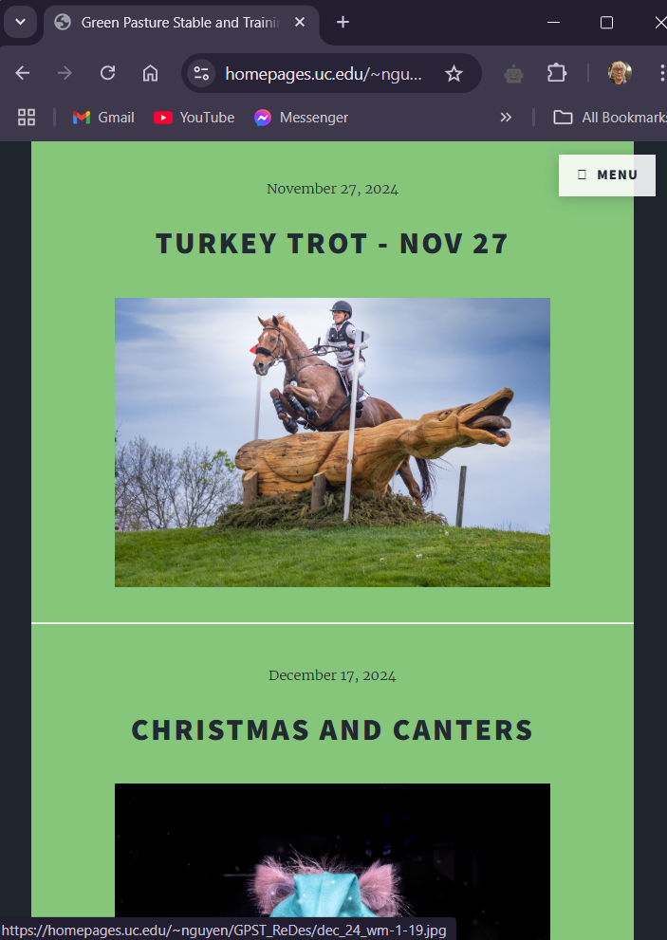

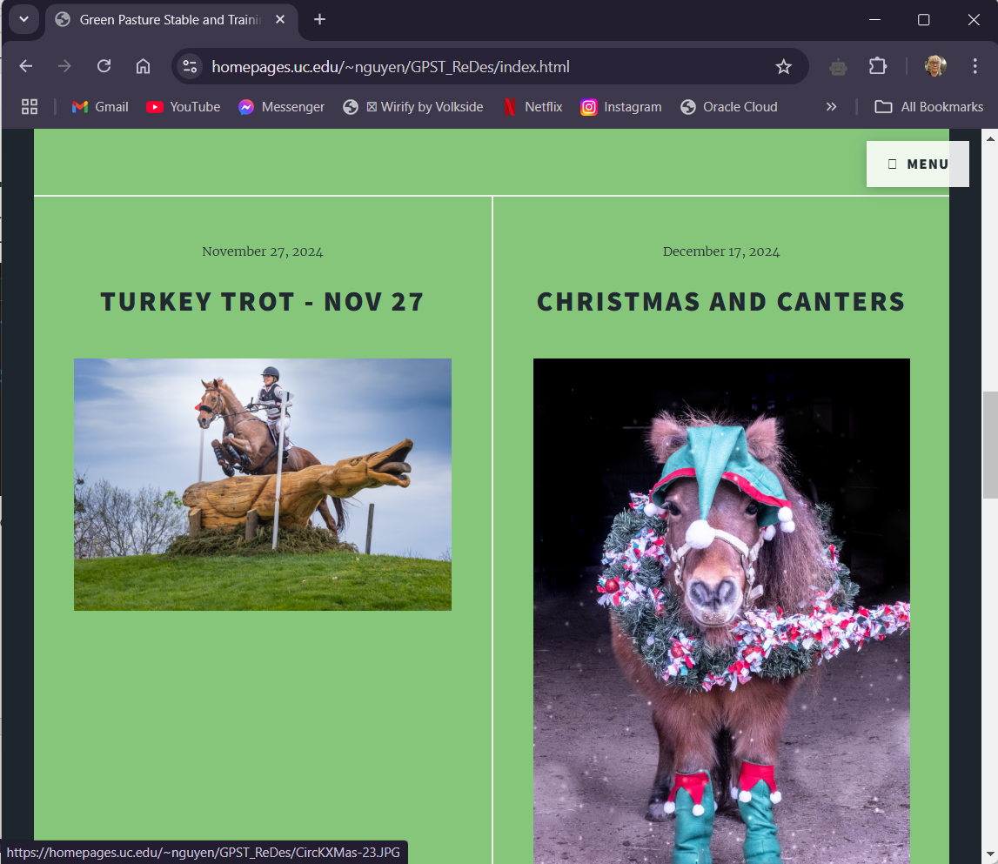

Overall, I really enjoyed remaking this website. It was a lot of work but seeing that I was capable of making such a complicated website makes me feel good about myself.