SNR varied with parameter
Note May 12th
As our polar-coordinates transform and Radon transform might be consistent an have same compute complexity, We take a SNR varied with gridding study with our original method.

Previously review,
SNR varied with Nbins:
Last time , We questioned the method to decide Nbins in rebin step might not be universal. We thought different DM might caused different result to Nbins. I did a simulate at different DM value data and also imply the real data for test. The result keep consistent with previous deduct:
To keep the information conservation, The data after changed should have same pixels as before in order to obtain the most information.

At DM=100 (last time is DM=50), SNR varied with Nbins looks like:
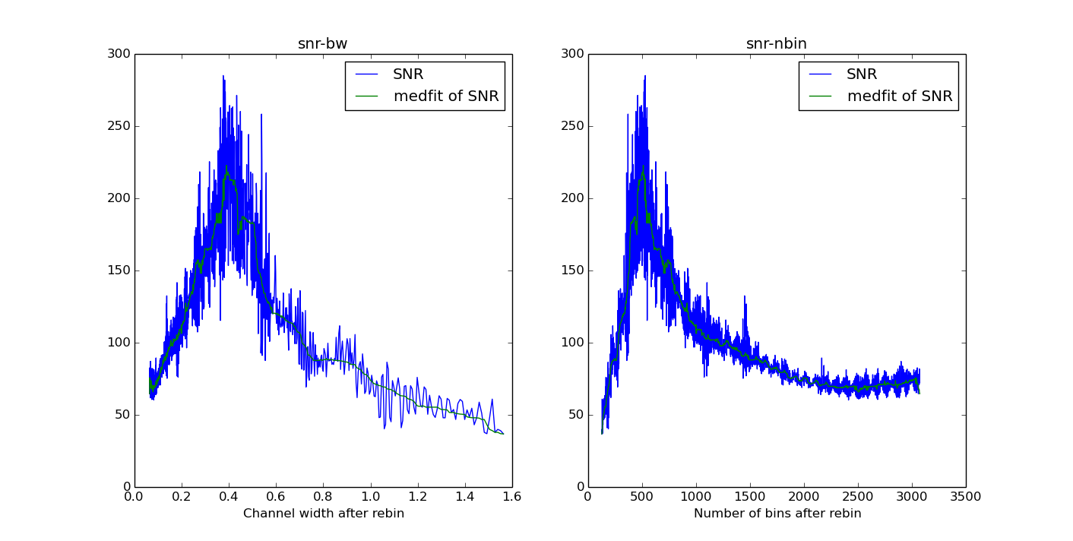
(bw means the channel band width which are from : BW/Nbins)
This is the DM at 500.
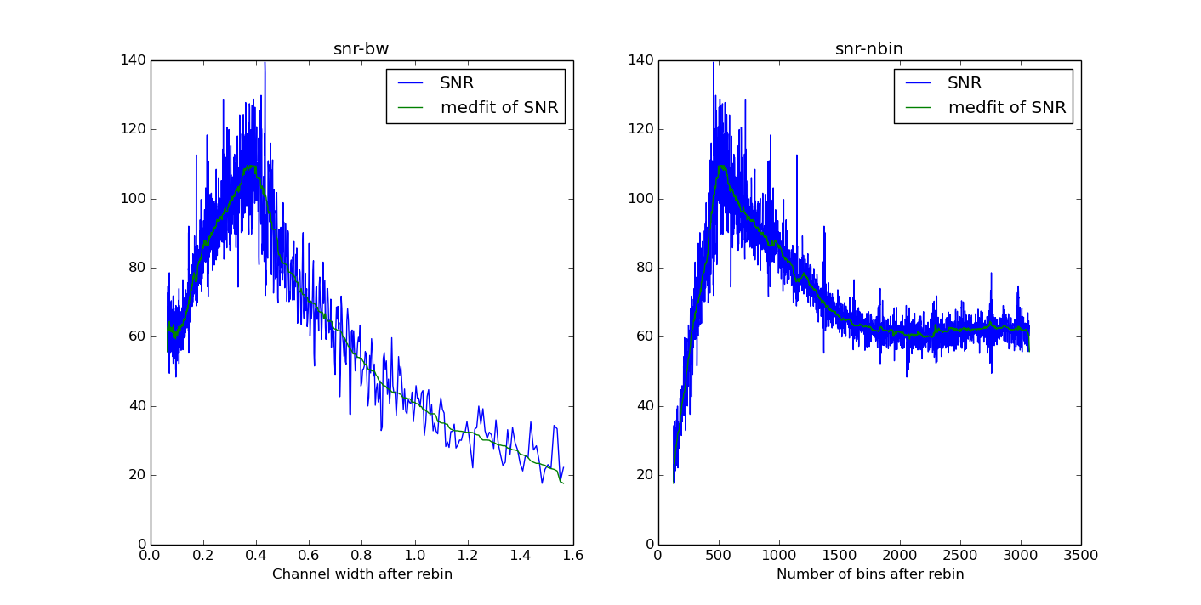
I also test the real data FRB110220, which has a :
SNR varied with resolution:

For the griding problem ( angle resolution problem), I did a test to varied the grid size around the theory value we deduct. And it also looks good .
SNR varied with grid :
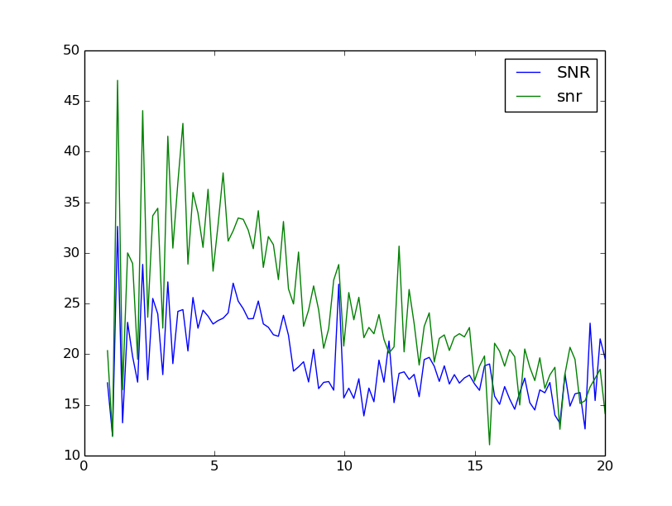
I use grid size max to 20 times bigger than theory grid size. And get the results like above. To noticed that, the grid size need be a integer, So it will appear some gear shape. But the whole trend is falling down. I did not choose the grid size smaller than 1 time of original grid size, because at that time , we could not find signal , the SNR is contribute with wrong point.

Two image can illustrate this,

At original grid size :
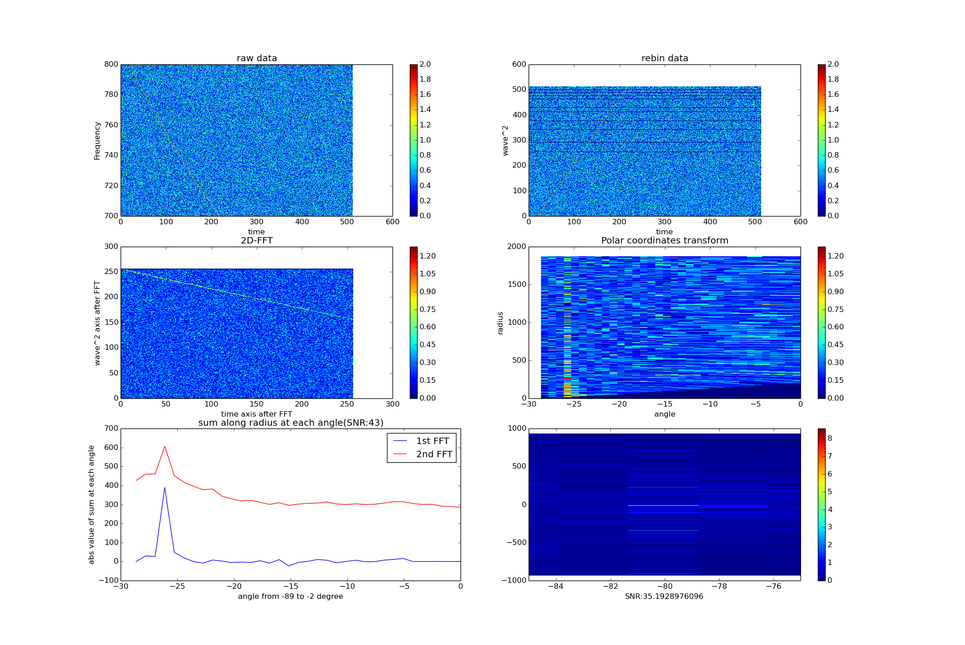
At 0.9 times of grid size:
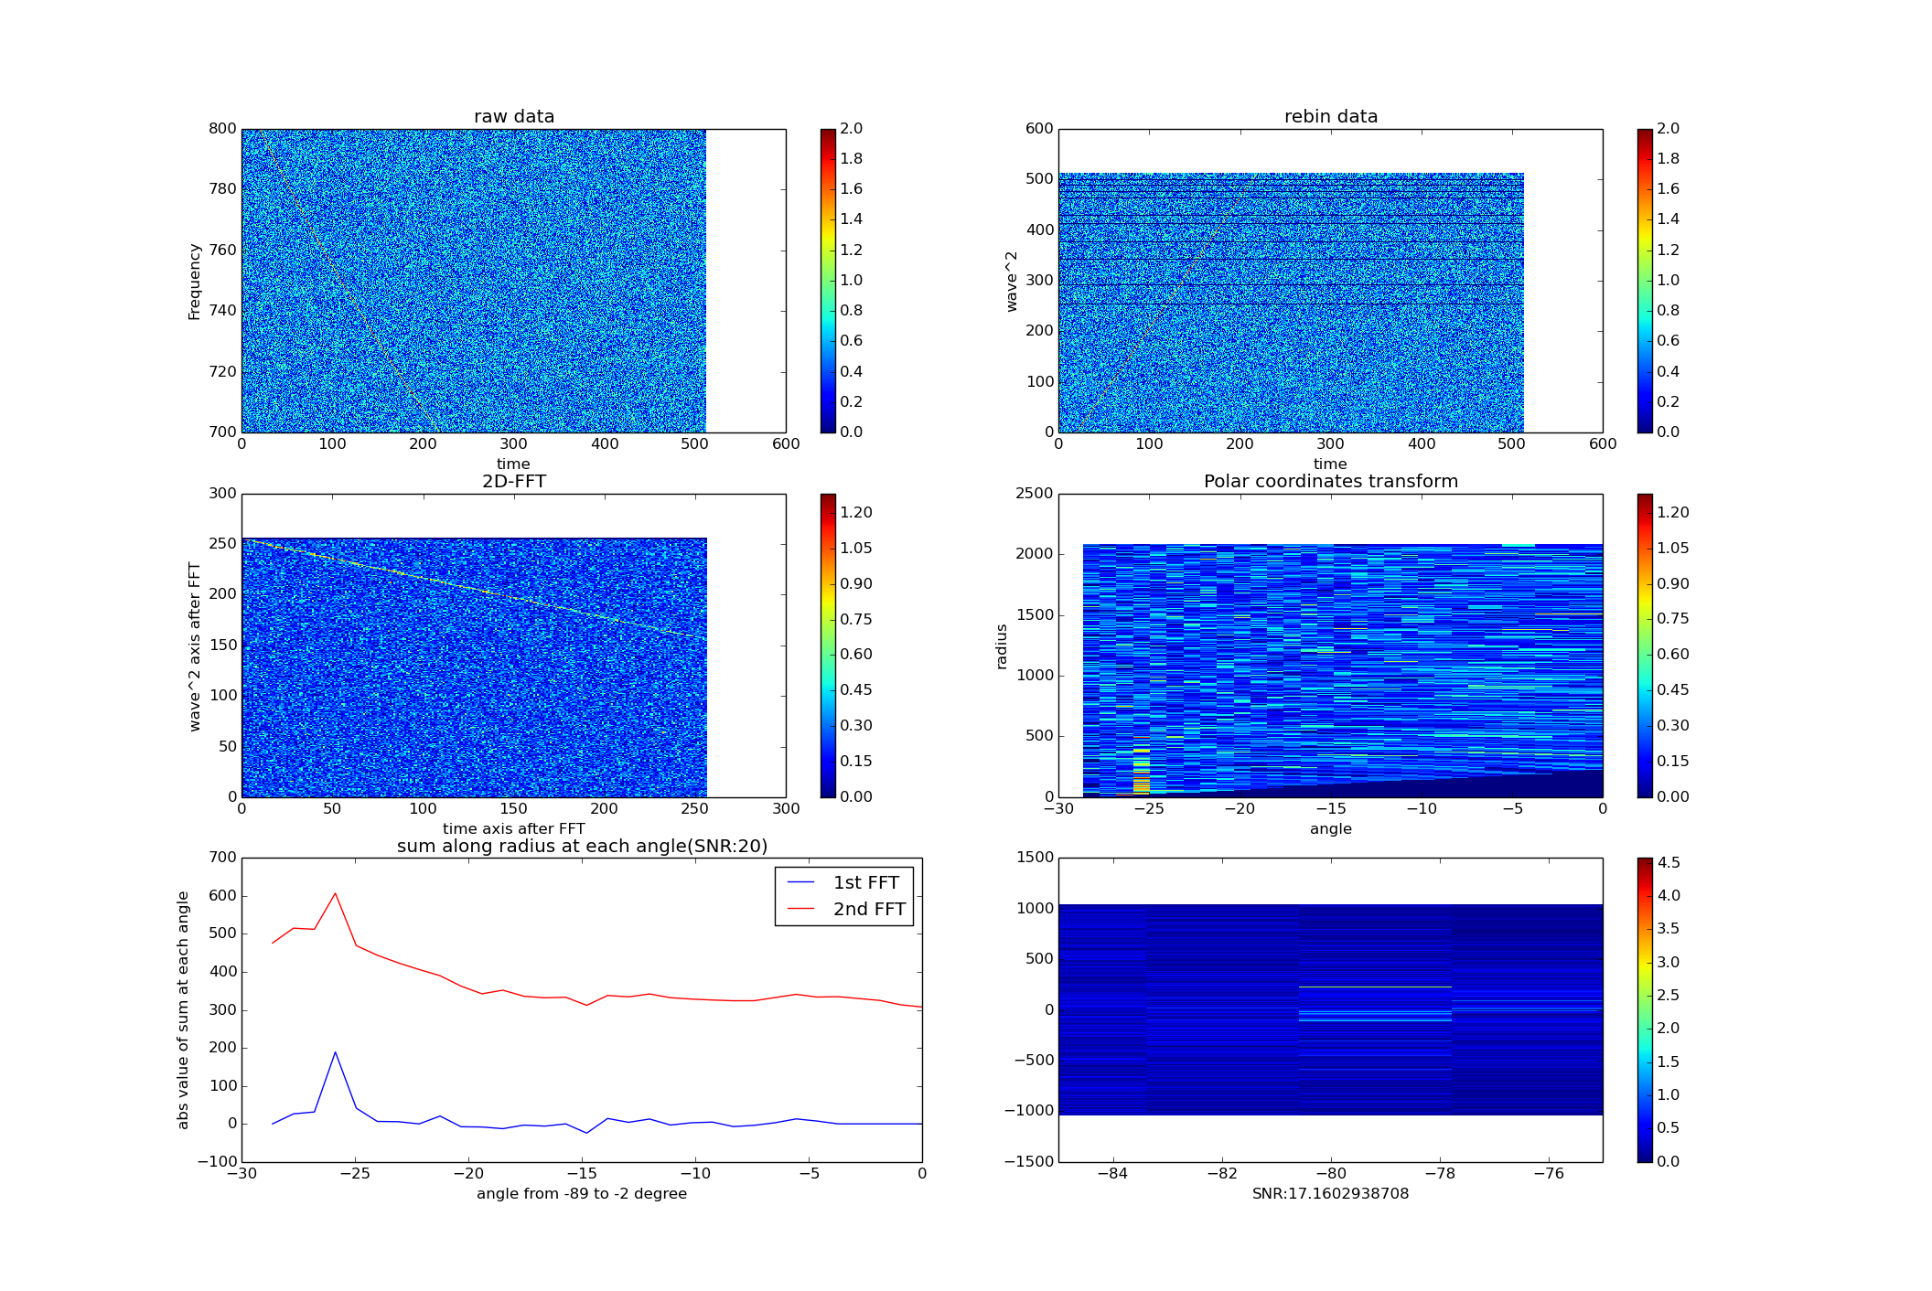

At 0.8 times of grid size:

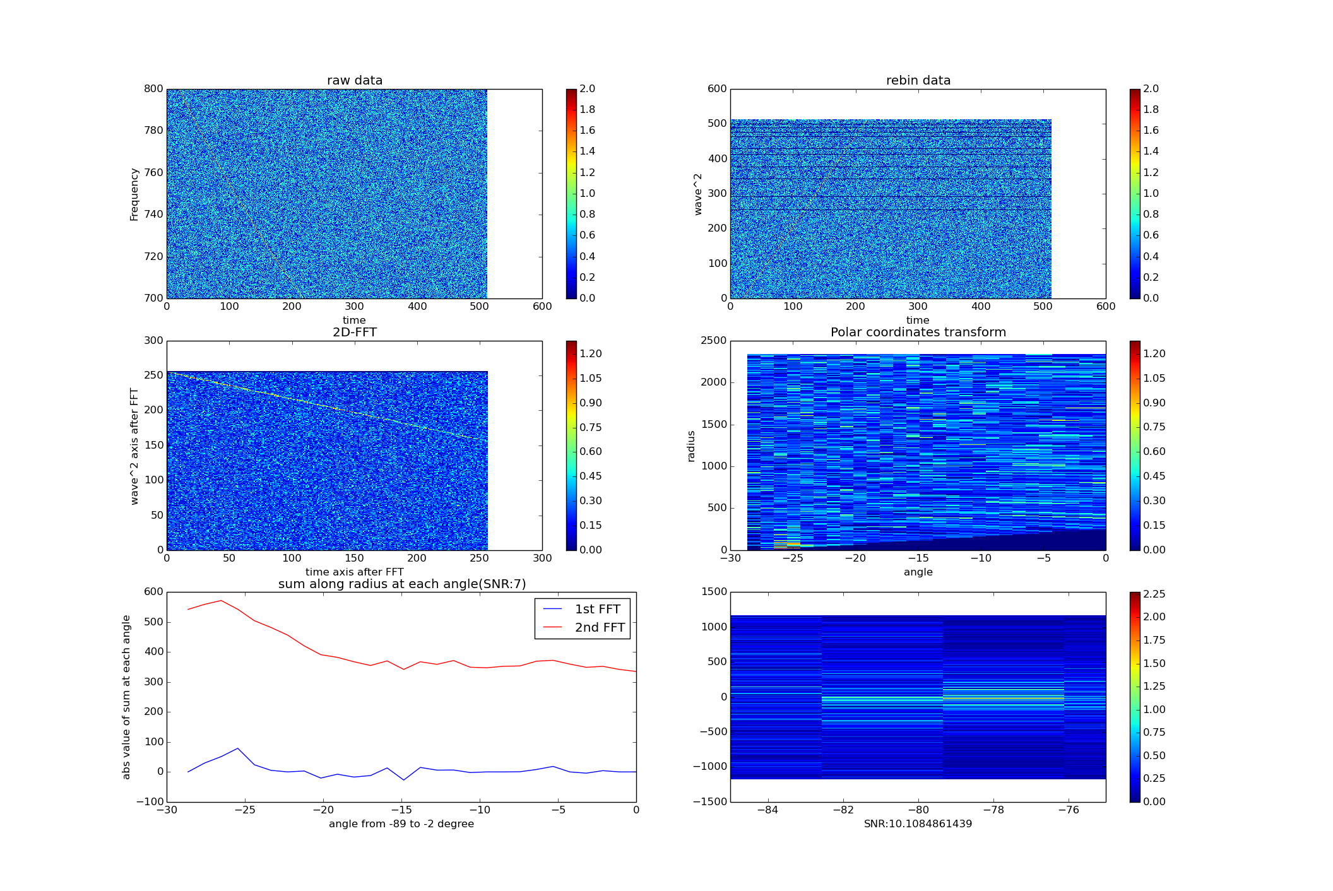
The 6th image in above pictures is 2nd 1-D FFT along radius axis. They have been scaled between -84 ~ -75 degree. And we can see the max value pixel is broadening.

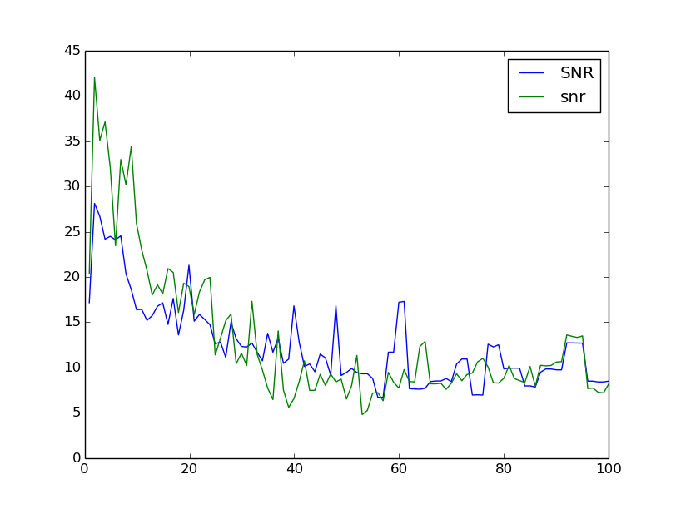
To make sure this confection is correct, I also did a extreme test ,that test the grid size 100 times of original size. The SNR is falling obviously.

Conclusion:

Using DM Smearing and pixels information conservation to constrain parameter seems correct. However , we are still facing the problem that tangent function or cotangent function could only be obvious at high or low angle. I am working on to combine them together to have a test recently.

