Hashpipe && rb-Hashpipe install

Chenhui Niu (peterniu@nao.cas.cn)

Source :
Hashpipe : http://astro.berkeley.edu/~davidm/hashpipe.git
(https://github.com/david-macmahon/hashpipe.git)
serendip6:https://github.com/UCBerkeleySETI/serendip6

rb-Hashpipe: https://github.com/david-macmahon/rb-hashpipe.git
(One Hashpipe monitor)

Peixin's demo:
demo1: https://github.com/SparkePei/demo1_hashpipe.git
demo2: https://github.com/SparkePei/demo2_hashpipe.git

require:
Ruby:
Using RVM could help install ruby conveniently:
(https://rvm.io/rvm/install)
1)gpg --keyserver hkp://keys.gnupg.net --recv-keys 409B6B1796C275462A1703113804BB82D39DC0E3
2)
\curl -sSL https://get.rvm.io | bash
\curl -sSL https://get.rvm.io | bash -s stable –ruby

When using this should make the terminal in status : “run command as a login shell”
(https://rvm.io/integration/gnome-terminal)
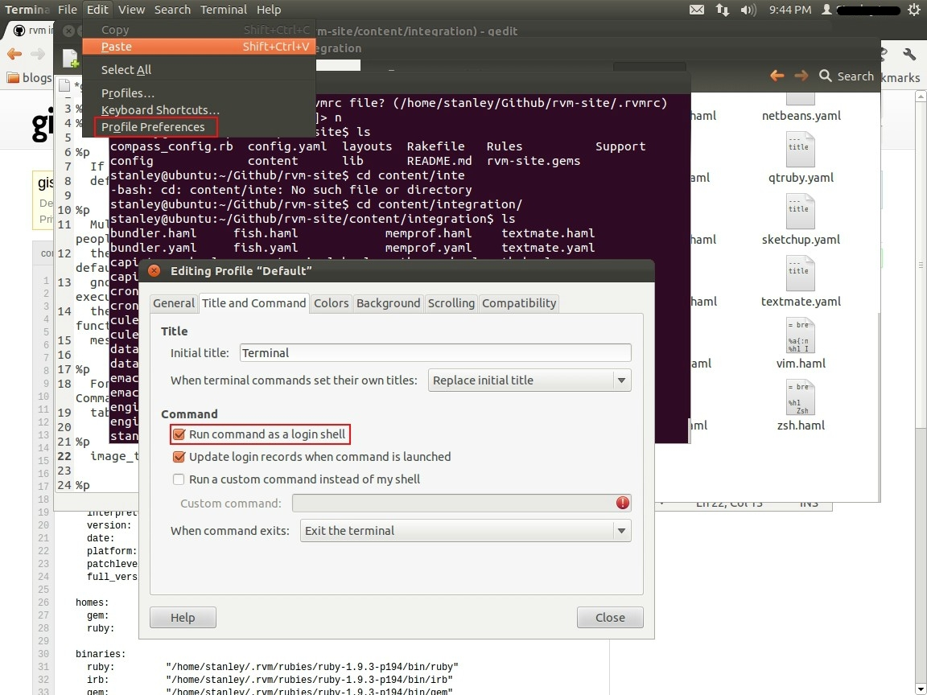
Then source .bashrc

To install ruby :
rvm list known
rvm install 2.1.1
To make default version:
rvm use 2.1.1 –default

Other support software:
sudo gem install curses
sudo gem install dev
sudo gem install bundle
sudo apt-get install autoconf
sudo apt-get install libtool

Install:
1) Hashpipe:
cd src
autoreconf -is
./configure
make && make install (sudo may require)
2) rb-Hashpipe:
rake gem
sudo gem install pkg/****.gem

3)Variable environment Setting up:
vi ~/.bashrc
export LD_LIBRARY_PATH =”/usr/local/lib:$LD_LIBRARY_PATH”
source ~/.bashrc

