The minus means in the original matrix and the zeros pad process indeed help to increase the SNR value. However , The zeros pad also caused the computation burden when doing the FFT.
As yichao suggest, we could find the signal in the 2nd 1-D_FFT 2-D map because we could see the bright spot by naked eyes. That will bring a higher SNR than the integration along the radius axis method.

Recently we are working on finding the proper grid size which could get a good SNR and cause as least computation burden as possible.
We use 2 for-loop of radius and angle to test the relation between SNR and grid size.
Here we use 2 types SNR value:
1)The SNR after integrate radius.
2) The SNR of 2nd 2-D FFT map.
We also marked the max value position of the 2nd 1-D_FFT 2-D map.

The grid of radius and angle increase like the following:

For I in seq(100 to 5000,step = 500):
for j in seq(100 to 10000,step =500):
rad_grid = i;
ang_grid = j;
done
done
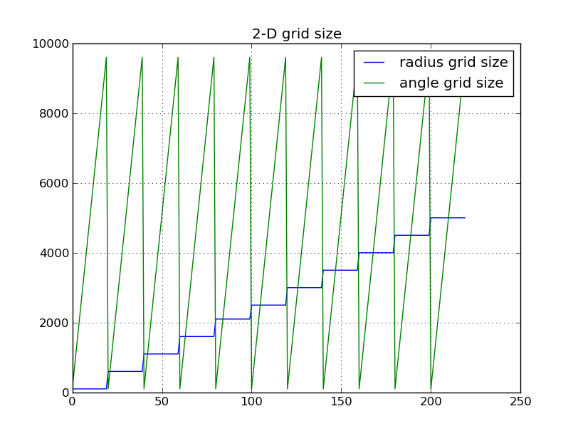

In the 2-D map of 2nd FFT, the bright spot position on the angle axis is almost the -30 degree,except
several points in beginning part. The Interpolation grid was too small to make a good integration. So we get the low limit of grid size are: radius grid-- 1100, angle grid –100. The grid size bigger than that will not give the wrong position of signal.
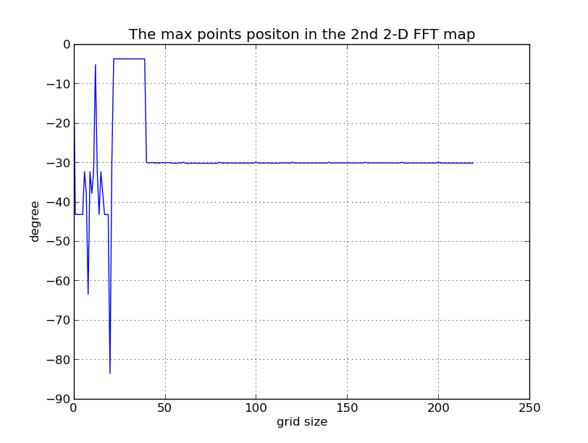
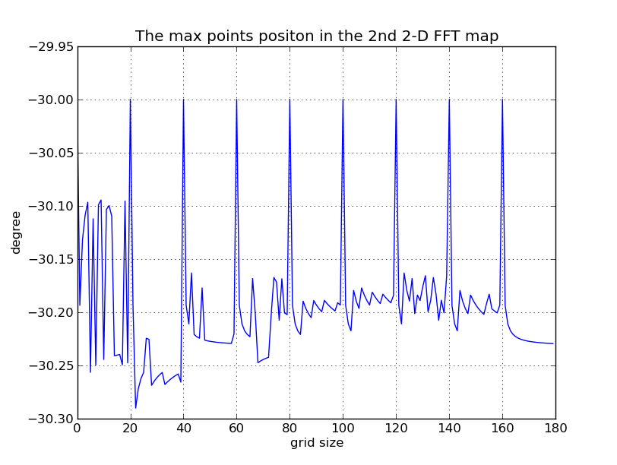
The upper figure is the position change with grid size, the lower is the position change with grid without the beginning part.

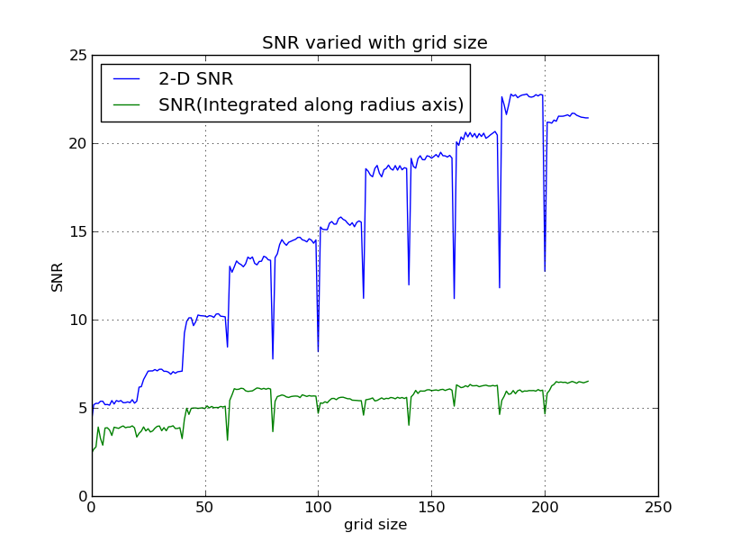
We also found the SNR is depend on the grid size, we could found the SNR of 2-D map of 2nd FFT is higher than the integrated method. The period decline caused by the for-loop of radius and angle.

