Recently, I work on the algorithm test. The followings are what I did.

1) I rewrite the code for MPI, search for 4.5G data may cost about 1 minute (I usually open 10 processes to run it).

2)The raw data may have a uneven frequency response, in other words, it has several bad channels. It will caused a fractional frequency after do the 2-D FFT .

This is the rebin process,(before 2-D FFT step)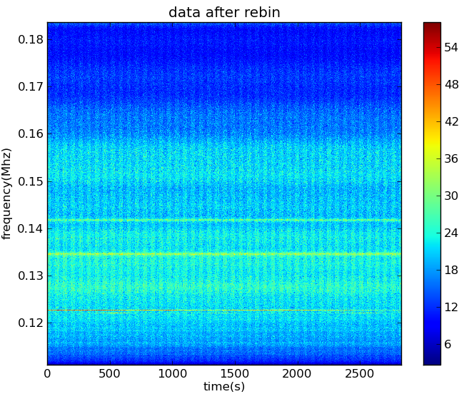

This is 2-D FFT map, 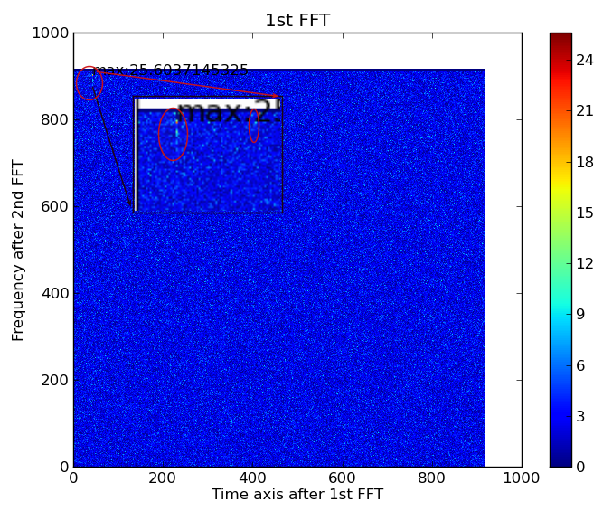

As the data has conjugate property, I choose the lower right corner of original 2-D FFT data.

This strong fractional frequency line is caused by the horizontal line of rebin map and it will make a

bad map for polar coordinate transformation.

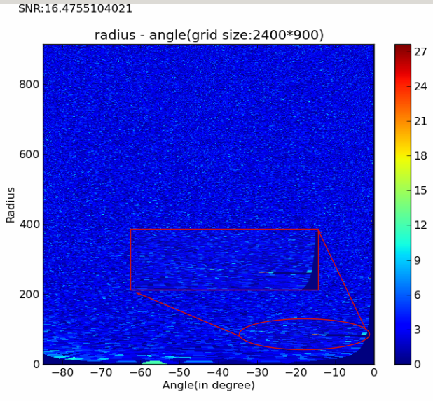The polar transform image,We could see the interfering line appearently.

After 1-D FFT along the radius axis, it will appear worse influence. The pictures above are the period that did not have the FRB signal. The followings are the data contain FRB110523:

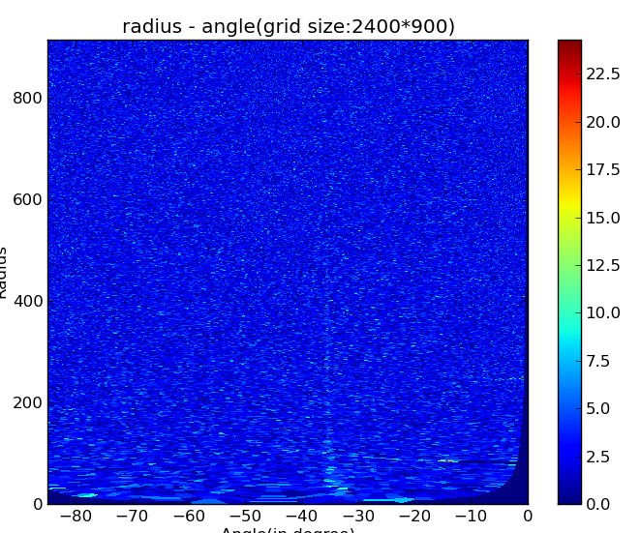

This is the fractional frequency has not been remove out completely,We could see the weak signal.

This is the image of fractional frequency ruled out.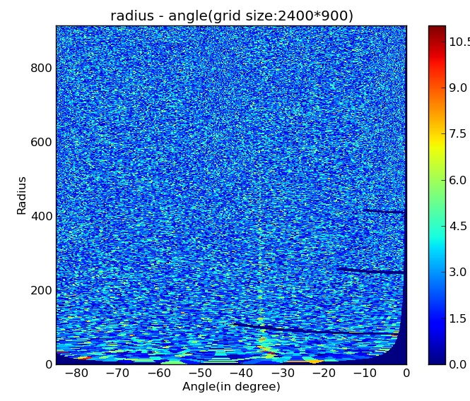

I separate total time into small blocks to make a parallel compute, after that I will gather the SNR of

each block to check whether there are candidates. For the already known FRB110523 (56s obsevation data), the gathered SNR varied with time block is like that:

We could see the 8 time block has a high SNR,which the FRB110523 locate.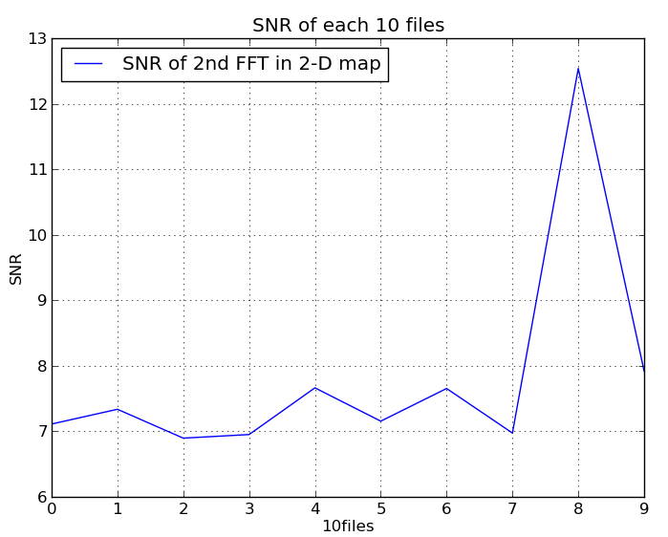

(This is before reduce fractional frequency line)

The SNR are the highest value of 2nd FFT minus mean then divide variance. As it will be a dot of the signal, so I add the surrounding values of the highest value .

This is after remove fractional frequency lines.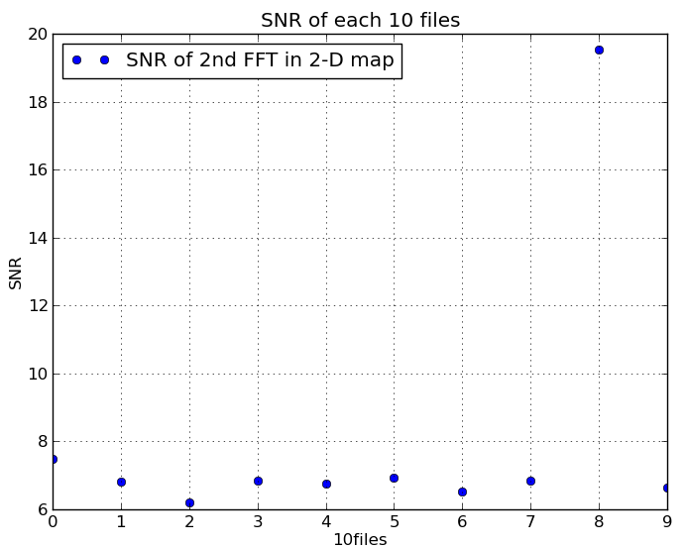

We could see a SNR improve for fractional frequency remove.

I test the pulsar survey data applied by kiyo on our fat server. Well , The 00dB attenuation is ok , for -25dB data,The pulsar is totally disappear, except some giant pulse. -15dB is fine to see the high signal pulsar.

3) Add the plot function of code, it can choose which process (raw, rebin ,1stFFT ,2-D or 3-D polar coordinate, 1-D FFT) to plot.