# 7.0 Appendices

## 7.1 Appendix A: Ethics Approval



## 7.2 Appendix B: Software development

## 7.3 Appendix C: Libraries

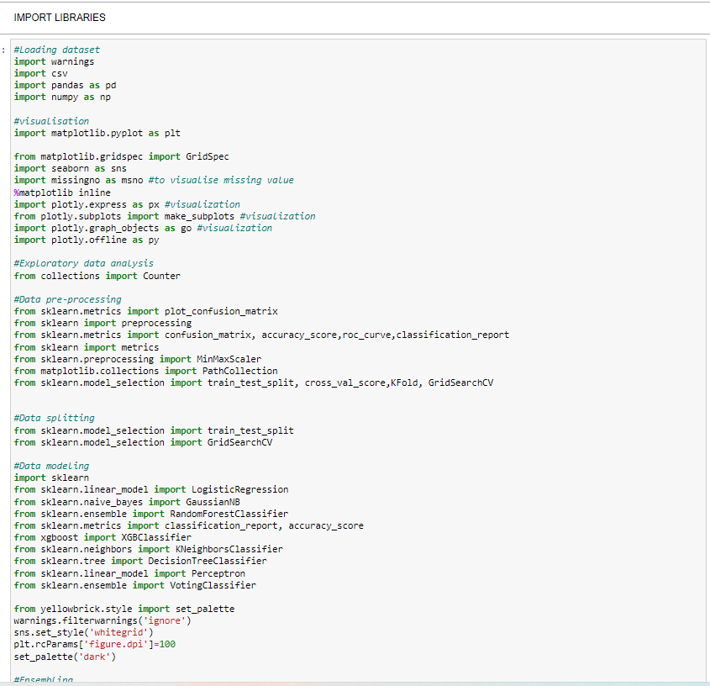

## 7.4 Appendix D: Data loading

## 7.5 Appendix E: Check for null values

## 7.6 Appendix F: Check for duplicate and resolving

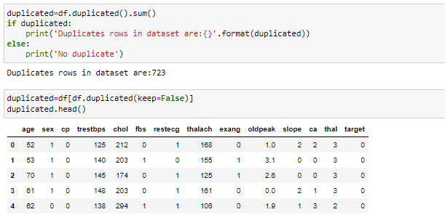

## 7.7 Appendix G: Data information

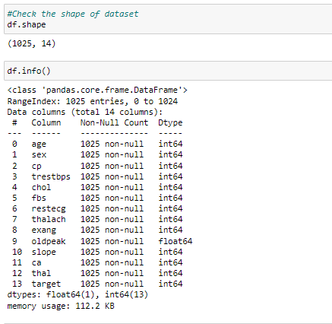

## 7.8 Appendix H: Correlation Matrix

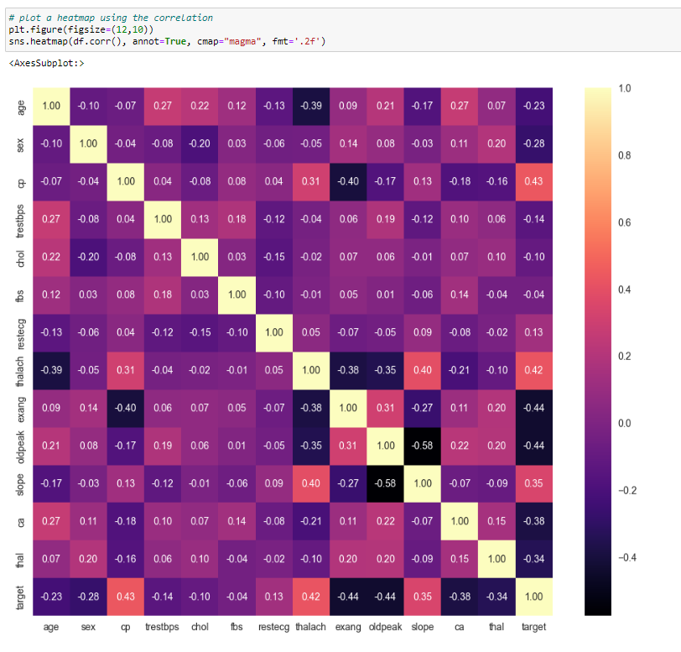

## 7.9 Appendix I: Sex Distribution

## 8. Appendix J: Age Distribution

## 8.1 Appendix K: Target Variable Distribution

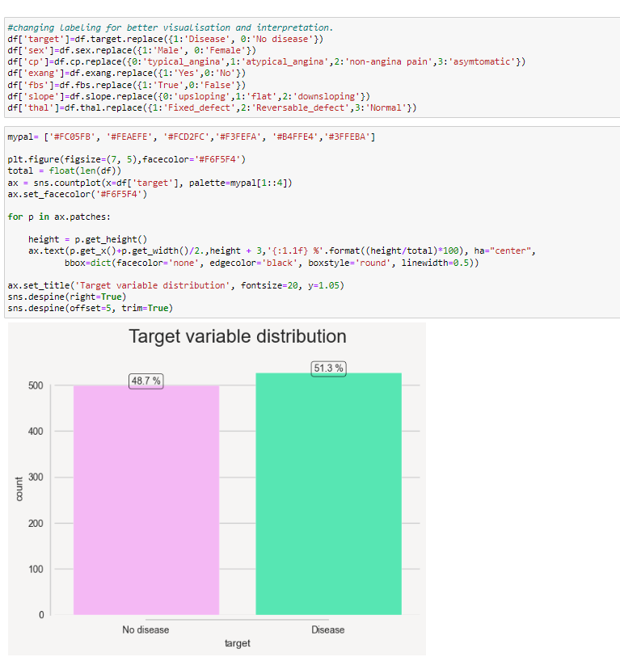

## 8.2 Appendix L: Heart Disease Gender Distribution

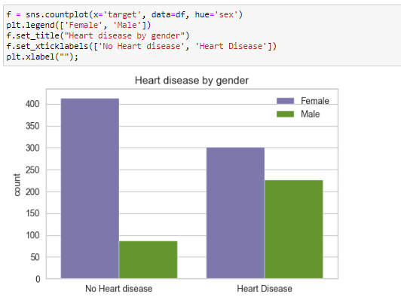

## 8.3 Appendix M: Categorical data distribution

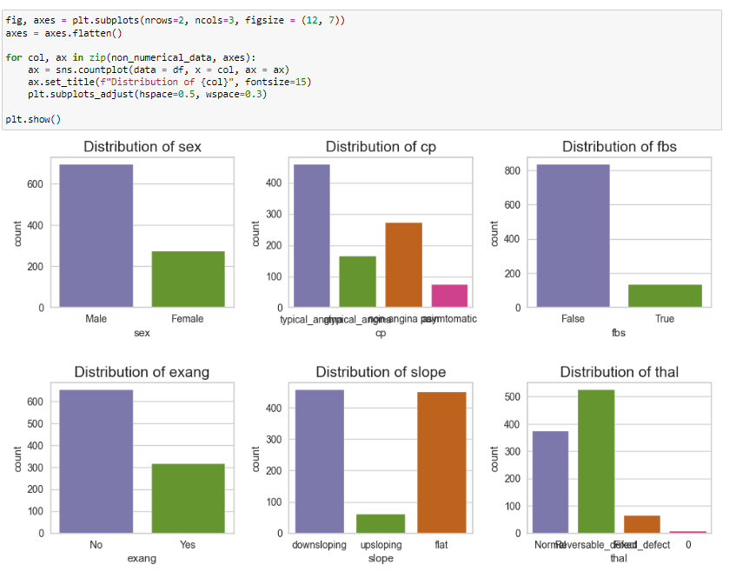

## 8.4 Appendix N: Numerical data distribution

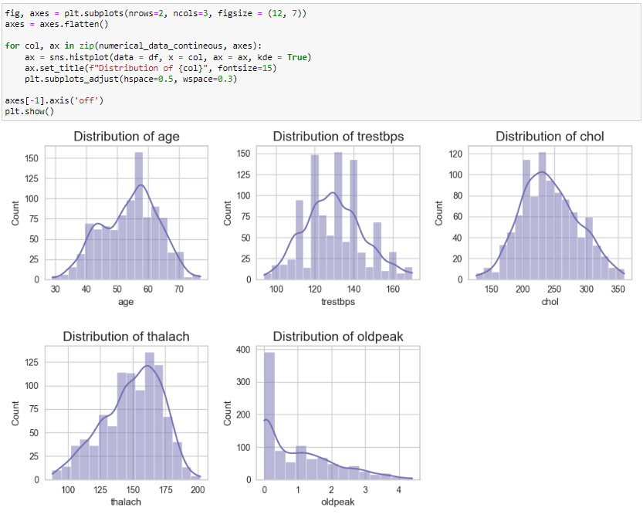

## 8.5 Appendix O: Data Skewness Check

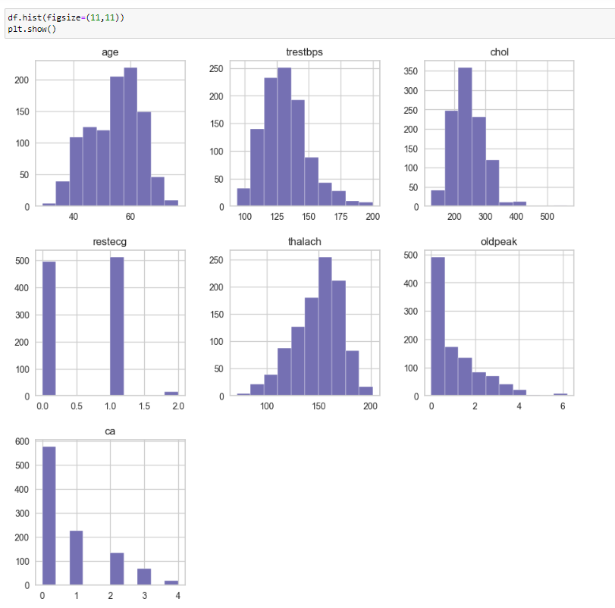

## 8.6 Appendix P: Data Skewness and Kurtosis Check

## 8.7 Appendix Q: Outliers Check

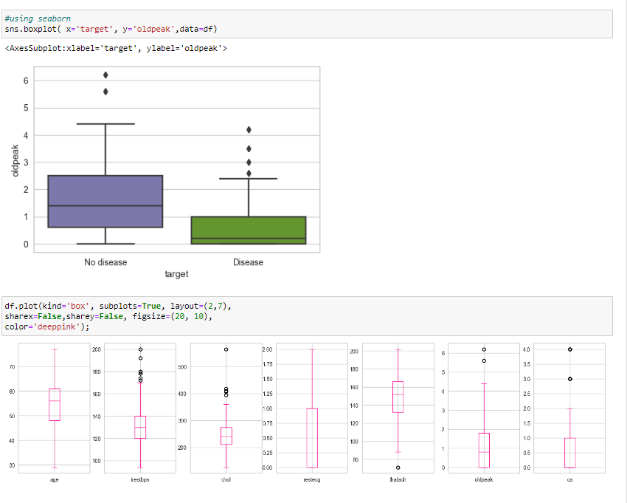

## 8.8 Appendix R: Outliers check and Removal

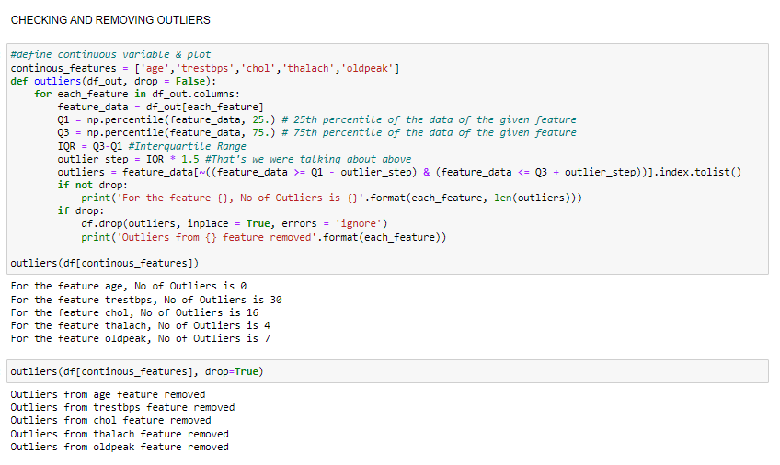

## 8.9 Appendix S: Data splitting and Normalising

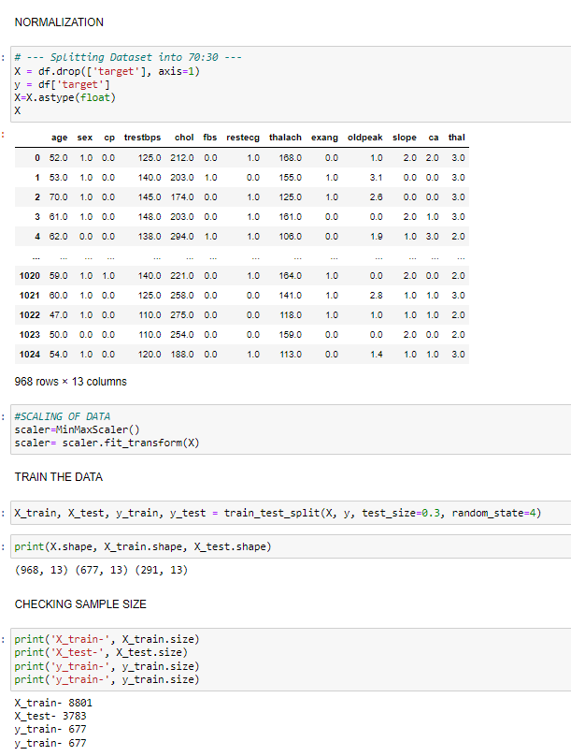

## 9.0 Appendix T: Extreme Gradient Boosting

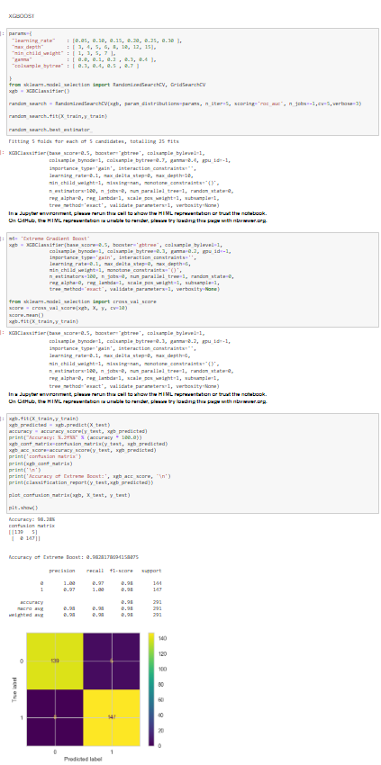

## 9.1 Appendix U: Random Forest

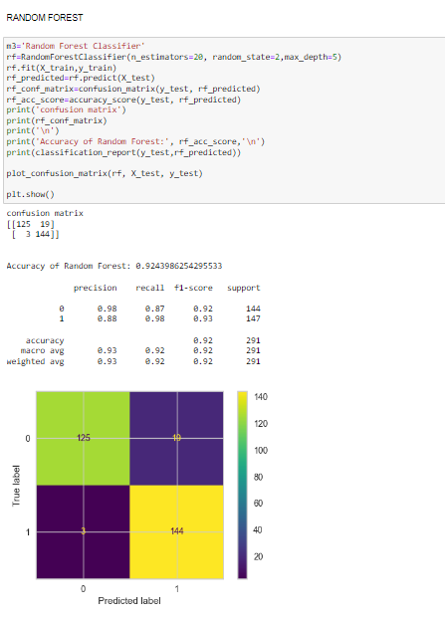

## 9.2 Appendix V: Decision Tree

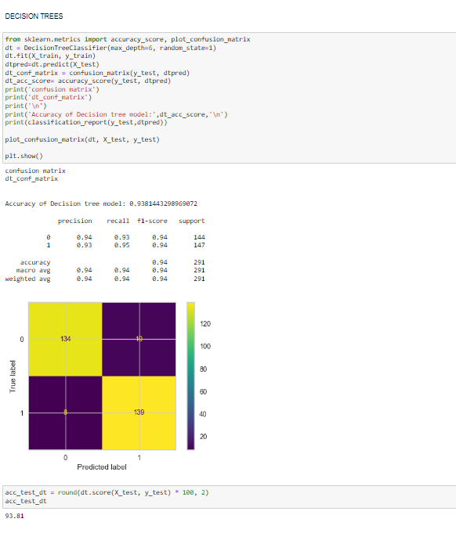

## 9.3 Appendix W: Ensemble classifier

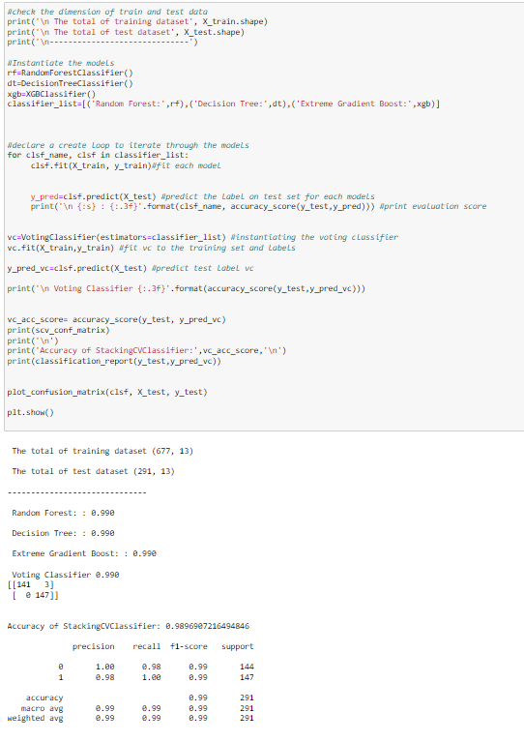

## 9.4 Appendix X: Model Performance using Bar Chart

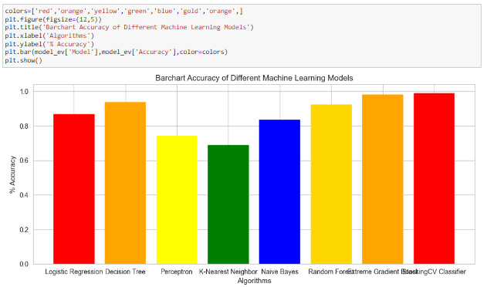

## 9.5 Appendix Y: ROC CURVE

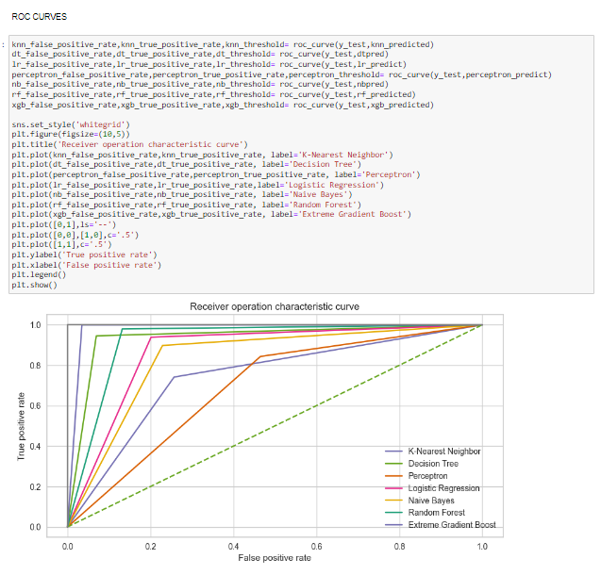

## 9.6 Appendix Z: Model save

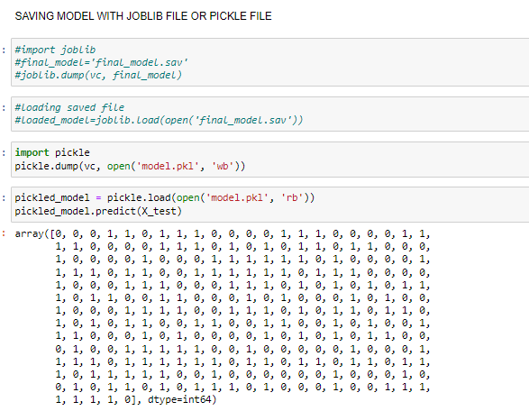

### 9.6.1 Appendix Z: Cross Validation

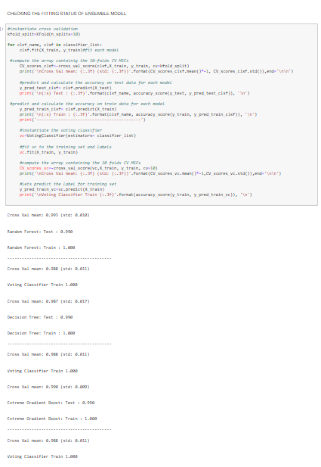

### 9.6.2 Appendix Z: Feature Importance

### 9.6.3 Appendix Z: PRISMA Flow Chart

### 9.6.4 Appendix Z: Data Science Framework

Web application (GUI)

Final prediction

Store result

Accuracy

Precision

F-1 score

Recall

Classification algorithms

Performance evaluation

Exploratory data analysis

Data pre-processing

Feature selection

### 9.6.5 Appendix Z: Graphical User Interface

### 9.6.5.1 Appendix Z: Graphical User Interface

