Peter Oostema
CS 374
December 14, 2017
Parallel Matrix Multiplication in Small Finite Fields
Finite field matrix multiplication is a special type of matrix multiplications where all elements are part of a finite field. Running this efficiently involves packing each 1 to 4 bit element sequentially in memory and writing the additions and moduli with bitwise operators. This was all work I did last summer at Carnegie Mellon.
For this project I looked at parallelizing the problem using MPI and OpenMP. Trying out MPI quickly resulted in much slower results as much of the speed of the program comes from writing C in a way that the assembly comes out just right. Compiling with MPICC and running with one process ran seven times slower. This drawback would likely not be overcome using many machines since the larger matrices used take up several MBs and so would have a large communication overhead.
For OpenMP a parallel for statement was added around the outermost loop that would guarantee threads not writing to the same location in the matrix C at one time. This means that the pragma goes around the second of the three loops after the precomputation of the table needed for the Method of Four Russians. The table pre computes all possible combinations of a set number of rows at a time. So in GF2 computing T rows takes O(2^{t}) time and in GF5 takes O(5^{t}) time. This became the limit to how much speedup could come from using more threads. The exponentially increasing sequential time meant the optimal value of T came down for a given size of matrix. For example in GF5 for the sizes tested a T value of 2 was always faster in parallel whereas sequentially a T value of 4 was optimal since more time was spent in the deeper loops.
The limitations of hyperthreaded cores are demonstrated by the performance of this program. When running the matrix multiply in GF2 using eight cores gives worse performance than using four. This is because the program uses the same block in the processor to perform a xor nearly every cycle. Since hyperthreaded cores can not do two of the same instruction for two threads no speedup comes from running more threads. The story changes slightly for GF5 and 7 where a slight speedup is achieved, as a larger number and wider range of instructions are used in the kernel and so have few conflicts between threads.
This project was a success as implementations for matrix multiplication in GF2, 5, 7 where all built and gave reasonable speedups. Amdahl’s law shows up in larger fields where the sequential times are much greater. OpenMP speeds up GF2 fairly well with efficiencies around 0.8 for large matrices, and speeds up GF5 and 7 very well for small T values.

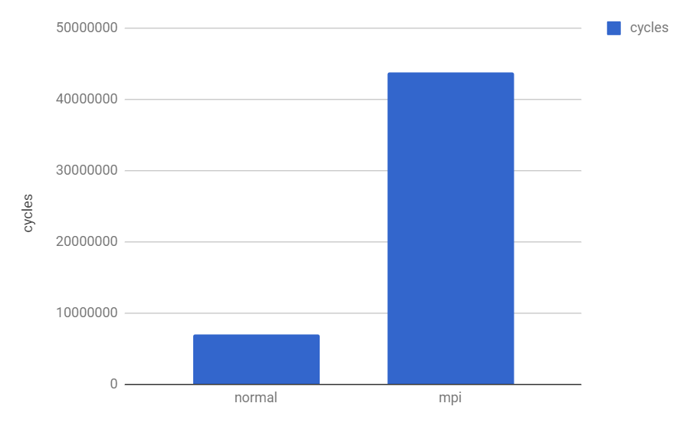
Figure 1. Single Process GCC and MPICC Times (MPI using one thread)

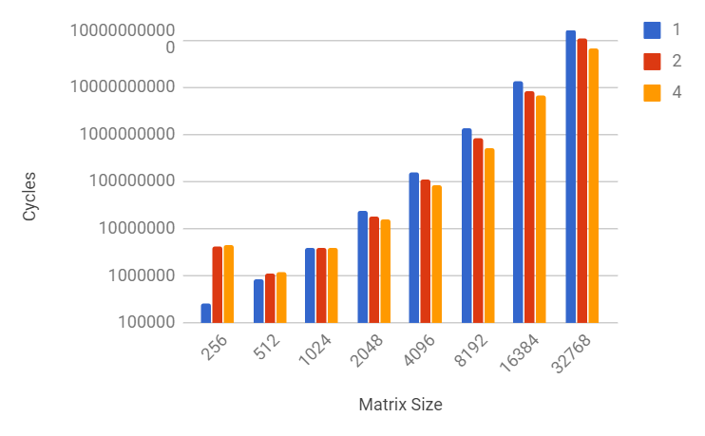
Figure 2. GF2 OpenMP Times (colors represent number of processors)

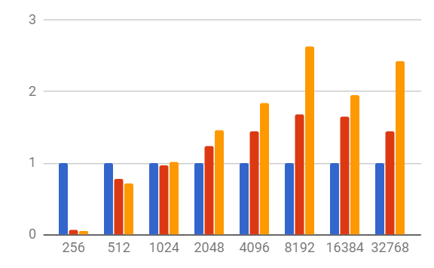
FIgure 3. GF2 OpenMP Speedups (colors represent number of processors)

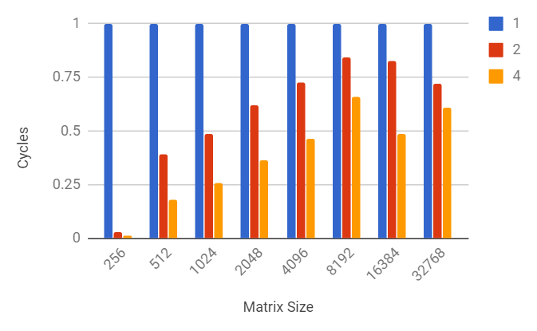
Figure 4. GF2 OpenMP Efficiencies (colors represent number of processors)

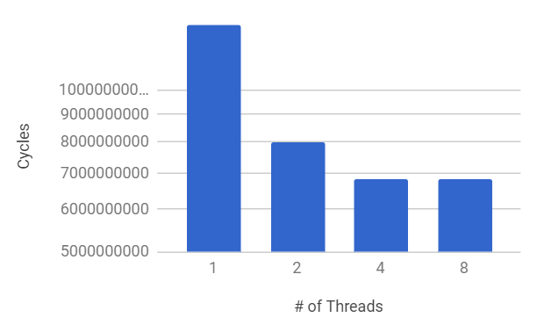
Figure 5. GF2 Hyperthreading. Four to eight threads show no speedup.

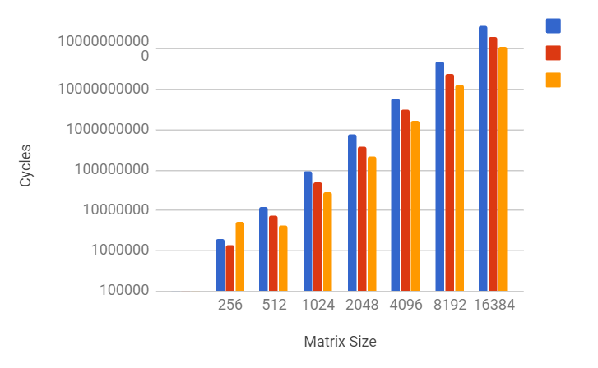
Figure 6. GF5 OpenMP Times, T = 1 (colors represent number of processors)

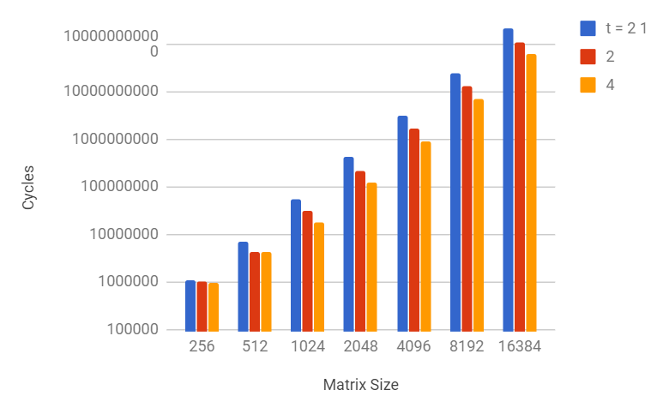
Figure 7. GF5 OpenMP Times, T = 2 (colors represent number of processors)
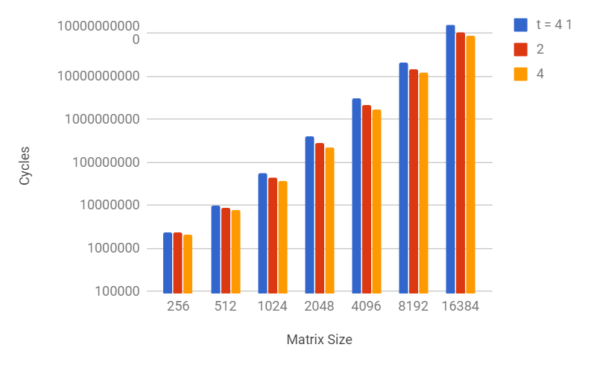
Figure 8. GF5 OpenMP Times, T = 4 (colors represent number of processors)

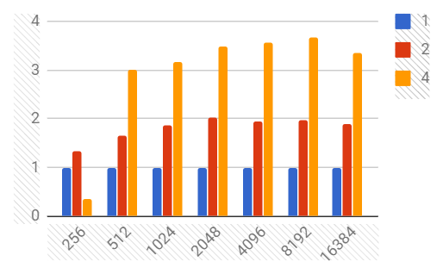
Figure 9. GF5 OpenMP Speedup, T = 1 (colors represent number of processors)
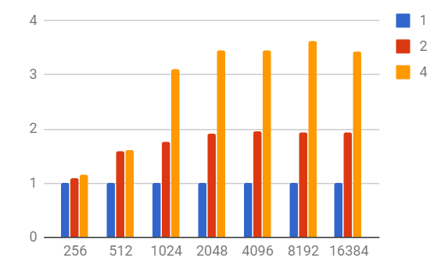
Figure 10. GF5 OpenMP Speedup, T = 2 (colors represent number of processors)

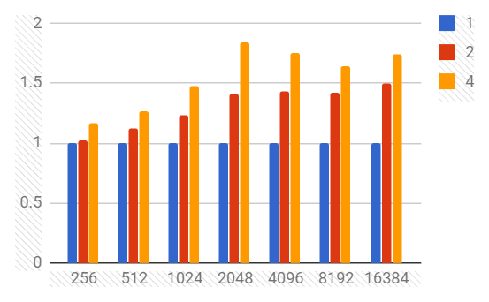
Figure 11. GF5 OpenMP Speedup, T = 4 (colors represent number of processors)

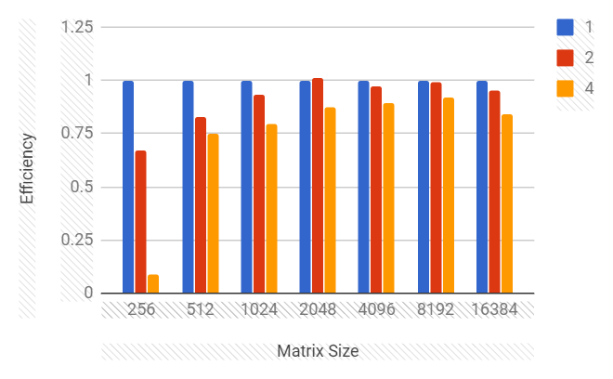
Figure 11. GF5 OpenMP Efficiency, T = 1 (colors represent number of processors)

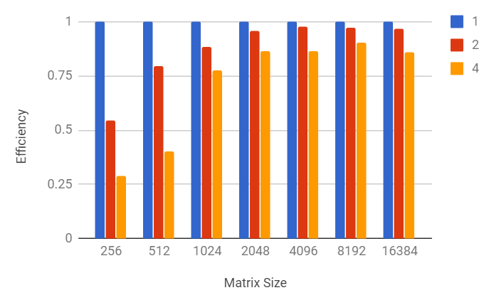
Figure 11. GF5 OpenMP Efficiency, T = 2 (colors represent number of processors)
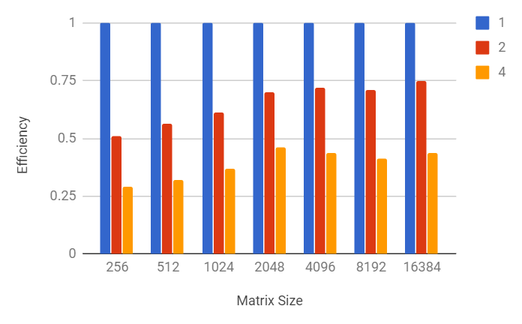
Figure 11. GF5 OpenMP Efficiency, T = 4 (colors represent number of processors)

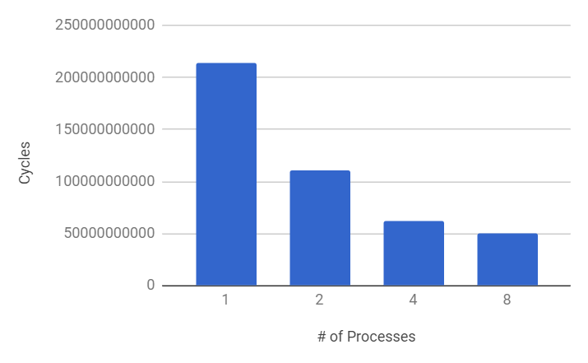
Figure 11. GF5 OpenMP Hyperthreading. Four to eight threads show little speedup.
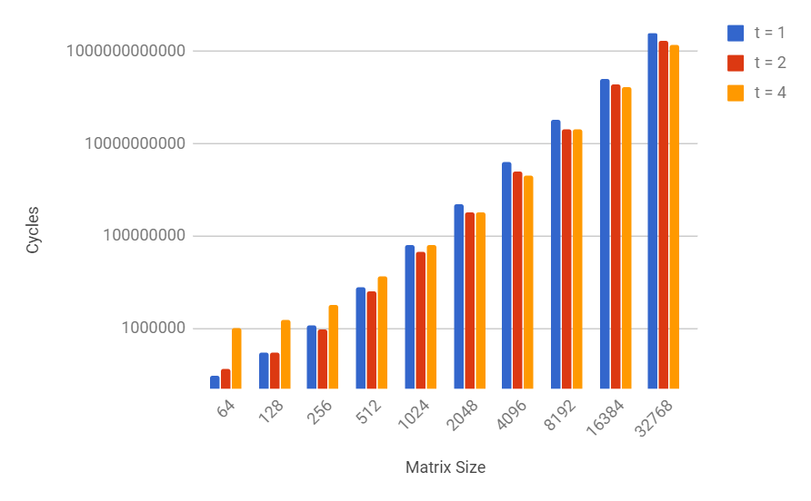
Figure 11. GF5 Sequential Times

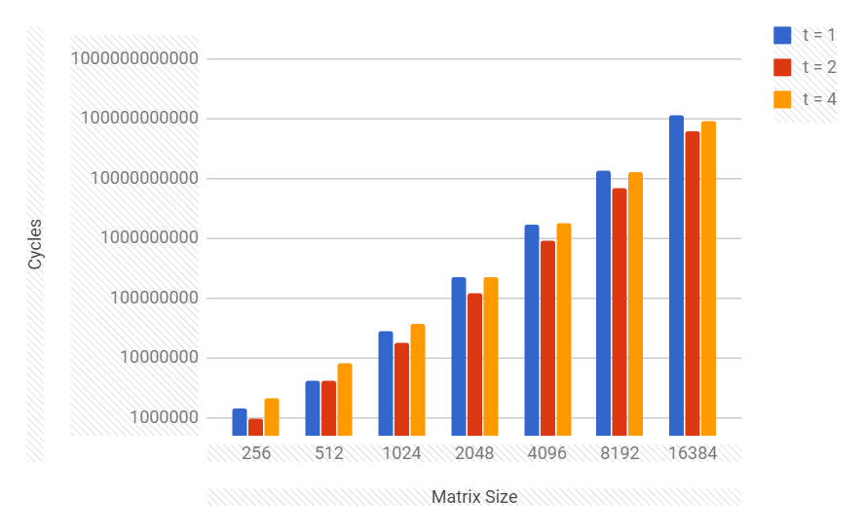
Figure 11. GF5 Fastest Run of Parallel Implementation
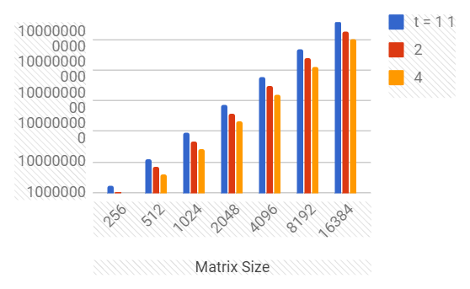
Figure 12. GF7 OpenMP Times, T = 1 (colors represent number of processors)

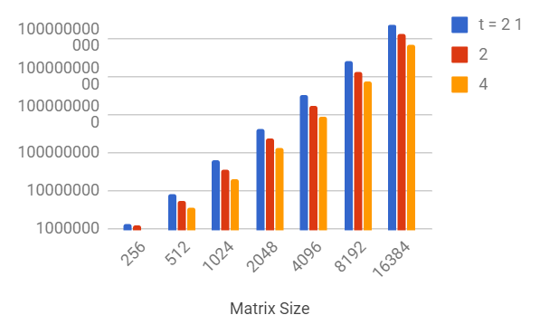

Figure 13. GF7 OpenMP Times, T = 2 (colors represent number of processors)

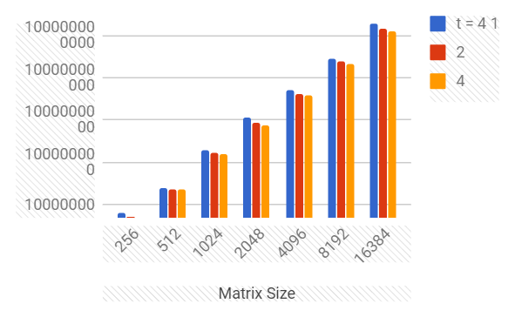
Figure 14. GF7 OpenMP Times, T = 4

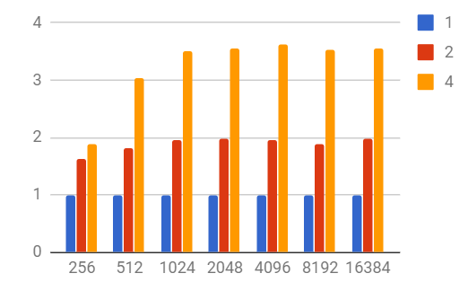
Figure 15. GF7 OpenMP Speedup, T = 1 (colors represent number of processors)

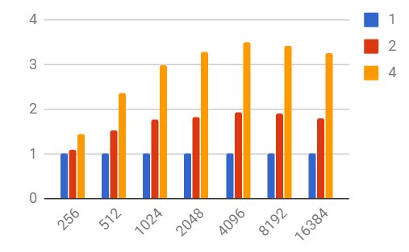
Figure 16. GF7 OpenMP Speedup, T = 2 (colors represent number of processors)
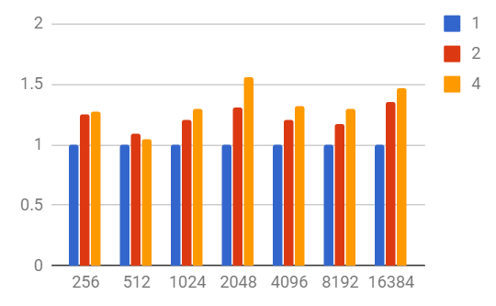
Figure 17. GF7 OpenMP Speedup, T = 4

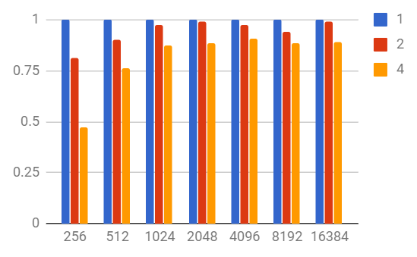
Figure 18. GF7 OpenMP Efficiency, T = 1

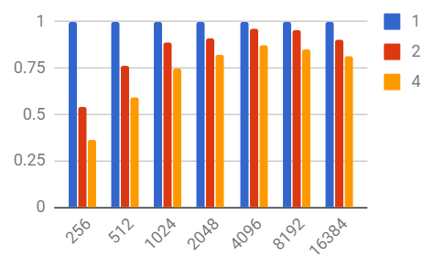
Figure 19. GF7 OpenMP Efficiency, T = 2

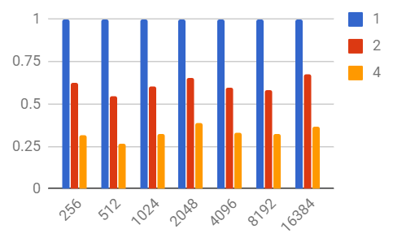
Figure 20. GF7 OpenMP Efficiency, T = 4

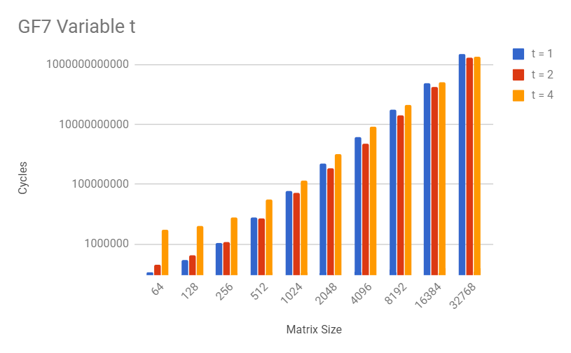
Figure 21. GF7 Sequential Times

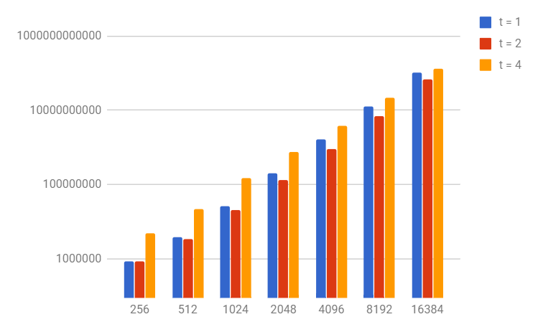
Figure 22. GF7 Fastest Parallel Run. Each data point represents the fastest run of that size of matrix and table for any number of threads.
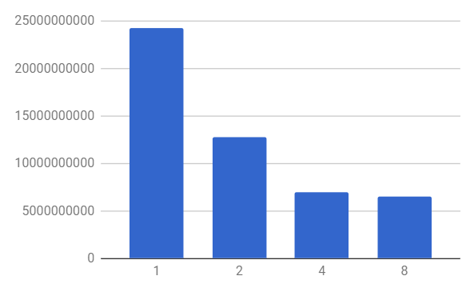
Figure 23. GF7 OpenMP Hyperthreading. Four to eight threads gives slightly more performance.

Table 1. GF5 Timing Results

GF2 | 1 | 2 | 4
256 | 261840 | 4299282 | 4577505
512 | 846960 | 1077057 | 1171023
1024 | 3877647 | 3977577 | 3806847
2048 | 23056986 | 18612768 | 15811689
4096 | 155912142 | 107356713 | 84367239
8192 | 1346798250 | 799903227 | 512039946
16384 | 13217098524 | 7979111919 | 6780332352
32768 | 159914542506 | 111082340046 | 65965470102
 | 1 | 2 | 4 | 8
16384 | 13217098524 | 7979111919 | 6814714911 | 6840215988
Speedup | 1 | 2 | 4
256 | 1 | 0.06090319267 | 0.05720146674
512 | 1 | 0.786365067 | 0.7232650426
1024 | 1 | 0.9748766649 | 1.018598068
2048 | 1 | 1.238772546 | 1.458224102
4096 | 1 | 1.452281256 | 1.848017594
8192 | 1 | 1.683701484 | 2.63026012
16384 | 1 | 1.656462355 | 1.949329006
32768 | 1 | 1.439603653 | 2.424215916
Efficiency | 1 | 2 | 4
256 | 1 | 0.03045159634 | 0.01430036668
512 | 1 | 0.3931825335 | 0.1808162607
1024 | 1 | 0.4874383324 | 0.254649517
2048 | 1 | 0.6193862729 | 0.3645560256
4096 | 1 | 0.726140628 | 0.4620043984
8192 | 1 | 0.8418507418 | 0.6575650301
16384 | 1 | 0.8282311777 | 0.4873322515
32768 | 1 | 0.7198018265 | 0.6060539789

Table 2. GF5 Timing Results

t = 1 |  |  | t = 2 |  |  | t = 4
1 | 2 | 4 | 1 | 2 | 4 | 1 | 2 | 4
1876158 | 1393068 | 5271264 | 1091934 | 999039 | 948435 | 2429223 | 2381262 | 2083959
12310146 | 7447827 | 4108974 | 6888321 | 4329639 | 4262289 | 10123032 | 9009099 | 7968375
91010331 | 48613389 | 28701471 | 55419720 | 31363308 | 17861022 | 55485408 | 45182982 | 37638159
787151385 | 389450919 | 225003084 | 417596418 | 217814733 | 120813174 | 404503149 | 288009267 | 219387918
6079353054 | 3117267729 | 1701497880 | 3169823562 | 1624428177 | 917505978 | 3056028174 | 2129361624 | 1747958853
48171730845 | 24355252605 | 13096556982 | 24727309104 | 12731514096 | 6835210725 | 20454757863 | 14458232157 | 12432235311
381993837081 | 200794150944 | 113645055570 | 214051911588 | 110642090049 | 62392381206 | 157436132202 | 105326332155 | 90395962260
Speedup
1 | 2 | 4 | 1 | 2 | 4 | 1 | 2 | 4
1 | 1.346781349 | 0.3559218434 | 1 | 1.092984358 | 1.151300827 | 1 | 1.020141001 | 1.165676964
1 | 1.652850691 | 2.995917229 | 1 | 1.590968901 | 1.616108387 | 1 | 1.123645328 | 1.270401054
1 | 1.872124797 | 3.170929149 | 1 | 1.767024065 | 3.102830286 | 1 | 1.228015628 | 1.474179648
1 | 2.021182507 | 3.498402649 | 1 | 1.917209237 | 3.456547032 | 1 | 1.404479631 | 1.843780426
1 | 1.950218455 | 3.572941892 | 1 | 1.951347315 | 3.454826059 | 1 | 1.435185146 | 1.748341026
1 | 1.977878515 | 3.678198088 | 1 | 1.942212758 | 3.61763669 | 1 | 1.414748196 | 1.645300089
1 | 1.902415161 | 3.361288665 | 1 | 1.93463366 | 3.430737976 | 1 | 1.494746176 | 1.741627925
Efficiency
1 | 2 | 4 | 1 | 2 | 4 | 1 | 2 | 4
1 | 0.6733906744 | 0.08898046085 | 1 | 0.546492179 | 0.2878252068 | 1 | 0.5100705004 | 0.291419241
1 | 0.8264253453 | 0.7489793072 | 1 | 0.7954844503 | 0.4040270967 | 1 | 0.561822664 | 0.3176002635
1 | 0.9360623984 | 0.7927322871 | 1 | 0.8835120326 | 0.7757075715 | 1 | 0.6140078138 | 0.3685449121
1 | 1.010591254 | 0.8746006621 | 1 | 0.9586046184 | 0.864136758 | 1 | 0.7022398154 | 0.4609451066
1 | 0.9751092275 | 0.8932354729 | 1 | 0.9756736576 | 0.8637065147 | 1 | 0.7175925732 | 0.4370852564
1 | 0.9889392573 | 0.9195495219 | 1 | 0.9711063789 | 0.9044091725 | 1 | 0.7073740981 | 0.4113250222
1 | 0.9512075807 | 0.8403221662 | 1 | 0.9673168298 | 0.8576844939 | 1 | 0.7473730879 | 0.4354069813
Best Runs
t = 1 | t = 2 | t = 4
1393068 | 948435 | 2083959
4108974 | 4262289 | 7968375
28701471 | 17861022 | 37638159
225003084 | 120813174 | 219387918
1701497880 | 917505978 | 1747958853
13096556982 | 6835210725 | 12432235311
113645055570 | 62392381206 | 90395962260

Table 3. GF7 Timing Results in Cycles

 | t = 1 |  |  | t = 2 |  |  | t = 4
GF7 | 1 | 2 | 4 | 1 | 2 | 4 | 1 | 2 | 4
256 | 1691925 | 1041987 | 893223 | 1291923 | 1193337 | 889425 | 6324759 | 5065383 | 4950279
512 | 12112338 | 6718368 | 3978582 | 8070786 | 5305707 | 3410928 | 24443037 | 22420845 | 23284668
1024 | 92809176 | 47538345 | 26550423 | 60542532 | 34031208 | 20211459 | 199512000 | 165810633 | 153910623
2048 | 733273563 | 370932267 | 207020901 | 425708895 | 233692101 | 129710172 | 1164137301 | 892254138 | 747418182
4096 | 5811501438 | 2990685474 | 1600660884 | 3123104325 | 1624183422 | 891637401 | 5082604959 | 4234320624 | 3851529390
8192 | 45204105585 | 24008709741 | 12794012712 | 24296459115 | 12749261166 | 7126200546 | 28057671099 | 24069303306 | 21606891099
16384 | 362284318233 | 182597811972 | 101800942533 | 223037910480 | 123511025298 | 68364846789 | 188099921139 | 139457062827 | 127816611972
Speedup
 | 1 | 2 | 4 | 1 | 2 | 4 | 1 | 2 | 4
256 | 1 | 1.623748665 | 1.894179841 | 1 | 1.082613713 | 1.452537313 | 1 | 1.248624043 | 1.277657078
512 | 1 | 1.80286909 | 3.044385663 | 1 | 1.521151846 | 2.366155486 | 1 | 1.090192497 | 1.049748143
1024 | 1 | 1.952301369 | 3.495581822 | 1 | 1.779029766 | 2.995455796 | 1 | 1.203252146 | 1.296284793
2048 | 1 | 1.976839516 | 3.54202672 | 1 | 1.821665744 | 3.282000852 | 1 | 1.304714936 | 1.557544798
4096 | 1 | 1.943200476 | 3.630688734 | 1 | 1.922876618 | 3.502661868 | 1 | 1.200335405 | 1.319632916
8192 | 1 | 1.882821113 | 3.533223438 | 1 | 1.905715068 | 3.409454864 | 1 | 1.1657035 | 1.298551974
16384 | 1 | 1.984056185 | 3.558752102 | 1 | 1.805813772 | 3.262464863 | 1 | 1.348801684 | 1.471639079
Efficiency
 | 1 | 2 | 4 | 1 | 2 | 4 | 1 | 2 | 4
256 | 1 | 0.8118743324 | 0.4735449602 | 1 | 0.5413068563 | 0.3631343284 | 1 | 0.6243120214 | 0.3194142694
512 | 1 | 0.9014345448 | 0.7610964158 | 1 | 0.7605759232 | 0.5915388715 | 1 | 0.5450962486 | 0.2624370358
1024 | 1 | 0.9761506843 | 0.8738954555 | 1 | 0.8895148829 | 0.7488639489 | 1 | 0.601626073 | 0.3240711981
2048 | 1 | 0.9884197578 | 0.8855066801 | 1 | 0.9108328719 | 0.820500213 | 1 | 0.6523574682 | 0.3893861994
4096 | 1 | 0.9716002382 | 0.9076721834 | 1 | 0.9614383088 | 0.8756654671 | 1 | 0.6001677023 | 0.3299082289
8192 | 1 | 0.9414105563 | 0.8833058596 | 1 | 0.9528575342 | 0.8523637161 | 1 | 0.5828517498 | 0.3246379936
16384 | 1 | 0.9920280926 | 0.8896880255 | 1 | 0.902906886 | 0.8156162156 | 1 | 0.6744008418 | 0.3679097698
Best Runs
 | t = 1 | t = 2 | t = 4
256 | 893223 | 889425 | 4950279
512 | 3978582 | 3410928 | 22420845
1024 | 26550423 | 20211459 | 153910623
2048 | 207020901 | 129710172 | 747418182
4096 | 1600660884 | 891637401 | 3851529390
8192 | 12794012712 | 7126200546 | 21606891099
16384 | 101800942533 | 68364846789 | 127816611972

