Project Brief - Northern Green: Empowering Ethical Choices Online | 

Recap: Northern Store has decided to set up a new store selling ethically sourced products. The UX team have created the Ethical Consumer persona to guide the development.
- I have created a database using SQL based on my unit3 diagram.
Here is my diagram from unit 3:
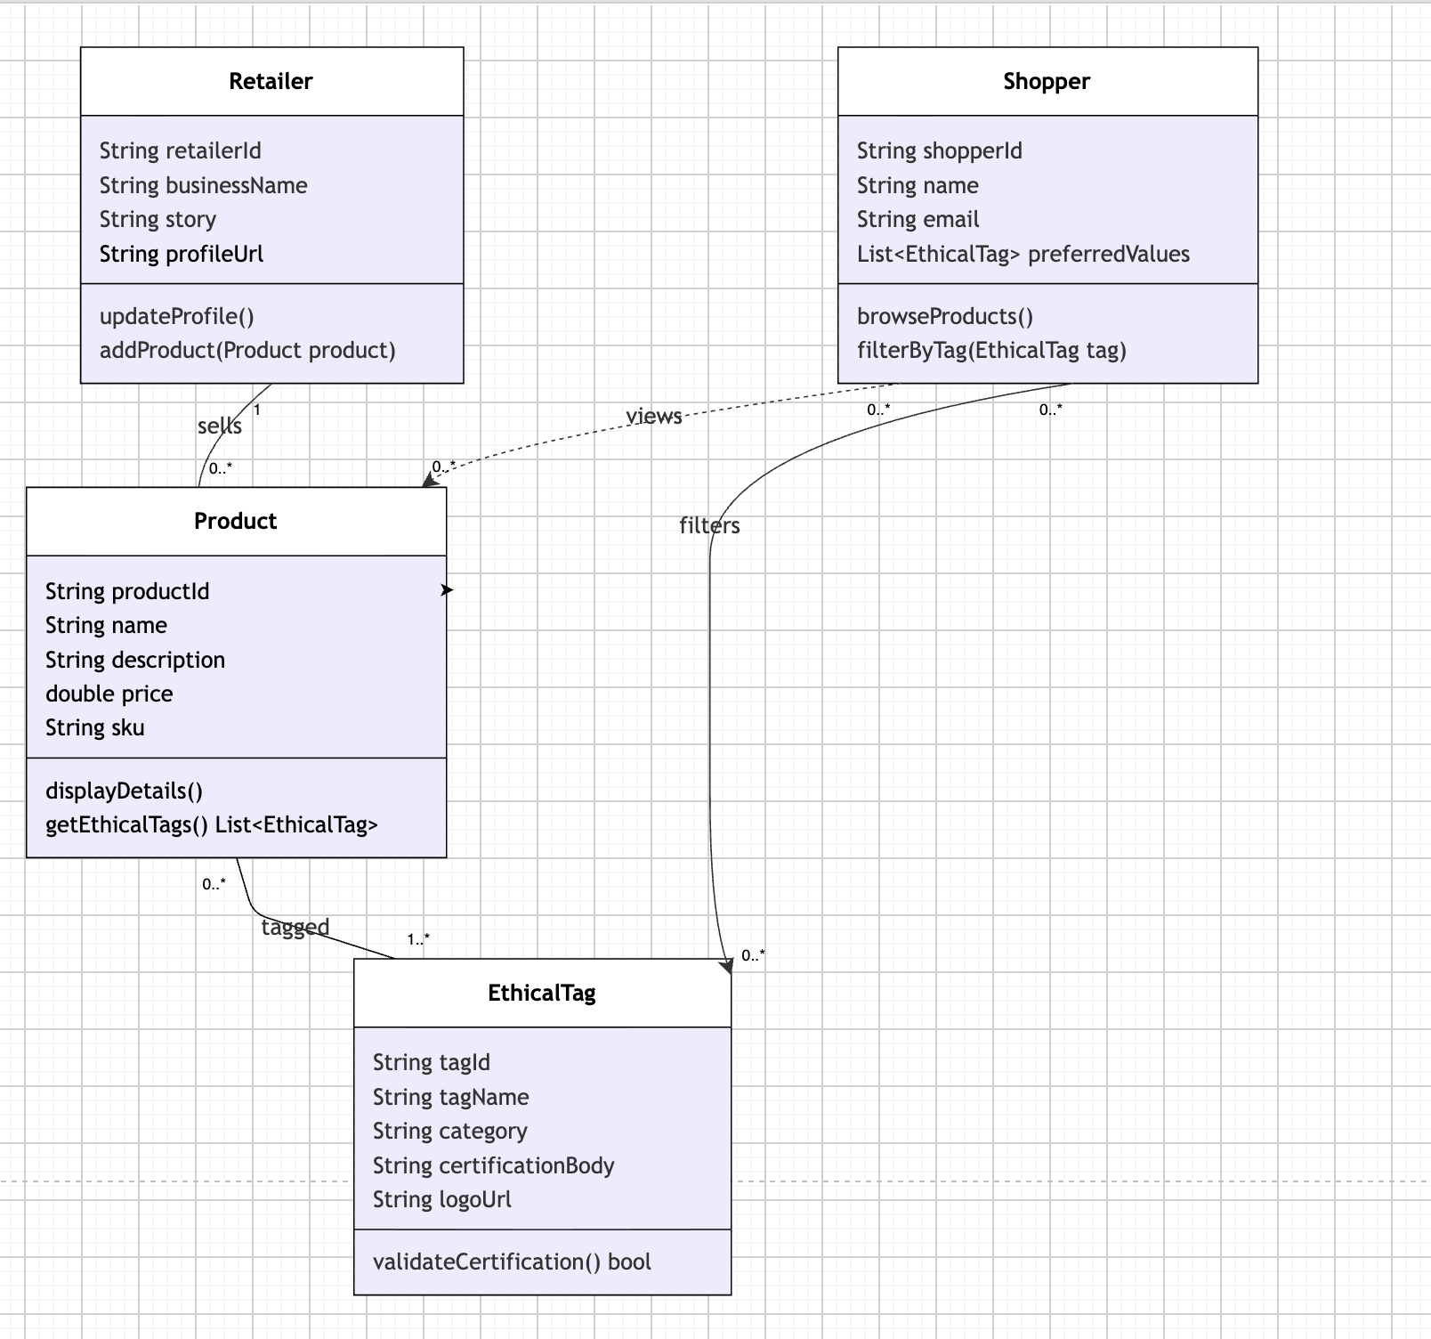
- Here is the SQL used:
CREATE TABLE retailer
(
retailer_id VARCHAR(255) PRIMARY KEY,
business_name VARCHAR(255) NOT NULL,
story TEXT,
profile_url VARCHAR(255)
);
CREATE TABLE shopper
(
shopper_id VARCHAR(255) PRIMARY KEY,
name VARCHAR(255) NOT NULL,
email VARCHAR(255) NOT NULL
);
CREATE TABLE ethical_tag
(
tag_id VARCHAR(255) PRIMARY KEY,
tag_name VARCHAR(255) NOT NULL,
category VARCHAR(255),
certification_body VARCHAR(255),
logo_url VARCHAR(255)
);
CREATE TABLE product
(
product_id VARCHAR(255) PRIMARY KEY,
name VARCHAR(255) NOT NULL,
description TEXT,
price DOUBLE PRECISION,
sku VARCHAR(255),
retailer_id VARCHAR(255),
CONSTRAINT fk_product_retailer
FOREIGN KEY (retailer_id)
REFERENCES retailer (retailer_id)
ON DELETE SET NULL
);
CREATE TABLE product_ethical_tag
(
product_id VARCHAR(255) NOT NULL,
tag_id VARCHAR(255) NOT NULL,
PRIMARY KEY (product_id, tag_id),
CONSTRAINT fk_pet_product
FOREIGN KEY (product_id)
REFERENCES product (product_id)
ON DELETE CASCADE,
CONSTRAINT fk_pet_tag
FOREIGN KEY (tag_id)
REFERENCES ethical_tag (tag_id)
ON DELETE CASCADE
);
CREATE TABLE shopper_product_views
(
shopper_id VARCHAR(255) NOT NULL,
product_id VARCHAR(255) NOT NULL,
viewed_at TIMESTAMP DEFAULT CURRENT_TIMESTAMP,
PRIMARY KEY (shopper_id, product_id),
CONSTRAINT fk_views_shopper
FOREIGN KEY (shopper_id)
REFERENCES shopper (shopper_id)
ON DELETE CASCADE,
CONSTRAINT fk_views_product
FOREIGN KEY (product_id)
REFERENCES product (product_id)
ON DELETE CASCADE
);
CREATE TABLE shopper_preferred_tags
(
shopper_id VARCHAR(255) NOT NULL,
tag_id VARCHAR(255) NOT NULL,
PRIMARY KEY (shopper_id, tag_id),
CONSTRAINT fk_spt_shopper
FOREIGN KEY (shopper_id)
REFERENCES shopper (shopper_id)
ON DELETE CASCADE,
CONSTRAINT fk_spt_tag
FOREIGN KEY (tag_id)
REFERENCES ethical_tag (tag_id)
ON DELETE CASCADE
);
- And here is the diagram of the database I created using IntelliJ’s database tools:
