ASSESSMENT 3 ANSWERS  Peter Palotas | 

- Activity Diagram
      - As a data entry technician, I want standardised, clearly formatted product details, so that I can efficiently upload new items

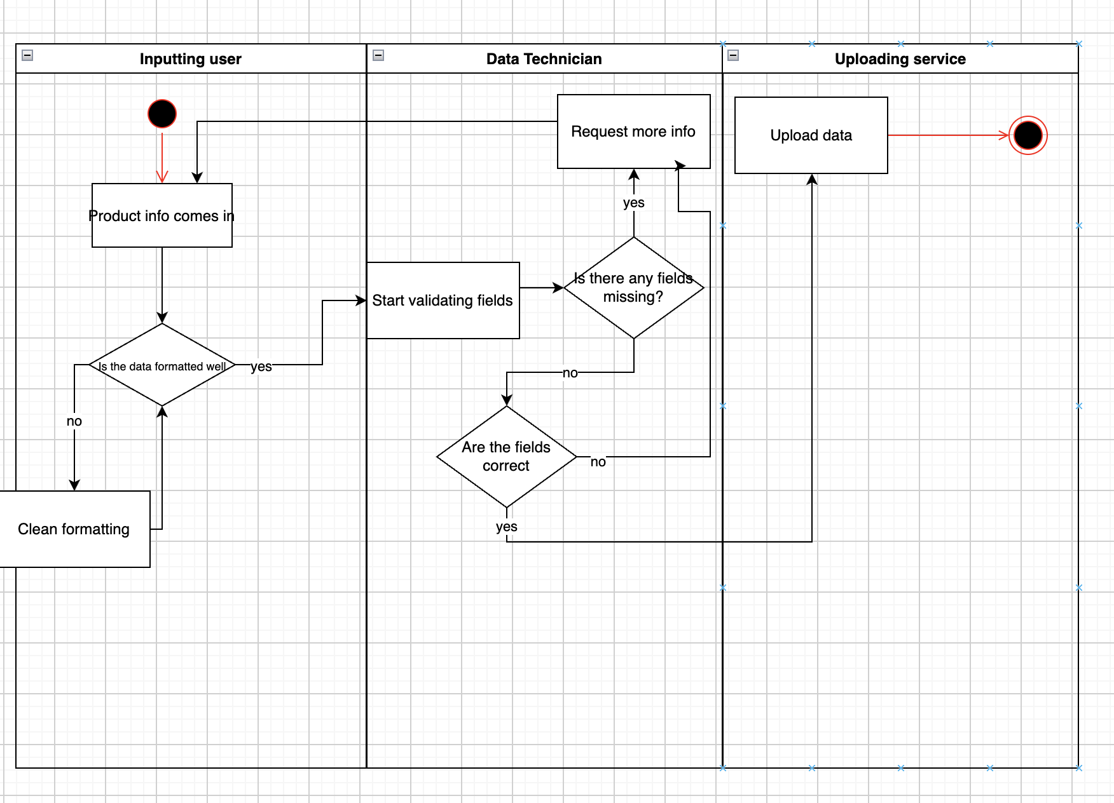

- Sequence Diagram
As a customer service employee, I want access to shipping information, and product information so that I can better help consumers
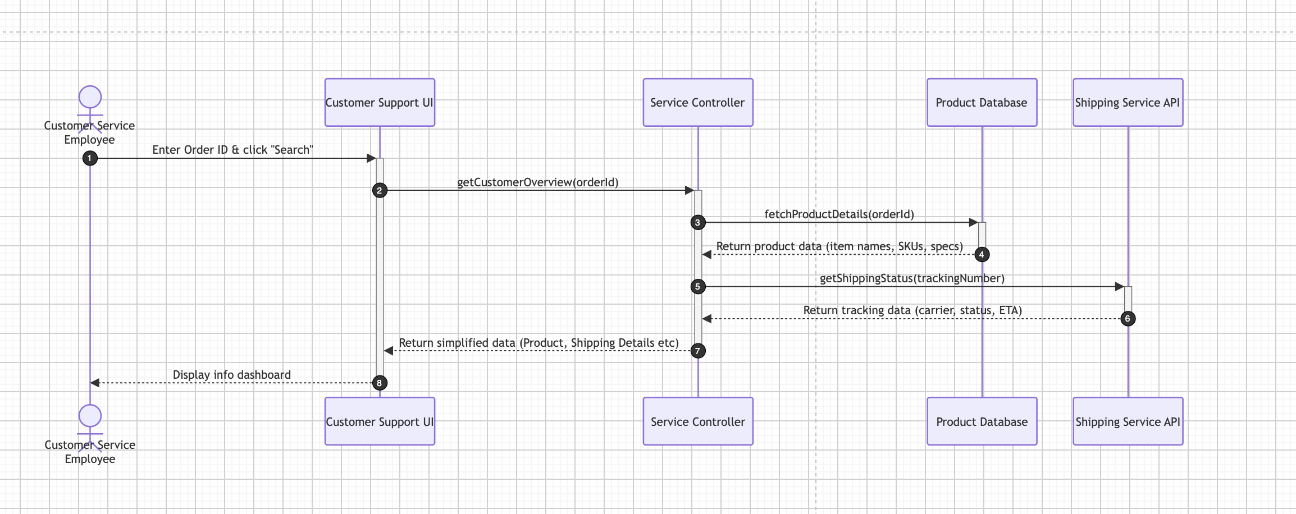

- Class Diagram
As a shopper, I want to see tags showing the products are ethically sourced (Like organic, fair trade…) so that I know my purchases align with my ethical values

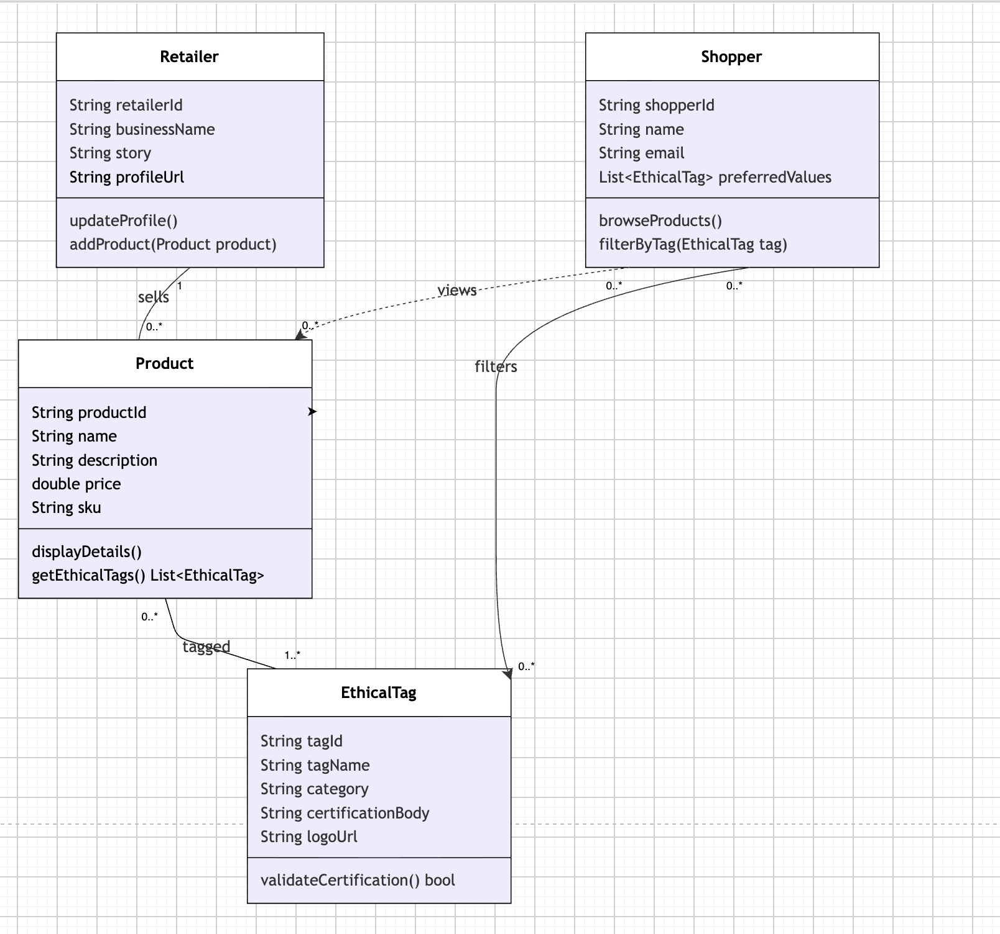

Identify the data needed for Northern Green with a focus on meeting the needs of the Ethical Consumer Persona and present as a Class or ER diagram

They would need:
      - Certifications (FairTrade, Organic…)
      - Product origins(For transparency)
      - Consumer preferences
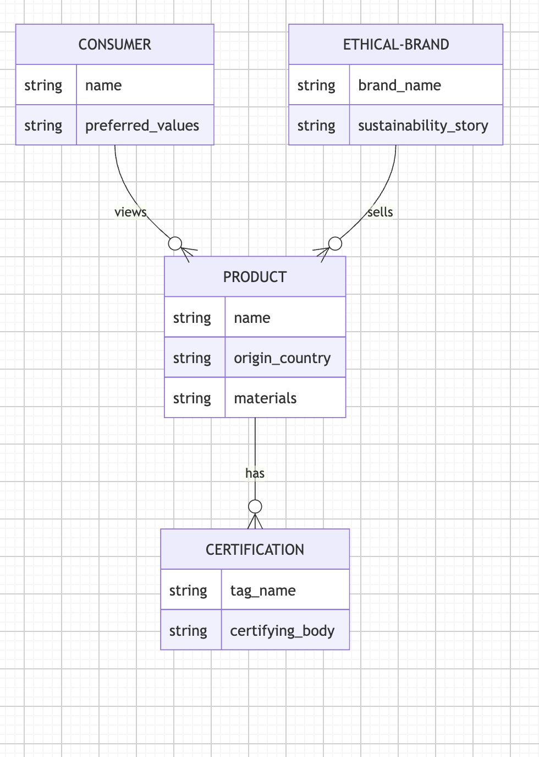

Review https://greensoftware.foundation/articles/10-recommendations-for-green-software-development and suggest how Northern Green could adopt at least one of the recommendations in its System Design

Reduce data usage. Adopt efficient cache policy, minimize data exchange, and manage the lifecycle of stored data - compress and aggregate data and use smaller sizes for media and image when possible.

Northern Green. Could do this by reducing the amount of redundant data that they store. And retain data for only as long as they need it

