**Atmospheric Correction Tool for WISE MAN (ACWISE)**

**User Manual (v0.1)**

Yanqun Pan, 2020/09/24

**Introduction**

**ACWISE** is a software package which is developed for atmospheric correction of WISE image. For the current version (v0.1), it can only handle the Level1G images which are geo-referenced radiance. To run it successfully, some other WISE data are also needed, like the navigation log and geo reference LUTs, etc. More details are given in section 4.

This package was written in pure Python, it runs in environment of Python>=3.5, but it may occur some warnings in Python 3.7 and 3.8. To run it, a bunch of 3rd part of libraries are required. To make it easier for user who is not very familiar with Python, this package is installed in a singularity image and all of the dependencies have been installed.

**Quick start**

Following the steps below to run it:

1. Go into the singularity sif image. Note that users don’t have the write permission, so it needs to mount the external directory that contains the WISE images to be processed.

singularity shell --bind /data:/mnt acwise.sif

1. Set the run environment



1. Run acwise to get help info

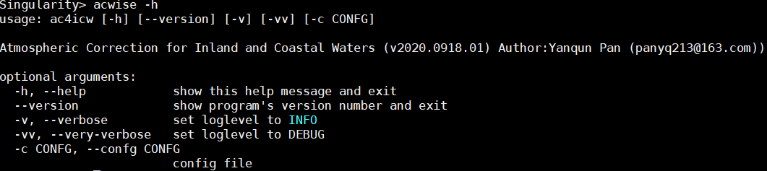

1. To run acwise, a configure file is mandatory.

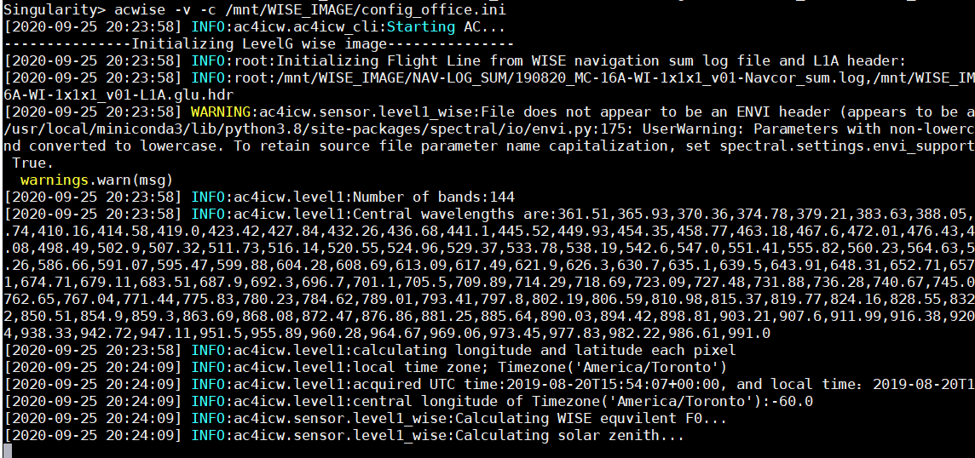

**The configure file**

To make the software package more extensible, a bunch of options can be set in the configure file. But for the current version which only implemented the basic function, most of options are fixed. Here is a template for the configure file, the options marked as yellow are fixed, it can not be modified by now. The details of the options are given as below:

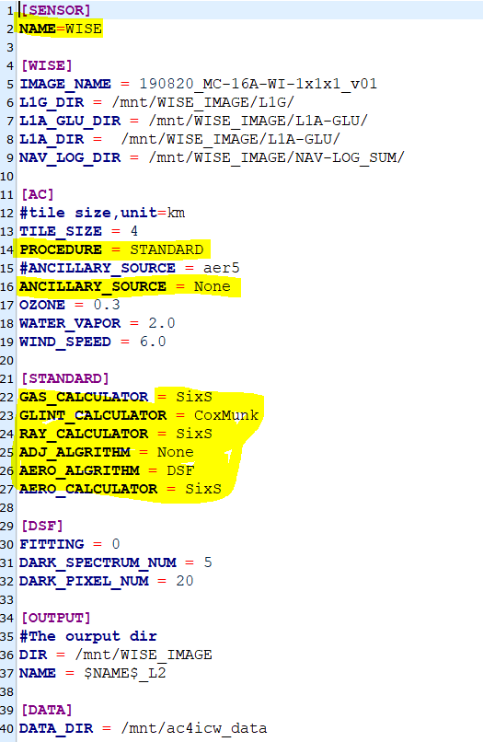

**[WISE]**

This is set for the input of the level-1 WISE image. **IMAGE_NAME** refers to the name of the image to be processed, for the pattern of the image name, please refers to the WISE flight document. L1G_DIR is for the directory that contains the L1G images. L1A_GLU_DIR and NAV_LOG_DIR are for the directories that contain the geo-reference LUTs ($IMAGE_NAME$-L1A.glu.hdr) and the navigation log files ($IMAGE_NAME$-Navcor_sum.log), respectively.

**[AC]**

This section configures some general information about atmospheric correction. Currently, the entire image will be split into several tiles (squares) for processing. The **TILE_SIZE** option is for the size of each tile, the unit of the size is *km.* **PROCEDURE= STANDADRD** means the atmospheric correction will be performed in a standard procedure, step by step. Except for STANDARD, the other kinds of procedure is not implemented yet. The **STANDARD** procedure is further configured in the **STANDARD** section. The ancillary data mainly includes the total concentration of **OZONE** (m.atm)**,WATER VAPOR** (g cm2) and **WIND SPEED** (m s-1). These data can only be fixed manually, since the automatically way is not implemented yet.

**[STANDARD]**

This section is set for the gas absorption, Rayleigh, glint, adjacency effect and aerosol correction. Note that adjacency effect correction algorithm was not implemented yet, so the option of **ADJ_ALGORIHTM** should be set **None**. The calculation of gas absorption, Rayleigh and aerosol are all based on 6SV, so they are set as **SixS**. The calculation of glint is based on the Cox&Munk model, so **GLINT_CALCULATION=CoxMunk**. For the aerosol retrieval algorithm, only the **DSF** (Quinten et al,2018) algorithm is implemented in current version, so **AERO_ALGORIHTM=DSF** (the details of DSF is further configured in the DSF section). If one of the options are set **None**, the related correction will be skipped, for example, no aerosol correction will be performed when **AERO_ALGORIHTM** **=None**, but the Rayleigh correction is mandatory, mean **RAY_CALCULATOR** should not be set **None**.

**[DSF]**

The darkest pixel could be determined directly or by linear fitting, which is controlled by the **FITTING** option, the value of 1 and 0 is a switch of using linear fitting or not. **DARK_SPECTRUM_NUM** determines the number of bands of the darkest pixel. For the hyperspectral WISE image, the default value is set 5, which means the aerosol reflectance spectra will be determined by darkest pixels in 5 bands. **DARK_PIXEL_NUM** is the number (the default value is 20) of real darkest pixels which are used to determine the ideal darkest pixel by linear fitting, it works only when **FITTING=1**.

**[OUTPUT]**

The level-2 file is save as GEOTIFF. Currently, only the Rrs product is saved in the level-2 file. The DIR option specifies the directory to save the level-2 file, and NAME specifies the name of the level-2 file. **$NAME$** will be replaced by **IMAGE_NAME**.

**[DATA]**

DATA_DIR specifies the directory that contains the internal data that will be used by the package. By default, the data will be located in **/opt/acwise_data**.

**Methodology**

# Radiative transfer and simulations

The basic theory atmospheric radiative transfer and the simulations of each term (except for the glint reflectance) are based 6SV. The glint reflectance was simulated using the Cox&Monk model.

The apparent reflectance ρ* at the sensor level is expressed as (6SV):

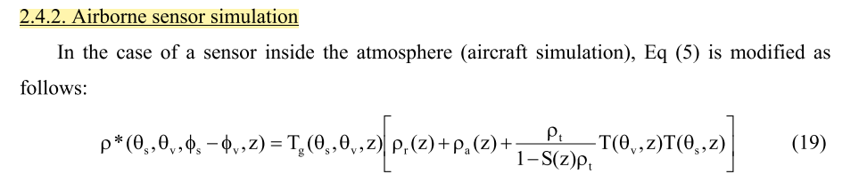

## Relative Spectral Response (RSR) of WISE

The RSR of WISE is calculated based on the center wavelength, the Full Width at Half Maximum (FWHM) recorded in the header file of WISE and the assumption of Gaussian distribution. For each channel, *RSR* is calculated using Equation 1:

$$RSR=\exp\left[-\frac{{\left(x-b\right)}^{2}}{2{(\frac{FWHM}{\sqrt{2*\log\left(2\right)}} )}^{2}}\right]\left(1\right)$$

where, x refers to the full wavelength, for example, from 400 to 1200 nm with interval of 0.5 nm; *b* refers to the center wavelength of the channel.

## LUT of transmittance due to gas absorption $T_{g}(θ_{s},θ_{v},z)$

The downwelling *and* upwelling of transmittance are expressed as $T_{g}(θ_{s}$) and $T_{g}(θ_{v}$). The values of $θ_{s}$ and $θ_{v}$ are set as:

$θ_{s}$ = 15, 25, 35, 45, 55, 65

$θ_{v}$ = 0, 5, 10,15, 25, 35, 45

The atmosphere profile was defined by water vapor (*wv*) and O3, the values are set as

*wv* = 1, 2, 4, 6 ()

o3 = 0.2, 0.3, 0.4, 0.5 ()

## LUT of the Rayleigh scattering reflectance $ρ_{r}$,diffuse transmittance $T_{r}$ and spherical albedo $S_{r}$ due to Rayleigh scattering

The values $θ_{s}$ and $θ_{v}$ refer to section 1.1. The values relative azimuth $ϕ$ are set as:

$ϕ$ = 0,15,30,45,60,75,90,105,120,135,150,165,180

The atmosphere profile is set as “SubarcticSummer”.

## LUTs of the aerosol scattering reflectance $ρ_{a}$,diffuse transmittance $T_{a}$ and spherical albedo $S_{a}$ due to aerosol scattering

The settings of $θ_{s}$, $θ_{v}$ and $ϕ$ refer to section 1.2.

The aerosol type is defined by the ratio of the four compositions, soot, water, oceanic and dust. The ratio interval was set as 0.2, therefore, 36 aerosol types in total were generated.

The aerosol optical thickness in 550 nm $τ_{a}(550)$ are set as:

$τ_{a}(550)$ = 0.005,0.01,0.02,0.04,0.08,0.16,0.32

## LUTs of the path reflectance $ρ_{P}$, the diffuse irradiance $E_{diff}$ reflected by the water surface $ρ_{sky_w}$, the total diffuse transmittance due to Rayleigh and aerosol scattering $T$, the total spherical albedo $S$.

Note that $ρ_{sky_w}$ is calculated based on the diffuse irradiance $E_{diff}$ at the ground level using Eq. 1-2:



$$ρ_{sky_w}=\frac{E_{diff}}{F_{0}\cos\left(θ_{s}\right)} r(1)$$

$$r= 0.0256+0.00039w+0.000034w^{2} (2)$$

## LUT of glint reflectance $ρ_{G}$

Glint reflectance is simulated using Cox&Monk model, and only the wind speed but not the wind direction is taken into account.

# Image Processing

## 2.1 Pre-processing

### 2.1.1 Calculation of observing geometry

The solar zenith angle $θ_{s}$ and azimuth $ϕ_{s}$ is calculated based on the local time-zone, local time, longitude and latitude.

The viewing zenith angle $θ_{v}$ is calculated based on the height (*h*), spatial resolution (*r*) and the pixel offset from the center. Note that the Curvature of the earth is ignored since the swath WISE is less than 10 km. In addition, the *pitch* and *roll* of the plan is assumed to be 0 and without change during measuring. Figure 1. Shows the geometry.

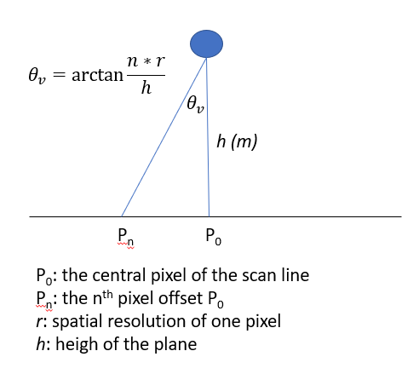

Figure 1. The basic geometry for $θ_{v}$ calculation

The geometry for calculating the viewing azimuth angle $ϕ_{v}$ is shown in Figure 2. Note that the pitch and roll of the plane are assumed to be 0, and there is no change during the measurement, and the heading is also assumed to be no change.

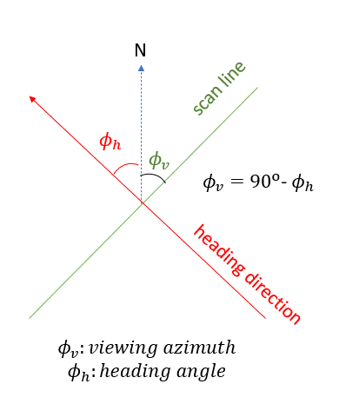

Figure 2. The basic geometry for $ϕ_{v}$ calculation

### Convert TOA radiance to reflectance

## The “STANDDARD” atmospheric correction

## The “PATHAC” atmospheric correction

This AC algorithm assumes the path reflectance are spatial homogenous, and the path reflectance and upward and downward transmittance due to scattering are determined based on the DSF algorithm proposed by Vanhellemont (2019). LUTs that support this AC method are generated using 6SV, details about the simulation are found in section 1.5.