1. Concept

* User

User is logger using site. There are super user and popular user .

* Wish list

Wish list is list of gift user want to get and like

* Gifts

Gifts is list of gift users sent their friends.

* Events

Events is lists of upcoming event(date) of user

(Birthday, Anniversary, Upcoming Wedding , Upcoming Bady Due Date …)

* Like(follow)

Users follow one they like.

1. Model
2. Users:

* admin (super user) : manage all users, gifts, events , and so on
* popular user :

• user has the following properties

name, password, email, phone number(optional), avatar image, favorite stories, favorite things, favorite drinks, favorite snacks, desserts & treats, wish list

interests/holidays/lift events, user special events(please explain these more detail)

• user has the following functions

login/sign up

add update, buy items of wish lists(please explain buying wish item more detail)

add/buy/share gift user like in wish list (please explain share)

search and follow Friends,

add and edit user events

add and edit Favorites(Favorite stories, Favorite things, Favorite drinks, Favorite snakes, dessers,treats)

invite friend (please explain inviting friends),

feedback

1. wish list

* item of wish list has the following proporties

gift id, most loved item, received_state, sent_user_id

* item of wish list has the following functions

add/update/remove/buy items in wish list

1. gift

* gift has the following properties

name, description, price, price point ,color/flavor/type, size, quantity, most loved item, gift state(1: sent, 0: unsent)

* gift has the following functions

add it in wish list

buy gift

*** who and how to add gifts?

1. user_events:

* user event has name property
* user events the following functions

add/update/delete events

*** how to add and update items of events ***

1. user_following

* user_ following has user id and list of following users(friends).
* user_following has following friends(user) function.

*** can remove following ? if okay, how to do?

1. Model

* Users collection

const users = {

id: int

first name: string,

last name: string ,

user_name: string,

email: string

password: string

phone_number: string (optional)

avatar_path: string,

fav_stories:[

{

Title: “FAVORITE STORIES”

Description: string,

Created_date: Date,

}

],

fav_things:[

{

Title: “FAVORITE THINGS”

Description: string,

Created_date: Date,

}

],

fav_drinks:[

{

Title: “FAVORITE DRINKS”

Description: string,

Created_date: Date,

}],

fav_others:[

{

Title: ”FAVORITE SNACKS, DESSERTS & TREATS”

Description: string,

Created_date: Date,

}

],

Wish_list:[

gift_id : int -> id of gifts collection,

most_loved_item: bool

sent_user_id: int -> id of users collection

]

}

* user_ events_list collection

const user_ events_list = [

{

user_id: int -> id of users collection,

[

{

friend_id: int, -> id of users collection

user_events_id: int, -> id of user_events collection

date: Date

}

]

},

],

* user_events collection

const user_events = {

id: int,

name: string,

}

const user_events = [

{ id: 1, name: Birthday},

{ id: 2, name: Anniversary}, …

]

* user_following collection

const user_following = [

{

user_id: int -> id of users collection

following_list:[

user_id: int

]

}

]

* Gifts collection

gift = {

id: int

Item_name: string,

Item_description: string,

Price: int.

Price: [

Under 25,

25~50,

50~100,

100~150,

150+

], *** if it is necessary to add price items, will use new collection.

url/web address: string,

color_flavor_type: string

size: string or int,

quantity: int,

image: string,

gift_state: 0: unsent,1 : sent

}

* Interests collection

const interests = {

id: int,

name: string,

}

* Holidays collection

const holidays = {

id: int,

name: string,

}

* life events collection

const life_events = {

id: int,

name: string,

}

1. UI Function

* Dashboard page

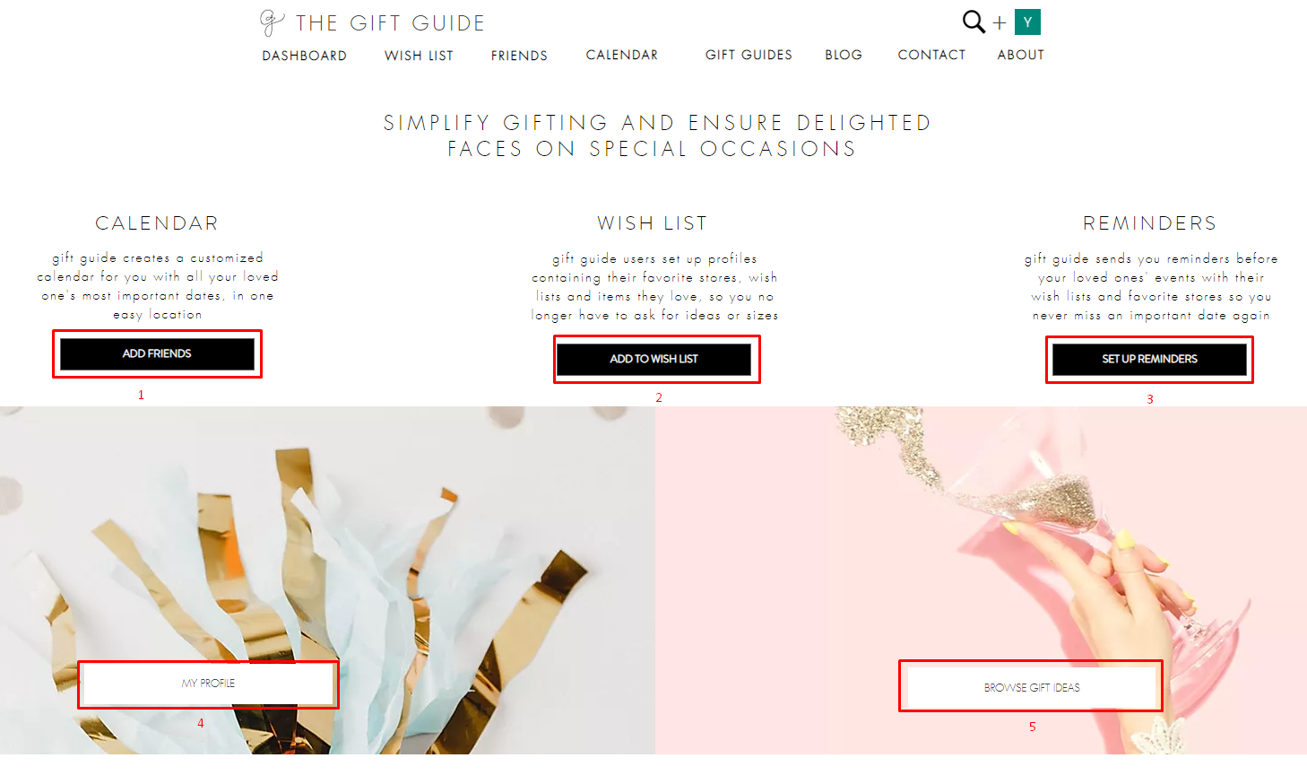

1: go to Friends page

2: go to add to wish list

3: go to account page

4: go to my profile page

5: go to gift guides page

* Header

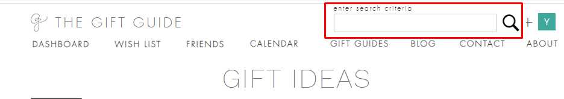

Go to seach page

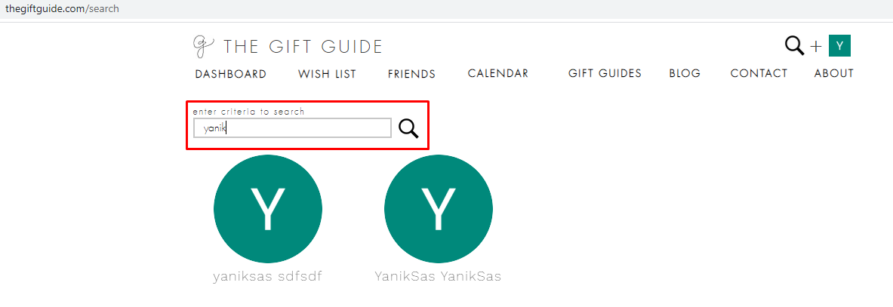

*** what is searched ? friend, gift or others?

* footer

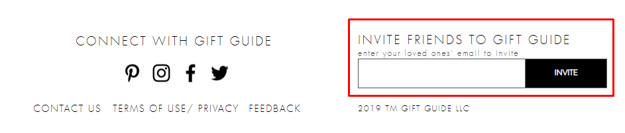

*** please explain inviting more detail

* Wish List page

Received items are the items that sets <item received> proporty into true

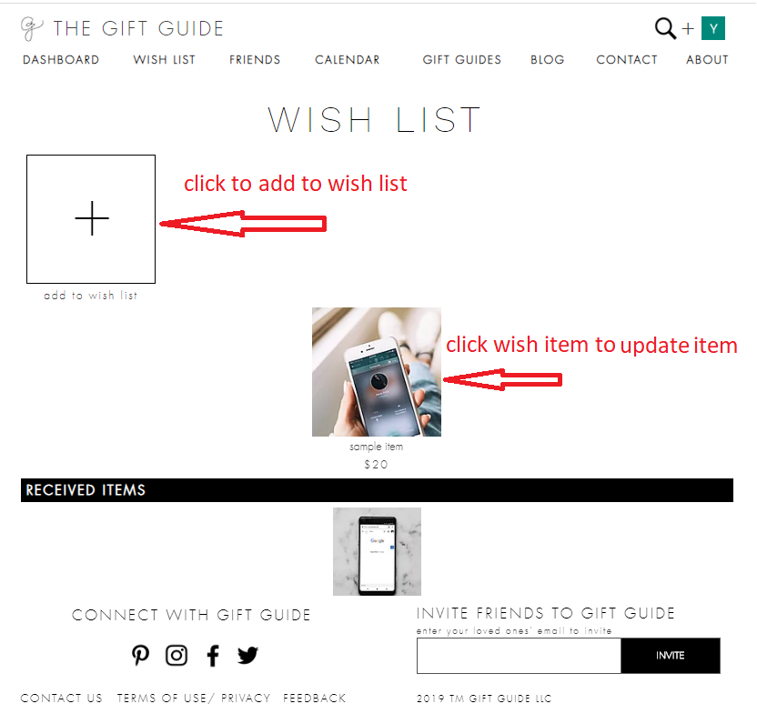

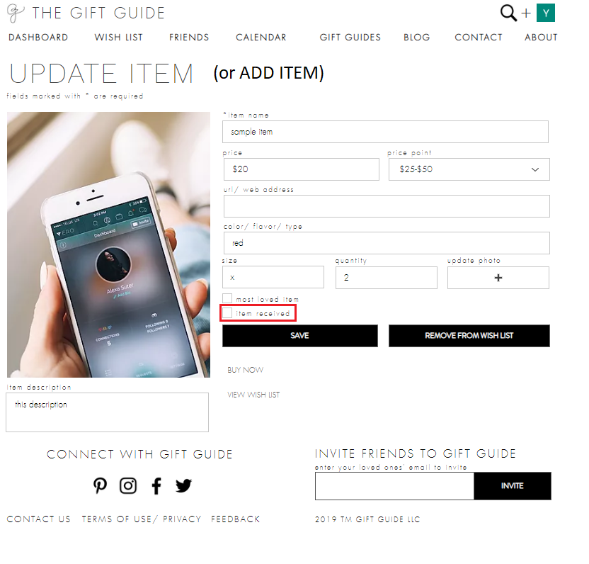

*** item received property is read-only?

Clicking buy now button, is it right linking url/address only?

* Friends Page

display user’s friends and add friends in find friend page.

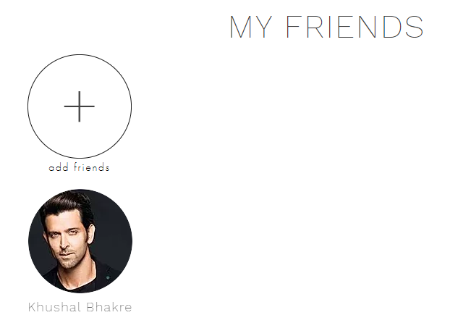

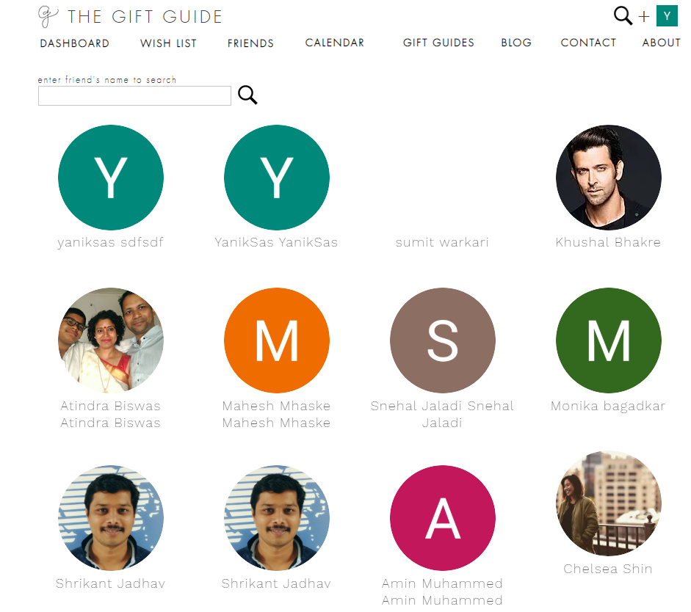

*** how to layout users? Order by createAt or other condition?

* Calendar Page

display information(events) of friends filtered by month.

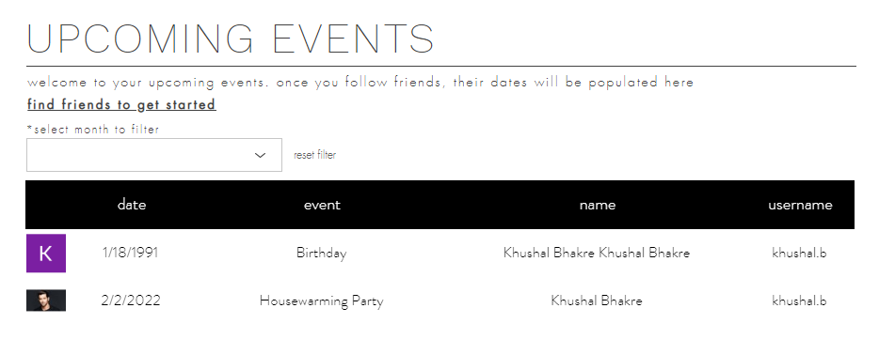

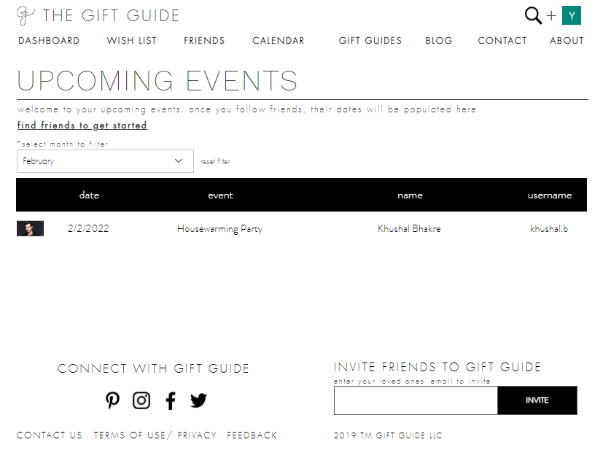

* Gift Guilds Page

display gifts. User can add gifts they loves in wish list.

Currently, not working filter, add to wish list and share function.

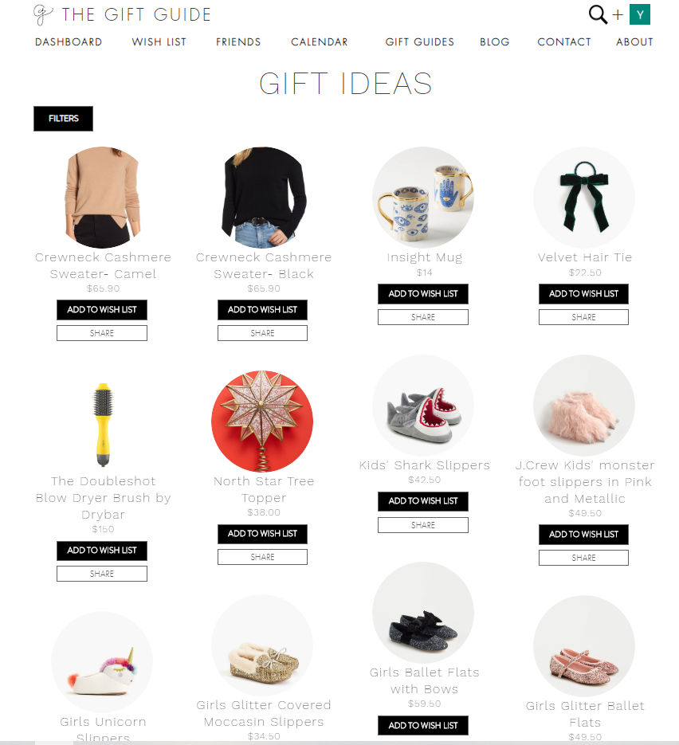

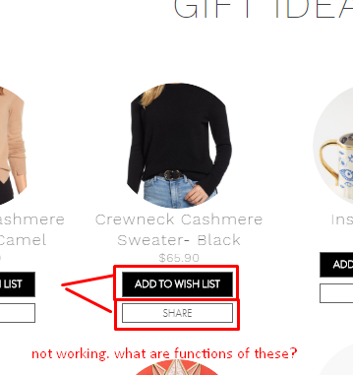

* user profile page

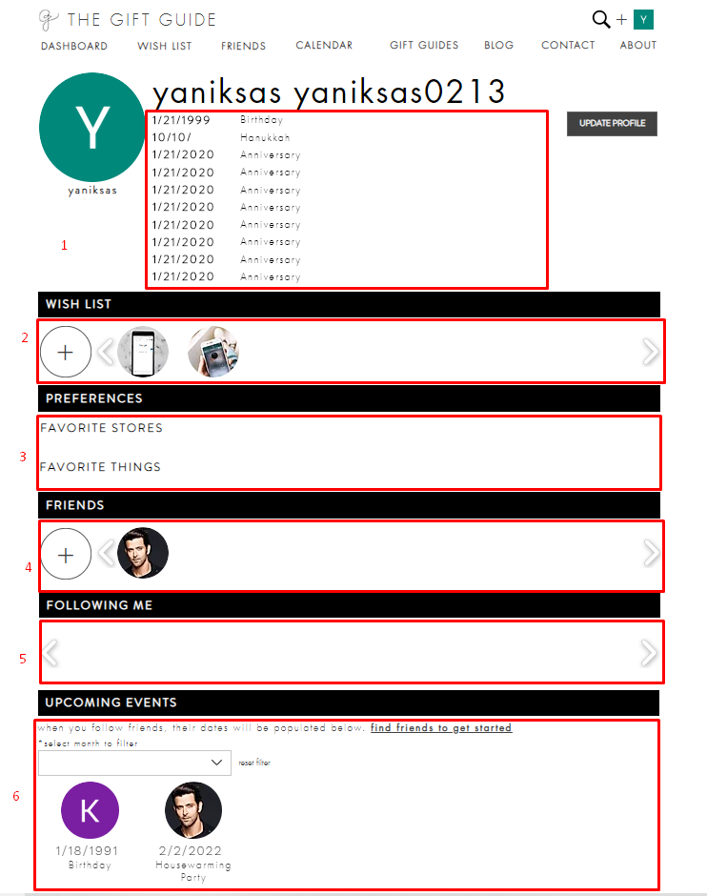

• Region 1

display user events added in user account page

this events will be shown to user’s friends and be displayed in friends’ calendar page.

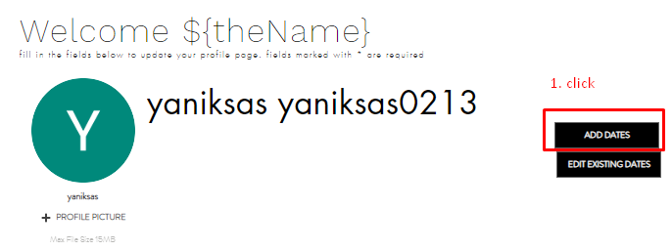 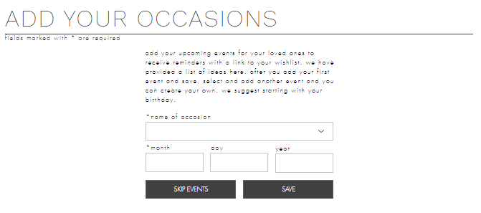

• Region 2 (wish list)

display wish list added in wish list page

• Region 3 (preferences)

display favorite stories and things added in user account page for showing friends

• Region 4 (Friends)

display friends added in friends page

• Region 5 (following me)

display users following me

• Region 6 (upcoming events)

display dates(events) of user’s friends

This function is the same with calendar page

* user- account page

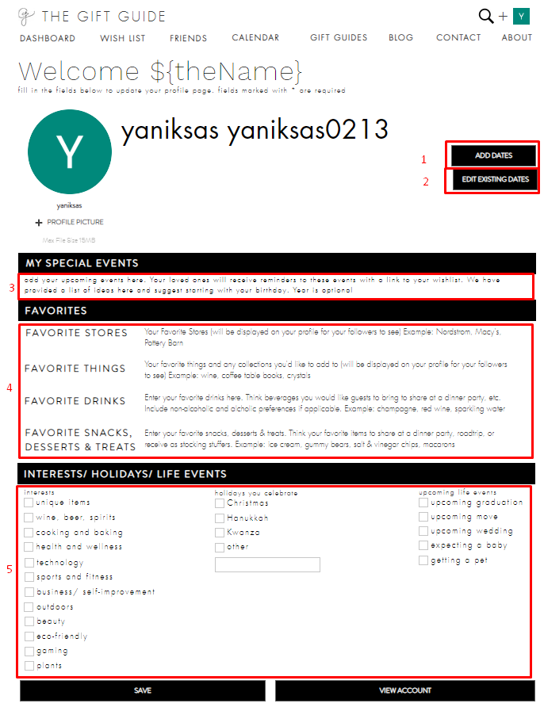

• Region 1 (ADD DATES)

add user’s events



**** how to add and change occasions itemes

• Region 2 (Edit Exist Date)

User can add and revise existing events.

Currently, not work adding and revising function.

Please explain about this more detail.

• Region 3 (Special Events)

Display Special Events

Currently, I don’t know how to add special events and how to be difference special events and user events.

• Region 4 (Favorites)

Add and edit favorite stories, things, drinks, snacks, desserts and treats for showing friends.

Currently, I don’t know how to add favorite items.

Those(4 items) are displayed on account page .

But currently, favorite stories and things are displayed on profile page

Please explain preferences and favorites more detail.

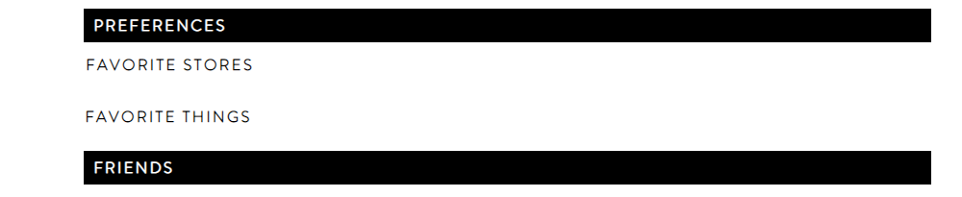

• Region 5 (interests/holidays/life events)

Display interests/holidays/life events.

Where and how can user add and edit items?

Please explain about it more detail

Currently. If click view accout button, go to account settings page.

Is it right?

* account setting

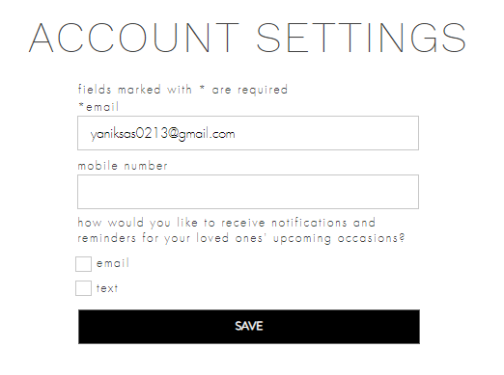

Save email or phone number for sending notification to user before upcoming events of friends

* blog page

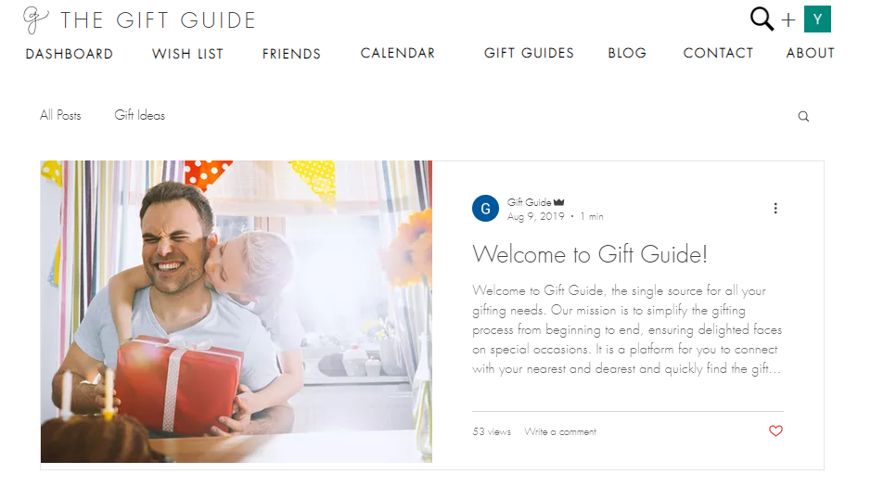

Who create blog? Can users create blog? Or only admin?

If user receive notification before your loved one’s upcoming events,

what does user do?

How to send the gift to user’s friends

Please explain about it