1b) Gaussian sampling has better performance than uniform sampling fro the world. This is due to the fact that as we are sampling from Gaussian distribution that is centered around the target, we will more likely extend the RRT closer to the target than otherwise. With uniform distribution we have no preference for which points we sample so there will more likely be a point that extends the leaves of the tree away from the target. The following shows the difference between two sampling approaches visually.

Uniform

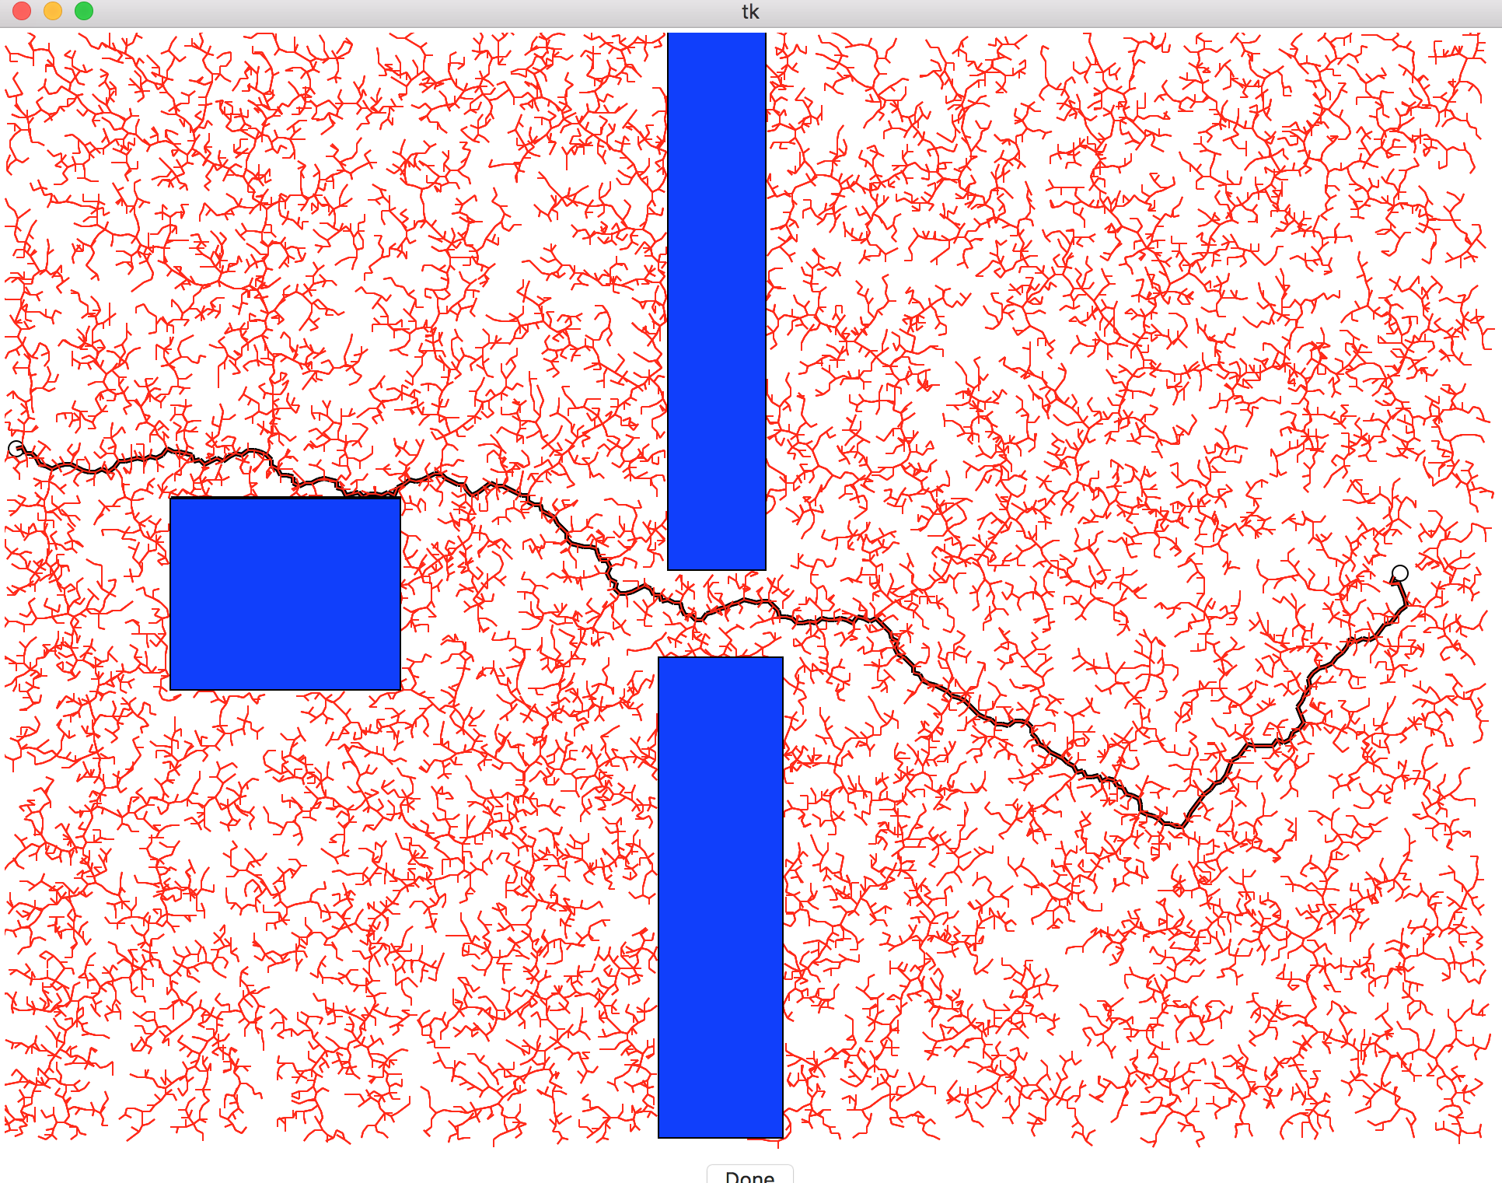

and the Gaussian distribution gives:

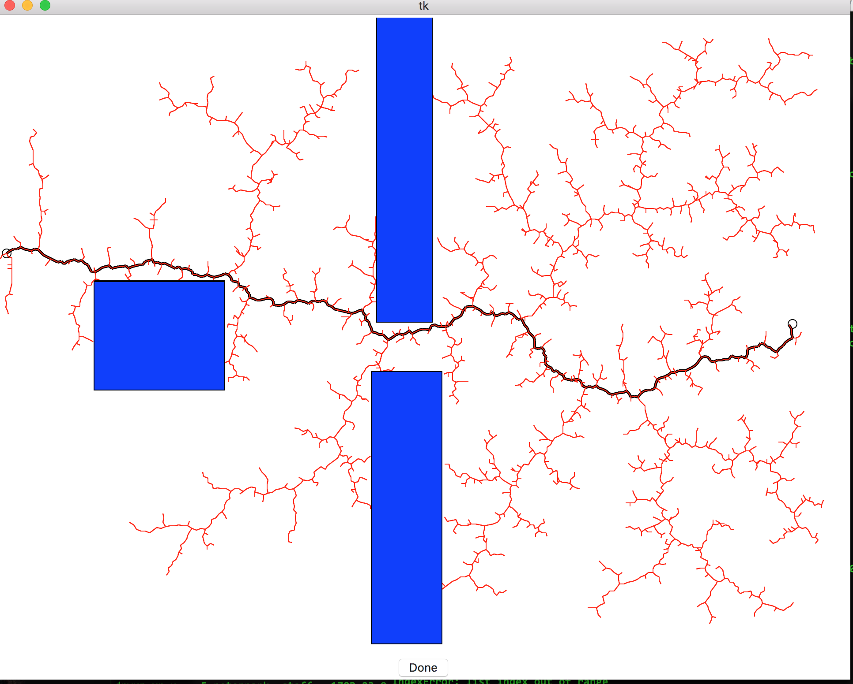

C)

The following plots show the differences in the variables;

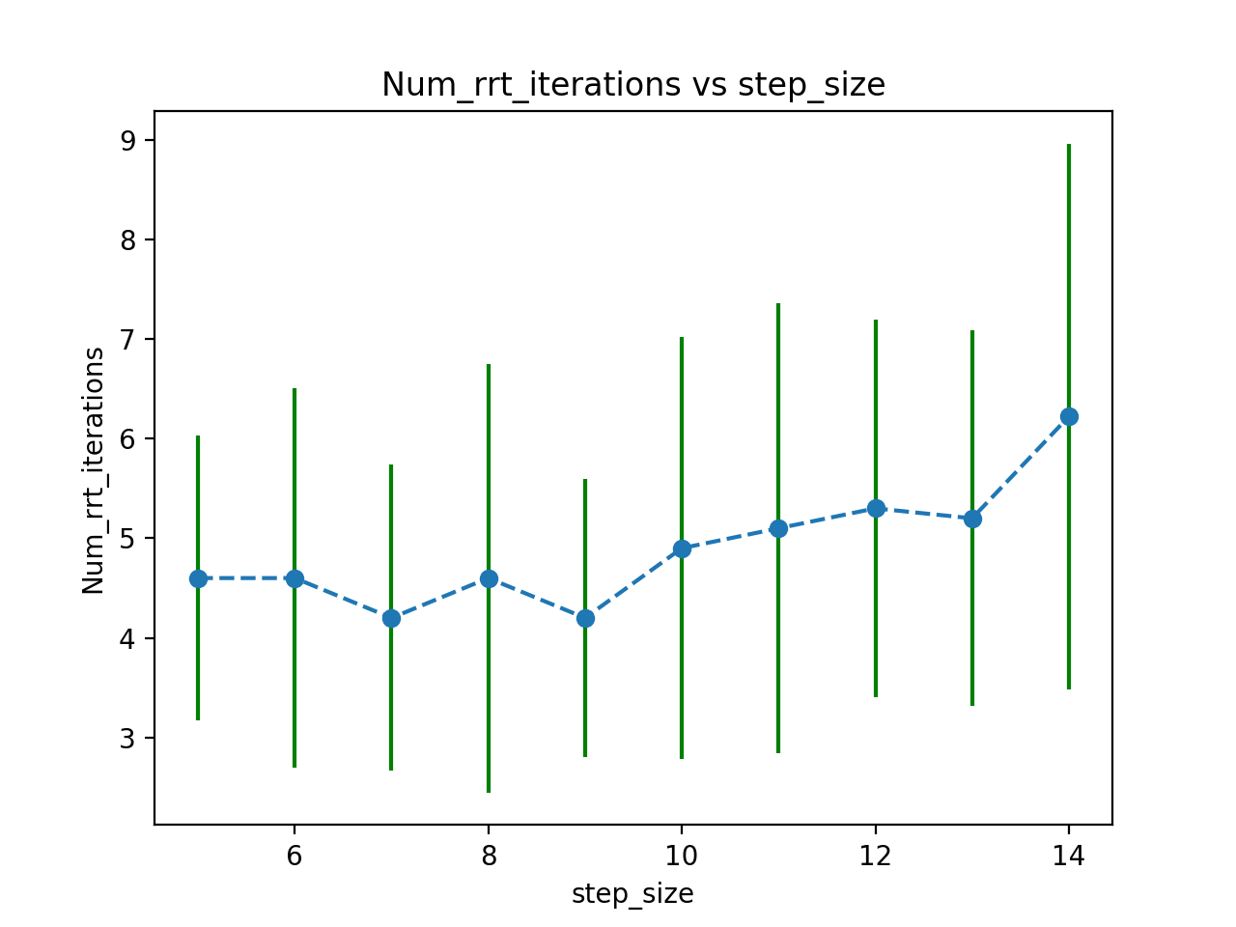

above shows the relationship between step size and Num_rrt_iteration. The code was modified to change the threshold for acceptance to be constant for all trials. Hence if we sample a point that is within 5 pixels of target than we will accept it as a path from start to end. Below shows the relationship between step size and length of the path.

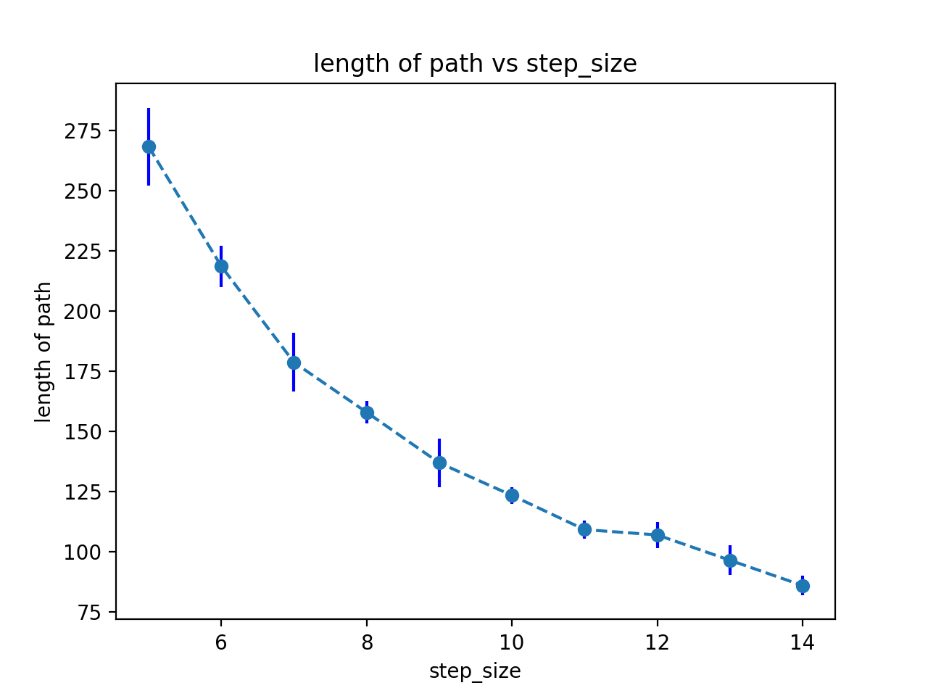

2 a)

we have the following output for the RRT with line length of 50 . 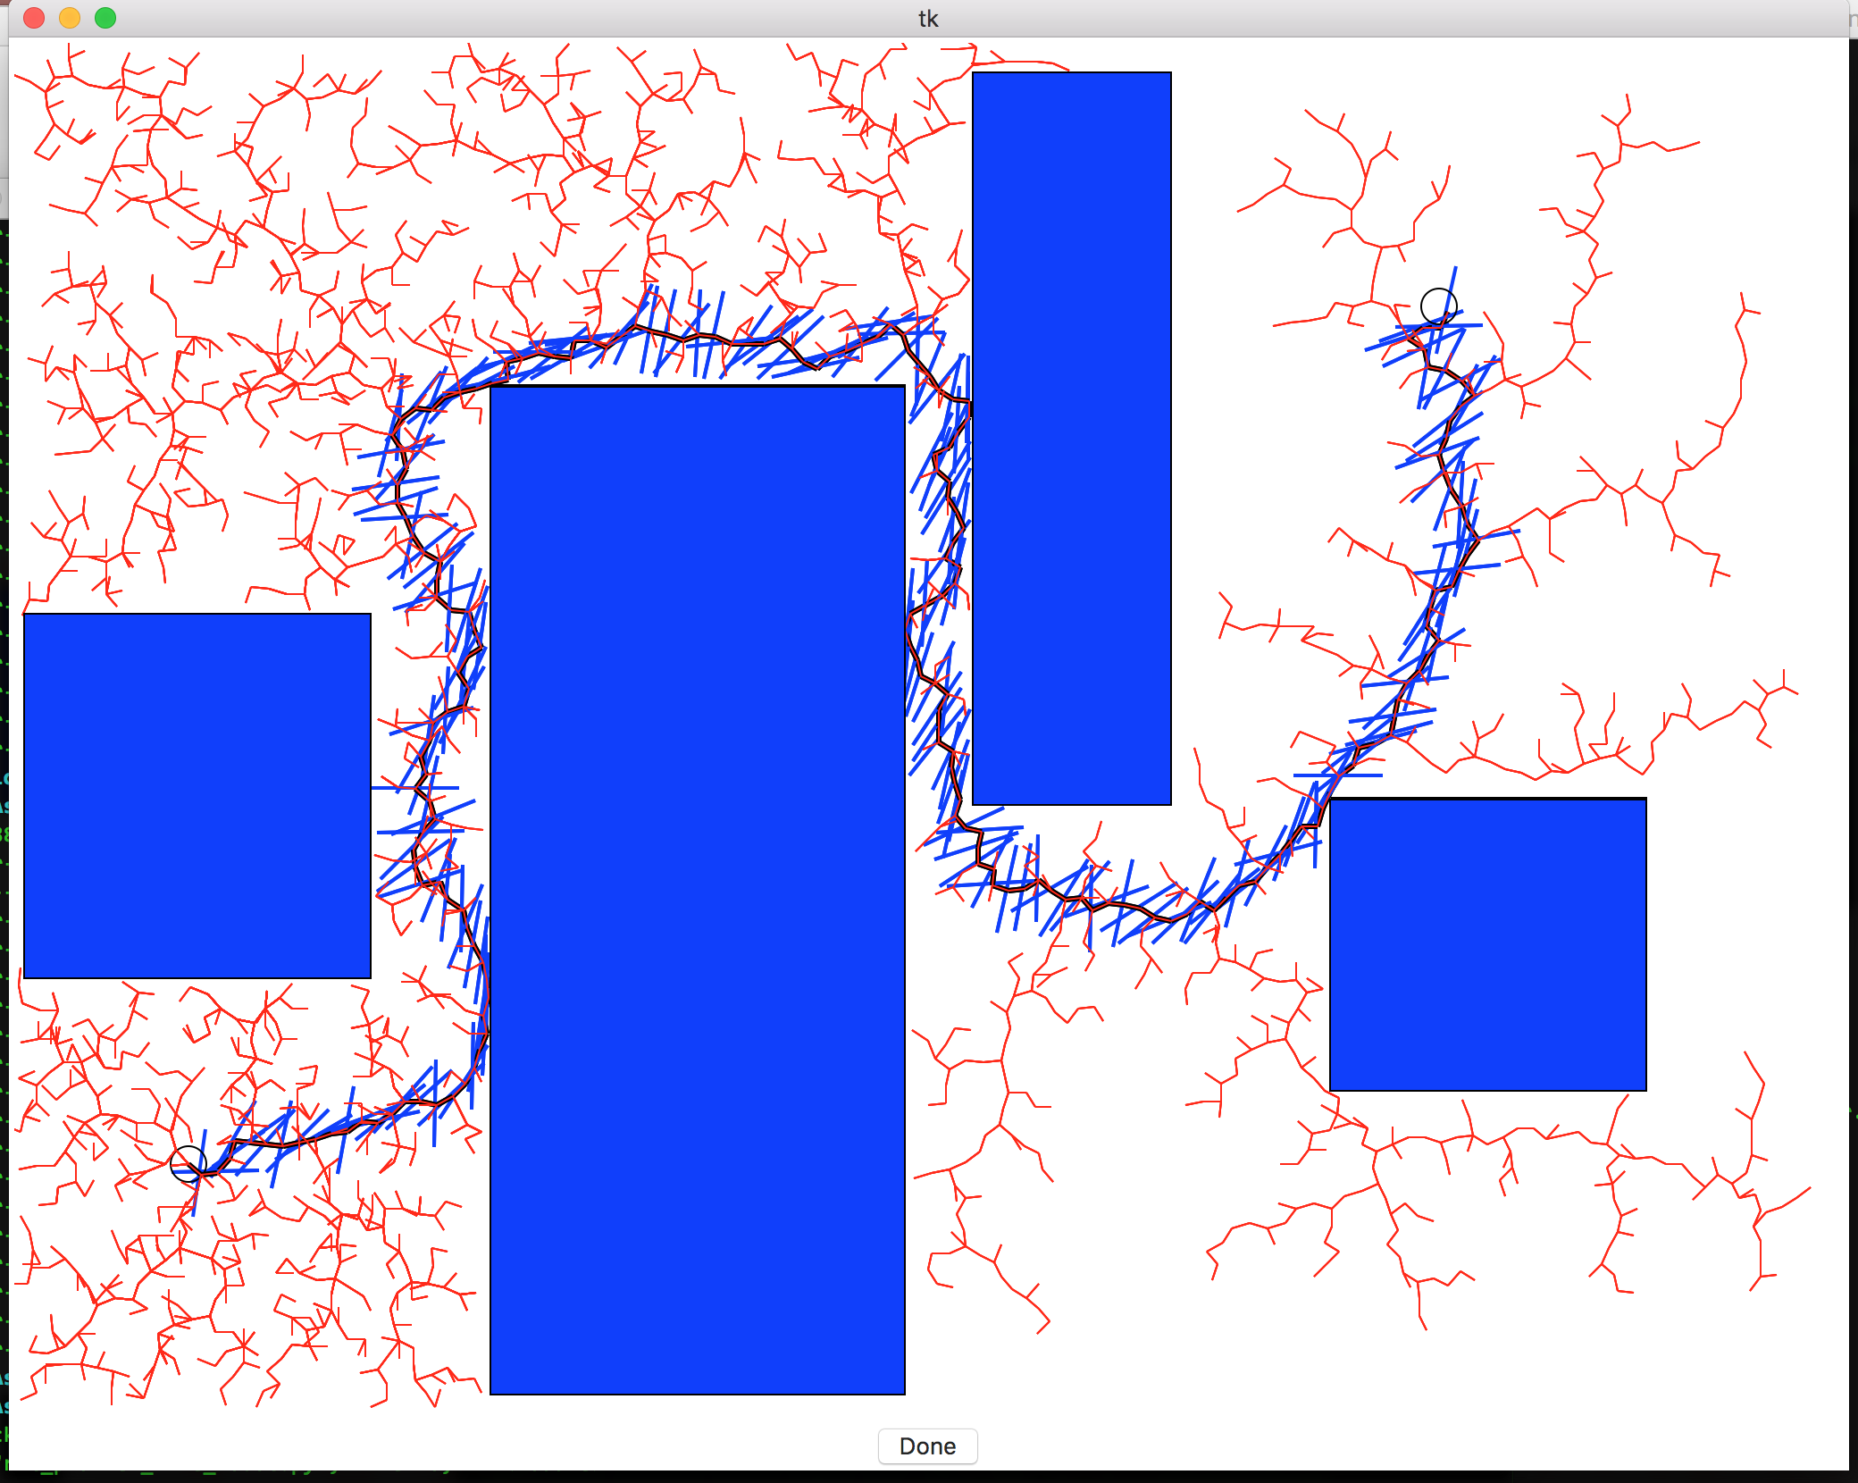

b)

Now the plot for the RRT iteration and the length of the robot gives the following:

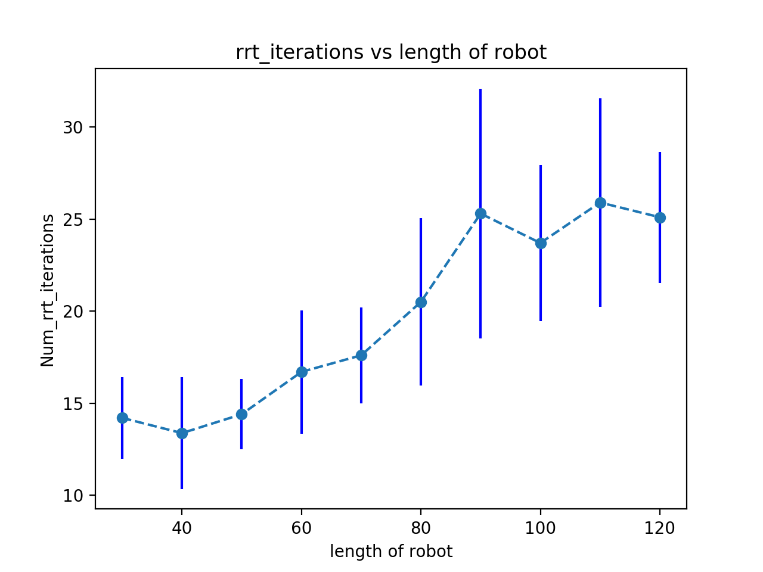

We can see that as the length of the robot increases, the number of RRT iteration increases.