1. Created a local only GIT Repository and commit all of the work to it.

2. Created the app using Flask. Developed the index.html with specific links to check Application, Secret_word, Load balancer and TLS

3. Created a Dockerfile with instructions to create the App. Used node as the base image. Version node:16

4. Deployed the app in a ECR Docker container

5. Used Terraform (IAC) the deploy the code using terraform

- Created a self-signed certificate for TLS check

- Used Created a docker container in EC2 instance

- Log on to ECR, pull the image and created the container

6. Created the Load balancer for app on port 5000 with backend as EC2 instances and Self Signed Certificate.

7. Created a Index page with the requirements on the required output with the links

8. Created NSG inbound rule for EC2 instance to allow access on Port 5000

1. Git commits

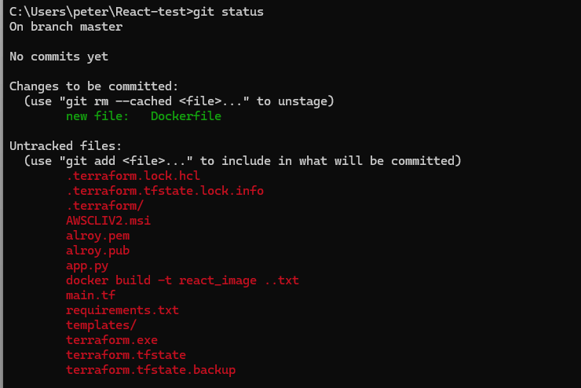

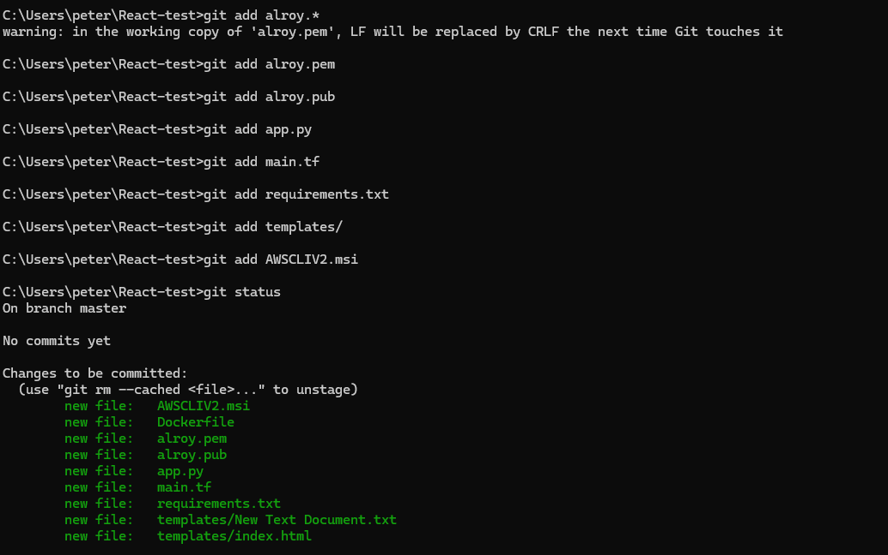

1. Created Docker Container and pushed the image

docker build -t rearc_image .

docker tag rearc_image 221500065327.dkr.ecr.us-east-1.amazonaws.com/my-docker-repo:rearc_image

aws ecr get-login-password --region us-east-1 | docker login --username AWS --password-stdin 221500065327.dkr.ecr.us-east-1.amazonaws.com

docker push 221500065327.dkr.ecr.us-east-1.amazonaws.com/my-docker-repo:rearc_image

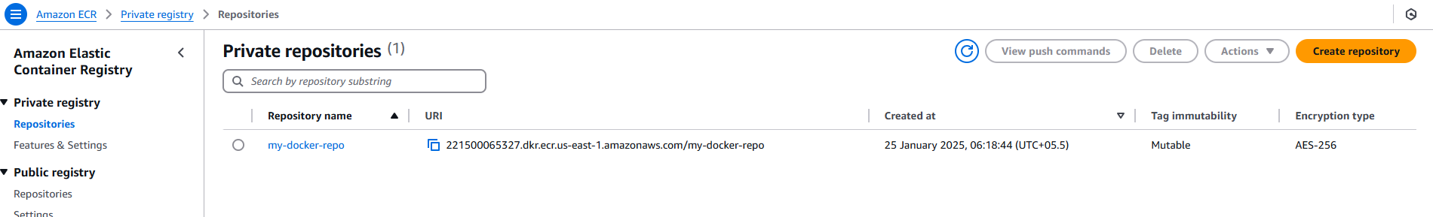

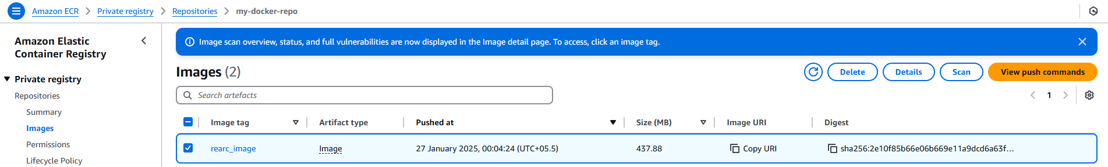

1. Created EC2 Instances

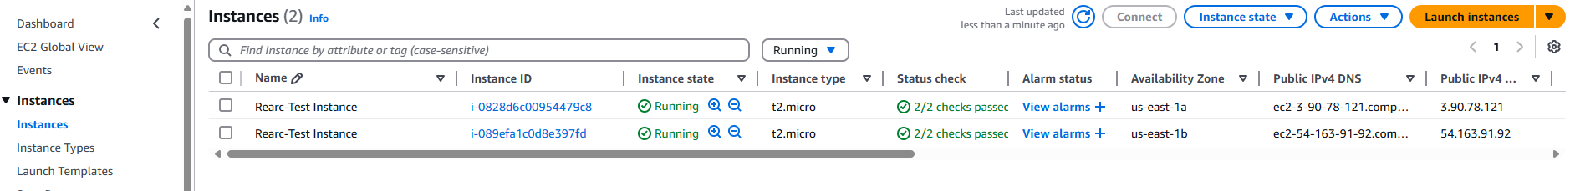

1. Created ELB with target group forwarding to App instances with Self signed TLS Certificates.

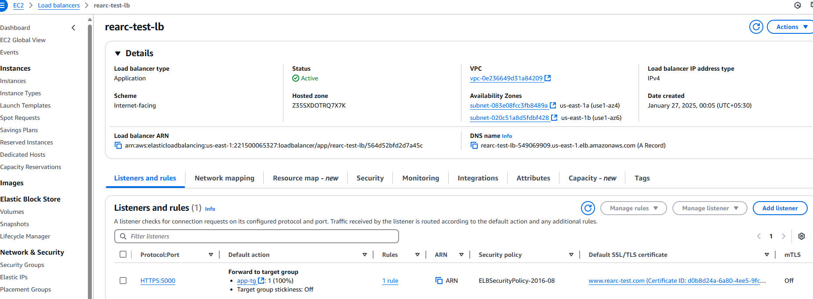

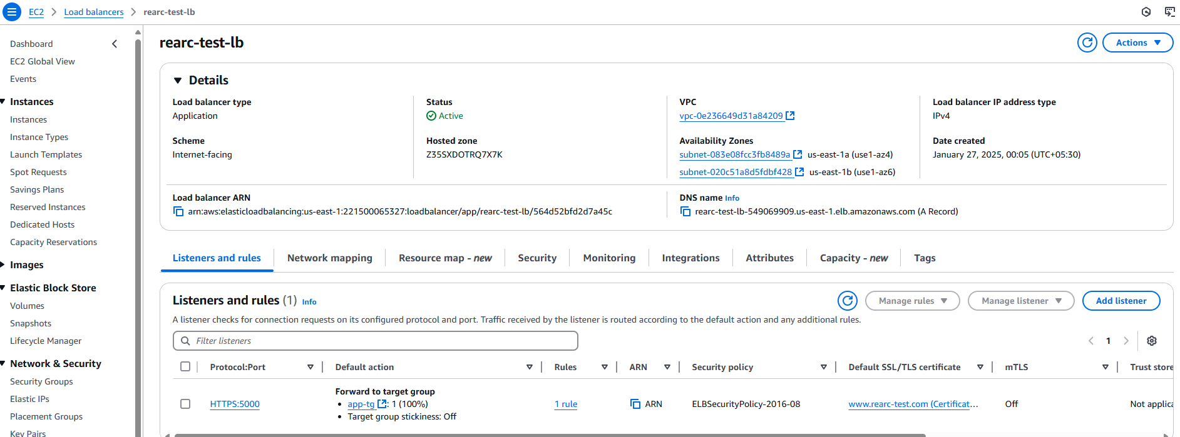

1. Verify the connections
   1. Public cloud & index page (contains the secret word) - <https://rearc-test-lb-549069909.us-east-1.elb.amazonaws.com:5000/>

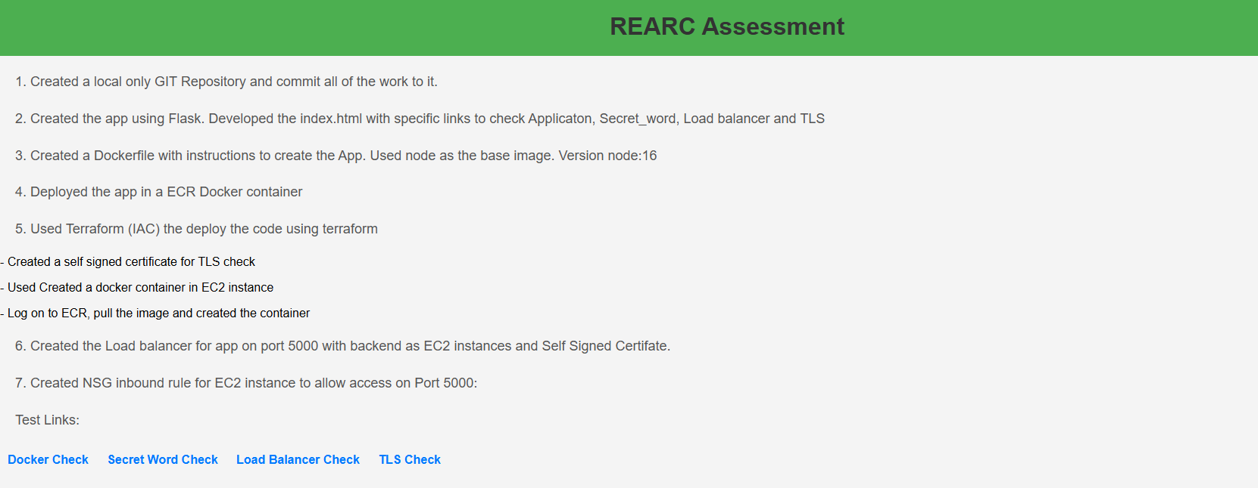

* 1. Docker check - <https://rearc-test-lb-549069909.us-east-1.elb.amazonaws.com:5000/docker>



* 1. Secret Word check - <https://rearc-test-lb-549069909.us-east-1.elb.amazonaws.com:5000/secret_word>

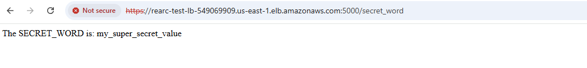

* 1. Load Balancer check - <https://rearc-test-lb-549069909.us-east-1.elb.amazonaws.com:5000/loadbalanced>

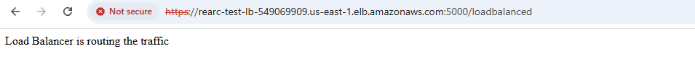

* 1. TLS check - <https://rearc-test-lb-549069909.us-east-1.elb.amazonaws.com:5000/tls>

