Inhoudsopgave

1. Sequence Diagrams 1

1. RestartGame SD 1

2. RestartLevel SD 1

3. QuitGame SD 1

4. EnableChildmode SD 2

5. Game scenario SD 2

2. Class diagrams 3

1. Analysis Class diagram 3

2. Design class diagram 4

3. Use case diagram 4

# Sequence Diagrams

## RestartGame SD

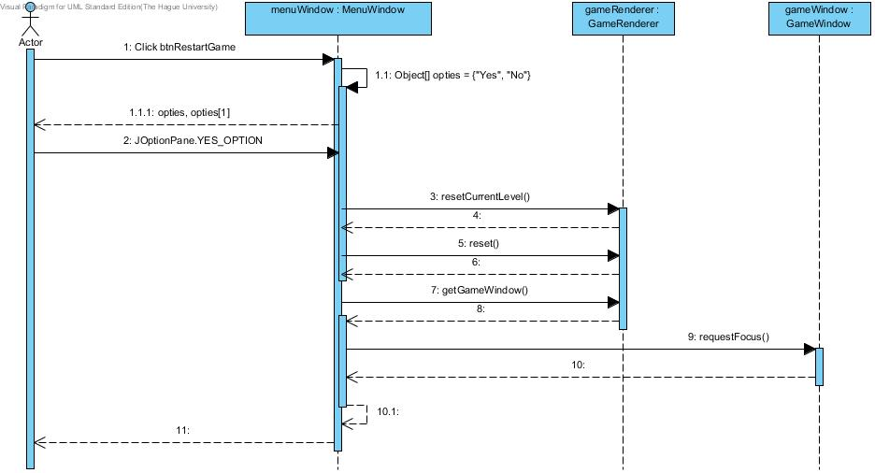

## RestartLevel SD

## QuitGame SD

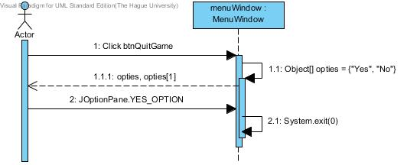

## EnableChildmode SD

## Game scenario SD

# Class diagrams

## Analysis Class diagram

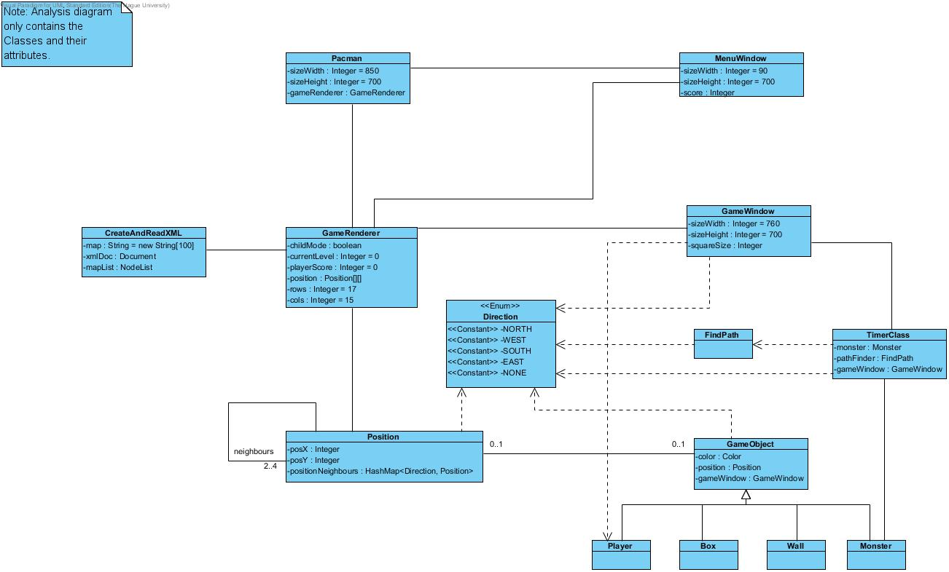

## Design class diagram

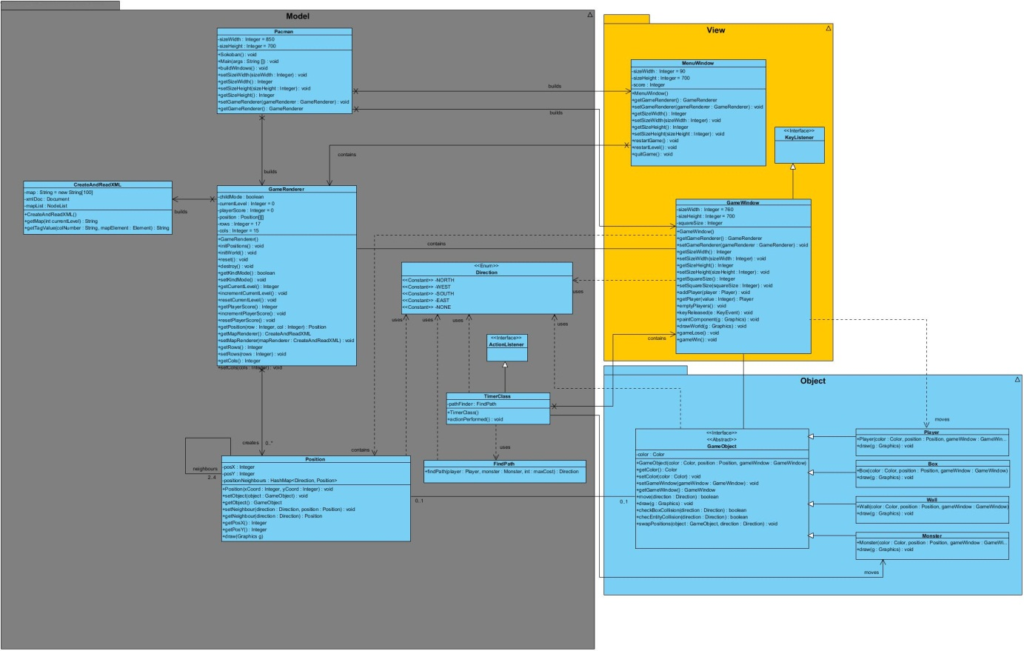

# Use case diagram

