Table of Contents
1. Repository Information
2. Images
3. Schematic
4. Gerbers
5. Bill of Materials
5.1. PCB Parts
5.2. Additional Parts
5.3. Vendor Parts Lists

Repository Information
Name
modular_device_base_3x2
Version
1.2
Author
Peter Polidoro
Email
peterpolidoro@gmail.com
License
Open-Source Hardware
This board is the base of 3x2 format modular devices. It is a breakout board for the microprocessor, with connections for power, communication, and top boards.

Images
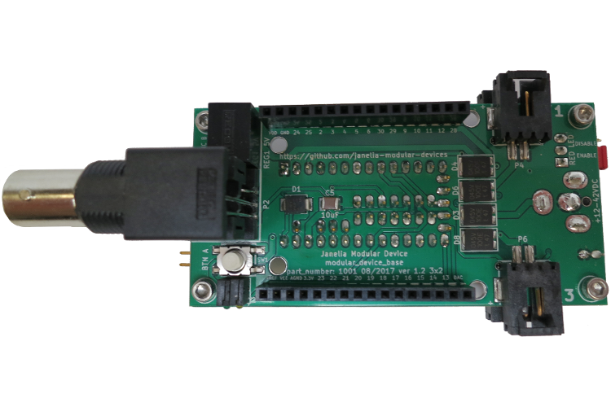
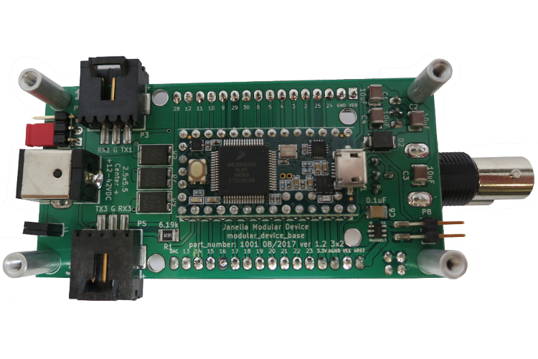

Schematic
./schematic/modular_device_base_3x2.pdf
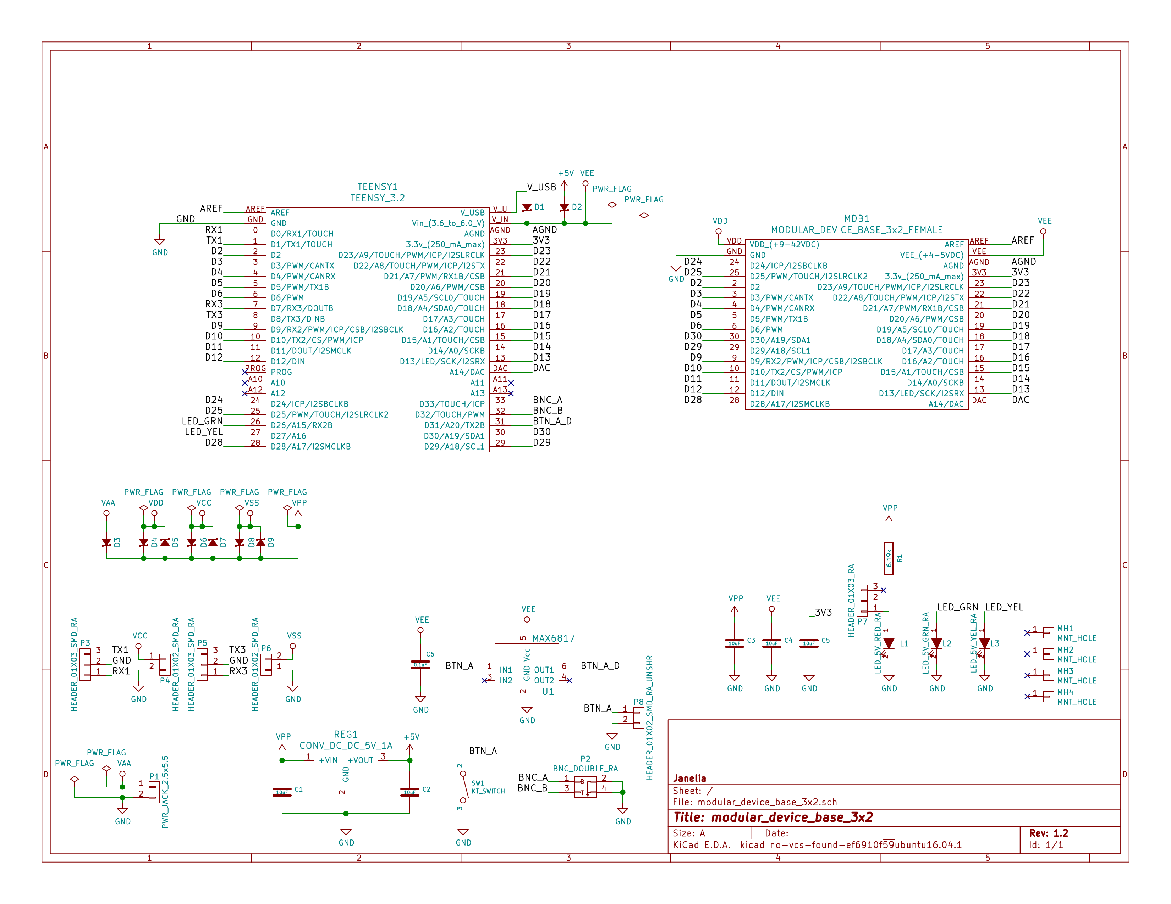

Gerbers
Save gerbers zip file and send to your favorite PCB manufacturer for fabrication.
./gerbers/modular_device_base_3x2_v1.2.zip
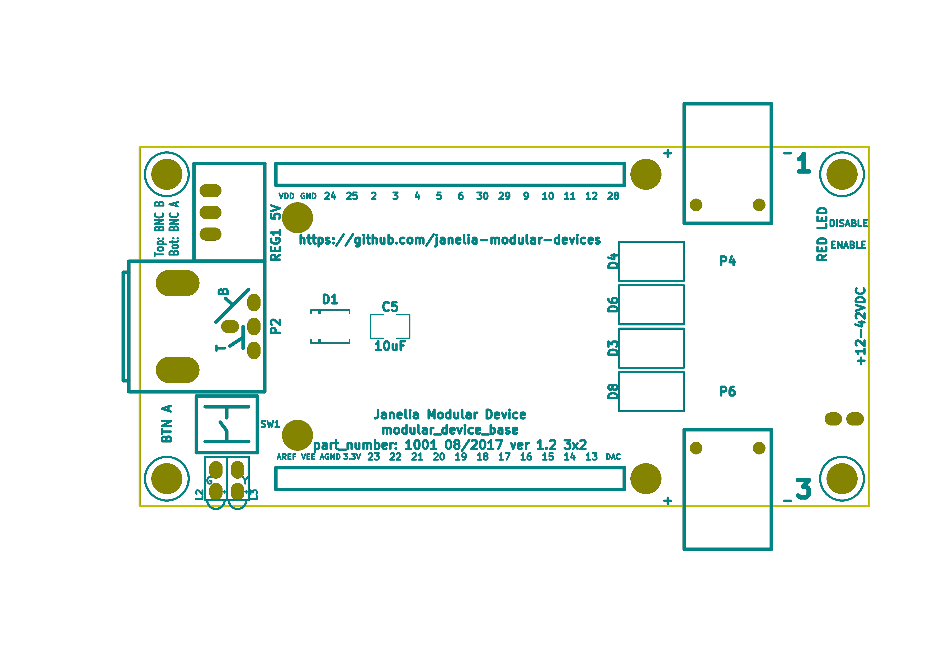
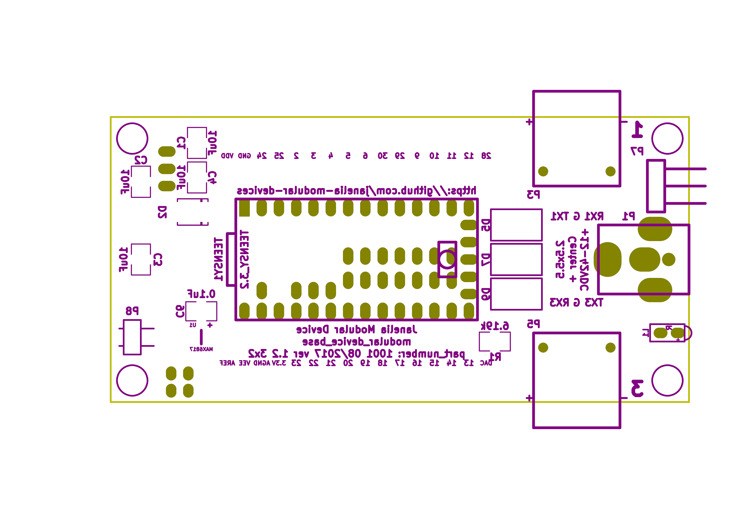

Bill of Materials

PCB Parts
./bom/bom_pcb.csv
Item | Reference(s) | Value | Quantity | Description | PartNumber | Vendor
1 | C1 C2 C3 C4 C5 | 10uF | 5 | CAP CER 10UF 50V 10% X7S 1210 | 445-4536-1-ND | digikey
2 | C6 | 0.1uF | 1 | CAP CER 0.1UF 100V X7R 1210 | 399-13229-1-ND | digikey
3 | D1 D2 | diode_schottky_15V_1A | 2 | DIODE SCHOTTKY 15V 1A DO214BA | LSM115JE3/TR13CT-ND | digikey
4 | D3 D4 D5 D6 D7 D8 D9 | diode_schottky_45V_10A | 7 | DIODE SCHOTTKY 45V 10A CFP15 | 568-11697-1-ND | digikey
5 | L1 | LED_5V_RED_RA | 1 | LED 2MM 5V RT ANGLE RED PCMNT | 350-1712-ND | digikey
6 | L2 | LED_5V_GRN_RA | 1 | LED 2MM 5V RT ANGLE GREEN PCMNT | 350-1717-ND | digikey
7 | L3 | LED_5V_YEL_RA | 1 | LED 2MM 5V RT ANGLE YELLOW PCMNT | 350-1719-ND | digikey
8 | MDB1 | MODULAR_DEVICE_BASE_3x2_FEMALE | 2 | 16 Position Header Through Hole Female Socket | S7049-ND | digikey
9 | MH1 MH2 MH3 MH4 | MNT_HOLE | 4 | Round Standoff Threaded 4-40 Aluminum 0.500in 0.187in | 36-2027-ND | digikey
10 | P1 | PWR_JACK_2.5x5.5 | 1 | CONN PWR JACK DC 2.5X5.5 8A T/H | CP-063BH-ND | digikey
11 | P2 | BNC_DOUBLE_RA | 1 | CONN BNC JACK R/A 75 OHM PCB | ACX1655-ND | digikey
12 | P3 P5 | HEADER_01X03_SMD_RA | 2 | CONN HEADER 3POS R/A SMD GOLD | A100890CT-ND | digikey
13 | P4 P6 | HEADER_01X02_SMD_RA | 2 | CONN HEADER 2POS R/A SMD GOLD | A100903CT-ND | digikey
14 | P7 | HEADER_01X03_RA | 1 | CONN HEADER 3 POS RA 2.54 | 732-5336-ND | digikey
15 | P8 | HEADER_01X02_SMD_RA_UNSHR | 1 | CONN HEADER 2POS .100in SNGL SMD | SAM10781-ND | digikey
16 | R1 | 6.19k | 1 | RES SMD 6.19K OHM 1% 1/2W 1210 | P6.19KAACT-ND | digikey
17 | REG1 | CONV_DC_DC_5V_1A | 1 | CONV DC/DC 1A 5V OUT SIP VERT | 945-1395-5-ND | digikey
18 | SW1 | KT_SWITCH | 1 | SWITCH TACTILE SPST-NO 1VA 32V | CKN1860CT-ND | digikey
19 | TEENSY1 | TEENSY_3.2 | 1 | DEV TEENSY 3.2 13736 | 1568-1231-ND | digikey
20 | U1 | MAX6817 | 1 | IC DEBOUNCER SWITCH DUAL SOT23-6 | MAX6817EUT+TCT-ND | digikey

Additional Parts
./bom/bom_pcb_add.csv
Item | Function | Quantity | Description | PartNumber | Vendor
1 | MODULAR_DEVICE_BASE | 1 | USB 2.0 Cable A Male to Micro B Male 2.00m Shielded | AE10342-ND | digikey
2 | POWER | 1 | AC/DC DESKTOP ADAPTER 24V 90W | 62-1187-ND | digikey
3 | POWER | 1 | 30 WATT DESKTOP POWER SUPPLY 24V | EPS594-ND | digikey
4 | POWER | 1 | CORD 3COND NEMA PLUG 320-C5 | 993-1037-ND | digikey
5 | CONNECTORS | 1 | 14 Positions Header Unshrouded Breakaway Connector 0.100in 2 row SMD | A106625CT-ND | digikey
6 | CONNECTORS | 2 | 24 Positions Header Unshrouded Breakaway Connector 0.100in 1 row Through | S1011EC-24-ND | digikey
7 | CONNECTORS | 1 | CONN JUMPER SHORTING GOLD FLASH | S9001-ND | digikey
8 | CABLE | 1 | CABLE USB-A TO MICRO USB-B 2M | AE10342-ND | digikey

Vendor Parts Lists
./bom/digikey_order.csv
./bom/digikey_order_pcb.csv
./bom/digikey_order_pcb_add.csv

