**3. Data Cleaned:**

* In manufacturing method 1, there was a piece of data that was formatted wrong, it was 26 instead of 0.26
* In manufacturing method 2, there is an outlier which might be formatted wrong, it was 1.50 when 0.15 could fit easier into the dataset (unsure because thickness is also quite high)

**4. What is the difference between measures of central tendency and measures of data dispersion?**

Measures of central tendency uses the dataset to find a middle while measures of data dispersion use central tendency and the dataset to calculate its spread.

**5. Equations**

|  |  |  |  |  |  |  |  |  |  |  |  |  |  |  |  |
| --- | --- | --- | --- | --- | --- | --- | --- | --- | --- | --- | --- | --- | --- | --- | --- |
|  | |  |  | | --- | --- | | Weight | Thickness | | (0.13+0.22+0.22+0.31)/4 | (0.47+0.68+0.71+0.92)/4 | | (0.22+0.22)/2 | (0.68+0.71)/2 | | 0.22 | N/A | | 0.31-0.13 | 0.92-0.47 | | (0.13-0.22)^2+(0.22-0.22)^2+(0.22-0.22)^2+(0.31-0.22)^2 | (0.47-0.70)^2+(0.68-0.70)^2+(0.71-0.70)^2+(0.92-0.70)^2 | | Sqrt(0.02) | Sqrt(0.10) | |

**6. Which type of measurement (measures of central tendency or measures of dispersion) would be better to use to determine which manufacturing method produces the most consistent chips?**

Dispersion will illustrate how far away from the average each chip is, meaning the lower our dispersion the more consistent the chips are. Using measures of dispersion, we can tell which method produces the most consistent chip.

**7. Roast factor histogram**

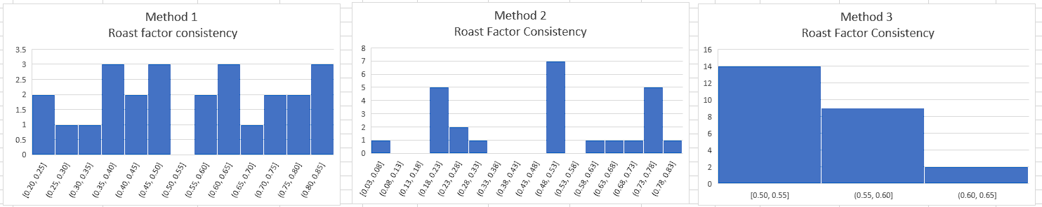

**8. Area whisker plot**

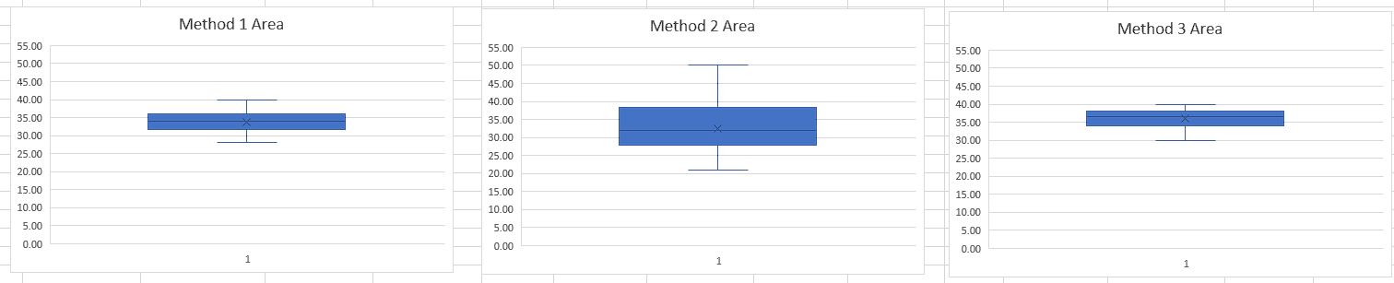

**9. Which manufacturing method should the potato chip company use to make the most consistent chips? Consistent in this case means that the chips are all close in size, weight, thickness, and “roastedness”. Use your mathematical calculations from 6. and your six plots from 7. and 8. to justify your answer.**

**10. Pretend you wanted to be a malicious data analyst. What is one way you could have modified one of the graphs in Project 1 or Project 2 to be misleading?**