Excel-2-Powerpoint Bridge

Generate Powerpoint slides from Excel rows

© 2016 Peter Postmann

This tool can be used to generate Powerpoint slides from Excel data. Each row results in a slide in the presentation.

The following steps show you how to use the tool:

**1. Prepare your data**

Table Header

Each column must have a header field, which indicates the name of the column. Column names must be unique.



ID column

The first row of your data must have a unique key per row



**2. Prepare your slides**

The tool will ask you for a template slide. This slide will be copied and filled with data from your Excel file. You need to prepare your template slide, that the tool know where to put the data.

The data and the slides are matched via the column names. You need to add names to your shapes which match the column names.

To edit the names of your shapes go to the selection pane (“Auswahlbereich):

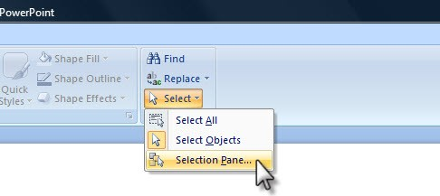

Source: http://files.articulate.com/~davidf/images/SelectionPane.jpg

|  |  |
| --- | --- |
|  | The tool will look for shapes with names which match this pattern: {{<column_name>}}  Add the column names to the corresponding shapes. The data will be insert into those shapes.  Shape names must not be unique: You can add one column name to multiple shapes, if you want the corresponding data to be insert in multiple places.  You must not use all column names. If certain column names are not present, the corresponding data will not be insert in the presentation |

Note: The names are case-sensitive.

**3. Run the tool**

Double to start the tool.



Select the Excel file with your data.

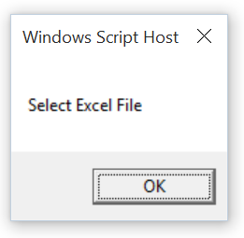

Enter the name of the worksheet where your data is stored. The tool automatically suggests the currently selected worksheet.

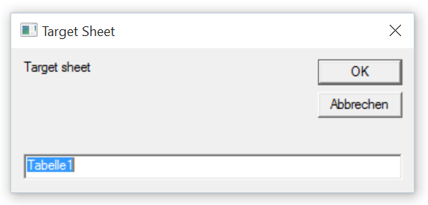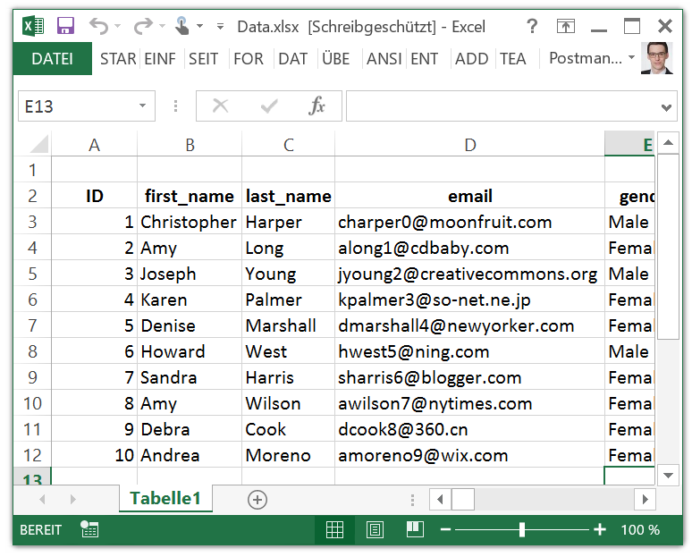

The tool asks for several information which are needed to locate your data.

First column

This is the column which holds a unique identifier for each row.

Key in the number of the column (not the name of the column).

Note: The first column must not be the most left column. There can be an offset. There can also be other columns with data, but the tool will only parse columns which are right from the first column.

First column



Offset

Header row

This is the row which holds the column names

Note: This row must not be the first row in your worksheet.



Header row

First data row

This is the first row with actual values. The tool will parse all subsequent rows until it finds a row were the identifier is an empty cell.

Note: This row must not immediately follow the header row.

Note: Parsing will fail, if the tool finds duplicated identifier.



First data row

Select the Powerpoint file with your template.

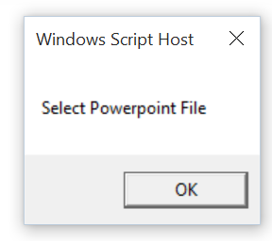

Template slide

Key in the number of the slide which will be used as template for all other slides.

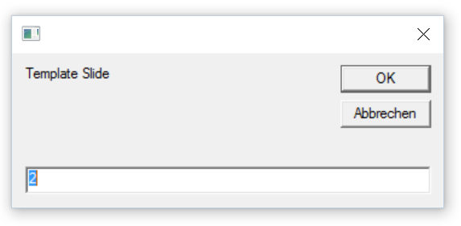

Insert new Slides after

Select the position were new slides shall be placed. The tool will automatically suggest the number of the last slide.

Afterwards the tool will immediately start with the coping process. You can actually observe the process and see the new slides which are insert. Do not interrupt this process.

For your convenience the progress is indicated:



After the tool finished, it asks if you wish to save the job.

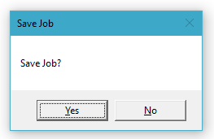

If you select so, the script will generate a batch file which includes all previously provided information.

Note: The name will be <Name-of-Excel-file>.bat

Then it indicates that everything is done.

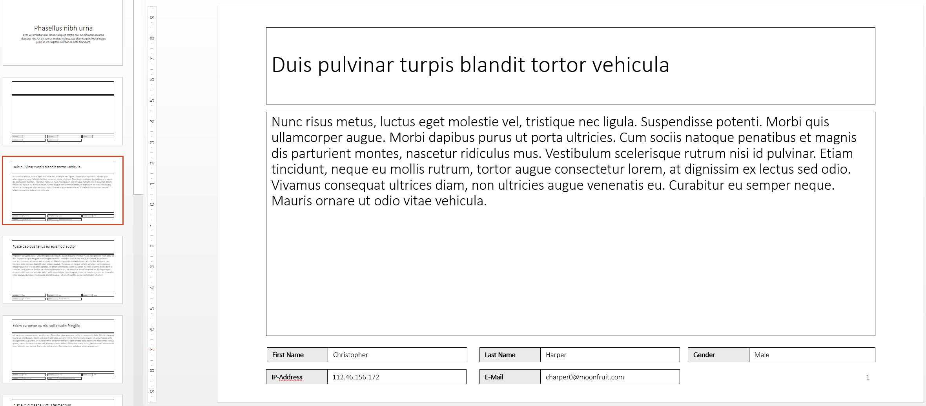

Note: You have to save the presentation manually. You can revert all changes caused by the script, by not saving the presentation.

**4. Re-run the tool (optional)**

If you saved the job you can use the generated batch file to re-run the job.



Note: You can manually re-run the job by re-providing all the information. The result will be the same.

If you re-run the tool, it will scan all slides and check if certain slides already exist. If so, these slides are updated with the information provided in the worksheet.

Note: The tool will not update the style of already existing slides. If you change the template and want this change on all other generated slides, you have to delete and re-generate them.

**Appendix**

**Command line parameters**

The tool can be started with parameters provided via command line. This feature is used by the batch file which is created if you safe a job.

**Known Bugs**

The window size of the progress indicator is not correct if you use DPI scaling.

**Possible improvements**

Decouple the first column and the identifier. Allow the user to select the first column and additionally the column were the unique identifier can be found.

Allow the user to change the name of the batch file.

Create a UI frame which indicates overall progress and not only message boxes for each step.

Enable roll-backs if errors are found. Allow the user to re-enter certain information.