**Streaming Big Data with Storm**

*Peter Prescott (201442927)*

**Introduction**

Storm is a Java program designed to reliably process unbounded streams of data. In this assignment we are required to create a Storm topology that performs a simple sentiment analysis on a stream of tweets relating to the coronavirus vaccine.

**Middleware Configuration**

While Storm can be run as a single local instance, its distributed design is intended to take advantage of a networked cluster of multiple computers. We can simulate this by creating a local standalone cluster.

A Storm program is run by a master *Nimbus* node that delegates tasks to some number of *Supervisor* nodes, which are coordinated by *Zookeeper*. Once this has been successfully set up, we can run the **storm ui** command, which allows us to monitor the status of the cluster in a browser at **localhost:8080** (Figure 1) We can then submit our topology to run on the cluster: **storm jar topology.jar piprescott.Topology**.

To simplify the process of setting up these components, and to keep them separate in isolated containers, I described the necessary configuration in a docker-compose.yml file.

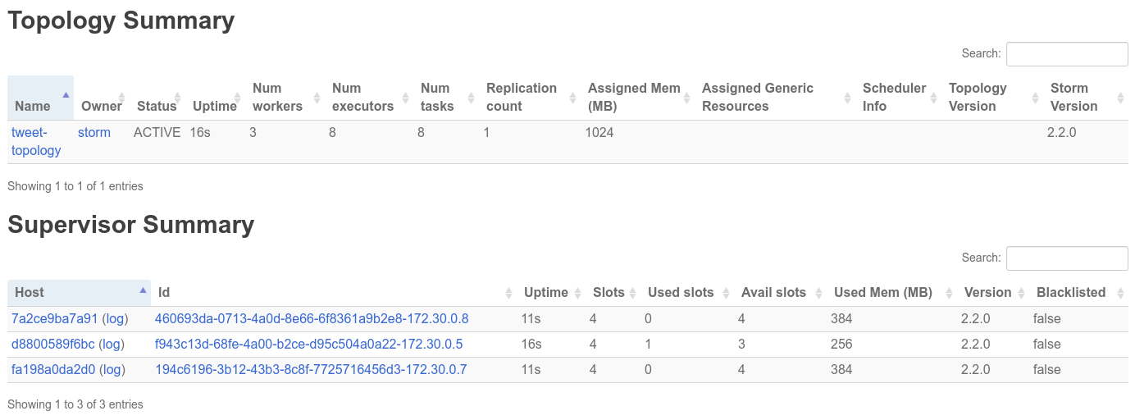  
Figure 1: Storm UI monitoring Topology and Supervisors

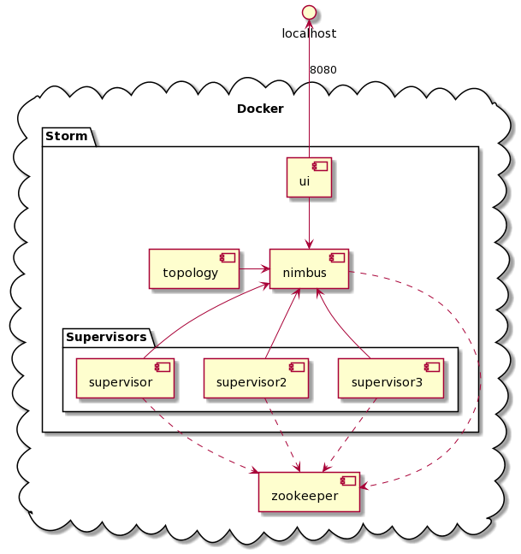  
Figure 2: Dockerized Storm Cluster

The cluster can then be deployed simply by running **docker-compose up**

(see Figure 2).

**Data Analytic Design**

To design our topology, first we define a TwitterSpout class (an extension of Storm’s BaseRichSpout). This establishes a connection to the Twitter API with the necessary developer access keys, using the twitter4j library. It then listens for, and emits a continuous stream of new Twitter status messages related to the coronavirus vaccine. We do this by tracking tweets containing “#COVID19”, ”#COVIDVaccine”, or “Vaccine”.

We then define a FilterBolt class which converts the text of each tweet into a list of lowercase, and then removes any which match a list of common irrelevant words.

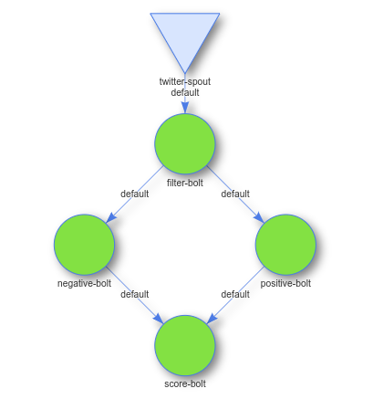Figure 3: Parallelized Storm Topology

We then define a NegativeBolt class which calculates a negativity score for the filtered words, by counting the words which match a specified list of negative words. Similarly our PositiveBolt class does the same, but for a list of positive words. We then define a ScoreBolt class, which classifies each tweet as positive or negative, depending on whether the tweet’s positivity score is greater of less than its negativity score. It then writes the tweet and its classification to a file, and prints the running totals of positive and negative tweets.

We then define our main Topology class, which builds our Storm topology by initiating a new instance of TopologyBuilder(), on which we set the Spout and Bolts that we have defined.

As can be seen in Figure 3, we connect the negative-bolt and positive-bolt in parallel; the rest has to be ordered sequentially. We could further parallelize our topology by creating multiple instances of the bolts, but for the sake of simplicity we have not done this.

**Discussion of Results**

To understand how our sentiment analysis functions, it is worth considering in detail a particular tweet: *“Awful glad vaccine is coming at last! #COVID19”*. Our twitter-spout passes it to the filter-bolt, which converts it to the list {“awful”, “glad”, “vaccine”, “is”, “coming”, “at”, “last”, “covid19”}, and filters out the common words “is” and “at”. Then the filtered list of words is passed in parallel to negative-bolt and positive-bolt, which each give it a score of 1 (for “awful” and “glad” respectively). Our score-bolt then finds that the tweets negativity and positivity scores are equal, so classifies it as neutral. This is clearly incorrect, for “awful glad” is in fact thoroughly positive -- so we must be aware of the limitations of our very simplistic sentiment analysis.

In a quick experiment running the topology, the program classified 22 tweets as positive and 12 as negative -- from a total of 1,150 tweets. Clearly our naive sentiment analysis needs improvement. But as an exercise in applying Storm’s real-time streaming capabilities, we can say it works.

**Conclusions and Recommendations**

In conclusion, we have demonstrated here how to build a simple topology using Storm to analyze the sentiments of a real-time stream of tweets on a subject of immediate relevance.

The obvious recommendation to improve our analysis would be to implement a more sophisticated system of natural language processing to analyze the positive and negative sentiments of a tweet.

We would also be able to analyze more tweets more quickly with greater computational power, and since we have defined our cluster configuration in Docker it should be easily transferable to the cloud.