ABSTRACT
This experiment addresses the decline in photovoltaic (PV) module power generation efficiency under high-temperature conditions by deeply investigating the effects of multiple spray strategies on net power generation benefit and water consumption. As module temperature rises, the photoelectric conversion efficiency decreases significantly; therefore, efficient cooling has become a key issue for improving economic returns. The author constructed a real physical system using STM32 and ESP chips, combined with a sensor array and a water-mist spray system, to implement a complete closed-loop chain of "acquisition–feedback–control." An objective function was established to comprehensively consider the economic benefits of PV module conversion efficiency, spray water consumption, and the power consumption of the spray system circuit. By comparing different strategies in terms of net power generation benefit and objective function indicators, effective conclusions were obtained. The results show that in a low-temperature stable environment, the linear regression model can accurately predict the next-moment PV panel electrical parameters. Under high-temperature conditions, the machine learning model Random Forest achieves the best objective function performance while improving power generation benefits and reducing water consumption. This experiment provides important experimental evidence for optimizing the economic efficiency of PV modules under high-temperature conditions.
Keywords: Photovoltaic modules; Spray cooling; Net power generation benefit; Economic optimization model; Embedded systems

Design of an Automatic Temperature Control System for Solar Photovoltaics
Abstract: This experiment focuses on the pain point of declining power generation efficiency in photovoltaic modules under high-temperature conditions, and conducts an in-depth investigation into the effects of multiple spray strategies on the net power generation benefit and water consumption of photovoltaic panels. As module temperature rises, the photoelectric conversion efficiency decreases significantly; therefore, how to ensure efficient cooling has become an important issue for improving economic returns. To this end, the author constructed a real physical system for experimentation, using STM32 and ESP chips in combination with a sensor array and a water-mist spray system to implement a complete closed-loop chain of “acquisition–feedback–control.” In this experiment, a target function was established to comprehensively consider the economic benefits of photovoltaic module power generation conversion efficiency, spray water consumption, and the power consumption of the spray system circuit. Based on this, by comparing different strategies in terms of net power generation benefit and the quantitative indicators of the target function, effective conclusions were obtained. The experimental results show that, in a low-temperature and stable environment, the linear regression model can accurately predict the electrical parameters of the photovoltaic panel at the next time step. Under high-temperature conditions, the machine learning model Random Forest can achieve the best performance in the target function metric while improving power generation benefits and reducing water consumption. This experiment provides important experimental evidence for optimizing the economic efficiency of photovoltaic modules under high-temperature conditions and has certain engineering application value and reference significance.
Key words: Photovoltaic modules; Spray cooling; Net power generation benefit; Economic optimization model; Embedded systems

1 Introduction
Against the backdrop of addressing global climate change and achieving the "dual carbon" goals, new energy technologies are developing rapidly. In 2025, renewable energy power generation surpassed coal power for the first time, accounting for over one-third of global generation, with solar PV being the core driver of clean energy.
However, PV cells have significant negative temperature coefficient characteristics. When PV modules are exposed to intense sunlight, approximately 80% of the incident solar energy is not converted into electricity but into heat accumulated within the silicon wafer, thereby affecting its physical properties. The open-circuit voltage and short-circuit current of PV cells exhibit an approximately linear negative correlation. For every 10 K increase in temperature, the relative power generation efficiency decreases by about 3.6%, which undoubtedly has a significant negative impact on PV power generation. In addition, if parts of the PV panel are shaded (by bird droppings, leaves, dust, or shadows), the shaded cells operate at low efficiency, increasing impedance and further generating heat.
To solve the above problems, many solutions have been studied to suppress high PV panel temperatures. Current cooling technologies for PV modules include active and passive cooling. Active cooling includes air cooling, liquid cooling, phase-change material cooling (materials absorb/release large amounts of latent heat during melting/solidification), heat pipe cooling (efficient heat transfer through liquid evaporation and condensation cycles inside the heat pipe), and thermoelectric cooler cooling. Based on cost considerations, most regions currently adopt efficient passive cooling with geometric structures (Tahir M.S. et al., 2025).
Passive cooling has its limitations, especially in areas with abundant solar energy. Air cooling has low heat dissipation efficiency, and liquid cooling is too costly. For regions with abundant solar energy and high temperatures (such as South China), active cooling by controlling water valve spray (hereinafter referred to as water mist cooling) is undoubtedly a better choice.
Therefore, this work designed a closed-loop controlled automatic temperature control system for solar modules using water mist spray cooling, aimed at mitigating the negative effects of temperature and dust accumulation during PV module operation. Through appropriate nozzle selection and measurement methods, the performance of the PV module is improved.
In addition, starting from the overall system benefit, this experiment constructs a comprehensive economic benefit model and objective function considering power generation gain, spray system power consumption, and water resource consumption. It compares the performance of different algorithms in real data power prediction and in samples constructed based on real data and physical evolution laws, seeking an approximate optimal solution for the comprehensive economic benefit model.
S. Nižetić, D. Čoko et al. first experimentally demonstrated the feasibility of the water mist cooling method. They placed the PV panel at a specific angle of 17 degrees and attached water mist nozzles at both the front and back for cooling. After multiple experiments, they rigorously demonstrated that water mist cooling effectively improves the net benefit of PV panels (considering pump power consumption) at an average temperature of about 40°C. Single-sided (upper surface) water mist cooling achieved a relative net benefit improvement of 6.0%, and double-sided cooling achieved 7.7%. This undoubtedly demonstrates the feasibility of the water mist cooling method and shows its great potential for improvement (Nižetić, S. et al., 2016). In the thermal environment simulation experiments of Wu Guangxing et al., the feasibility of spray cooling was also demonstrated (Wu Guangxing et al., 2024).
In 2021, a new pulsed spray cooling method was proposed by Amirhosein Hadipour et al. They proposed that under a water mist duty cycle of 0.2, water consumption is only 1/9 of continuous spray, while PV power output increases by 25.9% (continuous spray: 33.3%). This means that considering the pump's own power consumption, the net power generation benefit of pulsed spray cooling is slightly higher than that of continuous spray cooling. However, that article did not use this calculation method but instead used LCOE (Levelized Cost of Electricity) to measure the economics of pulsed water mist, with a unit cost per kWh about 75% lower than continuous spray (Hadipour et al., 2021).
Santiko Wibowo, Zainal Arifin and other scholars focused on the shape of water mist nozzles to study their impact on PV panel efficiency. The experiment used controlled variables and comparative experiments to examine the effects of three different nozzle types—flat spray nozzles, hollow cone nozzles, and solid cone nozzles—on cooling efficiency. Infrared imaging was also used to visually demonstrate the cooling range of different nozzle radii. Through thermal balance equation modeling and data comparison, it was concluded that a 2 mm full cone nozzle configuration has the best cooling performance, which is highly valuable for reference (Wibowo, S. et al., 2024). Ruey-Hung Chen et al. revealed the underlying principle, mentioning in their article that CHF (Critical Heat Flux) is not sensitive to droplet flux size but is sensitive to velocity (Chen, R.-H., 2004). Therefore, theoretically reducing nozzle size can improve water utilization without affecting CHF. However, the experiment needs to additionally consider air evaporation and wind resistance; excessively small droplets have a larger contact surface area with air and evaporate more easily, which can lead to insufficient water reaching the PV panel surface.
Additionally, Miguel A. Martínez et al. proposed that sensors should be placed close to the back of the PV panel to reduce interference from air and rain. Through thermal conduction and multi-point analysis for precise detection, after data processing, the measurement accuracy can approach that of traditional Pt100 systems. This research provides an engineering, economically feasible solution for PV panel-level temperature monitoring, with good reference value (Martínez, M.A., 2014).
These articles focus on optimizing water mist cooling to increase PV power generation, but generally overlook the power consumption of pumps and sensors. For example, Faruk Yesildal et al. in "Optimization of Operational Parameters for Spray-Cooled PV Panels" mentioned that a spray duration of 49.89 seconds with a spray flow rate of 0.0180 m^3/h and other specified parameters allows the solar panel to achieve maximum power generation efficiency (Yesildal, F., 2022), without considering pump power consumption. Similarly, Amirhosein Hadipour did not calculate net power generation benefit.
Generally speaking, in the field of PV temperature control research, only a few scholars such as Nižetić and D.C. Čoko have performed quantitative net benefit calculations when verifying the feasibility of water mist cooling. The current literature still lacks systematic research on how to achieve optimal net benefit under actual conditions, i.e., comprehensive optimization strategies related to water mist parameters, energy consumption, water resources, and power generation gain.

2 System Architecture Design
The system is divided into several parts, including the PV module, spray circuit, core control chip, sensor network, and communication circuit.

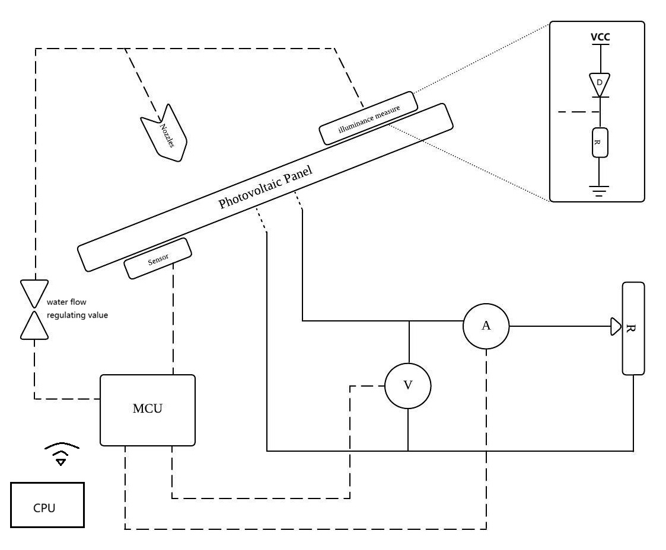
Figure 1 System Architecture Diagram

After the PV panel (photocell) receives photon energy, the output voltage and current are detected by the MCU. The resistor R on the right acts as a load; in practical applications it is replaced by a 12V lead-acid battery to power the entire spray system. The MCU controls the water valve (or pump) for spraying. Based on the research by Santiko Wibowo et al. on optimizing PV performance with different nozzle types, a 2 mm full cone nozzle configuration is adopted. Additionally, a photosensitive sensor circuit (or illuminance meter) is used to measure illuminance. The MCU integrates all sensor information, PV panel power generation information, and time information, and sends data to the host computer. The host computer performs data analysis and algorithm design, while simultaneously transmitting control information back to the MCU for water valve spray control to modify environmental parameters. This complete closed-loop control system can demonstrate in real time the impact of the spray system on PV module power generation parameters, facilitating the decoupling of hardware sensing and software decision-making, and laying the technical foundation for algorithm optimization and the subsequent construction of large-scale, highly intelligent solar module temperature control systems.

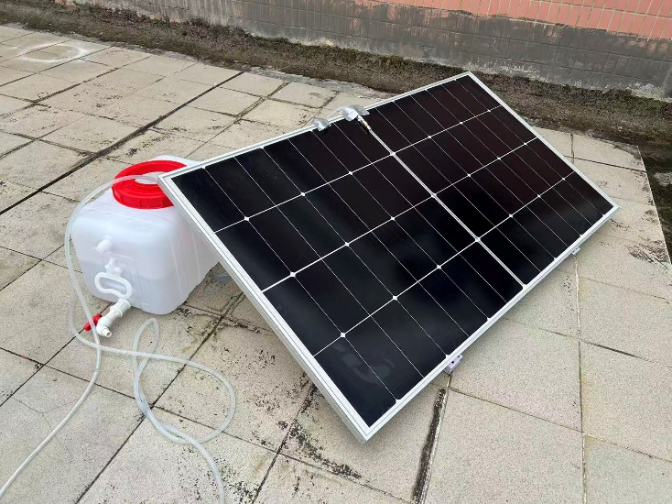
(a) Front view
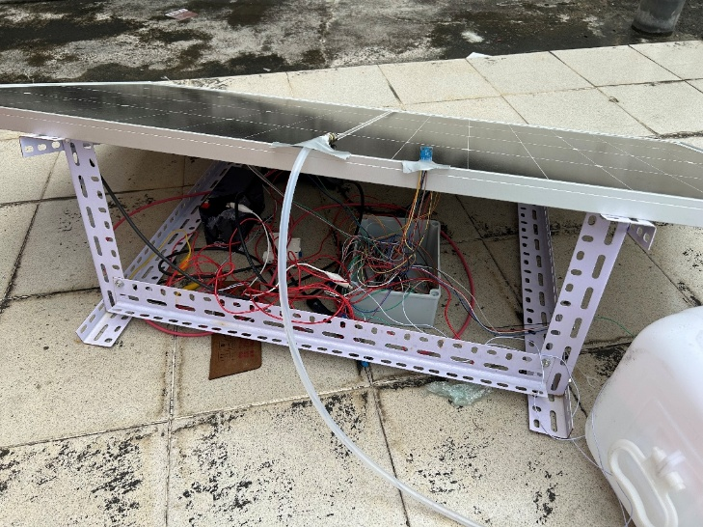
(b) Back view
Figure 2 Physical System
This system strictly follows the three-layer IoT architecture model for construction and design, including the perception layer, network layer, and application layer. Through the collaboration and deep coupling between layers, real-time collection, remote transmission, and intelligent control of data such as temperature and illuminance are achieved, improving system operational efficiency and temperature control accuracy for algorithm optimization. The following sections will introduce each of these three layers in order.

2.1 PV Power Supply Architecture Design

2.1.1 PV Module Selection and Parameters
The design uses a 225W rated monocrystalline silicon high-efficiency PV module as the energy source, with dimensions of 1354mm x 767mm. The module uses industrial-grade MC4 standard connectors, offering very low contact resistance and high protection level, ensuring robust electrical connections in outdoor unstable environments. The output power P_PV is nonlinearly affected by ambient irradiance G and temperature t, characterized by the following formula:
$P_{\left\{pv\right\}}= η⋅A ⋅G ⋅\left.\left[1 - 0.005 \left(T_{c}- 25\right)\right.\right]$(Eq. 1)
Where η is the conversion efficiency and A is the effective light-receiving area.

2.1.2 MPPT Power Tracking Control Unit
To overcome the uncertainty of PV array voltage output and improve power generation utilization efficiency, the experiment uses a Maximum Power Point Tracking (MPPT) device. This device employs a perturb-and-observe core algorithm to dynamically adjust the PWM duty cycle, thereby dynamically locking the peak point of the PV output I-V characteristic curve, ensuring energy capture efficiency above 90% under all weather conditions. At the same time, the unit features three-stage charging management logic (float charge, equalize charge, constant current charge) to achieve efficient energy coupling from the PV source to the bus and to protect the lead-acid battery lifespan.
2.1.3 Safety Isolation and Circuit Protection
The system deploys an air circuit breaker as the core protection component in the energy transmission path. This device features instantaneous short-circuit protection and delayed overload protection. When a transient surge current or short-circuit fault occurs, the circuit breaker can quickly cut off the physical link for electrical isolation, protecting precision temperature control electronic components and the MCU chip from surge damage.

2.2 System Deployment Location and Angle
The experimental system is located at 23°N, 113°E. The annual average horizontal total radiation at this location is approximately 4560 MJ/m^2. It is very close to the Tropic of Cancer, placing high demands on the PV module installation tilt angle and orientation. The calculation of the solar incidence angle on the module uses the following formula:
$cos θ= sin δsin\left(ϕ-β\right)+ cos δcos\left(ϕ-β\right)cos ω$(Eq. 2)
Where: Φ is the local latitude, δ is the solar declination angle, β is the module installation tilt angle, and ω is the hour angle.
From the above formula, at the spring equinox noon, the solar incidence angle on the ground is 23°9'42.1". Designing the PV panel tilt angle between 18° and 21° can achieve the annual radiation peak. Considering summer rainfall self-cleaning needs, component shading protection, and support structure stability, the system selected a deployment tilt angle of 20°, facing due south.

2.3 Perception Layer
2.3.1 Temperature Detection
The system uses the DS18B20 as the temperature detection chip, which offers high measurement accuracy, strong anti-interference capability, and good power control. It uses a single-bus transmission protocol, provides 9-bit to 12-bit Celsius temperature measurement, and has a measurement error of no more than 0.5°C in the -10°C to 85°C range. After careful consideration, five temperature detection chips were selected: four deployed on the back of the PV panel to obtain panel temperature data, and one deployed next to the STM32 chip to monitor MCU temperature. The five chips are simultaneously connected to one GPIO port. After scanning each chip's ROM in the program, polling is used for serial communication to obtain temperature information.

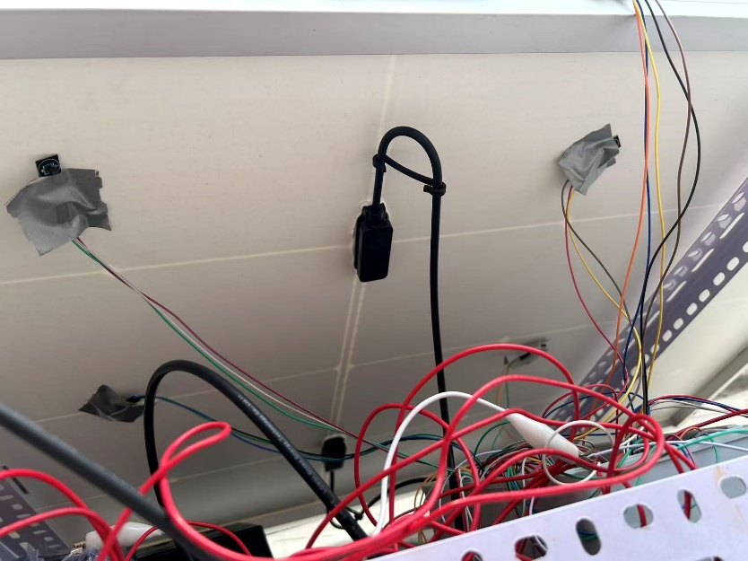
Figure 3 Temperature Sensor Distribution
To accurately obtain the average operating temperature of the PV panel and detect local hot spot effects, the four DS18B20 sensors are arranged in a four-corner symmetrical layout, closely attached to key sampling feature points on the back of the PV panel. This distribution effectively eliminates measurement temperature deviations caused by edge heat dissipation differences. A weighted average algorithm can reduce noise interference to obtain a panel temperature closer to the physical true value. Additionally, this multi-point distribution allows data comparison and timely monitoring of local temperature anomalies on the panel surface, improving the system fault tolerance.
The STM32 and ST7735 generate very little heat, so the temperature sensor next to the MCU can not only detect the controller's ambient temperature to prevent hardware overheating but also serve as the system's environmental reference temperature. Comparing the panel temperature with the ambient temperature difference provides a basis for the spray cooling algorithm.
2.3.2 Illuminance Detection
The system uses the BH1750 illuminance detection chip, which features a wide measurement range, high accuracy, and digital output. This chip uses the I2C transmission protocol, has 60 Hz light noise suppression, and after software calibration the error does not exceed 5%. The MCU sends the chip's slave address and read/write bits, and after receiving an acknowledgment, can perform read/write operations quickly and conveniently.
To assess the module's photoelectric conversion efficiency as accurately as possible, the sensor is deployed in an open area above the PV panel, parallel to the PV panel in the same horizontal plane. The unobstructed arrangement ensures the collected data represents effective total radiation, and the parallel arrangement ensures consistency between the sensor's incident light intensity and the PV panel's light-receiving surface, greatly reducing the cosine effect deviation caused by angle differences.
2.3.3 High-Precision Power Generation Parameter Acquisition
The system uses the INA226 power monitoring chip, which features high-precision current, voltage, and power measurement capability. Its high-precision ADC simultaneously samples the VBUS bus voltage and the voltage across the shunt resistor, directly computing current and power values internally. The chip uses the I2C transmission protocol. The INA226 can detect bus voltages from 0V to 36V and can be powered by 2.7V to 5.5V, ensuring linearity and measurement accuracy under all operating conditions.
The chip connects directly to the PV panel positive terminal through the VBUS port to obtain instantaneous voltage. A low-side detection scheme is adopted, with the IN- port as the current negative common ground and the IN+ port connected to the PV negative terminal for instantaneous current. This configuration enables real-time monitoring of the PV module's power generation status. Compared to traditional analog sampling, this solution uses the I2C digital interface for data transmission, effectively suppressing conducted noise interference on weak signals.
2.3.4 Display Module
A color TFT LCD driven by the ST7735 driver chip is used to display temperature, illumination, and PV panel power parameters in real time. Communication with the MCU uses the SPI protocol. By configuring the MCU's hardware SPI peripherals, the system achieves full-duplex data transmission driven by the SCK clock signal. To ensure display stability, the communication rate is configured at 2.25 Mbit/s.


Figure 4 LCD Display

2.4 Network Layer
2.4.1 Communication Circuit
The system uses the ESP8266 module to communicate with the MCU via the UART interface, establishing a physical link. The CH_PD pin of the module is pulled high through a pull-up resistor to enter working mode. Data sent from the MCU to the ESP8266 module is transparently forwarded to a cloud server node in South China, enabling data upload while also receiving water mist spray control commands returned from the server.
2.4.2 Campus Network Automatic Authentication and Connection Maintenance Strategy
Since the campus network uses a web-based admission control strategy, this study designed an automated login algorithm adapted to the ESP8266 hardware, effectively solving the pain point of embedded devices lacking an interactive interface for internet communication.
2.4.3 Dynamic Message Construction and Authentication
Through Wireshark packet capture, it was found that campus network authentication mainly involves dynamic session parameter extraction and reloading. The interaction logic is divided into three stages:
(1) Network detection and key message capture: The ESP8266 initiates a pseudo-HTTP request (e.g., to 1.1.1.1), triggering a gateway 302 redirect. The query string is extracted from after the <script> keyword.
(2) Protocol encapsulation: To ensure data validity and disguise, the system URL-encodes the extracted parameters, constructs a standardized HTTP message with a custom Content-Type and disguised User-Agent.
(3) The ESP8266's internal encapsulation library automatically converts the application layer data into underlying socket message exchange to complete authentication.

Error
(a) Communication interface
Error
(b) Message content
Figure 5 WireShark Packet Capture

2.4.4 Watchdog and Exception Handling
The system operates on a rooftop with an unstable network environment. Network congestion or DNS resolution failures often cause thread blocking. By enabling the hardware watchdog, a closed-loop feedback path of "monitoring–timeout–restart" is established. If authentication enters an infinite loop or communication times out, the system performs a soft reset and reinitializes the ESP8266 firmware, significantly improving operational continuity in complex electromagnetic environments.
2.4.5 Campus Network Authentication Core Code
url_encode(qs, encoded_qs);
sprintf (body, "userId=YOURUSERID&password=PASSWORD&service=&queryString=%s&operatorPwd=&operatorUserId=&validcode=&passwordEncrypt=false",encoded_qs);
uint16_t body_len=strlen(body);
sprintf (request, "POST /eportal/InterFace.do?method=login HTTP/1.1\r\nHost: 192.168.253.3\r\nConnection: close\r\nContent-Type: application/x-www-form-urlencoded\r\nUser-Agent: Mozilla/5.0 (Windows NT 10.0; Win64; x64) AppleWebKit/537.36 (KHTML, like Gecko) Chrome/146.0.0.0 Safari/537.36 Edg/146.0.0.0\r\nContent-Length: %u\r\n\r\n%s",body_len,body);
2.4.6 Web-Based Monitoring Platform Implementation
The frontend module serves as the system's interaction layer, responsible for data visualization output and control command input.
To dynamically present server status, the frontend builds a responsive monitoring view. The system continuously pulls structured data streams from the backend API using the HTTP GET method, updating the UI in real time via JavaScript. Additionally, a complete state machine switching mechanism is designed. Users can change the system's operating mode in real time through frontend interactive components. When switching to manual mode, the frontend establishes a high-priority command transmission link, directly driving the underlying hardware to perform water mist spray actions via POST/PUT commands.

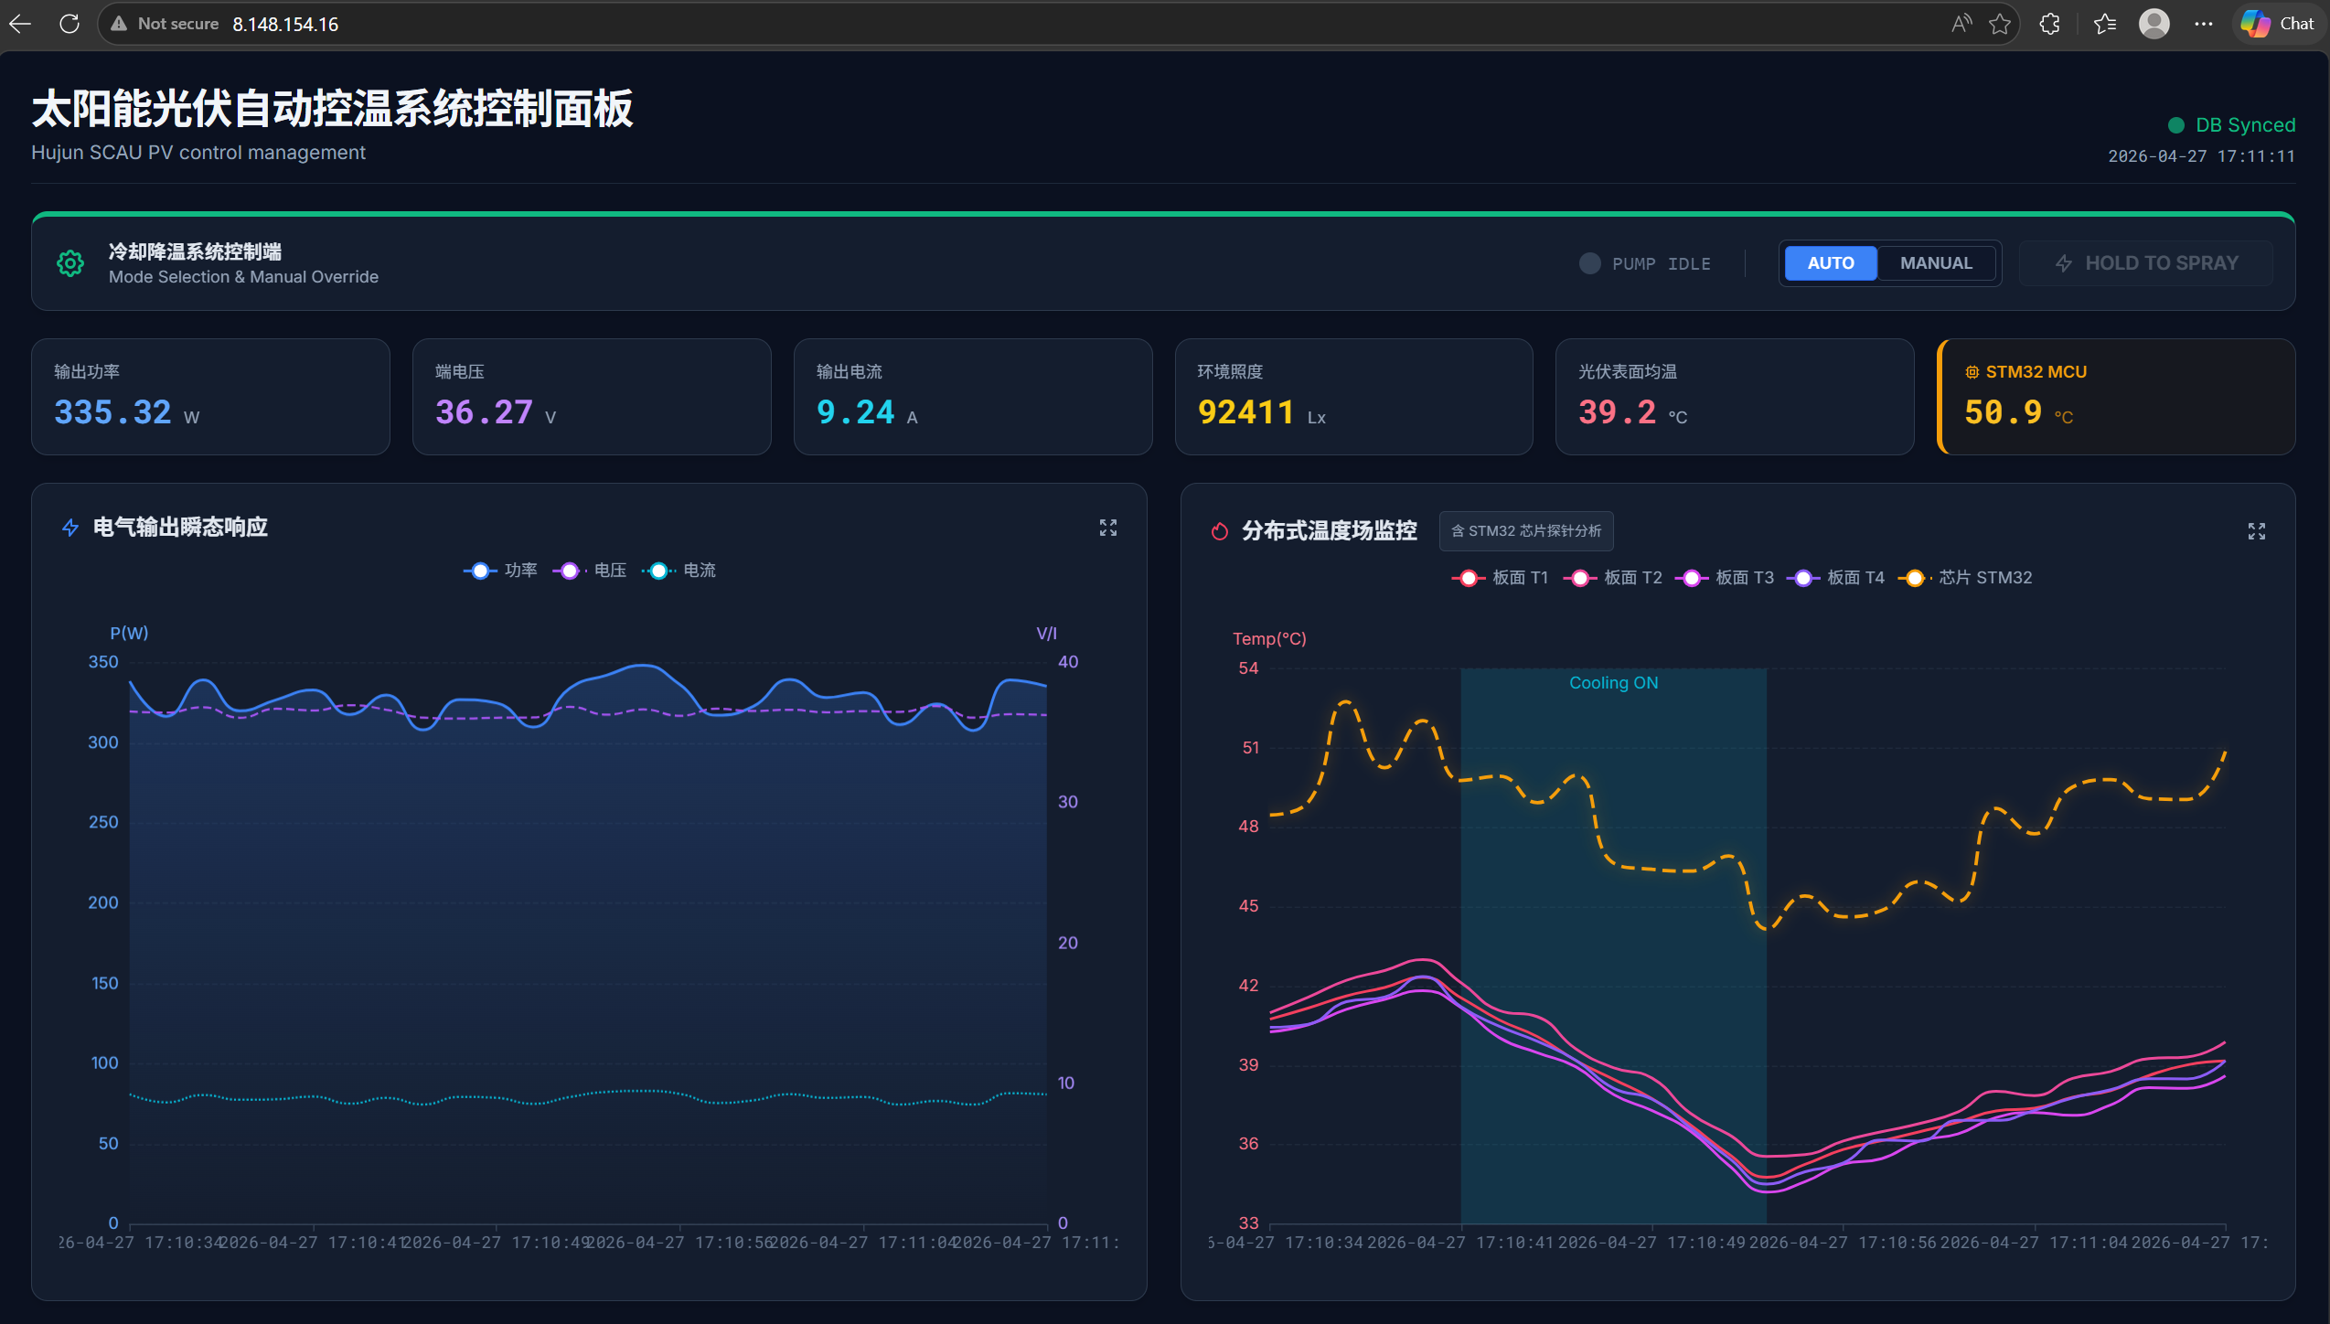
Figure 6 Web Frontend Interface

2.4.7 Backend Service Layer Design and Data Persistence Strategy
The backend layer of this system serves as the data hub and decision core, responsible for heterogeneous data aggregation, logical operations, and command dispatch. Based on the HTTP protocol, the system establishes real-time communication links with the frontend and underlying hardware, achieving comprehensive telemetry of the PV module operating status.
At the data interaction level, the backend receives and processes GET requests from the PV terminal in real time, including four critical node temperatures obtained by the distributed sensor array, the core control chip temperature, ambient illuminance, and real-time power generation performance indicators (such as voltage, current, and power). This multi-dimensional upstream data flow provides the raw basis for evaluating the thermal distribution and photoelectric conversion efficiency of the PV module.
Specifically, after receiving information from the MCU, the backend unpacks the parameters, saves them to the database, and initially tests with a simple temperature control algorithm, which can later be replaced with a more complex algorithm. The parameters are synchronized with the web frontend by changing the global variable ["is_spraying"]. The system then returns the timestamp and control variables.
Additionally, the system introduces the SQLAlchemy framework to build an Object-Relational Mapping (ORM) model for data management, implementing an efficient persistence solution that ensures the consistency and integrity of large-scale time-series data, laying a solid structured data foundation for subsequent statistical model development for PV efficiency prediction, equipment health assessment, and spray strategy optimization.
2.4.8 Asynchronous Communication Ring Buffer and Interrupt Management Design
In the interaction between the microcontroller (STM32) and the IoT RF module (ESP8266), UART serial communication is the core link for data upload and command dispatch. However, there is a significant clock domain gap and speed mismatch between the STM32 CPU instruction cycle and the UART physical layer data transmission cycle.
If a traditional blocking polling mechanism were used, the main controller would waste a large number of CPU clock cycles while waiting for data transmission to complete, greatly reducing the system's responsiveness to other sensors or real-time tasks. To address this, the system introduces a producer-consumer architecture combined with a ring buffer and dynamic interrupt management mechanism at the software communication layer, achieving non-blocking decoupling of the communication link.
A ring buffer is essentially a FIFO queue that stores elements in a fixed-length array, allowing efficient O(1) operations, cache optimization, and low memory overhead. Since ring buffers are limited to arrays and two counters, they are very useful in memory-constrained systems. Many applications (such as cloud-based services) rely on ring buffers to pass work from one thread to another. The rise of multi-core architectures has improved the performance of shared data structures such as ring buffers. Existing research has abandoned the use of locks, allowing these designs to achieve higher scalability and core utilization. This non-blocking design is classified by the level of progress guaranteed, with wait-free being the most desirable classification. This guarantee ensures freedom from deadlock, livelock, and thread starvation.
The ring buffer architecture introduced in this design facilitates "asynchronous" reading and sending of data, avoiding blocking and excessive time consumption. It also effectively saves memory, allowing memory-constrained embedded chips to efficiently transmit high-information-density messages. Specifically, the consumer pointer moves forward by 1 byte each time data is read, while the producer pointer moves forward by 1 byte each time data is written. Only when the data reading speed is far lower than the writing speed does slight blocking occur. This strategy enables the STM32 chip to maintain high-speed network interaction with the ESP8266, achieving more efficient parameter upload and low-latency control of the spray strategy.
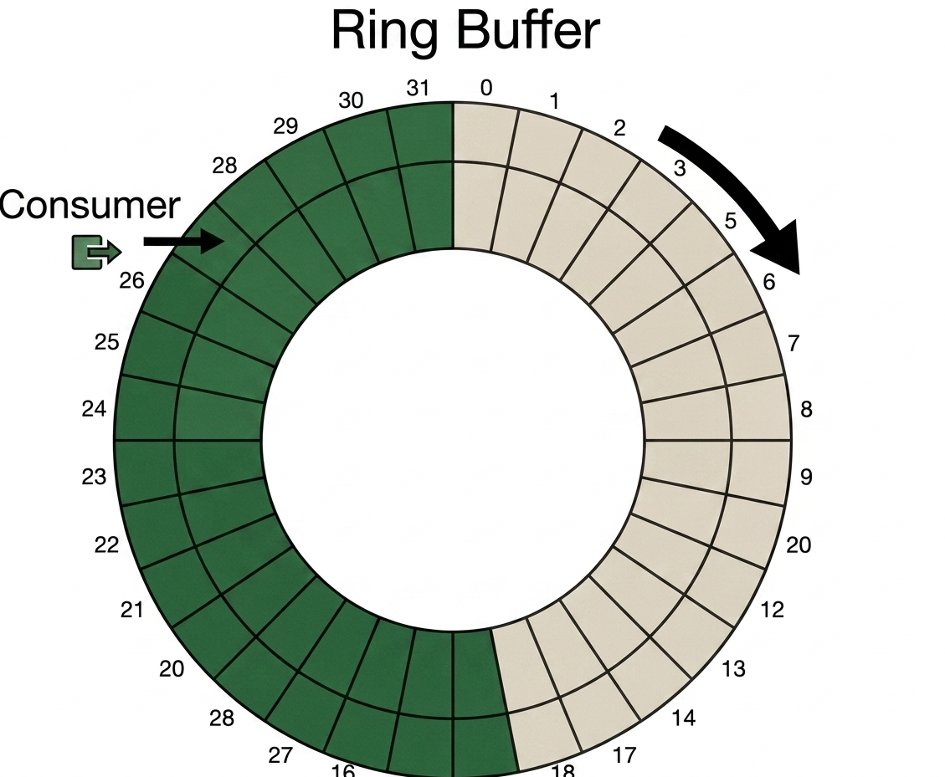
Figure 7 Ring Buffer
Additionally, if the write pointer index coincides with the read pointer index (a so-called "starvation" state), and the system continues to keep the TXE interrupt enabled, the ESP8266 may send interrupt requests to the MCU at an extremely high frequency. To avoid this risk, the program code disables the interrupt when no data is available for reading.
The core code is as follows:
if (((isrflags & USART_SR_TXE) != RESET) && ((cr1its & USART_CR1_TXEIE) != RESET))
{if(tx_buffer.head == tx_buffer.tail)
{
// Buffer empty, so disable interrupts
__HAL_UART_DISABLE_IT(huart, UART_IT_TXE);
}
else
{
// There is more data in the output buffer. Send the next byte
unsigned char c = tx_buffer.buffer[tx_buffer.tail];
tx_buffer.tail = (tx_buffer.tail + 1) % UART_BUFFER_SIZE;
huart->Instance->SR;
huart->Instance->DR = c;
}
return;
}

2.5 Active Spray Cooling System Design
2.5.1 Thermal Management System Architecture and Actuator Module
To suppress the high energy loss caused by temperature rise of PV modules under strong irradiance conditions, the execution layer designs an MCU-based automated active spray subsystem. A 6V micro DC centrifugal pump is used for spray cooling and dust removal, while achieving PV module temperature control through water evaporation heat absorption. This selection is based on the following considerations:
Energy efficiency matching: The pump has low power consumption characteristics, with sufficient head to meet atomization pressure requirements at low power, improving the system's net power generation benefit.
Dynamic response: The actuator uses DC drive with low mechanical inertia, enabling millisecond-level start/stop response for spray logic, ensuring controllability and precision.
2.5.2 Power Drive Topology and Control Logic
The system uses the MCU's GPIO port to send pulse signals to control the actuator. To achieve isolation between low-voltage logic and high-voltage circuits, the circuit uses an N-channel Metal-Oxide-Semiconductor Field-Effect Transistor (NMOS FET) as the control relay. Additionally, a pull-down resistor is connected in parallel between the NMOS gate and source to eliminate floating potential, improving system reliability and electromagnetic compatibility.
2.5.3 Spray Parameter Optimization
The atomization effect of the spray terminal is a key factor determining convective heat transfer efficiency. Based on the empirical research of Santiko Wibowo on PV cooling performance, this system is configured with a 2 mm diameter full cone nozzle. This nozzle specification produces a highly uniform droplet size distribution, ideally forming a complete liquid film on the PV panel's heat-receiving surface, rapidly removing heat accumulated on the module surface. Compared to conventional direct spray, this aperture design effectively improves the Nusselt number, maximizing heat dissipation flux while minimizing water consumption and pump power consumption.

2.6 Bill of Materials
Table 1 Bill of Materials
Device Name | Model/Specification | Key Parameters | Qty | Selection Rationale
Monocrystalline Silicon PV Panel | LONGi LR5-72HTHF 225W | 23.2% Conversion Efficiency | 1 | Stable performance PV module, highly efficient
PV Panel Mounting Bracket | Universal Bracket | 825mm*725mm*325mm | 1 | Structurally stable, secures PV panel
MCU Core Board | STM32 F103C8T6 | ARM Cortex-M3 72 MHz 32-bit RISC | 1 | STMicroelectronics M-series low power chip, rich peripherals, fast response
WiFi Module | ESP8266 ESP-01S | ESP8266EX 80 MHz 32-bit Tensilica L106 | 1 | IEEE 802.11 compliant WiFi module, efficient and stable data transmission
Temperature Sensor Chip | DS18B20 | 5V DC 28mm*12mm*10mm | 5 | Uses UART protocol and built-in ADC for stable temperature reading
Voltage & Power Sensor | INA226 | 0-36V range, 16-bit ADC precision | 1 | High-precision voltage/current measurement; I2C communication, easy data collection  High-precision voltage/current measurement; I2C communication, easy data collection
Lead-Acid Battery | KuaiDun | 12V8AH | 1 | Low cost, high safety, suitable for experiments; provides stable DC power  Low cost, high safety, suitable for experiments; provides stable DC power
Breadboard | MB-102 | 165mm*55mm*10mm | 1 | Convenient for prototyping and debugging
Light Sensor Chip | BH1750 | 3-5V DC, 16-bit ADC | 1 | Digital light intensity sensor; high precision, good stability  Digital light intensity sensor; high precision, good stability
LCD Display | ST7735 | 1.8 inch 128x160 | 1 | Real-time display of temperature, power, system state; improves visualization  Real-time display of temperature, power, system state; improves visualization
Plastic Waterproof Enclosure | AT-200*150*100 | 200*150*100 | 1 | Provides structural fixing and protection; waterproof, dustproof  Provides structural fixing and protection; waterproof, dustproof
16AWG Wire | 16AWG | 26/0.25TS 10m | 1 | Large cross-section, high current capacity; suitable for power supply  Large cross-section, high current capacity; suitable for power supply
24AWG Wire | 24AWG | 11/0.14TS 10m | 1 | Mainly for sensor and control signal connections
PWM Electronic Control Switch | NMOS FET | DC 5-36V -40℃-85℃ | 1 | Supports speed control; drives pump  Supports speed control; drives pump
Water Tank | 25L | 25L | 1 | Moderate capacity, meets long experiment needs; convenient independent water supply  Moderate capacity, meets long experiment needs; convenient independent water supply
Water Pump | JT-DC3W-3 | 3V 0.12A 0.36W | 1 | Small size, low power, suitable for spray cooling; fast response control  Small size, low power, suitable for spray cooling; fast response control
Hose | Silicone Tube | 6mm ID, 9mm OD, 5m | 1 | Ensures sealing and flow stability
Barb Fitting / Straight Connector / Cone Nozzle | 304 SS / ZG Thread / Full Cone | DN6-6mm / 1/8" Straight / 2mm | 1 | Spray terminal; builds complete spray circuit  Spray terminal; builds complete spray circuit
Cable Ties / Tape | Nylon / 3M DT8 | 3.6mm*20cm/48mm*25m | 1 | Cable management and fixing / Module fixing and insulation
Dupont Wires | Youxin | 40cm / Full Series | 1 | Signal transmission with breadboard
KF301 Terminal Block | KF301 | -5.0/3P | 6 | Connects Dupont wires to electronic wires
Buck Converter Module | LM2596S | DC-DC 3.2V-40V | 2 | Steps down to 5V and 3.3V for MCU and sensor network
Large Alligator Clip Leads | 4.5cm | 4.5cm | 1 | Used during debugging phase
DC Circuit Breaker | CHCYZO | 12V-125V | 1 | Power switch
Cloud Server | AliCloud | ECS KVM | 1 | Host computer; enables remote data upload and monitoring  Host computer; enables remote data upload and monitoring

3 Algorithms and Data

3.1 Objective Function and Parameter Definition
The purpose of this experiment is to build a high-precision PV system net benefit prediction model through real data collection and feedback. The physical model of net power generation benefit is given by the following formula:
$PPV_{gains}= PPV - P_{pump}- P_{others}$(Eq. 3)
Where: P_PV is the PV module conversion power, P_pump is the spray cooling system power consumption, and P_others covers the steady-state and transient power consumption of the STM32 microcontroller, sensor network, ESP8266 communication module, and other peripheral circuits.
To achieve comprehensive system benefit improvement, the objective function J is set as:
$J = PPV - λ_{1}\left(P_{pump}+ P_{others}\right)- λ_{2}C_{water}$(Eq. 4)
Where: λ_1 = 1, λ_2 = 0.1, and C_water represents the water flow rate per unit time.

3.2 Dataset Characterization and Analysis
This experiment collected a multi-dimensional time-series dataset containing environmental parameters and system states. The data originates from spring in the South China region. After removing outliers, the total valid sample size is 657 observations, basically covering a complete light cycle. As shown in the figure, the feature space includes four PV panel backside temperatures (t1–t4), ambient irradiance, system working voltage, module conversion power, operating current, and chip temperature parameters. Time-domain analysis shows a significant nonlinear coupling between irradiance and temperature, requiring high generalization ability from the models.
Outlier exclusion criteria: module conversion power P_PV > 250 W, PV panel backside temperature weighted average avg_temp > 50°C. The experiment was developed on Python 3.13.13, using NumPy (2.4.4) and Pandas (3.0.2) for data processing and analysis, and scikit-learn (1.8.0) and XGBoost (3.2.0) for model building. All models were trained on an Intel i7-12700H CPU.
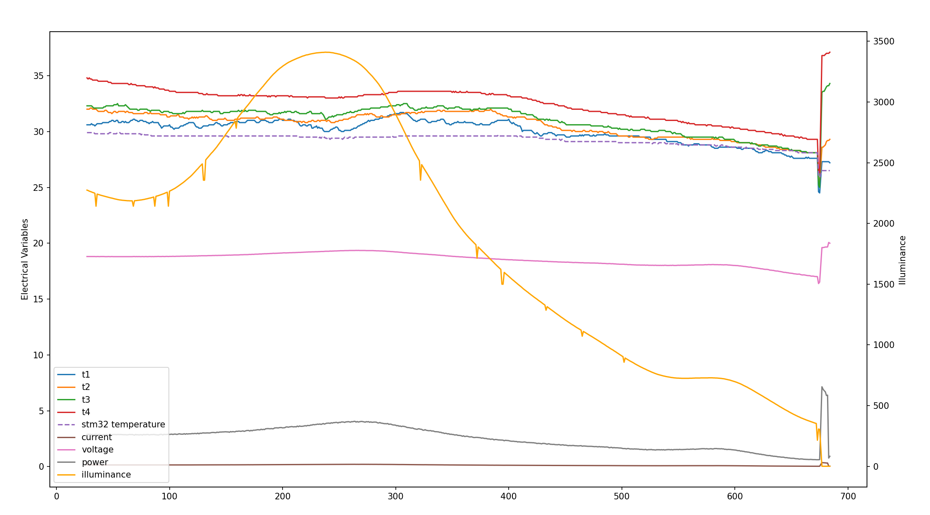
Figure 8 Original Data Distribution

3.3 Experimental Design Approach
To achieve the approximate maximum of the objective function J, this study proposes a strategy evaluation framework based on a "prediction–decision" mechanism. The specific method is: first, drive the model to predict the power generation at time t+1 or extreme environment power generation at different time periods. Then, compare the quantitative indicators of the net power generation benefit after spray selection to choose the optimal strategy. In this study, three comparative model experiments are planned: short-term prediction experiments with time series to characterize the model's predictive ability in relatively stable time periods and fixed locations; time-independent extreme environment prediction experiments to characterize the model's generalization ability and prediction accuracy on multi-span distribution low-dimensional data; and extreme environment spray strategy comparison experiments to characterize the model's spray strategy selection and resulting net benefit and objective function results on multi-span distribution data. Finally, by comparing the approximation effect of different models and strategies on the objective function and the net benefit differences, the advantages and disadvantages of different algorithms are analyzed.

3.4 Algorithm Selection
To investigate the performance of machine learning models of different complexity on small-sample high-dimensional datasets, this study adopts the following algorithms for comparative modeling:
(1) Multiple Linear Regression (MLR):
As a baseline model, it can well evaluate the Pearson correlation coefficient between targets and features.
(2) Random Forest: Using Bagging strategy, it builds multiple decision trees for voting and averaging, effectively capturing nonlinearity between features, providing high prediction robustness.
（3） XGBoost（Extreme Gradient Boosting）：
An efficient and popular gradient optimization algorithm. It performs a second-order Taylor expansion of the objective function while introducing regularization terms to prevent overfitting. It has strong convergence ability and prediction accuracy in regression tasks with large fluctuations.
(4) Temperature Threshold Control:
Simple logical judgment to trigger spray response when the temperature exceeds a threshold.

3.5 Short-Term Prediction Experiment

Table 2 Voltage Prediction Results at t+1
Model (V) | MAE | RMSE | R2 Score
Linear Regression | 0.0513 | 0.2742 | 0.8016
Random Forest | 0.3728 | 0.5367 | 0.2403
XGBoost | 0.3686 | 0.5287 | 0.2626

Table 3 Power Prediction Results at t+1
Model (W) | MAE | RMSE | R2 Score
Linear Regression | 0.1193 | 0.7336 | 0.6326
Random Forest | 0.5428 | 0.9660 | 0.3629
XGBoost | 0.5560 | 0.9969 | 0.3214
Where Random Forest settings: n_estimators = 100, max_depth = 10, n_jobs = -1, random_state = 42; XGBoost settings: n_estimators = 100, learning_rate = 0.1, max_depth = 6, random_state = 42, test_size = 0.2
The experimental results show that in the short-term prediction tasks for voltage and power, all models exhibit high consistency. Linear regression performed best in both tasks, especially in the voltage prediction task where R2 reached 0.8016, significantly higher than the ensemble learning models. This result indicates that under short-period high-dimensional small-sample data conditions, the voltage and power fluctuations at time t+1 have a strong linear dependence on the preceding features. The linear regression model shows stronger robustness and generalization ability when handling such tasks. The ensemble learning models exhibit severe overfitting in this prediction, as they are more susceptible to noise interference in sparse samples. Comparing the two tables, the prediction accuracy of all models for voltage is generally higher than for power, indicating that the voltage series is more stable, while power is more susceptible to fluctuation interference from higher-order load circuits.

3.6 Sample Distribution Optimization and Feature Decoupling
Given that the original sample set has severe "meteorological pattern singularity" and low temporal span, only focusing on the spring South China region makes it difficult to reflect the evolution patterns of PV power generation under all climate scenarios. Therefore, data augmentation methods are adopted to enhance algorithm generalization and universality. Specifically, Gaussian random noise with an expectation of 288.15 K and standard deviation of 274.15 K is injected into multiple temperature features in the tensor space of the dataset, constructing samples for different new environments, thereby counteracting the specialization caused by a single environmental variable. Furthermore, the injection of noise terms automatically significantly reduces the mutual information correlation between the time dimension and the target features, so time dimension features should be discarded. On the other hand, discarding time dimension features achieves decoupling of physical features from time labels, transforming the algorithm from simple "time-series fitting" to "environmental parameter–power" extraction. This processing ensures that the model has cross-regional and cross-temporal transfer prediction capability when facing PV modules of the same standard configuration.
While applying random perturbations to temperature features, this study introduces the power-temperature coefficient formula for PV cells to enhance algorithm performance (Fabiano Perin Gasparin et al., 2022):
$TC=\left(\frac{1}{Z}\right)\left(\frac{∂Z}{∂T}\right)$(Eq. 4)
Based on the PV module physical degradation characteristics expressed by this formula, strict linear compensation constraints are set: for every 1°C increase in ambient temperature, the corresponding output power/voltage is adjusted by a 0.4% attenuation coefficient. This strategy ensures that the generated samples strictly follow the semiconductor physics laws of PV conversion. The deterministic relationship between temperature fluctuations and energy loss enables the model to capture the implicit physical degradation mechanism, improving prediction accuracy while endowing the algorithm with logical rigor and high confidence.
The data distribution after decoupling is shown below:

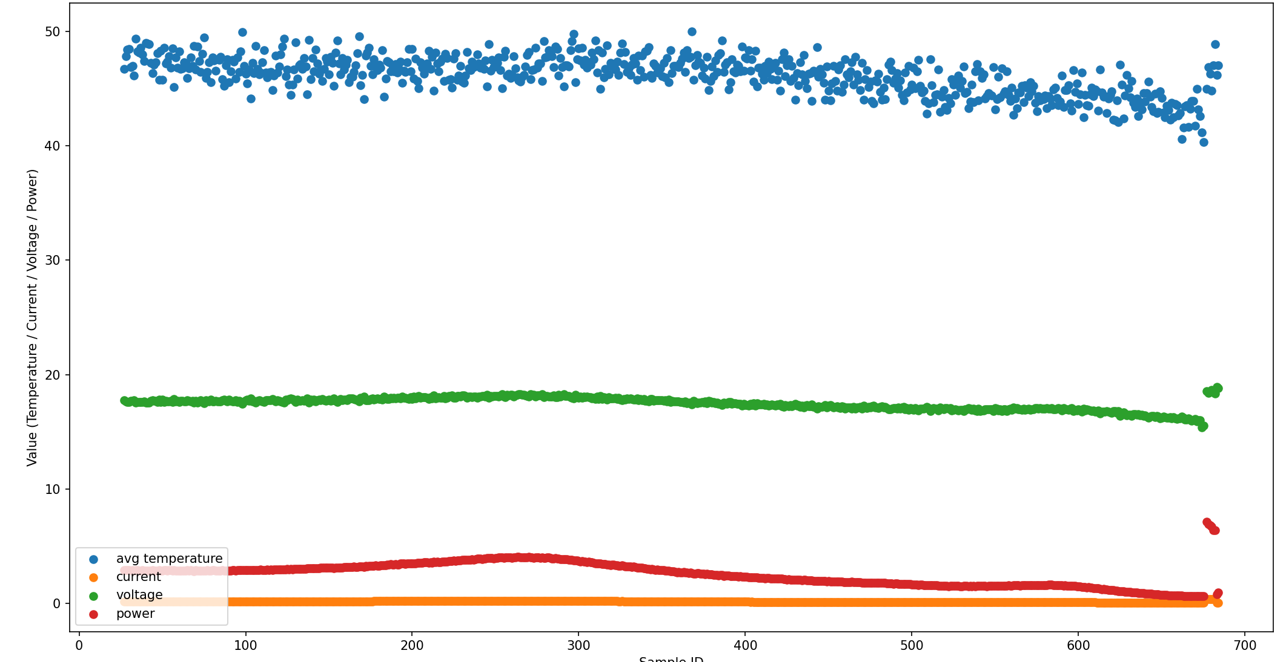
Figure 9 Decoupled Data Distribution

Where avg temperature represents the weighted average of the four distributed temperature parameters.

3.7 Multi-Distribution Parameter Environment Prediction Experiment
Based on the feature-decoupled data, the experimental results are as follows:
Table 4 Voltage Prediction Results
Model (V) | MAE | RMSE | R2 Score
Linear Regression | 0.1209 | 0.1628 | 0.9098
Random Forest | 0.0484 | 0.0691 | 0.9838
XGBoost | 0.0518 | 0.0931 | 0.9725

Table 5 Power Prediction Results
Model (W) | MAE | RMSE | R2 Score
Linear Regression | 0.1387 | 0.1725 | 0.9634
Random Forest | 0.0692 | 0.1201 | 0.9823
XGBoost | 0.0983 | 0.3397 | 0.8580

Where Random Forest settings: n_estimators = 100, max_depth = 10, n_jobs = -1, random_state = 42; XGBoost settings: n_estimators = 100, learning_rate = 0.1, max_depth = 6, random_state = 42, test_size = 0.2
The experimental results show that for the decoupled multi-span distribution data, the ensemble learning models can effectively capture nonlinear information between features, enabling more efficient strategies under extreme weather conditions. In the above two tasks, the Random Forest model performed best, with R2 reaching over 0.98 in both cases, undoubtedly indicating that it has better robustness and generalization ability when handling non-time-related multi-span samples. In comparison, XGBoost is more susceptible to interference from sparse data and environmental noise in such tasks.

3.8 Spray Strategy Performance of Models on Multi-Span Distribution Data
For the short-term real data, the experiment time/location was spring/South China, which has severe "meteorological pattern singularity." In the cloudy time domain, the peak electrical power is about 5 W. A 1°C temperature increase results in a maximum power loss of 0.02 W, while the pump power is about 0.36 W. Conservatively estimating, spraying for two seconds to cool by 3°C. After data modeling, it is clear that not opening the pump valve is the optimal solution for maximizing net benefit.
Analyzing the change in net power generation benefit, combined with the above formula, the following formula can be derived:
$ΔPPV_{gains}= PPV αΔT - P_{pump}$(Eq. 5)
Where: α represents the power temperature coefficient, and ΔT represents the temperature difference.
Therefore, to explore the algorithm strategy performance under high-temperature environmental parameters, modeling was performed on multi-span distribution data with the following results:

Table 6 Algorithm Performance Comparison
 | 0℃ (Threshold) | 48℃(Threshold) | Linear Regression | Random Forest | XGBoost
Trigger num | 196 | 22 | 0 | 108 | 116
ΔE(Ws) | 142.99 | 16.61 | 0.00 | 79.61 | 84.61
Epump(Ws) | 141.12 | 15.84 | 0.00 | 77.76 | 83.52
ΔEPV_gains(Ws) | 1.87 | 0.77 | 0.00 | 1.85 | 1.09
Δt*J(Ws) | 0.999 | 0.673 | 0.000 | 1.37 | 0.575
Where: Trigger num represents the number of pump activations, ΔE represents the total energy gain of the PV module during pump activation periods, Epump represents the total pump power consumption, ΔEPV_gains represents the net benefit change, T°C (Threshold) represents the temperature threshold strategy, and Δt represents the entire experimental period.
Where Random Forest settings: n_estimators = 100, max_depth = 10, n_jobs = -1, random_state = 42; XGBoost settings: n_estimators = 100, learning_rate = 0.1, max_depth = 6, random_state = 42, test_size = 0.3

4 Conclusion and Outlook
The above results show that in a short-term stable experimental environment, the conservative linear regression strategy performs well because it is insensitive to small environmental disturbances. In contrast, the ensemble models tend to overfit and perform poorly.
In the multi-distribution parameter environment prediction task, the threshold temperature control strategy can achieve the maximum net power generation benefit, but it also exhibits excessive intervention, reflecting a lack of refined trade-off between cooling and water consumption in complex unstable environments. In comparison, the Random Forest model selectively sprays data, effectively avoiding unnecessary energy consumption while having a net benefit change only 0.02 Ws different from full-time spraying. This is mainly attributed to its ability to capture the nonlinear physical relationship between power generation and environmental parameters while resisting environmental noise, thereby achieving more efficient control efficiency and maximizing the objective function. Additionally, unlike short-term power generation prediction, the linear model becomes conservative in this complex task. This is because its simple linear regression cannot accurately judge the physical mapping between environmental parameters and power generation, leading to predicted net power generation benefits after spraying being generally lower than non-spraying benefits, resulting in zero spray activations.
This experiment is based on a solar PV automatic temperature control system and water mist spray cooling. By constructing an objective function, it explores the optimal spray control strategy that balances power generation gain, spray system energy consumption, and water resource consumption to achieve maximum economic benefit. In low-temperature stable environments, the linear regression model can well predict the t+1 moment PV panel electrical parameters. In high-temperature environments, compared to traditional methods, the machine learning model Random Forest can improve power generation benefits while reducing water consumption, demonstrating good control strategy and engineering value potential, providing a reference for large-scale PV module spray control strategies in practice. Although this experiment conducted scientific method comparison of model performance and drew rigorous conclusions, due to cost constraints, the samples were constructed based on real data and physical evolution laws, and full-environment field sampling was not achieved. In the future, efforts will be made to build multi-distribution PV module temperature control clusters, add spray angle control, and combine reinforcement learning and closed-loop control strategies for further research to further improve the objective function and increase experimental confidence and engineering application value.

References
Becquerel, E. (1839). Mémoire sur les effets électriques produits sous l’influence des rayons solaires. Comptes Rendus de l’Académie des Sciences, 9, 561–567. Retrieved from https://gallica.bnf.fr/ark:/12148/bpt6k2968p/f561.chemindefer
Al-Ezzi, A. S., & Ansari, M. N. M. (2022). Photovoltaic Solar Cells: A Review. Applied System Innovation, 5(4), 67. https://doi.org/10.3390/asi5040067
Singh, P., Singh, S. N., Lal, M., & Husain, M. (2008). Temperature dependence of I–V characteristics and performance parameters of silicon solar cell. Solar Energy Materials and Solar Cells, 92(12), 1611–1616. https://doi.org/10.1016/j.solmat.2008.07.010
Tahir, M. S., Dong, X., Khan, M. M., & Rehman, I. U. (2025). Thermal management of photovoltaic systems: A comprehensive review of cooling strategies. Solar Energy, 299, 113811. https://doi.org/10.1016/j.solener.2025.113811
Nižetić, S., Čoko, D., Yadav, A., & Grubišić-Čabo, F. (2016). Water spray cooling technique applied on a photovoltaic panel: The performance response. Energy Conversion and Management, 108, 287–296. https://doi.org/10.1016/j.enconman.2015.10.079
吴光星, 易春龙 & 吴争光. (2024). 光伏板下喷雾降温的热环境模拟. 水电与新能源, 38 (02), 25-28. https://doi.org/10.13622/j.cnki.cn42-1800/tv.1671-3354.2024.02.007.
Hadipour, A., Rajabi Zargarabadi, M., & Rashidi, S. (2021). An efficient pulsed-spray water cooling system for photovoltaic panels: Experimental study and cost analysis. Renewable Energy, 164, 867–875. https://doi.org/10.1016/j.renene.2020.09.021
Wibowo, S., Arifin, Z., Rachmanto, R. A., Himawanto, D. A., & Prasetyo, S. D. (2024). Optimization of photovoltaic performance using a water spray cooling system with different nozzle types. International Journal of Computational Methods and Experimental Measurements, 12(1), 9–19. https://doi.org/10.18280/ijcmem.120102
Chen, R.-H., Chow, L. C., & Navedo, J. E. (2004). Optimal spray characteristics in water spray cooling. International Journal of Heat and Mass Transfer, 47(23), 5095–5099. https://doi.org/10.1016/j.ijheatmasstransfer.2004.05.033
Martínez, M. A., Andújar, J. M., & Enrique, J. M. (2014). Temperature Measurement in PV Facilities on a Per-Panel Scale. Sensors, 14(8), 13308-13323. https://doi.org/10.3390/s140813308
Yesildal, F., Ozakin, A. N., & Yakut, K. (2022). Optimization of operational parameters for a photovoltaic panel cooled by spray cooling. Engineering Science and Technology, an International Journal, 25, 100983. https://doi.org/10.1016/j.jestch.2021.04.002
Gasparin, F. P., Kipper, F. D., Oliveira, F. S. and Krenzinger, A. (2022) ‘Assessment on the variation of temperature coefficients of photovoltaic modules with solar irradiance’, Solar Energy, 244, pp. 126–133. doi: 10.1016/j.solener.2022.08.052.

