Workflow

GitHub
peterrdf/VNG

Docker

Start
# \VNG\Docker-Production
docker-compose up -d

Stop
docker-compose down

Set API Keys
Set-ExecutionPolicy Bypass -Scope Process -Force
.\set-api-key.ps1 -ServiceName "bag" -APIKey "your-api-key-here"
.\set-api-key.ps1 -ServiceName "dso" -APIKey "your-api-key-here"

SPARQ Endpoint
Apache Jena Fuseki UI
admin/admin123

Input Data

IFC
[your-model].ifc

Convert to RDF

IFCtoRDF
# \VNG\VNGPortal\VNGPortal\IFC2RDF
java -jar ifc2rdf-1.4.7-shaded.jar --baseURI http://vng.nl/geometry/ --dir ./

Output
[your-model].ttl

Export Geometries

Format
RDF 1.1 TriG

Command
# \VNG\Tools\IFCGeometry2RDF\IFCGeometry2RDF\bin\Release\net9.0\
IFCGeometry2RDF.exe [your-model].ifc

Output
[your-model]_geometry.trig

Jena-Fuseki

New dataset
# \VNG\Tools
Set-ExecutionPolicy Bypass -Scope Process -Force
.\create-dataset-SHACL.ps1 -DatasetName "test1"

Add default and https://vng.nl/geometries/ Graphs
Manage=> Add data =>
Apache Jena Fuseki UI - Upload Data

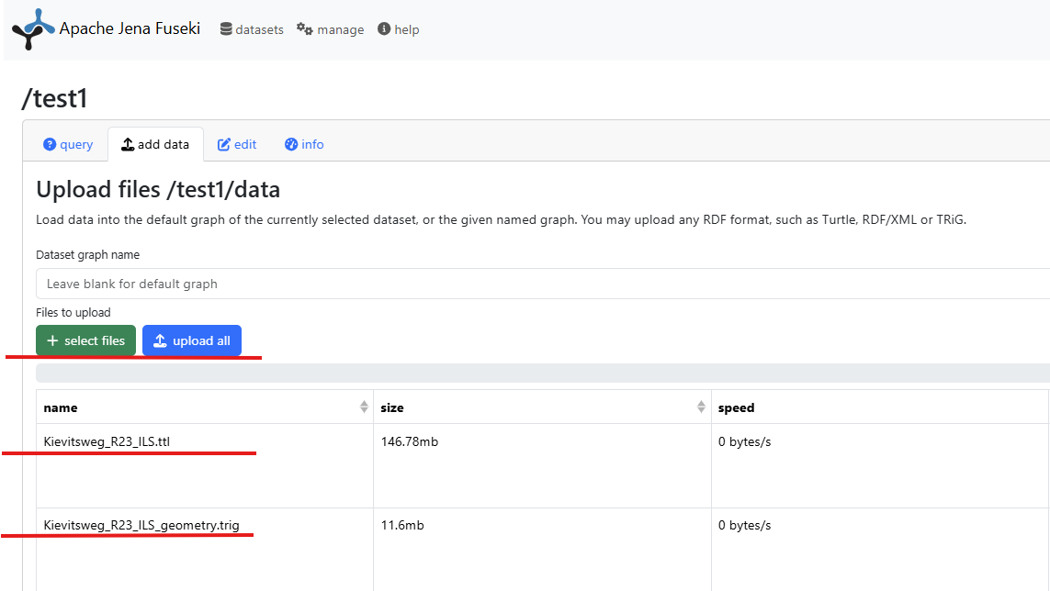

Test: IfcMapConversion => Eastings & Northings
PREFIX ifc: <https://standards.buildingsmart.org/IFC/DEV/IFC4/ADD2/OWL#>
PREFIX inst: <http://vng.nl/geometry/>
PREFIX express: <https://w3id.org/express#>
PREFIX rdf: <http://www.w3.org/1999/02/22-rdf-syntax-ns#>

# Eastings & Northings
SELECT ?eastingsValue ?northingsValue
WHERE {
?mapConversion rdf:type ifc:IfcMapConversion ;
ifc:eastings_IfcMapConversion ?lengthMeasureEastings ;
ifc:northings_IfcMapConversion ?lengthMeasureNorthings .
?lengthMeasureEastings express:hasDouble ?eastingsValue .
?lengthMeasureNorthings express:hasDouble ?northingsValue .
} LIMIT 1

Test: IFC Elements (default Graph) => Geometry (geometries Graph)
PREFIX rdf: <http://www.w3.org/1999/02/22-rdf-syntax-ns#>
PREFIX ifc: <https://standards.buildingsmart.org/IFC/DEV/IFC4/ADD2/OWL#>
PREFIX express: <https://w3id.org/express#>
PREFIX geom: <https://vng.nl/geometry/>

SELECT ?ifcElement ?globalIdValue ?base64Data
WHERE {
?ifcElement rdf:type ?ifcType ;
ifc:globalId_IfcRoot ?globalIdNode .

?globalIdNode rdf:type ifc:IfcGloballyUniqueId ;
express:hasString ?globalIdValue .

GRAPH <https://vng.nl/geometries/> {
?geometry rdf:type geom:Geometry ;
geom:globalId ?globalIdValue ;
geom:base64Data ?base64Data .
}
}
ORDER BY ?ifcElement

Add Buildings Graph (VNG Docker Service)
Apache Jena Fuseki UI

SPARQL Endpoint
/test1/

Query
PREFIX vng: <http://vng.nl/geometry-ext.ttl#>
PREFIX bldg: <http://vng.nl/buildings/>
PREFIX ifc: <https://standards.buildingsmart.org/IFC/DEV/IFC4/ADD2/OWL#>
PREFIX express: <https://w3id.org/express#>
PREFIX rdf: <http://www.w3.org/1999/02/22-rdf-syntax-ns#>

DROP SILENT GRAPH <buildings.ttl> ;

INSERT {
GRAPH <buildings.ttl> {
?buildingUri a bldg:Building ;
bldg:id ?id ;
bldg:name ?name ;
bldg:geometry ?geometry .
}
}
WHERE {
{
SELECT ?e ?n WHERE {
?mc rdf:type ifc:IfcMapConversion ;
ifc:eastings_IfcMapConversion ?le ;
ifc:northings_IfcMapConversion ?ln .
?le express:hasDouble ?e .
?ln express:hasDouble ?n .
} LIMIT 1
}
("Buildings" ?e ?n) vng:pdokFeature (?id ?name ?geometry) .
BIND(IRI(CONCAT(STR(bldg:), ?id)) AS ?buildingUri)
}

Test: Building => id, name, geometry
PREFIX bldg: <http://vng.nl/buildings/>

SELECT ?id ?name ?geometry
WHERE {
GRAPH <buildings.ttl> {
?building a bldg:Building ;
bldg:id ?id ;
bldg:name ?name ;
bldg:geometry ?geometry .
}
}
ORDER BY ?id

Add Parcels Graph (VNG Docker Service)
Apache Jena Fuseki UI

SPARQL Endpoint
/test1/

Query
PREFIX vng: <http://vng.nl/geometry-ext.ttl#>
PREFIX pcl: <http://vng.nl/parcels/>
PREFIX ifc: <https://standards.buildingsmart.org/IFC/DEV/IFC4/ADD2/OWL#>
PREFIX express: <https://w3id.org/express#>
PREFIX rdf: <http://www.w3.org/1999/02/22-rdf-syntax-ns#>

DROP SILENT GRAPH <parcels.ttl> ;

INSERT {
GRAPH <parcels.ttl> {
?parcelUri a pcl:Parcel ;
pcl:id ?id ;
pcl:name ?name ;
pcl:geometry ?geometry .
}
}
WHERE {
{
SELECT ?e ?n WHERE {
?mc rdf:type ifc:IfcMapConversion ;
ifc:eastings_IfcMapConversion ?le ;
ifc:northings_IfcMapConversion ?ln .
?le express:hasDouble ?e .
?ln express:hasDouble ?n .
} LIMIT 1
}
("Parcels" ?e ?n) vng:pdokFeature (?id ?name ?geometry) .
BIND(IRI(CONCAT(STR(pcl:), ?id)) AS ?parcelUri)
}

Test: Parcel => id, name, geometry
PREFIX pcl: <http://vng.nl/parcels/>

SELECT ?id ?name ?geometry
WHERE {
GRAPH <parcels.ttl> {
?parcel a pcl:Parcel ;
pcl:id ?id ;
pcl:name ?name ;
pcl:geometry ?geometry .
}
}
ORDER BY ?id

Add Areas Graph (VNG Docker Service)
Apache Jena Fuseki UI

SPARQL Endpoint
/test1/

Query
PREFIX ifc: <https://standards.buildingsmart.org/IFC/DEV/IFC4/ADD2/OWL#>
PREFIX rdf: <http://www.w3.org/1999/02/22-rdf-syntax-ns#>
PREFIX express: <https://w3id.org/express#>
PREFIX vng: <http://vng.nl/geometry-ext.ttl#>
PREFIX dso: <http://vng.nl/areas/>

DROP SILENT GRAPH <areas.ttl> ;

INSERT {
GRAPH <areas.ttl> {
?areaUri a dso:area ;
dso:id ?id ;
dso:name ?name ;
dso:group ?group ;
dso:type ?type ;
dso:geometry ?geometry .
}
}
WHERE {
{
SELECT ?e ?n WHERE {
?mc rdf:type ifc:IfcMapConversion ;
ifc:eastings_IfcMapConversion ?le ;
ifc:northings_IfcMapConversion ?ln .
?le express:hasDouble ?e .
?ln express:hasDouble ?n .
} LIMIT 1
}
(?e ?n) vng:dsoArea (?id ?name ?group ?type ?geometry) .
BIND(IRI(CONCAT(STR(dso:), ?id)) AS ?areaUri)
}

Test: Area => id, name, group, type, geometry
PREFIX dso: <http://vng.nl/areas/>

SELECT ?id ?name ?group ?type ?geometry
WHERE {
GRAPH <areas.ttl> {
?area a dso:area ;
dso:id ?id ;
dso:name ?name ;
dso:group ?group ;
dso:type ?type ;
dso:geometry ?geometry .
}
}
ORDER BY ?id

Add BBoxes (VNG Service)
Apache Jena Fuseki UI

SPARQL Endpoint
/test1/

Query
PREFIX geom: <https://vng.nl/geometry/>
PREFIX pf: <java:org.example.>

INSERT {
GRAPH <https://vng.nl/geometries/> {
?instance geom:bboxMinX ?minX ;
geom:bboxMinY ?minY ;
geom:bboxMinZ ?minZ ;
geom:bboxMaxX ?maxX ;
geom:bboxMaxY ?maxY ;
geom:bboxMaxZ ?maxZ .
}
}
WHERE {
GRAPH <https://vng.nl/geometries/> {
?instance a geom:Geometry ;
geom:base64Data ?base64Data .
FILTER NOT EXISTS { ?instance geom:bboxMinX ?any }
}
(?minX ?minY ?minZ ?maxX ?maxY ?maxZ) pf:BBoxPropFunction ?base64Data .
}

Test: https://vng.nl/geometries/ => globalId, min/max X/Y/Z
PREFIX rdf: <http://www.w3.org/1999/02/22-rdf-syntax-ns#>
PREFIX geom: <https://vng.nl/geometry/>

SELECT ?globalId ?minX ?minY ?minZ ?maxX ?maxY ?maxZ
WHERE {
GRAPH <https://vng.nl/geometries/> {
?geometry rdf:type geom:Geometry ;
geom:globalId ?globalId ;
geom:bboxMinX ?minX ;
geom:bboxMinY ?minY ;
geom:bboxMinZ ?minZ ;
geom:bboxMaxX ?maxX ;
geom:bboxMaxY ?maxY ;
geom:bboxMaxZ ?maxZ .
}
}
ORDER BY ?globalId

Add Projections (VNG Service)
Apache Jena Fuseki UI

SPARQL Endpoint
/test1/

Query
PREFIX geom: <https://vng.nl/geometry/>
PREFIX ext: <http://vng.nl/geometry-ext.ttl#>

INSERT {
GRAPH <https://vng.nl/geometries/> {
?instance geom:projectionBase64Data ?projection .
}
}
WHERE {
GRAPH <https://vng.nl/geometries/> {
?instance a geom:Geometry ;
geom:base64Data ?base64Data .
BIND(ext:projection(?base64Data) AS ?projection)
FILTER NOT EXISTS { ?instance geom:projectionBase64Data ?any }
}
}

Test: https://vng.nl/geometries/ => globalId, base64Data, projectionBase64Data
PREFIX rdf: <http://www.w3.org/1999/02/22-rdf-syntax-ns#>
PREFIX geom: <https://vng.nl/geometry/>

SELECT ?globalId ?base64Data ?projectionBase64Data
WHERE {
GRAPH <https://vng.nl/geometries/> {
?geometry rdf:type geom:Geometry ;
geom:globalId ?globalId ;
geom:base64Data ?base64Data ;
geom:projectionBase64Data ?projectionBase64Data .
}
}
ORDER BY ?globalId

Add Topological Relations (VNG Service)
Apache Jena Fuseki UI

SPARQL Endpoint
/test1/

Query
PREFIX rdf: <http://www.w3.org/1999/02/22-rdf-syntax-ns#>
PREFIX ifc: <https://standards.buildingsmart.org/IFC/DEV/IFC4/ADD2/OWL#>
PREFIX express: <https://w3id.org/express#>
PREFIX geom: <https://vng.nl/geometry/>
PREFIX dso: <http://vng.nl/areas/>
PREFIX ext: <http://vng.nl/geometry-ext.ttl#>
PREFIX topo: <http://vng.nl/topology/>

DELETE {
GRAPH <https://vng.nl/geometries/> {
?geometry geom:topologicalRelation ?oldRelation .
}
}
INSERT {
GRAPH <https://vng.nl/geometries/> {
?geometry geom:topologicalRelation ?topologicalRelation .
}
}
WHERE {
VALUES ?ifcType { ifc:IfcWall }

?ifcElement rdf:type ?ifcType ;
ifc:globalId_IfcRoot ?globalIdNode .
?globalIdNode rdf:type ifc:IfcGloballyUniqueId ;
express:hasString ?globalIdValue .

GRAPH <https://vng.nl/geometries/> {
?geometry rdf:type geom:Geometry ;
geom:globalId ?globalIdValue ;
geom:projectionBase64Data ?base64Data1 .
}

{
SELECT (GROUP_CONCAT(?base64Data2; SEPARATOR="|") AS ?allBase64)
WHERE {
GRAPH <areas.ttl> {
[] a dso:area ;
dso:group "wonen" ;
dso:geometry ?base64Data2 .
}
}
}

BIND(ext:topologicalRelation(?base64Data1, ?allBase64) AS ?topologicalRelation)

OPTIONAL {
GRAPH <https://vng.nl/geometries/> {
?geometry geom:topologicalRelation ?oldRelation .
}
}
}

Test: Topological Relation Property => https://vng.nl/geometry/: {ifc:IfcWall
PREFIX rdf: <http://www.w3.org/1999/02/22-rdf-syntax-ns#>
PREFIX ifc: <https://standards.buildingsmart.org/IFC/DEV/IFC4/ADD2/OWL#>
PREFIX express: <https://w3id.org/express#>
PREFIX geom: <https://vng.nl/geometry/>

SELECT ?ifcElement ?globalIdValue ?topologicalRelation
WHERE {
VALUES ?ifcType { ifc:IfcWall }

?ifcElement rdf:type ?ifcType ;
ifc:globalId_IfcRoot ?globalIdNode .
?globalIdNode rdf:type ifc:IfcGloballyUniqueId ;
express:hasString ?globalIdValue .

GRAPH <https://vng.nl/geometries/> {
?geometry rdf:type geom:Geometry ;
geom:globalId ?globalIdValue ;
geom:topologicalRelation ?topologicalRelation .
}
}
ORDER BY ?ifcElement

SHACL

Validate

SPARQL Constraint – Topological Relation; globalId annotation
# \VNG\Tools
Console Output
.\SHACL-validate-Topological-Relations-SPARQLConstraint.ps1 -DatasetName "test1"

FilePath Output
.\SHACL-validate-Topological-Relations-SPARQLConstraint.ps1 -DatasetName "test1" > validation-results.txt

Console and FilePath Output
.\SHACL-validate-Topological-Relations-SPARQLConstraint.ps1 -DatasetName "test1" | Tee-Object -FilePath validation-results.txt

SPARQL Constraint - BBox [1, 100]; globalId annotation
# \VNG\Tools
Console Output
.\SHACL-validate-BBoxes-SPARQLConstraint.ps1 -DatasetName "test1"

FilePath Output
.\SHACL-validate-BBoxes-SPARQLConstraint.ps1 -DatasetName "test1" > validation-results.txt

Console and FilePath Output
.\SHACL-validate-BBoxes-SPARQLConstraint.ps1 -DatasetName "test1" | Tee-Object -FilePath validation-results.txt

SPARQL Constraint - BBox [1, 100]; globalId annotation
# \VNG\Tools
Console Output
.\SHACL-validate-Model-BBox-SPARQLConstraint.ps1 -DatasetName "test1"

FilePath Output
.\SHACL-validate-Model-BBox-SPARQLConstraint.ps1 -DatasetName "test1" > validation-results.txt

Console and FilePath Output
.\SHACL-validate-Model-BBox-SPARQLConstraint.ps1 -DatasetName "test1" | Tee-Object -FilePath validation-results.txt

