Welcome to GatherSync! 🎉
Your Personal Event Coordination Assistant

Peter has invited you to test GatherSync - a new app designed to make coordinating group events easier. This app helps you find the perfect date when everyone is available.

Quick Start Guide

Step 1: Install Expo Go
- iPhone Users:
- Open the App Store
- Search for "Expo Go"
- Install the app (it's free)

- Android Users:
- Open the Google Play Store
- Search for "Expo Go"
- Install the app (it's free)

Step 2: Open GatherSync

Option A: Scan the QR Code (Easiest!)
- Open the Expo Go app
- Tap "Scan QR code"
- Point your camera at the QR code below:

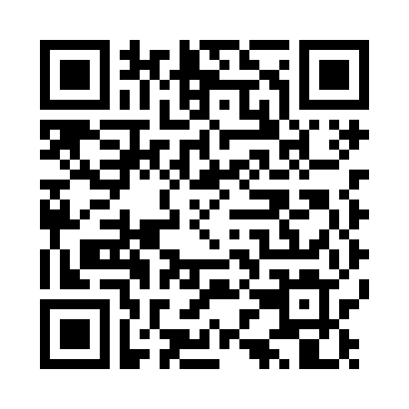

Option B: Enter URL Manually
- Open the Expo Go app
- Tap "Enter URL manually" at the bottom
- Copy and paste this URL:
https://8081-ienb1rj930k0x92csc3x6-a41ba8ee.manus-asia.computer
- Tap "Connect"

Step 3: Log In to Enable Cloud Sync
- When GatherSync opens, you'll see a "Cloud Sync Available" banner
- Tap the "Log In" button
- Create an account or use OAuth (Google/GitHub)
- After logging in, you'll be redirected back to the app

Step 4: Sync Your Events
- You should now see "Cloud sync enabled" banner (green)
- Tap the "Sync Now" button
- Wait 10-20 seconds while syncing
- You should see 2 events appear:
- AI Guys - Monthly flexible event
- Guru Breakfast - Monthly event

Step 5: Mark Your Availability

For Flexible Events (AI Guys):
- Tap on the AI Guys event
- Find your name in the participants list
- Tap on your name
- Mark the dates you're available or unavailable
- The app will help find the best date when most people can attend

For Fixed Events (Guru Breakfast):
- Tap on the Guru Breakfast event
- Find your name in the participants list
- Tap on your name
- Select your RSVP status:
- ✅ Attending
- ❌ Not Attending
- ❓ No Response (default)

Step 6: Sync Your Changes
After marking your availability or RSVP:
- Go back to the Events list (tap the back arrow)
- Tap "Sync Now" again
- Your responses will be uploaded to the cloud
- Everyone else will see your updates when they sync

Important Tips
- ✅ Always sync after making changes - Your availability/RSVP won't be shared until you tap "Sync Now"
- ✅ Sync regularly to see updates - Other people's responses will appear when you sync
- ✅ Keep Expo Go installed - You'll need it to access GatherSync until we release the standalone app
- ✅ Internet connection required - Syncing requires an active internet connection

Need Help?
If you encounter any issues:
- Force close and reopen - Swipe up from app switcher and reopen Expo Go
- Check your internet connection - Sync requires WiFi or mobile data
- Contact Peter - He's testing this app and wants your feedback!

What to Test
Peter would love your feedback on:
- ✅ Does the app load correctly?
- ✅ Can you see the events after syncing?
- ✅ Can you mark your availability/RSVP?
- ✅ Do your changes sync back to other users?
- ✅ Is the app easy to use?
- ✅ What features would make it more useful?

Privacy & Data
- Your data is stored securely in the cloud
- Only members of your events can see your responses
- You can delete your account and data at any time
- This is a test version - please don't enter sensitive information

Thank you for testing GatherSync!
Your feedback will help make this app better for everyone.

Questions? Contact Peter Scarfo

© 2025 Peter Scarfo. All rights reserved.

