Systems Architecture

Reducing friction with business solution delivery

Peter Giles
peter.s.giles@gmail.com
Problem or Opportunity

Manual build processes lead to production defects and difficult-to-manage application releases. This document presents a solution for organisations to optimise and automate build processes into a powerful pipeline that creates, vets and packages software as soon as developers commit code.

Basic Solution

The primary Scenario involves a developer committing code to a Source Code Repository. Build Agents detect that new code has been pushed to the server and begin the process of building the application. When complete a Test Agent would run any available automated tests. Once successful a Deployment Agent would automatically deploy the application to an Integration or staging environment.

A Test Manager or Product owner would run any further tests before using the Deployment Agent to promote the working code to other environment s.

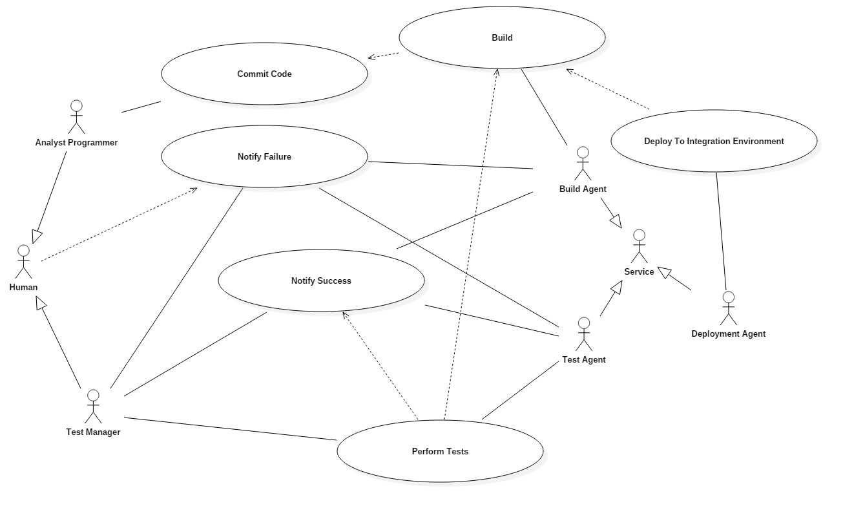

Logical View

The Logical View of a Continuous Integration solution shows the interaction of Services and Agents in the process.

