BOM:
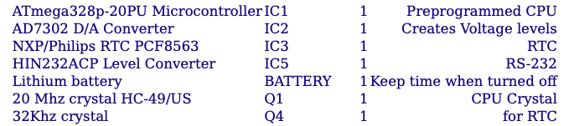
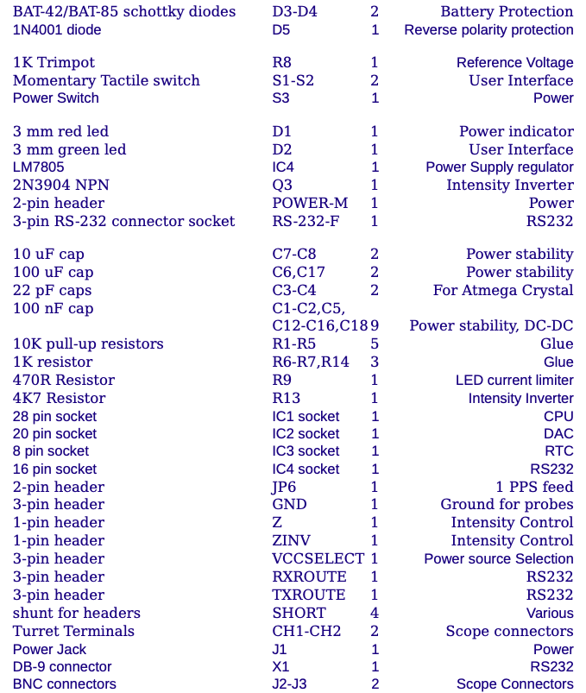
The five 10K resistors R1-R5 have color codes Brown Black Orange
The three 1K resistors R6-R7 and R14 have color codes Brown Black Red
The 470R resistor R9 has color codes Yellow Violet Brown.
The 4K7 resistor R13 has color code Yellow Violet Red.
The red LED D1 and green LED D2 has 2 uneven legs. The longer leg is the +, the shorter one the -. The positive side (+) of these LEDs are clearly marked on the PCB.
The BAT-42 diodes D3-D4 are either BAT-42 or BAT-85.

Pay attention to:
The turret terminals CH1 and CH2 are easiest installed when done as the first item on the PCB; solder them on the bottom side.
Install the IC sockets next. Solder just 2 pins on opposite ends of each socket first and make sure the socket is properly seated before soldering the other pins.
Capacitor C1-C2, C5, C12-C16, C18, C3-C4 are ceramic, non-polarized capacitors. The Electrolytic Capacitors C6-C8 and C17 are polarized.
The front of the Backup battery (lettering) is the + side. The battery legs will need to be squeezed a little to fit in the holes; be careful doing this so the legs don't break. Please bend the unused tabs on the battery away to reduce any risk of shorting the battery. The positive (+) side of the battery is clearly marked on the PCB.
Do not insert any components in the vias, which are small holes to transfer a signal from one side of the board to the other side.
Install the Power (2-pin) polarized header with the flat back towards the
center of the board in the location marked "VCCPOWER".
Install the RS-232 (3-pin) polarized header with the flat back towards the center of the board in the location marked "RS232".
All ICs are oriented (pin 1) towards the left of the PCB.
Install a 2 pin header in the location marked "1PPS" and then put one of the supplied shunts on the 2 pins.
Install a 3 pin header in the location marked "VCCSELECT" and then put a shunt on the 2 pins closest to the "VCCPOWER" polarized header.
Install 3 pin headers in the locations marked "TXROUTE" and "RXROUTE", then put a shunt on the right most pins of each of these headers (next to the 3 pin RS232 header)
If installing IC6 (the FT232RL USB chip, not included), do this as early as possible, but certainly before installing the optional 10-pin ISP header.
The optional 10-pin ISP header is only useful if you intend to program the AVR microcontroller directly and have the appropriate programmer available. This header is not included.
Resistor R7 is marked incorrectly as 2K. This should be 1K.
Trimpot R8 is marked incorrectly as 2K. This should be 1K.
Install the large connectors last; this includes the 2 BNC connectors and the DB9 connector.
The following components are unpopulated in the Clock kit:
IC6, C9, C10, C11, L1, X2: these are the USB interface components

Cable Connection:
The easiest method to power the AVR Oscilloscope clock is to use an external wall wart, voltage range 7-15V, with a 5.5 mm (external diameter) center positive DC connector. The AVR Oscilloscope Clock kit can also be powered by an external 5V regulated power source. The on-board RS-232 level Serial Port can be used for:
Control the clock using a command line interface (for example send NTP time to the clock) Run the terminal display application Connect the clock to a GPS device
Upgrade the clock firmware
The onboard female DB-9 connector allows the use of a standard Serial Cable. Such a cable has one female DB-9 connector and one male DB-9 connector. The male DB-9 connector plugs into the female DB-9 connector on the clock. These cables also connect the proper RX and TX pins on each side of the cable (crossover cable.)
However, a 3-pin polarized header is also available for use with a custom cable, similar to the original Dutchtronix AVR Oscilloscope Clock Hardware 2-0.
3-pin connector - 1:GND, 2:out/RXpc, 3:in/TXpc. DB-9 connector - 5:GND, 2:RX, 3:TX.
Pin 1 on the RS232 3-pin polarized header is the right-most pin. It is marked on the PCB but invisible once you install the header. Your connector must match this.

Other instructions:
Install components in order of increased height. For example do the probe connectors first, followed by the IC sockets, the resistors and the diodes. This way, you can lay the board face down while soldering the bottom side. Do not install the 4 ICs initially. When complete, before applying power, test the voltage at the right side junction of diodes D3 and D4. It should read about 3V from the backup battery. Next apply power and test the IC power supply points (IC1 pin 7, IC2 pin 15, IC3 pin 8, IC4 pin 16). If that all tests OK, install the ICs (all are oriented (pin 1) to the left) After the first power up, the RTC may report a low battery status. This usually goes away after a couple of power cycles. It can also be cleared by writing the correct time to the clock (long push on the S1 push button switch enters Time Set mode) followed by a clock reset. See the FAQ for more details.

