# Supplemental Figures

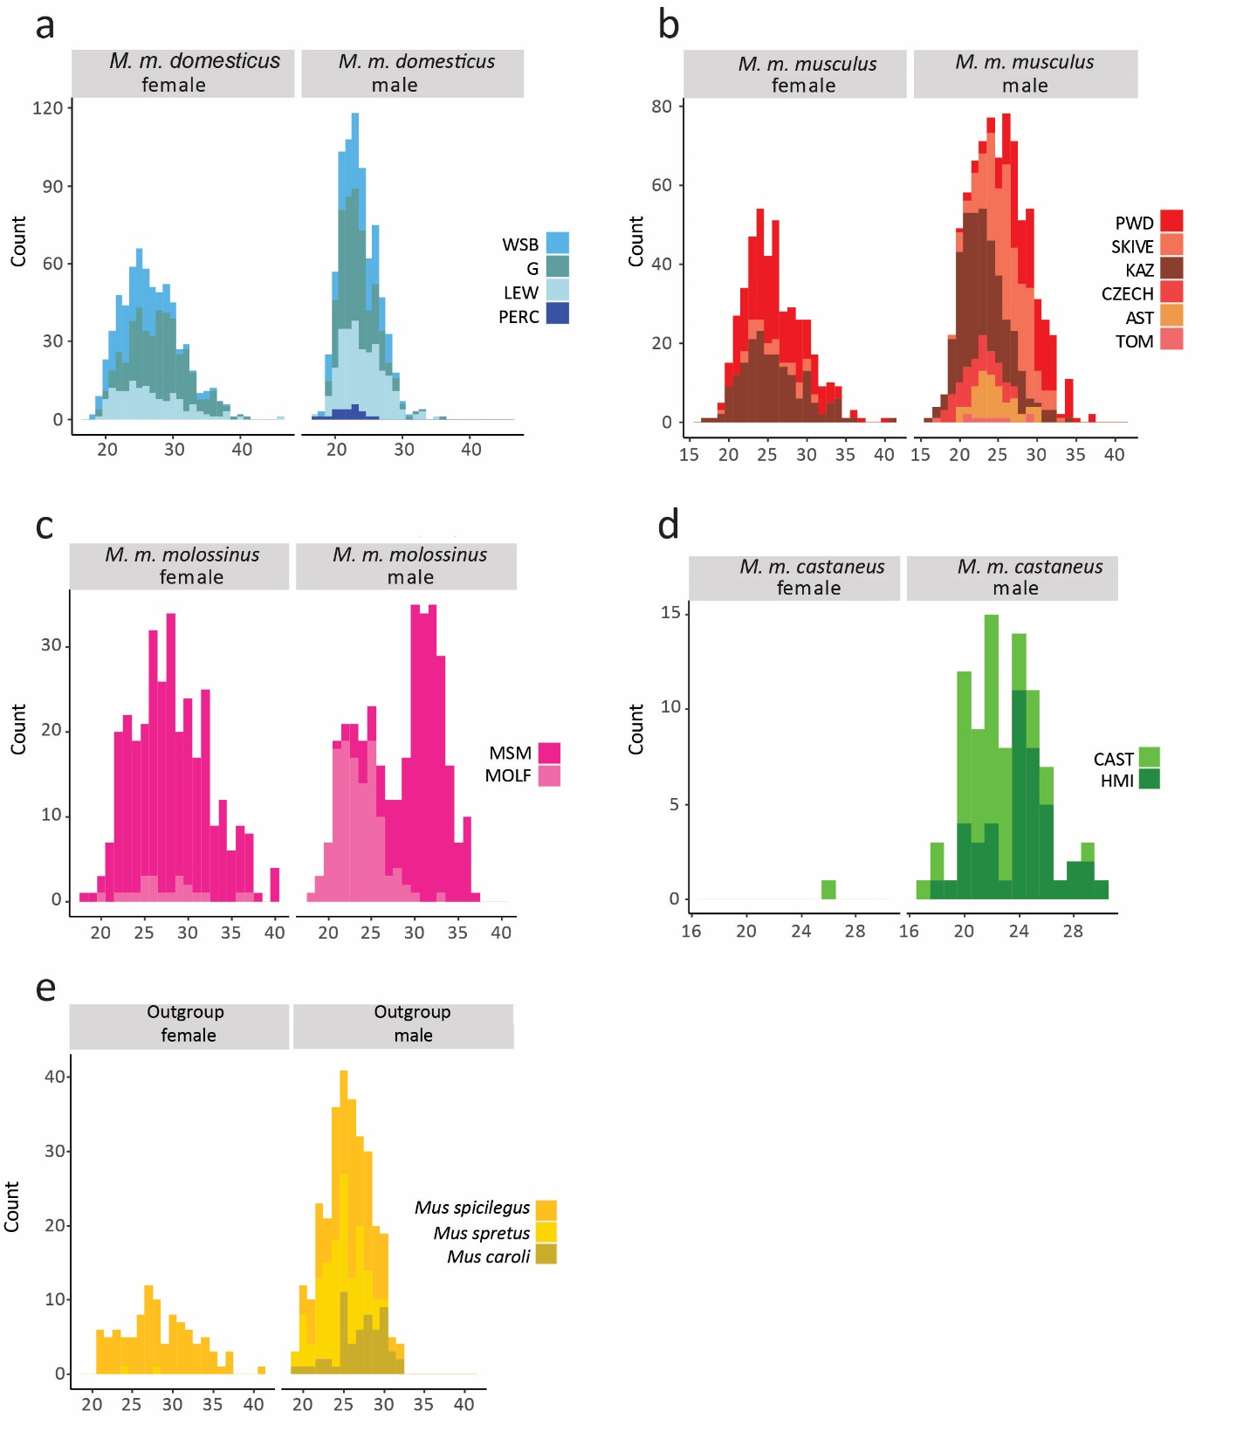

Supplemental Figure 1 Distributions of MLH1 Counts per Cell. Strain names are abbreviated for space.

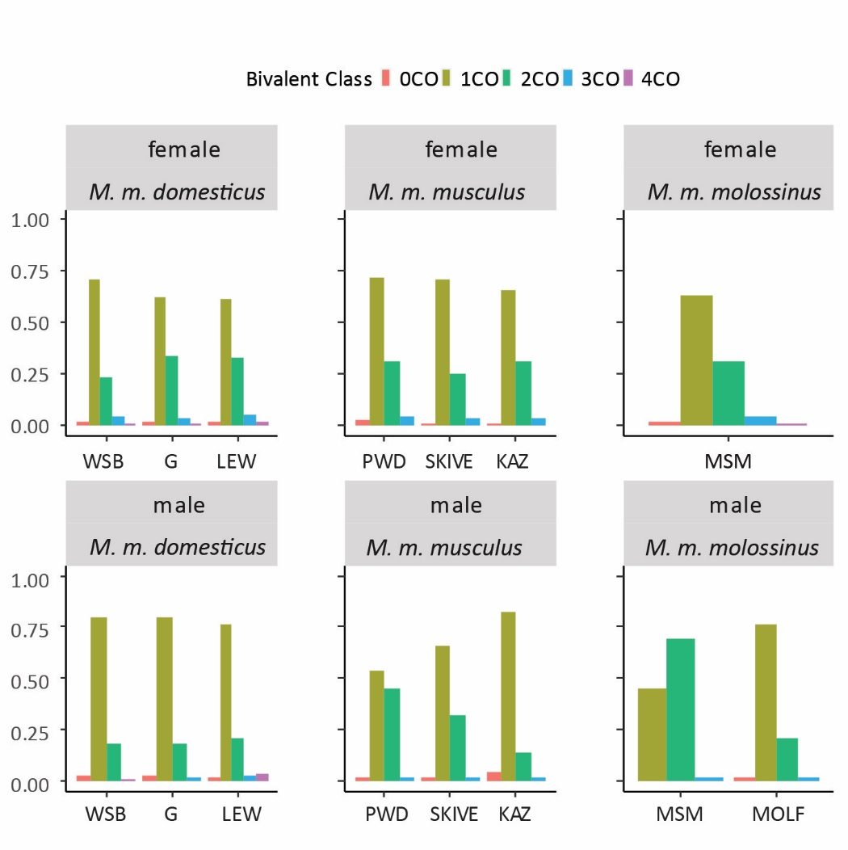

Supplemental Figure 2. Proportions of Bivalents with Different Numbers of MLH1 Foci. Strain names are abbreviated for space.

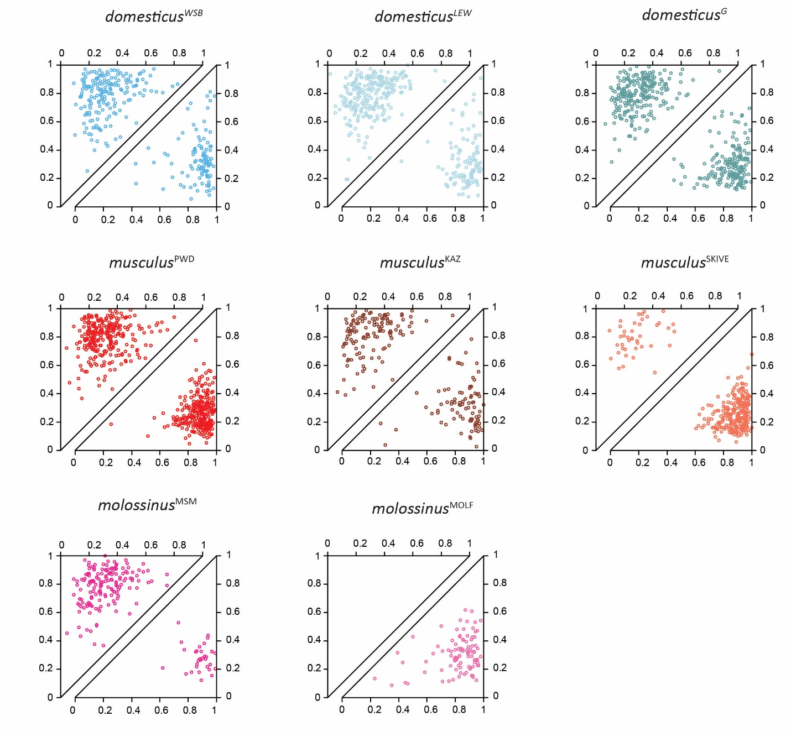

Supplemental Figure 3. Inter-focal Distances on Bivalents with Two MLH1 Foci. Each point shows the positions of both foci, normalized by bivalent SC length. Observations are separated by sex (females=top triangles; males=bottom triangles).