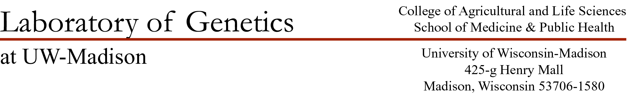

July 5, 2020

Dear Senior Editors Tautz and Wittkopp:

I’m pleased to submit an original article entitled “Sex-Specific Evolution of the Meiotic Recombination Rate” for publication in eLife. Meiotic recombination is a fundamental genomic process that shapes evolution and is an essential cellular process for ensuring proper chromosome disjunction and gamete formation. Differences between females and males are perhaps the most striking form of variation in genome-wide recombination rates. However, the evolutionary origin for this patterns is somewhat obscured by the large evolutionary distances between the empirical measures in the literature. Patterns of variation across short evolutionary scales, for example within and between subspecies, would provide a more complete description of the evolutionary pattern.

Our manuscript measures genome-wide recombination rates for multiple wild-derived inbred strains from three subspecies of *Mus musculus.* Using a cytological approach to visualize crossovers in single cells allowed us to estimate recombination rates for individuals and compare general recombination landscapes of single chromosomes. From this direct comparison of males and females, we isolated sex as a primary factor in the evolution of this fundamental meiotic trait. We observe distinct evolutionary trajectories, with female recombination rates centering on a group mean and male recombination rates separating into two low and high-recombining groups. We also document conserved and evolved features of the recombination landscape.

To our knowledge this is the largest dataset of genome-wide recombination rates to include data for both sexes. Due to the importance of meiotic recombination areas population genetics and cell biology, we believe this manuscript will be of interest to researchers from a broad range of sub-fields.

Our manuscript has not been published and we have not considered publication elsewhere. We have no conflicts of interest to declare. We believe Graham Coop and Molly Przeworski would be excellent choices for reviewing editors. We also suggest the following reviewers: (TBD)

Thank you for your consideration. We look forward to hearing from you.

Sincerely,

April Peterson (on behalf of the authors)