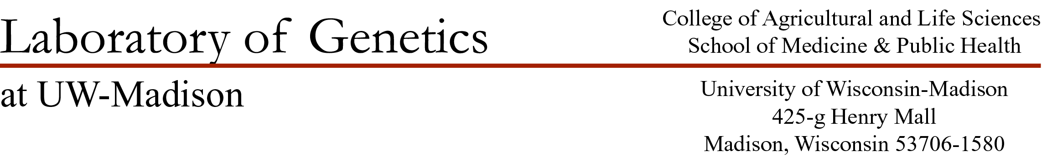

Dear Senior Editors Tautz and Wittkopp:

I am pleased to submit an original article entitled “Sex-Specific Evolution of the Genome-wide Recombination Rate” for publication in eLife.

Meiotic recombination is a fundamental genomic process that shapes evolution and ensures proper chromosome segregation during gamete formation. Females and males recombine at different rates, constituting the most visible form of inter-individual variation in recombination rate. Despite this established pattern, a clear picture of how sex determines the evolution of recombination rate is still missing. Most comparisons of variation in recombination rate between males and females have been conducted using outbred populations, where the role of sex is confounded by contributions from genetic variation.

We used a simple, powerful approach to discover the role of sex in recombination rate evolution. Applying immunohistochemistry to oocytes and spermatocytes, we visualized crossovers in single cells and quantified recombination rates for individuals drawn from a panel of wild-derived inbred strains of house mice. By directly comparing females and males across a common set of diverse genomes, we demonstrated that recombination evolves differently in the two sexes. Whereas male recombination shows rapid and substantial evolution at the genome-wide level, female recombination is mostly static in the same strains. With our experimental design, we can conclude that sex plays a primary role in the evolution of recombination rate. We supplement these results with the characterization of conserved and evolved features of the recombination landscape along single chromosomes in females and males.

To our knowledge, ours is the largest dataset of genome-wide recombination rates that includes measurements from both sexes. Due to the broad significance of meiotic recombination to fields ranging from evolutionary biology to cell biology to human genetics, we believe our findings will attract a broad audience. Our manuscript has not been published and we have not considered publication elsewhere. We have no conflicts of interest to declare.

We believe Graham Coop and Molly Przeworski would be excellent choices for reviewing editors. We also suggest the following reviewers:

Nadia Singh (nsingh@uoregon.edu)

Eva Hoffman (eva@sund.ku.dk)

Pavel Borodin (borodin@bionet.nsc.ru)

Jason Sardell (jsardell@austin.utexas.edu)

Carl Veller (carl.veller@gmail.com)

Thank you for your consideration. We look forward to hearing from you.

Sincerely,

April Peterson (on behalf of the authors)