**MLH1 variance preliminary results**

<put the sex*subspecies variance plots here>

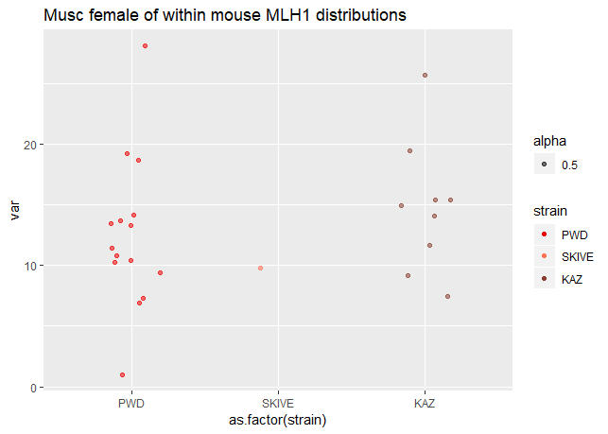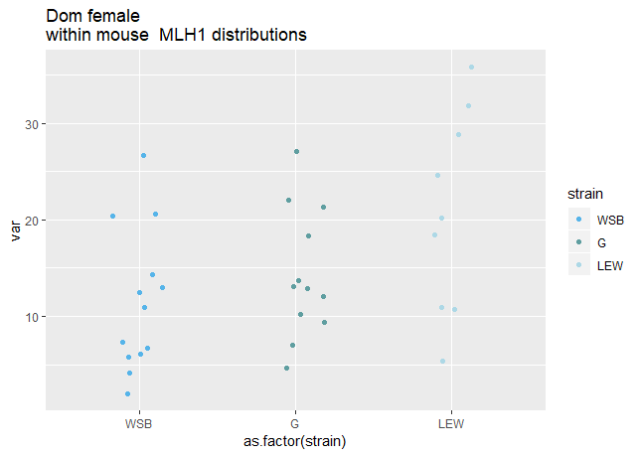

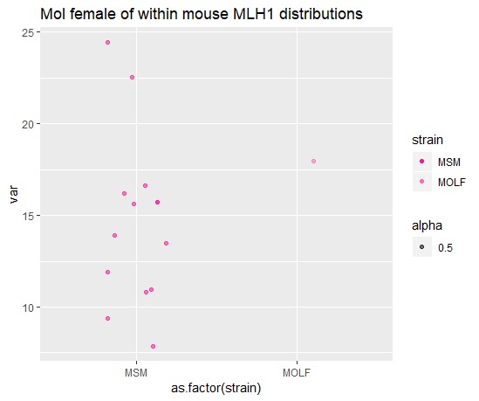

Model results

M1-M3

(sex is most sig (with variance and cV)

M4 (sex specific)

Male (lew, spic? Slightly significant)

Female (Lew sig for full dataset but goes away in the Higher quality data set (Q12).

**Testing Poisson**

-comparing a Poisson distribution/expectations (mean and variance are equal) – Is there interference?

<this is not a very exciting question>

**Within nucleus co-variation in axis-loop structure**

-Ho: This is the mechanism through which within animal variation in CO count per cell evolves

-Ha: ‘interference’ is the mechanism (the power for detecting interference would be greatly diminished).

**Cons**

-technical noise of females

-‘evolution’ of variance in MLH1 per cell disappears in higher quality cells – divergence in variance across cells could be due to technical noise.

- lower numbers of mice and cells in females

-noise across chromosomes