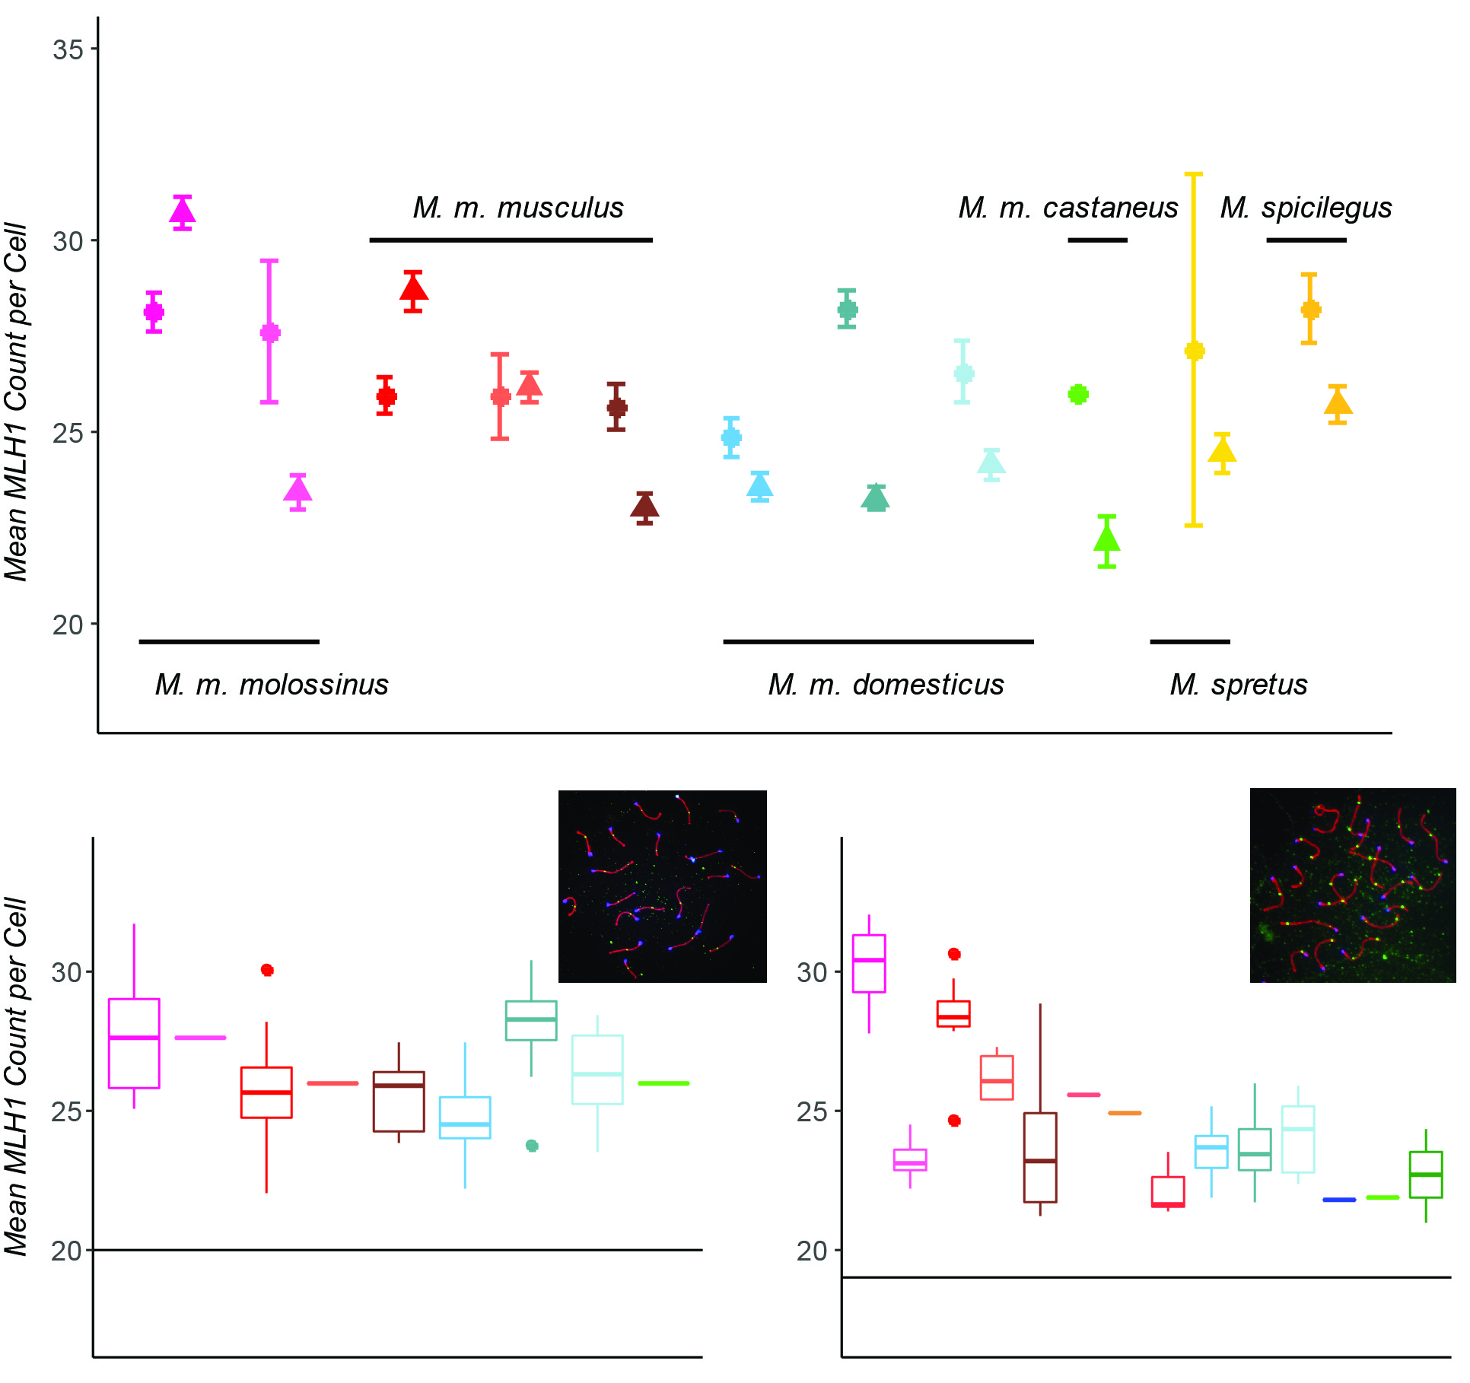

Figure 1. MLH1 Counts. A) Strain mean MLH1 counts (+/- 2 standard errors) in both sexes. Females = circles; males = triangles. B) Boxplots of female MLH1 counts for strains of house mice. Whiskers indicate interquartile range. Inset: example oocyte, SYCP3 stained in red, CREST (centromeres) stained in blue and MLH1 foci stained in green. Horizontal line at 20 indicates the expected minimum number of foci per cell. C) Boxplots of male MLH1 counts for strains of house mice. Inset: example spermatocyte. Additional strains with only male observations are included with the values from Table 2.

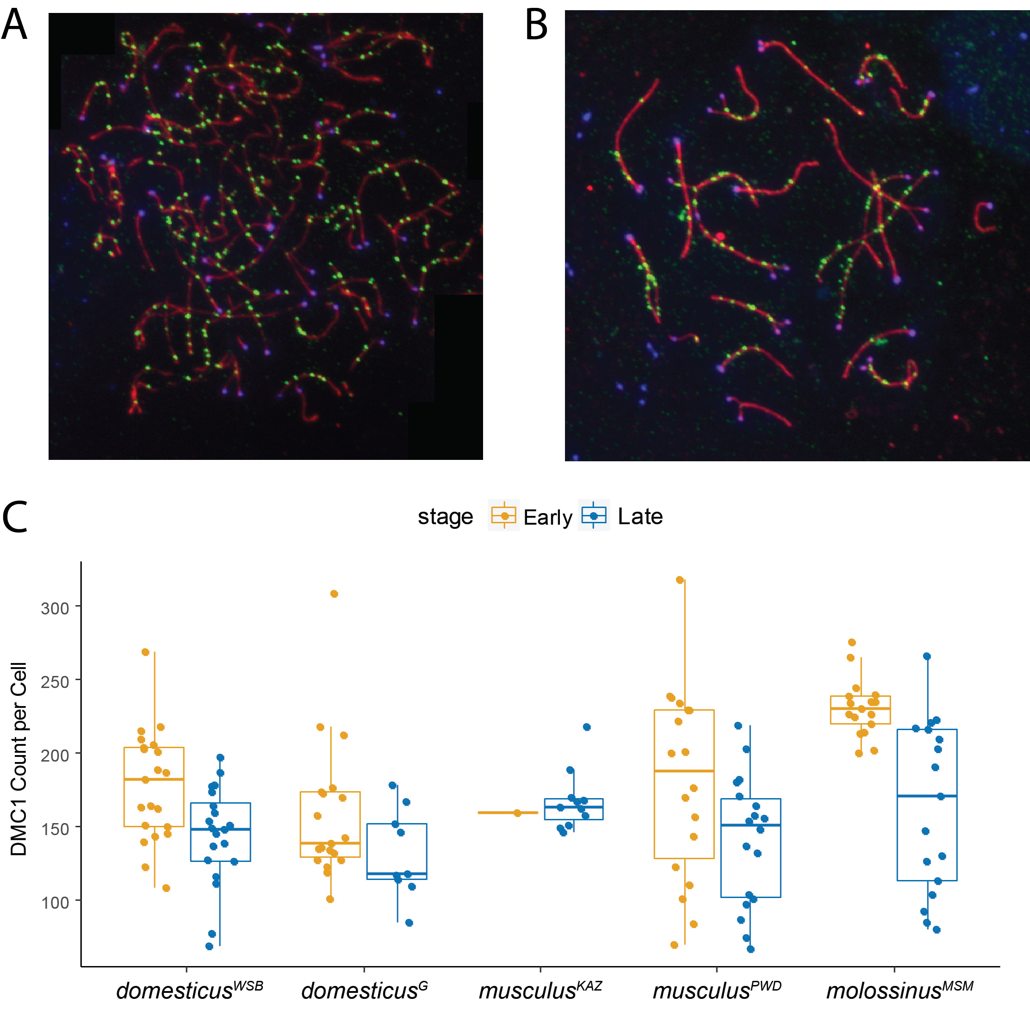

Figure 2. DMC1 Counts in Males. A) Example early zygotene spermatocyte spread. SYCP3 stained in red, CREST (centromeres) stained in blue and DMC1 stained in green. B) Example late zygotene spermatocyte spread. C) Boxplots of DMC1 counts for strains of house mice. Whiskers indicate interquartile range.

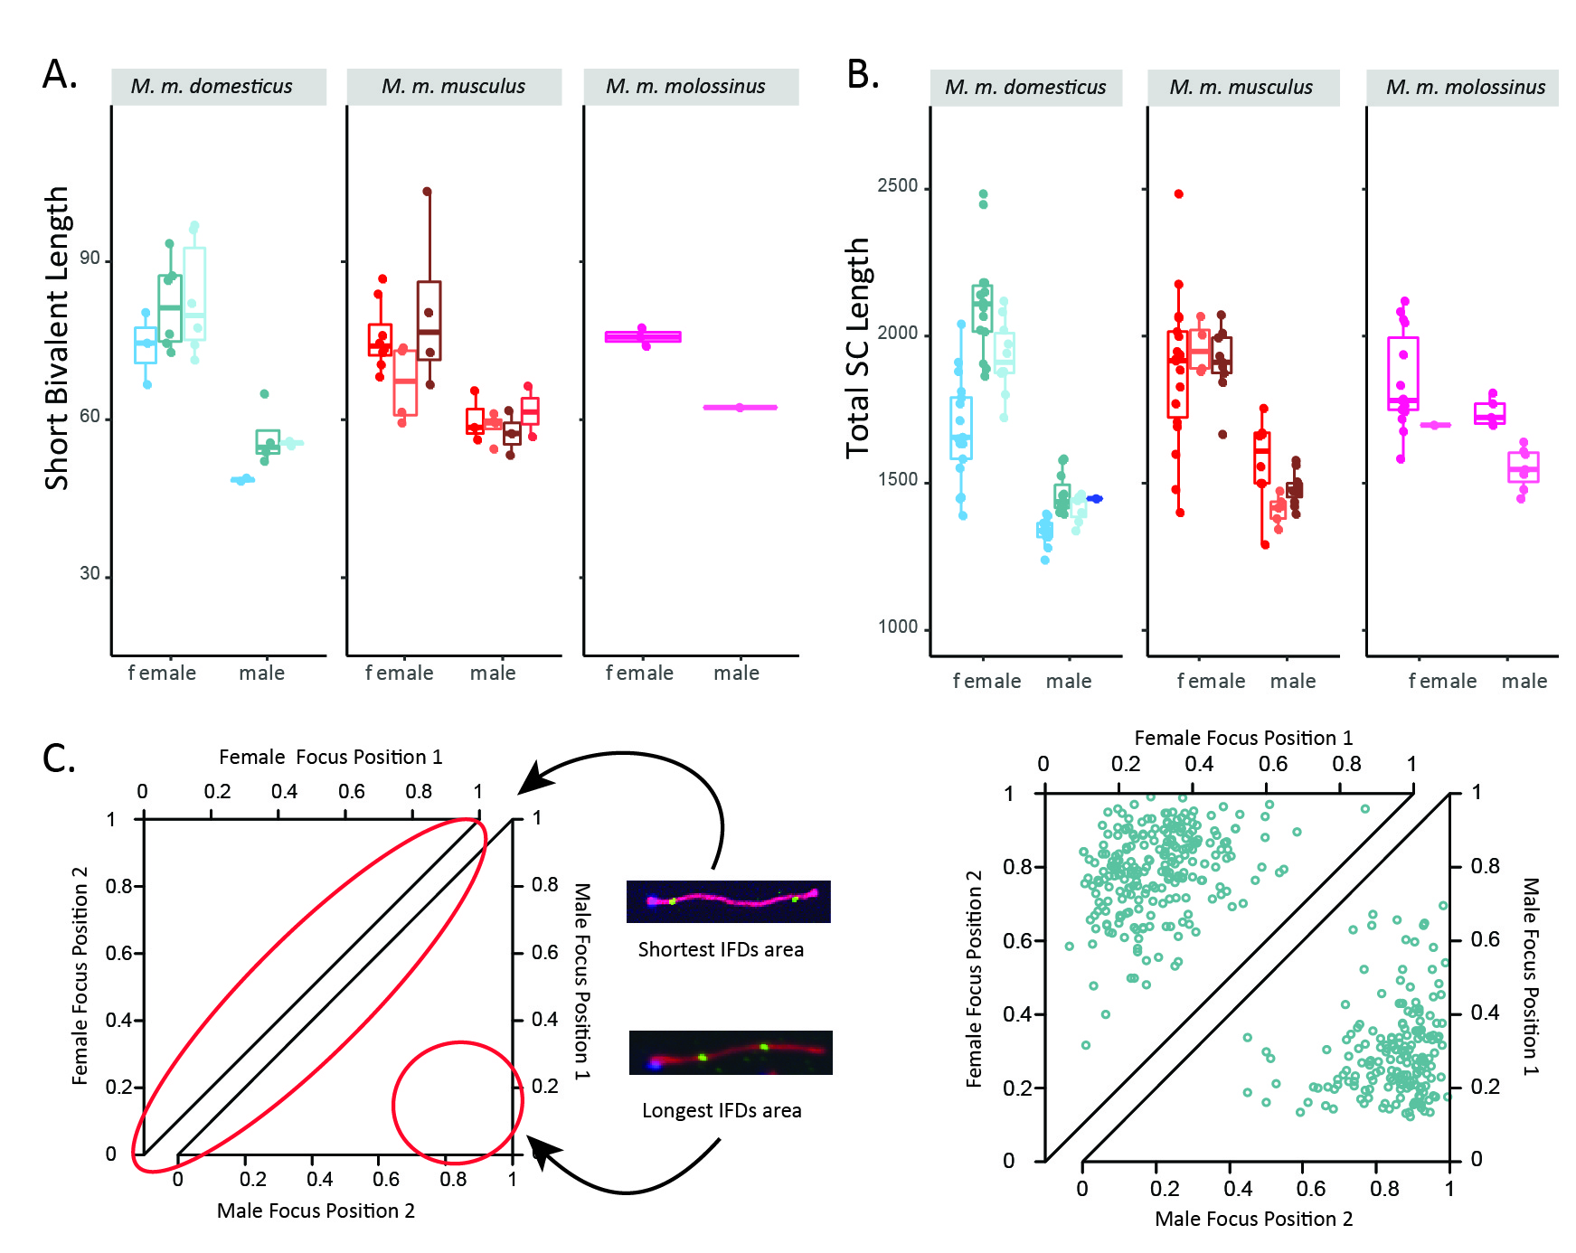

Figure 3. Sex Differences in Synaptonemal Complex (SC) Length and MLH1 Foci Positions. A) Mouse average length of short bivalents. Whiskers indicate interquartile range. B) Mouse average length of total SC. C) Example of sex differences in inter-focal distances and foci locations on bivalents with two foci. Female observations shown in top triangle; male observations shown in bottom triangle. Data from domesticusG.

**Supplemental Figures**

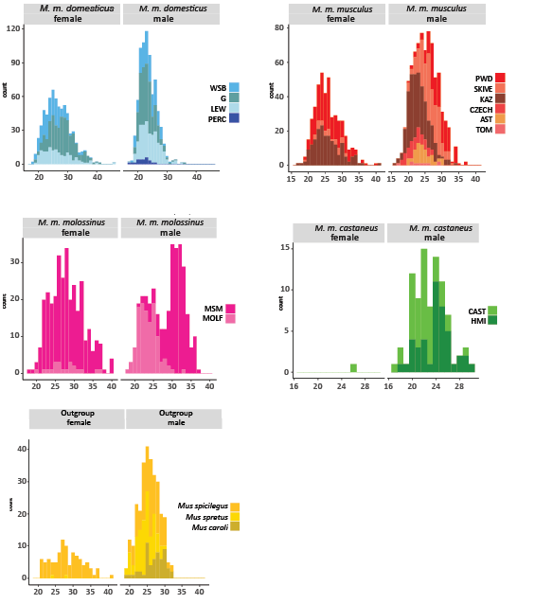

Supplemental Figure 1 Distributions of MLH1 Counts per Cell.

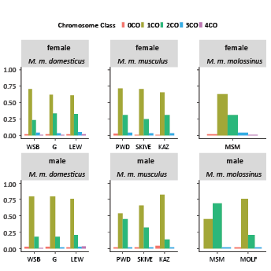

Supplemental Figure 2. Proportions of Bivalents with Different Numbers of MLH1 Foci. Strains names are abbreviated for space.

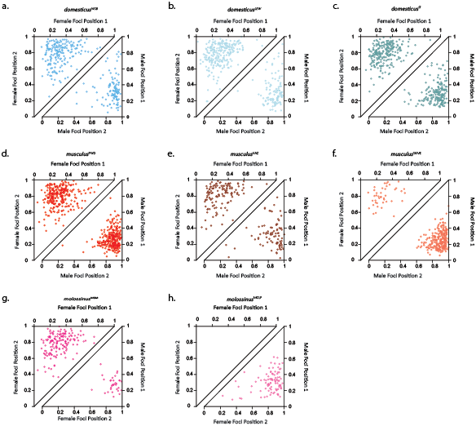

Supplemental Figure 3. Inter-focal Distances on Bivalents with Two MLH1 Foci. Each point shows the positions of both foci, normalized by bivalent SC length. Observations are separated by sex (females=top triangles; males=bottom triangles).