Finalize the methods for MM (MLH1) (which function ect
Summarize – the results (Predictions not met,

Female Specific gwRR Pattern
Female Table (Mice)
WSB G LEW PWD MSM MOLF SKIVE KAZ CAST
14 12 9 15 14 1 1 9 1

lm( mouse.av.CO ~ subsp * strain )
 | Estimate | Std. Error | t value | Pr(>|t|)
(Intercept) | 24.71164 | 0.470242 | 52.55094 | 3.45E-56
subspCast | 1.288357 | 1.821238 | 0.707407 | 0.481767
subspMusc | 0.85569 | 0.751733 | 1.13829 | 0.259053
subspMol | 2.907357 | 1.821238 | 1.596363 | 0.115114
strainG | 3.297524 | 0.692177 | 4.763989 | 1.06E-05
strainLEW | 1.696468 | 0.751733 | 2.256742 | 0.027291
strainPWD | 0.302533 | 0.741863 | 0.407802 | 0.684719
strainMSM | 0.069857 | 1.821238 | 0.038357 | 0.969517
strainSKIVE | 0.370667 | 1.854658 | 0.199857 | 0.842198

Neither subspecies effect is significant.

lm( mouse.av.CO ~ strain )
 | Estimate | Std. Error | t value | Pr(>|t|)
(Intercept) | 24.71164 | 0.470242 | 52.55094 | 3.45E-56
strainG | 3.297524 | 0.692177 | 4.763989 | 1.06E-05
strainLEW | 1.696468 | 0.751733 | 2.256742 | 0.027291
strainPWD | 1.158224 | 0.653845 | 1.771405 | 0.081041
strainMSM | 2.977214 | 0.665022 | 4.476865 | 3.02E-05
strainMOLF | 2.907357 | 1.821238 | 1.596363 | 0.115114
strainSKIVE | 1.226357 | 1.821238 | 0.673364 | 0.503032
strainKAZ | 0.85569 | 0.751733 | 1.13829 | 0.259053
strainCAST | 1.288357 | 1.821238 | 0.707407 | 0.481767

Several more strains effects become significant when the subsp effect is removed from the model.

G female, is 1.07 greater than the average female mean CO count per cell.

Male Specific gwRR Pattern
Male table (extra males which don’t have female observations)
WSB G LEW PERC PWD MSM MOLF SKIVE KAZ TOM AST CZECH CAST HMI
12 18 10 1 8 8 6 6 13 2 3 3 2 4

M1. lm( mouse.av.CO ~ subsp * strain )
 | Estimate | Std. Error | t value | Pr(>|t|)
(Intercept) | 24.45317 | 0.425583 | 57.45803 | 5.15E-68
subspCast | -0.09892 | 0.851166 | -0.11621 | 0.907768
subspMusc | -1.2595 | 0.951633 | -1.32351 | 0.189342
subspMol | -0.21317 | 0.737132 | -0.28918 | 0.77317
strainG | -0.25628 | 0.549425 | -0.46645 | 0.642132
strainLEW | 0.590533 | 0.631242 | 0.935511 | 0.352272
strainPERC | -1.64517 | 1.534462 | -1.07215 | 0.2868
strainPWD | 6.112708 | 0.998081 | 6.124462 | 3.00E-08
strainMSM | 7.21425 | 0.796193 | 9.06093 | 5.44E-14
strainSKIVE | 3.881833 | 1.042461 | 3.723719 | 0.000359
strainKAZ | 1.039641 | 0.944284 | 1.100983 | 0.274125
strainTOM | 1.506333 | 1.345812 | 1.119275 | 0.266291
strainAST | 2.105333 | 1.203731 | 1.749007 | 0.084032
strainCAST | -1.34525 | 1.276749 | -1.05365 | 0.295137
Neither subspecies is significant, the same high rec strains are also sig

M2. lm( mouse.av.CO ~ strain )
 | Estimate | Std. Error | t value | Pr(>|t|)
(Intercept) | 24.45316667 | 0.425583099 | 57.45803 | 5.15E-68
strainG | -0.256277778 | 0.549425418 | -0.46645 | 0.642132
strainLEW | 0.590533333 | 0.631241747 | 0.935511 | 0.352272
strainPERC | -1.645166667 | 1.534461686 | -1.07215 | 0.2868
strainPWD | 4.853208333 | 0.672905963 | 7.212313 | 2.48E-10
strainMSM | 7.001083333 | 0.672905963 | 10.40425 | 1.19E-16
strainMOLF | -0.213166667 | 0.73713155 | -0.28918 | 0.77317
strainSKIVE | 2.622333333 | 0.73713155 | 3.557484 | 0.000626
strainKAZ | -0.219858974 | 0.590177571 | -0.37253 | 0.710459
strainTOM | 0.246833333 | 1.125987042 | 0.219215 | 0.827027
strainAST | 0.845833333 | 0.95163274 | 0.888823 | 0.376698
strainCZECH | -1.2595 | 0.95163274 | -1.32351 | 0.189342
strainCAST | -1.444166667 | 1.125987042 | -1.28258 | 0.203254
strainHMI | -0.098916667 | 0.851166198 | -0.11621 | 0.907768
I use these results as the primary evidence that PWD, MSM and SKIVE should be classified as ‘High Rec’ group.

PWD_male gwRR is 1.2, MSM_male gwRR is 1.292392 and SKIVE_male gwRR is 1.112478 compared to the other male gwRR means.

gwRR estimates
Summary table of average mouse averages – Only using strains with both male and female observations.
gwRR | Fn cells  (pooled) | F mean | N Male cells  (pooled) | M mean
WSB
LEW
G
PWD
MSM
KAZ
SKIVE
MOLF

MLH1 and Mixed Model

Given that – gwRR varies – what are the patterns of variation? (Do they fit any specific evolutionary models?)
(What evolutionary models fit/explain the patterns of variation for gwRR?
(major forces
Sex –(if sex / heterochiasmy is the driving force for gwRR variation --- this effect will be significant)
Divergence – constant (different evolution on different branches)
(mice / inbred strains from more divergent strains will be more dissimilar than mice from the same sub species
Polymorphism – (effect which allows variation within subspecies )

THE FINAL MODEL:
Examine, mouse averages for MLH1 mean and variance
Subsp: 3 (unordered factors)
Sex:
Strain: (nested within subsp, still random, can just one be random if it’s nested?)

MLH1.MM.M1 <- lmer(mean_co ~ subsp * sex + (1|strain), data=DF.HetC.MixedModel.HQ)
Model 2  Lmer – random p value | intercept | Subsp  Anova(full, reduced) | Sex  Anova(full, reduced) | subsp*sex  drop1() | Strain (random)
MLH1  mouse.av | 26.3486 | -0.5205  -0.7247 | -1.6283 | 3.2750  2.9098 | ExactRLRT  RLRT = 26.933
p values |  | 0.001087 **  (if the 2 are additive, 0.5244 ) | 0.0006177 ***  if the 2 are additive, 0.5876 ) | 0.0002045 ***  (drop1) | < 2.2e-16
All of the effects /components of the Mixed model are significant.

glm(mean_co ~ subsp * sex * strain, data=DF.HetC.MixedModel.HQ)
Model 3, all fixed effects | intercept | subsp | Sex | strain | Sex*subsp | Sex*strain | Interpert
3. lm() ALL 3 fixed effects and interactions |  | 2.907357  0.855690 | -0.156443 | 3.297524  1.696468  0.302533  0.069857  0.370667 | -3.222557  -0.807890 | -3.171906 G  -1.190954 LEW  4.400842 PWD  6.946393 MSM  2.262333 SKIVE | Strain effects by themselves are more significant (LEW, G)
p values |  | 0.096333  0.234412 | 0.822008 | 0.000002 G  0.019408 LEW  0.669318 PWD  0.967945 MSM  0.834162 SKIVE | 0.431760 | 0.001651  0.278086  0.000054 PWD  0.000920 MSM  0.256521 | The sex*strain is sig in 3 strains, G-female higher, MSM-PWD male.

glm(mean_co ~ subsp * sex * strain, data=DF.HetC.MixedModel.HQ)
 | Estimate | Std. Error | t value | Pr(>|t|)
(Intercept) | 24.71164 | 0.447915 | 55.17044 | 1.28E-87
subspMol | 2.907357 | 1.734765 | 1.675937 | 0.096333
subspMusc | 0.85569 | 0.716041 | 1.19503 | 0.234412
sexmale | -0.15644 | 0.693906 | -0.22545 | 0.822008
strainG | 3.297524 | 0.659312 | 5.001459 | 1.95E-06
strainLEW | 1.696468 | 0.716041 | 2.369234 | 0.019408
strainPWD | 0.302533 | 0.706639 | 0.42813 | 0.669318
strainMSM | 0.069857 | 1.734765 | 0.040269 | 0.967945
strainSKIVE | 0.370667 | 1.766599 | 0.209819 | 0.834162
subspMol:sexmale | -3.22256 | 1.938665 | -1.66226 | 0.09905
subspMusc:sexmale | -0.80789 | 1.024176 | -0.78882 | 0.43176
sexmale:strainG | -3.17191 | 0.98535 | -3.21906 | 0.001651
sexmale:strainLEW | -1.19095 | 1.093091 | -1.08953 | 0.278086
sexmale:strainPWD | 4.400842 | 1.051561 | 4.185055 | 5.43E-05
sexmale:strainMSM | 6.946393 | 2.044441 | 3.397698 | 0.00092
sexmale:strainSKIVE | 2.262333 | 1.984432 | 1.140041 | 0.256521

glm(mean_co ~ sex * strain, data=DF.HetC.MixedModel.HQ)
4. JUST sex and strain | intercept | sex | strain | Sex*strain | Interpret
Coefficients |  |  | 3.297524 -G  1.696468 -LEW  1.158224 -PWD  2.977214 -MSM  2.907357 -MOLF  1.226357 -SKIVE  0.855690 -KAZ | -3.171906 (male-G)  -1.190954  3.592951  3.723836  -3.222557  1.454443  -0.807890 (male-KAZ)
p= |  | 0.822008 | 0.000002 -G  0.019408 -LEW  0.065356 -PWD  0.000007 -MSM  0.096333 -MOLF  0.480969 -SKIVE  0.234412 -KAZ | 0.001651  0.278086  0.000535  0.001962  0.099050  0.460095  0.431760 | Sex and strain interactions – PWD and MSM male higher  G female higher

 | Estimate | Std. Error | t value | Pr(>|t|)
(Intercept) | 24.71164 | 0.447915 | 55.17044 | 1.28E-87
sexmale | -0.15644 | 0.693906 | -0.22545 | 0.822008
strainG | 3.297524 | 0.659312 | 5.001459 | 1.95E-06
strainLEW | 1.696468 | 0.716041 | 2.369234 | 0.019408
strainPWD | 1.158224 | 0.6228 | 1.859705 | 0.065356
strainMSM | 2.977214 | 0.633447 | 4.700023 | 6.95E-06
strainMOLF | 2.907357 | 1.734765 | 1.675937 | 0.096333
strainSKIVE | 1.226357 | 1.734765 | 0.70693 | 0.480969
strainKAZ | 0.85569 | 0.716041 | 1.19503 | 0.234412
sexmale:strainG | -3.17191 | 0.98535 | -3.21906 | 0.001651
sexmale:strainLEW | -1.19095 | 1.093091 | -1.08953 | 0.278086
sexmale:strainPWD | 3.592951 | 1.009879 | 3.557803 | 0.000535
sexmale:strainMSM | 3.723836 | 1.176575 | 3.164979 | 0.001962
sexmale:strainMOLF | -3.22256 | 1.938665 | -1.66226 | 0.09905
sexmale:strainSKIVE | 1.454443 | 1.962663 | 0.741056 | 0.460095
sexmale:strainKAZ | -0.80789 | 1.024176 | -0.78882 | 0.43176

Glms: For fixed effects none of the sex effects are sig, only interaction effects. Degrees of hetC is weak and not uniform across subsp or strains.

Mixed Model: variance due to strain effect, is greater than 0. Sex and the interaction effects are significant.

MLH1 count Variance Models

lmer( var ~ subsp * sex +(1|strain), data=DF.HetC.MixedModel.HQ )
Model 1  Lmer – random p value | Subsp  anova(full, reduce) | Sex  anova(full, reduce) | subsp*sex  (drop1) | Strain (random)  exactRLRT()
MLH1.var  mouse.av  p values | 0.8668 | 1.618e-10 *** | 0.7551 | 0.0419
MLH1.cv  mouse.av  p values | 0.8649 | 5.033e-12 *** | 0.8843 | 0.0498
Q12.var | 0.02136 | 2.092e-11 | 0.03049 * | 1
Q12.cv | 0.07327 | 1.315e-12 | 0.359 | 0.3939

The fixed sex effect has the largest effect sizes. All are negative (for male). (I’m not sure if I should switch to testing the additive fixed effects by themselves) – I’m pretty sure the outcome would be that the sex effect gets very large in those models.
The strain effects are only slightly significant for within mouse variance measures in the full dataset (includes low quality cells)

(For the next two sets of models, which have many interaction effects, I only report the p values for significant ones)
M3 lm(mean_co ~ subsp * sex * strain, data=DF.HetC.MixedModel.HQ)
M3 | Subsp | Sex | strain | Sex*subsp  (too many to list) | Sex*strain
var | 6.333  3.197 | -4.646 | Too many? | Too many?
P values summary | 1.63e-12 *** (int) | 0.044181 * (male) | 0.000169 *** (LEW) |  | 0.027610 * (male LEW)
p values  (anova) | 0.36414 | 4.675e-12 | 0.05789 . | 0.74179 | 0.17383
cv | 2.21049  1.63817
Pval. summary |  | 0.02244 | 0.00407 (LEW) |  | --?
p values  (anova) | 0.35157 | 3.188e-13 *** | 0.08555 . | 0.80793 | 0.53015
Q12 var
Summary() |  | 0.000228 *** (male)
p values  (anova) | 0.10536 | 2.362e-11 *** | 0.48325 | 0.05775 . | 0.22231
Q12 cv
Summary() |  | 3.16e-05 *** (male) | 0.0919 . (G) |  | 0.0534 . (G male)
p values  (anova) | 0.06403 . | 2.429e-13 *** | 0.52698 | 0.37513 | 0.12912

For LEW – females must have high variance, for CV Lew strain alone has increased cv. Consider plotting the variance – and diving deeper into this pattern
Most of the strain specific differences in within mouse variance go away in the Q12 dataset.

M4. strain.fixed <- lm(mean_co ~ sex * strain, data=DF.HetC.MixedModel.HQ)
The summary for lm’s will give p values --- the are different than the anova p values
M3 | int | sex | strain | Sex*strain
Coefficients |  | -4.6455 | 9.1510 | -8.0239
P values  (summary) |  | 0.044181 * (male) | 0.000169 *** (LEW) | 0.027610 * (LEW male)
P (anova) |  | 3.195e-12 *** | 0.1133 | 0.3044
CV |  | -2.60550 | 3.40510 (LEW)
 |  | 0.02244 (male) | 0.00407 **
P (anova) |  | 3.195e-12 *** | 0.1133 | 0.3044
Q12Var  – coeff |  | -13.4472 | -8.7385 (PWD) | 10.1708
Summary |  | 0.000228 *** | 0.010686 * | 0.034838 * (male PWD)
anova |  | 2.487e-11 *** | 0.24657 | 0.08073 .
Q12  cv |  | -7.05868 (male) | -2.5841 (G)  -4.36531 (PWD)  -2.64563 (MSM) | 4.0256 (male G)  4.14951 (male PWD)
Summary |  | 3.16e-05 *** | 0.0919 . (G)  0.00573 ** (PWD  0.08002 . (MSM | 0.05336 . (male G)  0.06073 . (male PWD)
anova |  | 4.009e-13 *** | 0.1299 | 0.1700

Do I have a good justification for using the summary p value and anova?

Even with the inconsistent strain effects, females still have more within mouse variance. (How much does strains differ for females in full and Q12?)

Qualitative Descriptions (Summary for within mouse variance on CO count per cell)
-all strains / data sets show that females have more within mouse variance for MLH1 counts per cell.
-Female observations have some variation (but are largely similar)
-male specific rapid evolution of two inbred strains from two subspecies, (note Musc and Mol share ancestry)
-Musc has gradient of polymorphism for gwRR across inbred strains (PWD > SKIVE > KAZ)
(WANT to say something like – multiple types of models are applied but most all of them back up the qualitative descriptions )

Sex specific variance, Female
Within Mouse Variance
Lew – is significant for both models (significantly more within mouse variance) (try this is Q12)

Sex specific within mouse variance, Male
Variance for males neither of the two models gave significant results (or very slight sig).

DMC1 and precursors
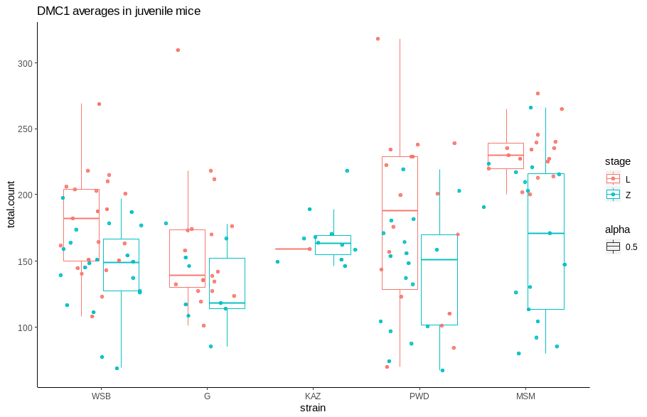

In order to investigate the recombination pathway – we quantified DSBs a precursor in a subset of strains for males. (juvinille male mice)

category | ncells | mean.count | stage
WSB male | 21 | 177.7619 | L
G male | 19 | 158.1579 | L
PWD male | 18 | 180.2222 | L
MSM male | 17 | 231 | L
KAZ male | 1 | 159 | L
WSB male | 20 | 144.25 | Z
G male | 9 | 131.7778 | Z
PWD male | 18 | 140.7778 | Z
MSM male | 17 | 164.4118 | Z
KAZ male | 11 | 167.3636 | Z

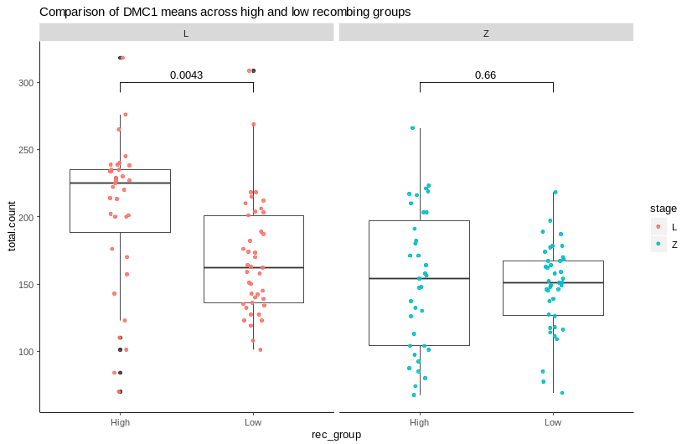

DMC1 foci t.test | Stage | P value
High -- Low | Z | 0.6627983
High -- Low | L | 0.0021446

Chromosome Class Proportions
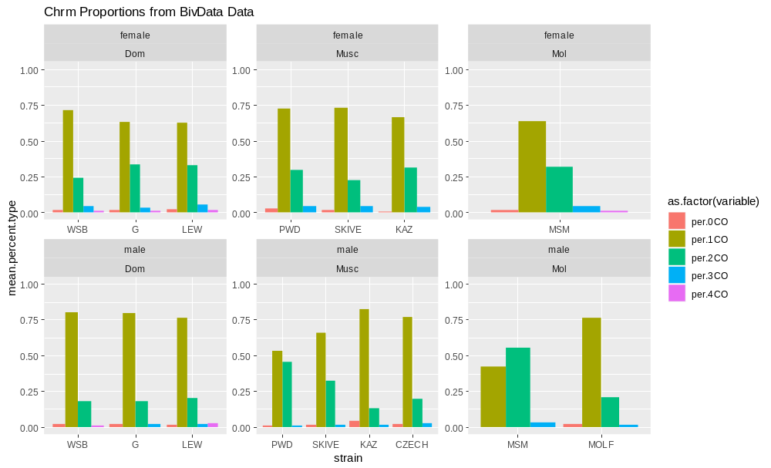
I use a chi square test, prop.test(), to compare the proportions of chromosome class across groups. a significant p value indicates, at least one group is different from the rest
Female
Chi square  pvals | Dom  WSB, LEW, G | Musc  PWD, SKIVE, KAZ, |  | High  G, LEW | Low  (the rest)
1CO | 0.0001969 | 0.08492 |  | 0.3861 | 7.064e-06
2CO | 2.524e-05 | 0.1658 |  | 0.7207 | 3.938e-06
WSB has lower proportion of 2CO (21% vs 31%), compared to the other strains. The female high strains, G and LEW, have the high proportion of 2COs.
Male
Chi square  pvals | Dom  WSB, LEW, G | Musc: PWD, SKIVE, KAZ, CZECH | Mol; MSM, MOLF |  | Low  (-SKIVE) | High  (-SKIVE) |  | Low  (+SKIVE) | High  (+SKIVE)
1CO | 0.3924 | < 2.2e-16 | 2.949e-12 |  | 0.04539 | 0.03519
2CO | 0.6758 | < 2.2e-16 | 4.719e-13 |  | 0.009171 | 0.0647

There is no significant difference in the proportions of the Dom strains. The proportions across are very different across the Musc and Mol sub species. When the high and low groups are compared the p-values are much higher, indicating that the proportions of low Musc and Dom are more similar than low Musc and high Musc strains. SKIVE is an intermediate high recombining strain, so it has different proportions than all groups. (including in the low and high group decreases the p values.)

High female strains, G and Lew have significantly more 2CO bivalents.

The overall male pattern that’s most striking is the gradient of 2CO proportions
**MSM 60% > PWD 50% > SKIVE 30% > 20 - 10% remaining (low) strains**

Q1 Single Bivalent Heterochiasmy Predictions

Which bivalent level traits will be sexually dimorphic?
- SC length, SC length will be sexually dimorphic
(result) A. single SC are longer in females than male
B. (this differences in SC size is beyond the effect of XX), (the expected difference if XX was the only source of difference), ALL bivalents (by class) are longer in females than males. The distributions for female SCs within cells are all longer. (The bottom 25% of bivalents are longer in females than males)
2) Normalized CO positions
A. 1CO normalized positions will be sexually dimorphic
Telomere bias and uniform 1CO landscapes are (pretty conserved in all strains) (look closer at a few male Dom strains)
B. Sis-co-ten (sister cohesin tension) will also be sexually dimorphic: this metric reflects the overall uniform vs telomere pattern documented in males and females.
C. Centromere and telomere distances will be sexually dimorphic; males having more telomere positioned COs

3) IFD, No predicted difference in physical distance between foci on the same bivalent across sexes.
A. raw IFDs are longer in females, and normalized IFDs are longer in males. This is driven by more observations of lower normalized IFDs in females. (Try running the MM without PWD, MSM and SKIVE – Is sex a sig factor for normalized IFD) (I am not sure if I could classify the close IFD positions are different classes)
B. the high Rec strains (and SKIVE) have a male specific 30% normalized IFD lower threshold. (Males in these strains lack bivalents with very close foci on 2 CO bivalents)

Q1 SC Lengths

Means of SC length separated by Chrm Class
SC Length  Means | Fmean  1CO | F  N  1CO | Mmean  1CO | M  N  1CO | Fmean  2CO | F  N  2CO | Mmean  2CO | M  N  2CO | Fmean  3CO | F  N  3CO | M.mean  3CO | M  N  3CO
WSB | 92.58 | 540 | 68.86 | 472 | 112.58 | 187 | 85.62 | 107 | 121.70 | 31 | -- | --
LEW | 94.965 | 433 | 73.92 | 409 | 112.57 | 245 | 91.868 | 106 | 125.43 | 28 | 89.50 | 10
G | 101.77 | 457 | 78.455 | 797 | 123.55 | 242 | 94.49 | 183 | 135.58 | 19 | 95.20 | 10
PWD | 100.25 | 698 | 77.49 | 365 | 119.44 | 286 | 97.24 | 301 | 118.41 | 36 | 99.33 | 9
MSM | 104.69 | 362 | 80.48 | 77 | 127.51 | 159 | 95.406 | 91 | 150.62 | 21 | 97.000 | 5
KAZ | 96.20 | 351 | 79.006 | 502 | 122.51 | 128 | 91.631 | 84 | 166.00 | 5 | 92.57 | 7
SKIVE | 92.304 | 352 | 73.05 | 510 | 110.88 | 113 | 91.956 | 253 | 116.5 | 20 | 98.0 | 6
MOLF |  |  | 78.58 | 326 |  |  | 92.794 | 97 |  |  | 94.6 | 5

M1. Lmer(mean_sc ~ subsp * sex + (1|strain))
Q1. SC Length  M1 | Fixed Effects |  |  | Random Effect  exactRLRT | Predictions met
Q1. SC Length  M1 | subsp | sex | subsp*sex | strain | Predictions met
SC length  All pooled | 0.364038  NS | -28.769236  Highly Sig | 6.037493  NS | Slightly significant  0.0045 | Yes, female bivalents are longer (still need to test XX adjustment)
Long.biv | -0.126264  NS | -23.719327  High sig | 6.096744  NS | p-value = 0.2933 | (this model started throwing error)
1CO | 1.616610  NS | -24.979951  Highly sig | 1.646027  NS | p-value = 0.0124
2CO | -- | - | 0.3093 | p-value = 0.3114 | Can’t get these models to work
3CO | -- | - | - |  | Can’t get these models to work, Na.omit()

The fixed sex effects are significant for all the models. The fixed sex effect is stronger than the subsp and interaction fixed effect.
Glm( SC.mean ~ sex * strain )
Q1. SC Length M2.all | int | strain | sex | Sex*strain
M2.Dom | 98.986 | 11.272 (G)  8.370 (LEW) | -27.418 | -1.791  -1.719
P values | < 2e-16 *** | 0.0390 *  0.0956 . | 1.77e-05 *** | 0.7975  0.8096
M2.Musc | 106.234 | -9.730 (skiv)  5.457 (KAZ) | -19.091 | 2.432  -12.559
P values | < 2e-16 *** | 0.0435 *  0.2096 | 9.92e-05 *** | 0.7141  0.0925 .
M2.Mol | 112.965 | -7.315 | -25.277 | NA
P values | 9.61e-12 *** | 0.0796 . | 7.66e-05 *** | NA

Q1. SC Length M2.1CO | int | strain | sex | Sex*strain
M2.Dom.1CO | 93.3889 | 9.1802  6.4464 | -24.7618 | 0.1611  -0.8169
P values | < 2e-16 *** | 0.103773  0.215679 | 0.000131 *** | 0.982403  0.912903
M2.Musc.1CO | 100.94305 | -8.60856  2.27481 | -24.20312 | 5.09431  0.06147
P values | < 2e-16 *** | 0.0463 * (skiv  0.5557 (KAZ) | 5.41e-07 *** | 0.3945  0.9925
M2.Mol.1CO | 104.422 | -1.789 | -24.897
P values | 5.78e-12 *** | 0.593 | 3.00e-05 ***

Q1. SC Length M2_2CO | int | strain | sex | Sex*strain
M2.Dom.2CO | 115.31989 | 8.17870  4.96878 | -29.01999 | -0.03051  0.45889
P values | <2e-16 *** | 0.3459  0.5369 | 0.0026 ** | 0.9979  0.9686
M2 Musc.2CO | 118.828 | -10.775  7.513 | -19.950 | 5.108  -15.937
P values | < 2e-16 *** | 0.12915  0.24890 | 0.00409 ** | 0.60250  0.14513
M2.Mol.2CO | 126.020 | -2.875 | -31.755
P values | 6.43e-12 *** | 0.485 | 2.12e-05 ***
The general pattern is that / the overall pattern is that all the models have significant sex effects, with the male effect being smaller. Slightly strange outcomes for the Musc – They are the only subsp with significant strain effects. (it is a very slight p value). (Make plots – to take a closer look – post hoc)
I think the plots indicate that the SKI
For the Musc – SKIVE has a significant strain effect – because BOTH female and male SC lengths are shorter compared to PWD and KAZ. (This is kinda strange cause SKIVE is a

Q1 IFD Lengths

Mean IFD values / tables
IFD | F.n | M.n | F.  mean  raw | M.IFD.  mean  raw | F.  norm | M.  norm
WSB | 187 | 107 | 52.50538 | 47.14019 | 0.4602812 | 0.5362821
LEW | 245 | 106 | 53.96327 | 51.80952 | 0.4791878 | 0.5533493
G | 242 | 183 | 60.44583 | 52.55738 | 0.4886198 | 0.5477403
PWD | 286 | 301 | 57.15088 | 58.81333 | 0.4770388 | 0.6018426
MSM | 159 | 91 | 60.67089 | 56.25275 | 0.4711622 | 0.5874693
KAZ | 128 | 84 | 63.27344 | 48.94048 | 0.5087810 | 0.5239928
SKIVE | 113 | 253 | 53.93805 | 57.61508 | 0.4846905 | 0.6266287
MOLF |  | 97 |  | 47.36458 |  | 0.5133379

The SKIVE male is normalized IFD is the highest! SKIVE male also has high Norm IFD, like PWD and MSM. – Is it strange that SKIVE has intermediate gwRR (but maybe some aspects are like MSM and PWD). **SKIVE has (IFD) patterns that is closer to the high MSM-PWD**

Models to test effects
Traits | Fixed Effects |  |  | Random Effect | Predictions met
Traits | subsp | sex | subsp*sex | strain | Predictions met
2CO_IFD.raw | 0.448646  P= 0.8551 | -6.358345  P= 0.04751 | 3.661211  P= 0.38178 | X | No, the male effect coeff is  -6.5. Female IFDs are slightly longer.
2CO_IFD.PER  (1-0) | 0.004682 p= 0.737 | 0.072634  p= 0.00553 | 0.026687  p= 0.41905 | p=0.0548
2CO_IFD.PER  (-PWD,MSM,  SKIVE) | 0.008505  p=0.707425 | 0.071628  p=0.000003 | -0.027552  p=0.320879 |  | Males slightly higher, sex is still significant.

Differences in lower IFD threshold.

 | 2CO | 2CO | Below  30% | Below  30% | Female ratio 2CO IFD  PER below 30% | Male ratio 2CO IFD  PER below 30% | F - M
WSB | 187 | 107 | 16 | 35 | 0.18716578 | 0.14953271 | 0.03763307
G | 242 | 183 | 15 | 28 | 0.11570248 | 0.08196721 | 0.03373527
LEW | 245 | 106 | 10 | 30 | 0.12244898 | 0.09433962 | 0.02810936
PWD | 286 | 301 | 4 | 46 | 0.16083916 | 0.01328904 | 0.14755012
KAZ | 128 | 84 | 14 | 12 | 0.09375000 | 0.16666667 | -0.07291667
SKIVE | 113 | 253 | 0 | 11 | 0.09734513 | 0.00000000 | 0.09734513
MSM | 159 | 91 | 3 | 20 | 0.12578616 | 0.03296703 | 0.09281913
MOLF |  |  |  |  | (need female data) | 0.08247423

i) All high rec strains have a large difference between the proportions of bivalents which have short normalized IFDs. The ‘high rec strains’
ii) KAZ is the only strain with more short normalized IFDs in males than females.

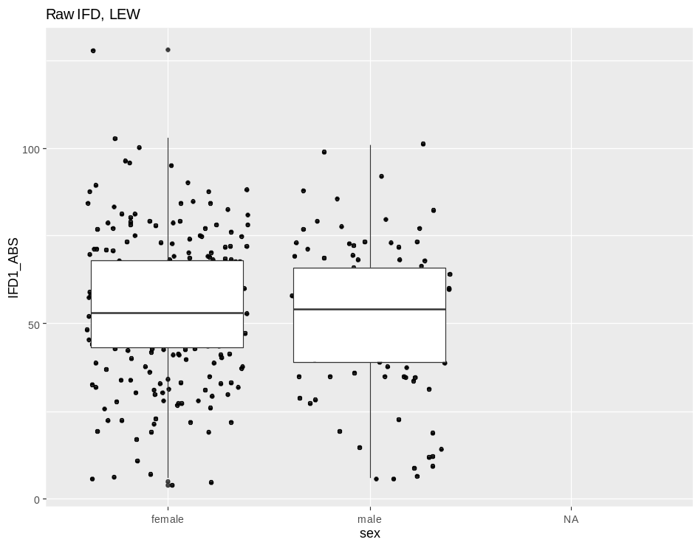
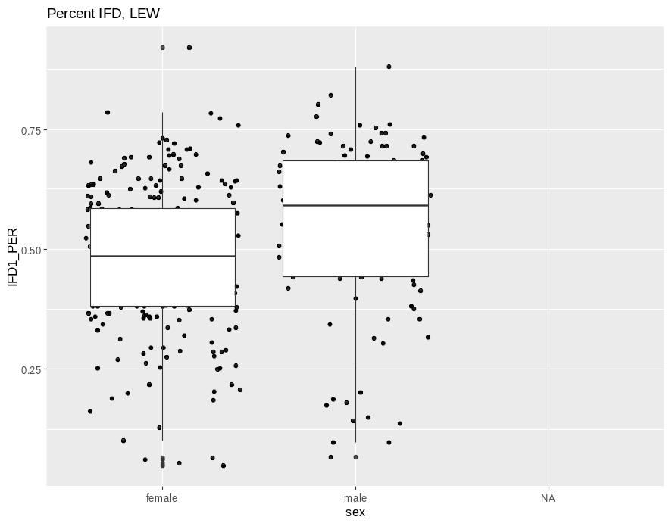
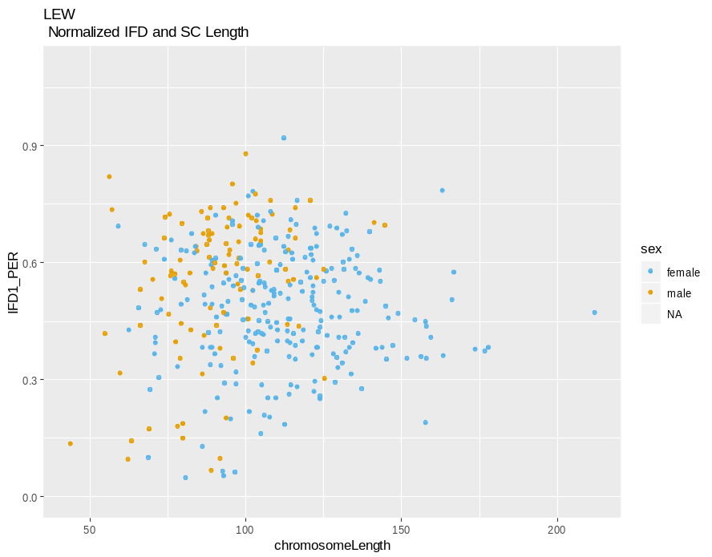

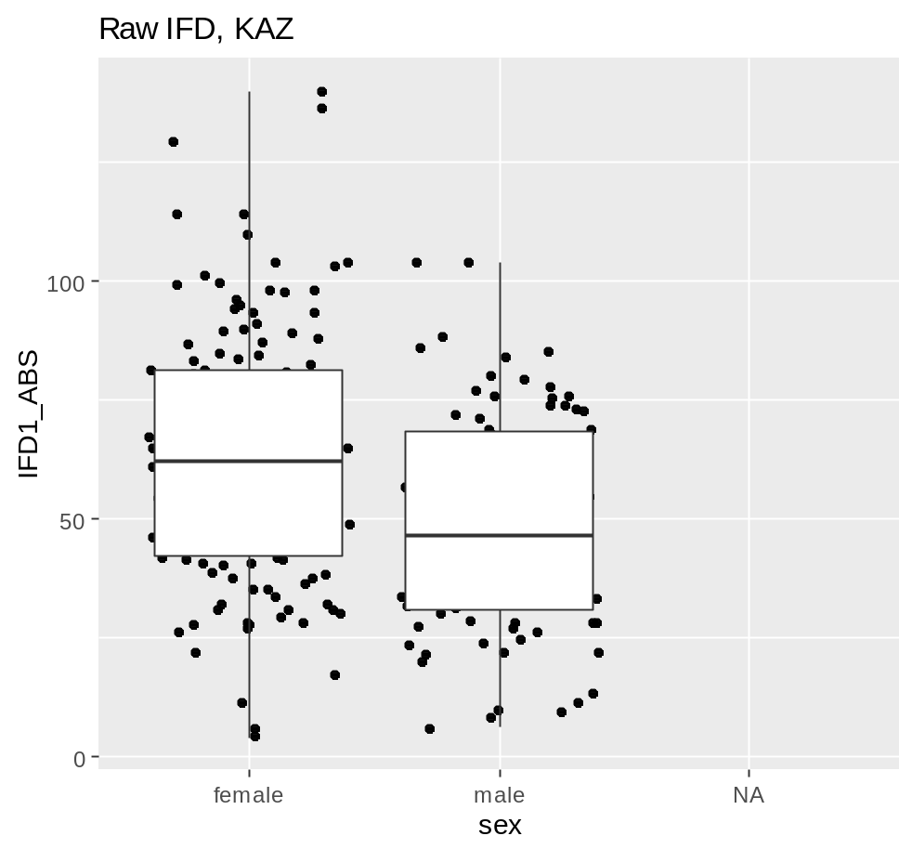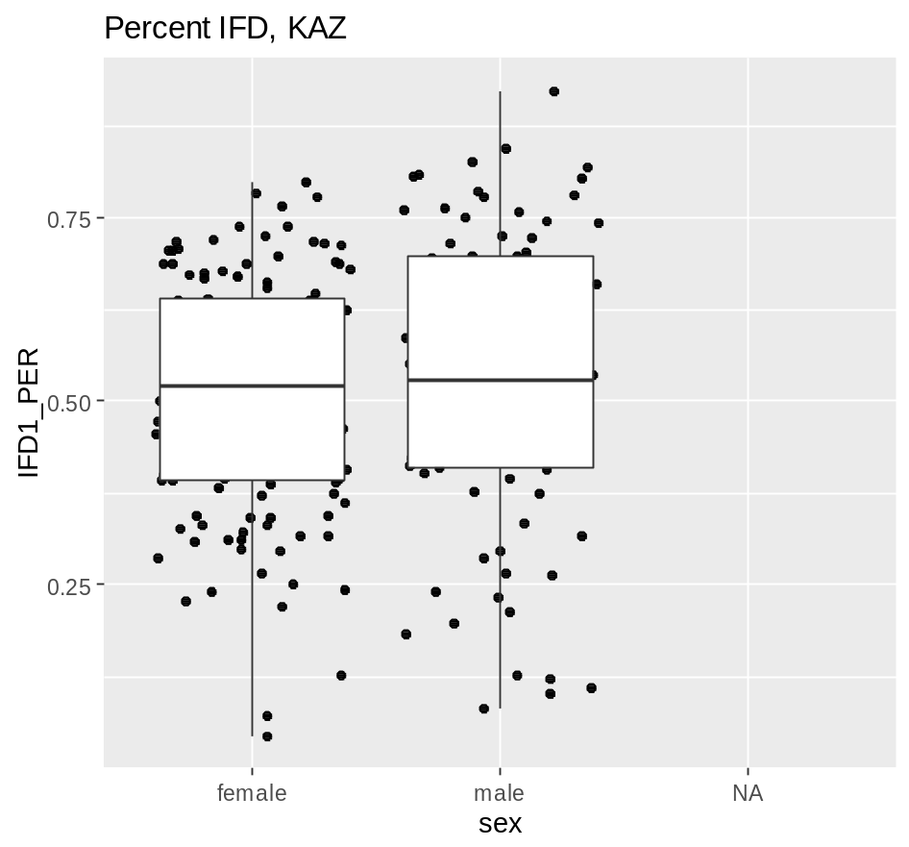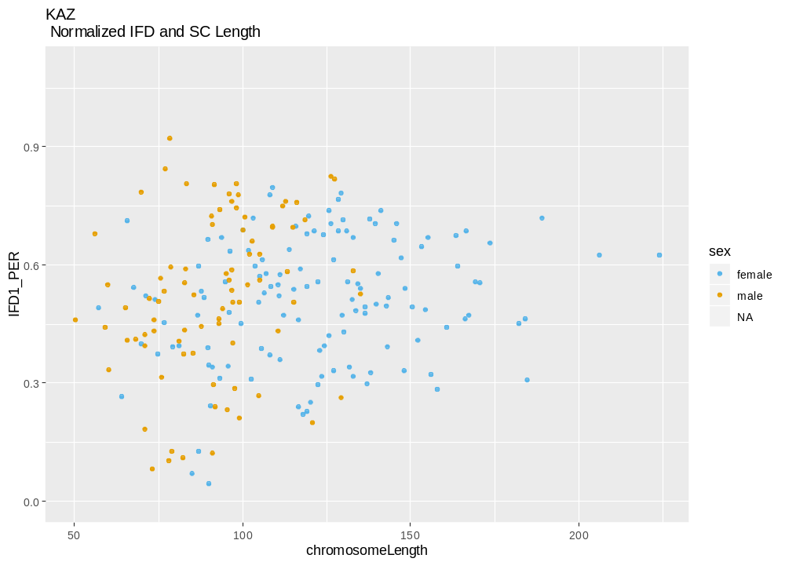

Q1 CO Landscape
We choose to limit our analysis for this section to bivalents with single foci in order to compare the sex differences in the Rec landscape. While the landscape of bivalents with multiple foci will be highly influenced by the CO interference, bivalents with single foci/COs may display positional biases independent of interference. Sex differences in the positional bias of COs along a bivalent/chromosome, with females displaying a uniform landscape and males displaying a bias towards telomeres (for both metacentric and telocentric chromosomes), is one of the most widely documented forms/traits of heterochiasmy (Sardell + Kirkpatrick). We use the normalized position for the foci to account for differences in total SC length. (There are other metrics which can be used to examine the Rec landscape across all chromosome classes; centromere/telomere distances and sis-co-ten).

Nrm.1CO.pos | F.n 1CO  (hand.check) |  | F.mean | M.n 1CO  (hand check) | M.mean
WSB | 540 (540) |  | 0.5893896 | 472 (472) | 0.7315466
LEW | 433 |  | 0.5406755 | 409 | 0.6684583
G | 458 |  | 0.5520921 | 797 | 0.6695704
PWD | 698 |  | 0.5718473 | 365 | 0.6684583
MSM | 362 |  | 0.5748201 | 77 | 0.6885456
KAZ | 351 |  | 0.5470663 | 502 | 0.6792991
SKIVE | 352 |  | 0.5771802 | 511 | 0.6795809
MOLF |  |  |  | 326 (326) | 0.5914709
The average female norm.Foci position is around 50%, the male normalized position ranges from 60% to 73%.

M1.nrmCO  Lmer()? | Fixed Effects |  |  | Random Effect
M1.nrmCO  Lmer()? | subsp | sex | subsp*sex | strain
Nrm.1CO.pos | X | p=0 | X | p=0
Sis.co.ten | -0.981277  p=0.712167 | -20.767638  p=0 | 9.928147  p=0.005 | p=0.0018
Telomere.dist | X | p=0 | X | p=0.0021
Cent.dist | X | X | p=0.0009 | X

Strain and sex effects are very significant for the Nrm.1CO.pos

Q1. NrmF1pos  M2 | int | strain | sex | Sex*strain
All | 0.589390 | -0.037298 (G)  -0.048714 (LEW)  -0.017542 (PWD)  -0.014569 (MSM)  -0.140076 (MOLF)  -0.012209 (SKIVE)  -0.042323 (KAZ) | 0.142157 | -0.024679  0.009589  -0.045546  -0.028431  NA  -0.039756  -0.009924
pvalues | < 2e-16 *** | 0.1065 (G )  0.0266* (LEW)  0.4024 (PWD)  0.5562 (MSM)  1.18e-08*** (MOLF)  0.6217 (SKIVE)  0.0767 . (KAZ) | 7.08e-08 *** (male) | 0.3985  0.7473  0.1227  0.3889  NA  0.2103  0.7667
M2.Dom | 0.589390 | -0.037298 (G)  -0.048714 (LEW) | 0.142157 | -0.024679  0.009589
P values | < 2e-16 *** | 0.0624 . (G)  0.0117 * (LEW) | 5.11e-08 *** | 0.3230  0.7047
M2.Musc | 0.571847 | 0.005333 (Skive)  -0.024781 (KAZ) | 0.096611 | 0.005790  0.035622
P values | < 2e-16 *** | 0.786  0.177 | 8.55e-06 *** | 0.839  0.251
M2.Mol | 0.57482 | -0.09707 | 0.11373
P values | 5.56e-10 *** | 0.00964 ** | 0.00400 ** | NA

Q1.M2 nrm Foci pos
Nrm F1 ~ strain * sex

It seems like the most prevalent pattern is that the sex effect is v. significant
But there are strains with sig effects
LEW has a significant strain effect – make plots to investigate these.
MOLF has a v. significant strain effect – are both sexes effected?

I think the lack of interaction effect indicates that – there’s no strain specific sexual dimorphic effect. The sex effect explains most of the pattern – but some strains differ in both sexes.

For the Dom data set – both G and LEW strain effects are significant (Less than the sex effect). By the coefficients it seems like G and LEW are more teloemric in the nrm Foci pos. (make post – hoc plots for this).

For the Mol, both the sex effect and MOLF strain effect are significant (this means both female and male rec landscapes are effected – most of the time towards the middle

GENERALLY – Sex is the biggest effect for the 1CO landscape (female middle male telomereic)
molf

Long Biv? -- don’t have female long biv (there are ~500 female long biv obs)
USE LONG biv models !!!

Sis-co-ten – Even with in the normalized siscoten, I think the male data shows more clustering. I’m not sure
Sex and interaction are significant. – what does normalized sis.co.ten mean? I’m not sure that it’s most biologically relevant since I don’t think cohesion adjusts to size of chrms.
Table of proportions below 30% IFD PER
(sis-co-ten)? Sis-co-ten by chromosomeLength --- There are distinct patterns by across sexes – In males the chrm classes (1CO, 2CO) separate/cluster very cleanly – where as they don’t separate / cluster in females.

Q1 Summary of Results
Which bivalent level traits will be sexually dimorphic?
- SC length, SC length will be sexually dimorphic
Prediction supported
2) Normalized 1CO position
Prediction supported
i) SC length/chromatin condensation and ii) differing recombination ‘landscapes’ are conserved chromosome level aspects of heterochiasmy.

3) normalized IFD, No predicted difference in physical distance (AE-SC) between foci on the same bivalent across sexes. (DeBoer)
-Prediction not supported. There’s sex differences for IFD values in the physciale SC scale. This is primarily due to females having an enrichment for short IFDs.
- Lower female nrm.IFD means fit the general pattern of uniform distribution of Rec landscape in the female Rec landscape.
-High rec males, have striking cut off ~30% for normalized IFD values. This indicates 2COs from high rec strains are more often further apart.

Q2 Male Musc Polymorphism
Which traits distinguish high and low recombining males in Musc strains? (High: MSM, PWD, SKIVE, Low: KAZ, MOLF, CZECH, Dom strains).

Male number of mouse (consider removing the cast strains)
WSB G LEW PERC PWD MSM MOLF SKIVE KAZ TOM AST CZECH CAST HMI
12 18 10 1 8 8 6 6 13 2 3 3 2 4
Long Biv Dataset (show the number of Bivalents)
WSB G LEW PWD MSM MOLF SKIVE KAZ CZECH
19 47 10 21 4 16 33 45 13

For Q2 3 models will be applied to the mouse av single bivalent metrics
M1. Lm(mouse.av.meteric ~ subsp * strain)
M2. Lm(mouse.av.meteric ~ strain) - divided by subsp
M3. Logistic regression ( rec group ~ mouse.av.metric ) and (rec.group ~ bivalent.metric)

Three predictions for how the strains will very within each subsp(based on the gwRR pattern.
1. Dom strain will not have significant effect (WSB = LEW = G)
2. Musc strains (PWD > SKIVE > KAZ, CZECHII )
3. Mol strains (MSM > Mol)

1. SC length positive correlation with high Rec
2. COI / IFD negative correlation with high Rec
(No prediction for CO position)

Q2 Variation in the SC Lengths

Male Mean SC lengths across classes
SC Length  Means | Total  obs | Mean total  sc | Mean  0CO | n | mean  1CO | n | mean  2CO | n | M.mean  3CO | n | Interpretation
WSB | 625 | 71.7328 | 59.33333 | 12 | 68.86653 | 472 | 85.61682 | 107
G | 1031 | 81.6033 |  |  | 78.45546 | 797 | 94.4918 | 183 | 95.2 | 10
LEW | 558 | 77.89068 | 64.5 | 6 | 73.91932 | 409 | 91.86792 | 106 | 89.5 | 10
PWD | 718 | 86.68384 |  |  | 77.49041 | 365 | 97.24585 | 301 | 99.33333 | 9 | Expected order not followed
SKIVE | 813 | 79.35547 | 76.83333 | 6 | 73.04902 | 510 | 91.95652 | 253 | 98 | 6 | Expected order not followed
KAZ | 740 | 79.99054 |  |  | 79.00598 | 502 | 91.63095 | 84 | 92.57143 | 7 | Expected order not followed
CZECHII | 256 | 82.61328 | 52.5 | 4 | 79.40223 | 179 | 96.5 | 50 | 100.6667 | 6 | Expected order not followed
AST | --
TOM | --
MSM | 178 | 88.20787 |  |  | 80.48052 | 77 | 95.40659 | 91 | 97 | 5 | Expectation followed
MOLF | 466 | 81.29185 | 68.66667 | 9 | 78.57669 | 326 | 92.79381 | 97 | 94.6 | 5 | Expectation followed

Q2.SC all Chrm Classes
M2 glm() | Full dataset  all | Dom | Musc | Mol
M2. Glm()  SC ~ strain | All strains sig  Int (WSB),  G,  PWD,  MSM are most sig | Strain G, LEW are sig  Intercept (WSB) - < 2e-16 ***  G - 9.05e-05 ***  LEW - 0.0055 ** | 4 (strains)  -intercept(PWD) -  < 2e-16 ***  SKIVE - 0.00254 **  KAZ - 0.01256 *  CZECH - 0.05200 . | molf is sig diff from MSM  0.0284 * | WSB and G were not expected to be sig.  Dom doesn’t meet prediction. I think Musc and Mol met predictions
P values
M2 glm()
Log regression high vs low  P value | 0.00544 **  0.00665 ** | --NA-- | 0.425  0.396 | 0.283  0.283
My prediction for variation across Dom strains isn’t met, there is more variation across strains for mouse average SC length. (I need to address the fact that there might be variation due to the number of mice or cells)

SC Length Chrm Class
Log regression( High vs Low ~ SC Length )
Log regression  SC predict high vs Low  p values | SC length 1CO | SC length 2CO | SC length 3CO
All | 0.910  0.999 | 0.0363 *  0.0441 * | 0.179  0.221
Musc | 0.0685 . (wrong direction)  0.0700 . | 0.364 (right direction, not sig)  0.333 | 0.367  0.351
Mol | 0.4  0.4 | 0.294  0.295 | 0.808  0.807
Shaper clustering of SC lengths across chromosome classes in the high Rec males (In high rec strains, 1CO bivalents are shorter and 2CO are longer– because longer chromosomes move into the 2CO bin, whereas in the low rec group both physical long and shorter chroms have 1CO). A good way to display this pattern is the SC length y axis and CO number on the x axis
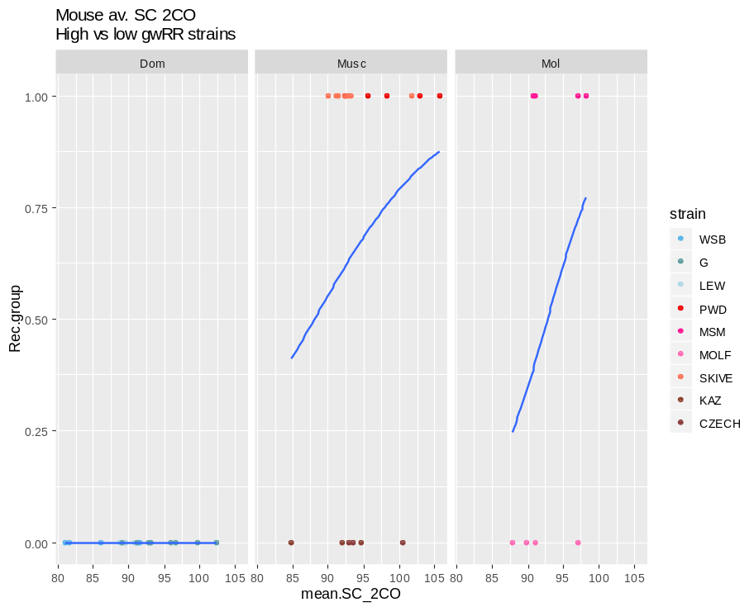
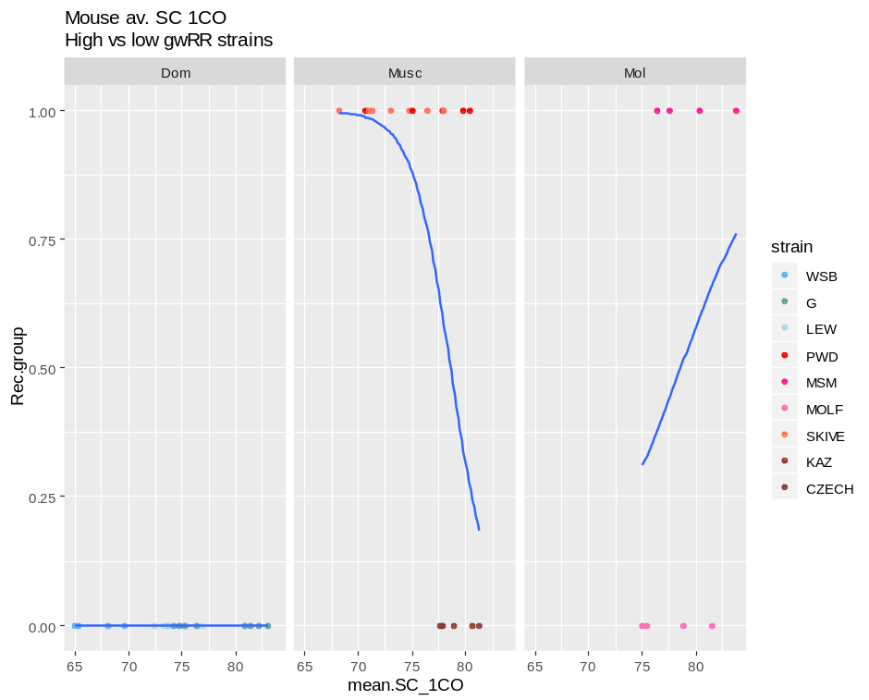

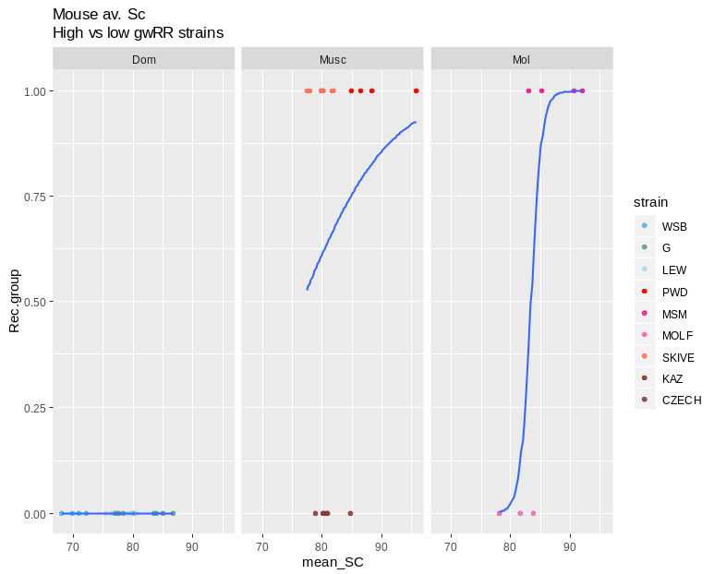
Each point is a mouse average SC. When all bivalents are pooled, the logistic regression SC lengths predict the groups. When the data is divided by CO number, 1CO’s have a higher SC length in the low group – in the low group more chrms, including the longer ones have 1CO – whereas in the high group, only shorter chrms (SC) are in the 1CO class.
For the 2CO class of bivalents – all the SC are longer, the high group averages were longer than the low.

and the mean 2COs SC are higher in the high strains
(this must have something to do with the physical size effect)

Long Biv Data set
 | all | Dom | Musc | Mol
M2. Glm()  SC ~ strain | Int 4.35e-10 ***  MSM 0.0089 **  SKIVE 0.0667 .  CZECH 0.0361 * | G 0.32  LEW 0.41 | SKIVE 0.602  KAZ 0.842  CZECH 0.267 | NA  (not enough observations?) | subsetted by subsp – I’m not surprised there are no average difference for the binned long chrms
SC ~ strain * subsp |  | --NA-- | --NA-- | --NA--
Log regression high vs low  P value | Int 0.155  Mean_SC 0.181 |  |  |  | Not enough obs to split by subsp,
For the full data set --- MSM long biv SC’s are significantly longer? --- this is in agreement with the main finding of longer SC. There is limited variation in the long biv group to detect effects due to strain or subspecies.

Number of long biv observations by chrm class
WSB G LEW PERC PWD MSM MOLF SKIVE KAZ TOM AST CZECH CAST
0 0 0 0 0 0 0 0 0 1 0 0 0 0
1 12 29 5 0 3 2 9 18 21 0 0 4 0
2 7 16 4 0 17 1 4 11 11 0 0 8 0
3 0 1 1 0 0 1 0 2 0 0 0 0 0

How well does SC length predict chromosome class? Prediction, High rec strains will have more sig pvalue, given the lower overlap in SC lengths across chrm class

Log regression( 1CO vs 2CO ~ SC Length) (within categories / male strains)
By strain
Log regression  SC predict  1CO | 2CO | Co-efficients | P values
WSB | -6.267440  0.062024 | <2e-16 ***  <2e-16 ***
G | -5.780909  0.049946 | <2e-16 ***  <2e-16 ***
LEW | -6.107735  0.057577 | < 2e-16 ***  1.43e-15 ***
PWD | -5.129187  0.056649 | <2e-16 ***  <2e-16 ***
SKIVE |  | <2e-16 ***  <2e-16 ***
KAZ |  | 7.25e-16 ***  3.83e-08 ***
CZECH |  | 4.08e-10 ***  2.63e-07 ***
MSM |  | 6.33e-06 ***  2.03e-06 ***
MOLF |  | 9.3e-15 ***  4.2e-10 ***

All the within strain logistic regressions are significant for predicting 1 or 2COs.
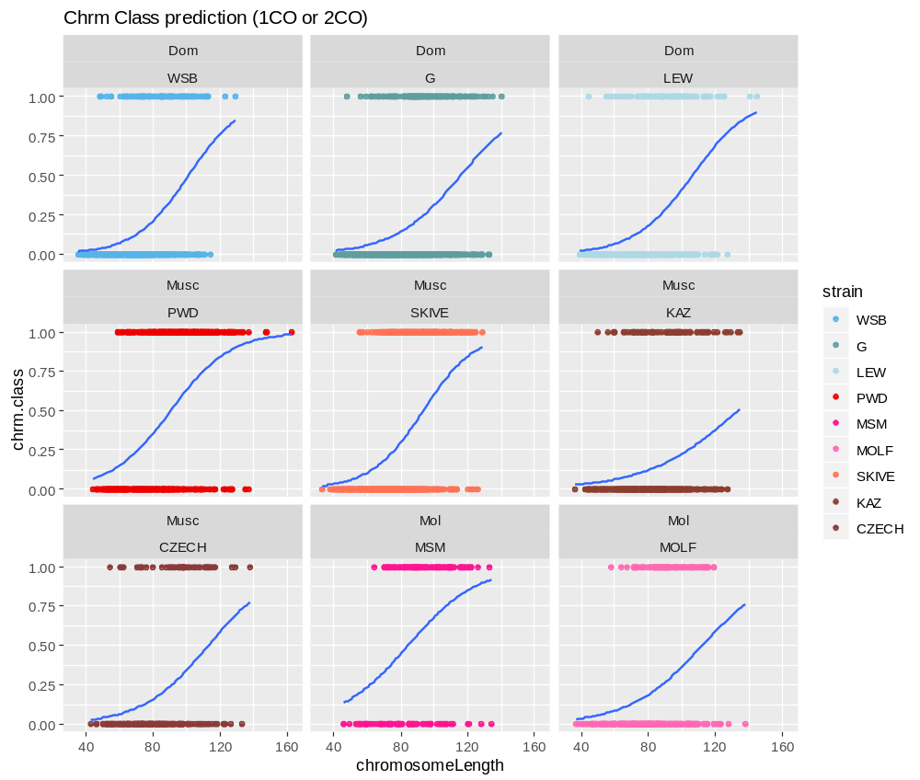

Q2 CO placement (1CO)
-Has the male 1CO landscape evolved across house mouse?
-Is there a consistent pattern for the high Rec strains?

Mouse av 1CO F1_PER (are any of the strains significant?)
Nrm.1CO | Intercept | Subsp | strain
M1. SC ~ strain * subsp | 0.73155 | -0.04064  -0.14008 | -0.06198 (G)  -0.03912 (LEW)  0.09707 (MSM)
pvals | < 2e-16 *** | 0.119031 (Musc)  7.8e-07 *** (Mol) | 0.002990 **  0.084331 .  0.000368 *** | MOLF strain effect is NA,
M2. SC ~ strain | 0.73155 |  | -0.06198  -0.03912  -0.06309  -0.04300  -0.14008  -0.05197  -0.05225  -0.04064
pvals | < 2e-16 *** |  | 0.00299 ** (G)  0.08433 . (LEW)  0.00701 ** (PWD)  0.07412 . (MSM)  7.8e-07 *** (MOLF)  0.01877 * (SKIVE)  0.04744 * (KAZ)  0.11903 (CZECH) | WSB is most telomeric.  MOLF is very centrally positioned.  G – is also pretty central.
-WSB has the most terminal F1 pos,
-MOLF has the largest strain effect, with more centrally placed F1. PWD, SKIVE and KAZ also are significantly more central.
--This table is partially duplicated below

Lm, mouse average, Norm1CO
 | all | Dom | Musc | Mol
 |  | 0.73155  -0.06198  -0.03912 | 0.66846 (int PWD)  0.01112 (SKIVE)  0.01084 (KAZ)  0.02245 (CZECH) | 0.68855  -0.09707
P value | 0.00299 ** (G)  0.08433 . (LEW)  0.00701 ** (PWD)  0.07412 . (MSM)  7.8e-07 *** (MOLF)  0.01877 * (SKIVE)  0.04744 * (KAZ)  0.11903 (CZECH) | < 2e-16 ***  0.00256 **  0.06427 . | 3.89e-16 ***  0.557  0.635  0.332 | 1.47e-07 ***  0.0328 *
WSB is the most telomereic of the strains.

Nrm.1CO | Intercept | Subsp | strain
M1. SC ~ strain * subsp | 0.73155 | -0.04064  -0.14008 | -0.06198 (G)  -0.03912 (LEW)  0.09707 (MSM)
pvals | < 2e-16 *** | 0.119031  7.8e-07 *** | 0.002990 **  0.084331 .  0.000368 *** | MOLF strain effect is NA,
M2. SC ~ strain | 0.73155 |  | -0.06198  -0.03912  -0.06309  -0.04300  -0.14008  -0.05197  -0.05225  -0.04064 | WSB has the most terminal F1
pvals | < 2e-16 *** |  | 0.00299 ** (G)  0.08433 . (LEW)  0.00701 ** (PWD)  0.07412 . (MSM)  7.8e-07 *** (MOLF)  0.01877 * (SKIVE)  0.04744 * (KAZ)  0.11903 (CZECH) | WSB is most telomeric.  MOLF is very centrally positioned.  G – is also pretty central.
-can’t detect any clear connection between the 1CO normalized position and the Rec.groups
Logistic regression – can the 1CO normalized position predict if the Rec Group
Log regression  1CO position | All (mice) | Interpt
All (mice)  p values | 0.802  0.910 | When all mice are analyzed,
Musc All (mice)  p values | 0.437  0.466
Mol All (mice)  p values | 1  1
Bivalent level measures | 0.802  0.910
Bivalent level measures  Musc | 0.00447 **  0.15912 | The intercept is significant.
Bivalent level measures  Mol | 1  1
The rec group can’t be accurately predicted based on the mouse averages normalized 1CO positions
What do these logistic regression plots look like? – Is it important – Maybe just conclude that Norm.1CO isn’t relevant for (predicting gwRR variation)
1CO Pos | n.obs | Mean  F1 | Mean  nrmF1 | interp
WSB | 472 | 49.59534 | 0.7278682
G | 797 | 51.82058 | 0.6650317
LEW | 409 | 51.05623 | 0.6918036
PWD | 365 | 50.96986 | 0.6666695 | The higher strains are more centromeric  (is this difference stat sig)
SKIVE | 510 | 48.45383 | 0.6671023
KAZ | 502 | 53.37649 | 0.6807107
CZECHII | 179 | 54.15642 | 0.6870426
AST
TOM
MSM | 77 | 52.1039 | 0.6627513 | MSM is more telomeric – subsampling might be an issue
MOLF | 326 | 46.4816 | 0.5963067 | MSM is more telomeric – subsampling might be an issue

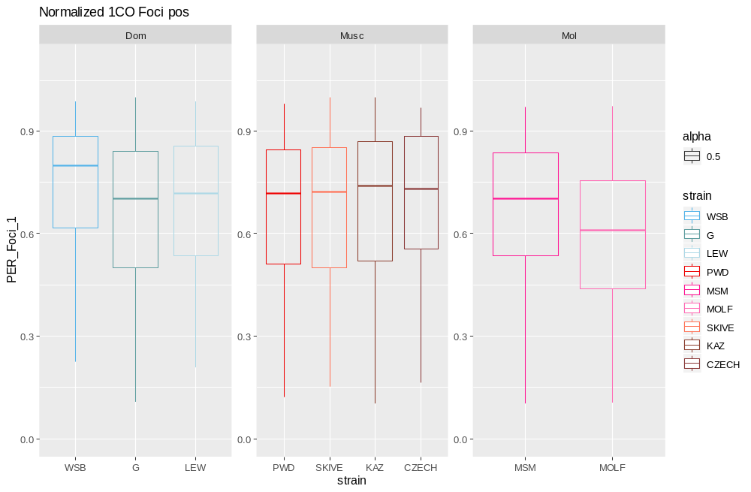
This plot is from bivalent level observations. From the plot you can see that PWD, SKIVE and MSM have more centralized / centromeric Foci

- WSB is the most telomeric strain (the position has evolve? What about mouse specific patterns)
- The high rec strains have more central foci.
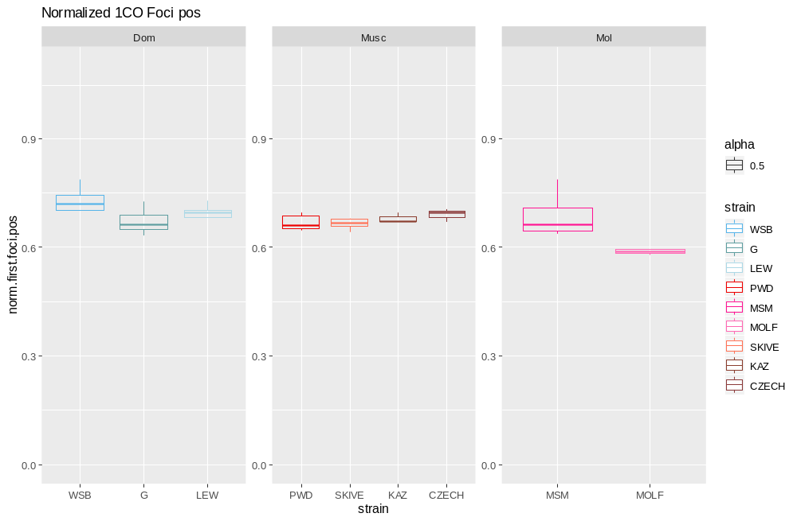
What if this is due to chromosome size effect? (smaller chrms are more likely to be 1CO – smaller chrms have more uniform landscape)

This second plot is made from the mouse averages. They generally show the same pattern. MOLF is very central.
The Musc high Rec are a bit lower than the other Musc strains.

Q2 IFD and Interference

M1. (mouse av IFD metric ~ subsp * strain )
M2. (mouse av IFD metric ~ strain) *split up by subsp?
M3. ( Rec. group ~ mouse av IFD metric )
The dataset used for this section will be only the 2CO bivalent measures of IFD. The raw and normalized measures will be compared.

IFD | n.obs | Mean  F1 | Mean  nrmF1 | interp
WSB | 107 | 47.14019 | 0.5362821 | (are these sig) – test mouse averages
G | 183 | 52.55738 | 0.5477403 | (are these sig) – test mouse averages
LEW | 106 | 51.80952 | 0.5533493 | (are these sig) – test mouse averages
PWD | 301 | 58.81333 | 0.6018426 | (looks like PWD and SKIVE are greater )
SKIVE | 253 | 57.61508 | 0.6266287 | (looks like PWD and SKIVE are greater )
KAZ | 84 | 48.94048 | 0.5239928 | (looks like PWD and SKIVE are greater )
CZECHII | 50 | 52.54 | 0.5362667 | (looks like PWD and SKIVE are greater )
AST |  |  |  | (looks like PWD and SKIVE are greater )
TOM |  |  |  | (looks like PWD and SKIVE are greater )
MSM | 91 | 56.25275 | 0.5874693 | MSM loot sig greater than MOLF
MOLF | 97 | 47.36458 | 0.5133379 | MSM loot sig greater than MOLF

M1 glm
IFD.raw | Intercept | Subsp | strain
M1. SC ~ strain * subsp | 47.9445 | 3.5507  0.1004 | 3.8170  3.9088  8.5103  6.4044  NA  8.3345  -3.4689  NA
pvals | <2e-16 *** | 0.3306 (Musc)  0.9760 (Mol) | 0.1736 (G)  0.2181 (LEW)  0.0236 * (PWD)  0.0745 . (MSM)  NA (MOLF)  0.0193 * (SKIVE)  0.3945 (KAZ)  NA (CZECH)
The raw IFD, measures, PWD and SKIVE are sig greater. MSM are in the same direction, but not significant.

M2.IFD.raw | all | Dom | Musc | Mol
M2 IFD.raw | 47.94446 (Int)  3.81697 (G)  3.90881 (LEW)  12.06096 (PWD)  6.50475 (MSM)  0.10039 (MOLF)  11.88519 (SKIVE)  0.08182 (KAZ)  3.55071 (CZECH) | 47.944 (int)  3.817 (G)  3.909 (LEW) | 60.0054  -0.1758  -11.9791  -8.5103 | 54.449  -6.404
P value | < 2e-16 ***  0.173649  0.218064  0.000442 ***(PWD)  0.056945 .  0.975952  0.000214 ***(SKIV)  0.981995  0.330619 | 3.24e-12 ***  0.256  0.303 | 1.75e-14 *** (int / PWD)  0.94403 (SKIVE)  0.00158 ** (KAZ)  0.01491 * (CZECH) | 1.3e-07 ***  0.0571 .
For the full molf dataset, PWD and SKIVE raw measures are significantly longer.
For Dom males, the raw IFD are not sig different.
For Musc males, KAZ and CZECH are significantly shorter than PWD(int).
For Mol, the MOLF IFD is slightly shorter the MSM.

2CO IFD.PER | Intercept | Subsp | strain
M1. SC ~ strain * subsp | 0.542597 | -0.017080  -0.013032 | -0.002548 (G)  0.012029 (LEW)  0.079650 (PWD)  0.045054 (MSM)  NA (MOLF)  0.115751 (SKIVE)  -0.005417 (KAZ)  NA (CZECH)
pvals | < 2e-16 *** | 0.52802  0.59985 | 0.90164  0.60749  0.00525 ** (PWD)  0.09112 . (MSM)  NA  5.54e-05 *** (KAZ)  0.85757
Subsp effects for the normalized IFD aren’t significant. The strain effects that are significant, (SKIVE should be sig?)
The normalized IFD values are greater for PWD and MSM. KAZ has significantly shorter KAZ.

M2.IFD_PER | all | Dom | Musc | Mol
M2.IFD_PER | 0.542597 (int)  -0.002548 (G)  0.012029 (LEW)  0.062570 (PWD)  0.032022 (MSM)  -0.013032 (MOLF)  0.098671 (SKIVE)  -0.022497 (KAZ)  -0.017080 (CZECH) | 0.542597  -0.002548 (G)  0.012029 (LEW) | 0.60517  0.03610  -0.08507  -0.07965 | 0.57462  -0.04505 | PWD and SKIVE are significant, but MSM isn’t.  The Dom prediction is met  -musc are all differnt  The Mol prediction isn’t met
P value | < 2e-16 ***  0.9016  0.6075  0.0106 *  0.2017  0.5999  5.2e-05 ***  0.4068  0.5280 | 3.76e-15 ***  0.916  0.661 | < 2e-16 *** (int)  0.031619 * (SKIVE)  0.000489 *** (KAZ)  0.000851 ***(CZCH) | 1.43e-07 ***  0.174
For the full male dataset, PWD and SKIVE are significantly longer than other strains.
For Dom male strains, there’s not a sig diff between the normalized IFDs.
For Musc males, the normalized (and raw) values for IFD are significantly shorter in KAZ and CZECH.
For Mol, the normalized IFD isn’t significantly different.

consider – all Musc strains – even if they don’t have female) – run a new mixed model --- all male, all musc – There are no other effects

Log regression  IFD.RAW | pvalues | Interpt
All (mice)  p values | 0.000549 ***  0.000706 *** | Given all the mouse data, the mouse av.IFD.raw is a significant predictor.
Musc All (mice)  p values | 0.998  0.998 | Mouse averages for raw.IFD aren’t good predictors for Rec group.
Mol All (mice)  p values | 0.122  0.128
SINGLE BIVALENT OBS
Bivalent level measures  all | 7.17e-12 ***  1.88e-13 ***
Bivalent level measures  Musc | 0.856  3.52e-06 ***
Bivalent level measures  Mol | 0.000518 ***  0.000430 ***
The Mouse av values are not good at indicating rec group, hen the data is split into subspecies – only when the whole data are used.
the log regression. The Bivalent levels IFD observations are significant predictors for the rec group.

Log regression  IFD.PER | p.values | Interpret
All (mice)  p values | 0.000556 ***  0.000612 ***
Musc All (mice)  p values | 0.999  0.999 | *algorithm didn’t converge.
Mol All (mice)  p values | 0.203  0.200
SINGLE BIVALENT OBS
Bivalent level measures | 8.94e-15 ***  3.66e-16 ***
Bivalent level measures  Musc | 0.0198 *  2.91e-09 ***
Bivalent level measures  Mol | 0.000944 ***  0.000822 ***
The Mouse av values PER values are not good at indicating rec group, when the data is split into subspecies – only when the whole data are used. The single bivalent observations have more power for predicting the Rec group.

Long BivData
WSB G LEW PWD MSM MOLF SKIVE KAZ CZECH
7 16 4 17 1 4 11 11 8

*No significant strain effect

Q2 Results review
- SC length will be longer in higher rec strains.
There is an effect of CO per chrm, which results in high rec strains having less overlap in SC lengths across chrm class.
- Normalized CO positions,
A slightly significant pattern of higher rec strains have more centrally placed norm.F1.pos
- Shorter IFD in high rec strains to allow denser packing of COs
No, higher rec strains, PWD and MSM have longer normalized IFD.

Traits | Logistic regression |  | t.tests
^all bivs | Mouse average | Single bivalent | Mouse average | Single  bivalent | Predictions met
^SC length | 0.0237 * | <2e-16 *** | 0.001567 | < 2.2e-16 | Yes
1CO | 0.0973 . | 0.179 | 0.1905 | < 2.2e-16
2CO | 0.0176 * | 3.01e-05 *** | 0.03376 | < 2.2e-16 | No (2CO are distinct?)
3CO | 0.223 | 0.567 | 0.3661 | 9.889e-08
2CO_IFD.raw | 0.0366 * | 9.98e-05 *** | 0.009133 | 3.595701e-05 | No, High Rec groups have longer, not shorter IFDs.
2CO_IFD.PER | 0.1143 | 0.0443 * | 0.06068 | 1.304e-07 | No, High Rec groups have longer, not shorter IFDs.
Nrm.1CO.pos | 0.942 | 0.355 | 0.2558 | 0.3529 | Yes, (NS)  Yes, pooled pattern is sig, Separated chrm classes NS  No, (redo with chrm separated tests)
^Sis.co.ten | 0.00725 ** | <2e-16 *** | 8.823e-12 | 4.74e-16
Sis.co.ten_1CO |  |  | 0.6619
Sis.co.ten_2CO |  |  | 0.1787
Sis.co.ten_3CO |  |  | 0.4327
^Telomere.dist | 0.0555 . | 0.00902 ** | 0.0007462 | 0.007452
^Telo.Dist_PER |  | 1.32e-05 *** |  | 5.425e-06
^Cent.dist | 0.00368 ** | 5.21e-09 *** | 0.006659 | 3.658e-09
^Cent.Dist_PER |  | 6.74e-16 *** |  | 4.52e-16

Main Points for Paper
- Heterochiasmy extends to chromosome level, (could stem from cell processes). SC / Chromatin compaction and placement of COs are conserved traits of heterochiasmy in house mouse.

-Interference (in the physical SC scale), may also be sexually dimorphic.

- Larger IFD/stronger interference might be act as a limit/suppressor of gwRR getting too high in the high Musc strains.

- Male High Rec strains in Musc have more 2CO bivalents per cell. It’s unclear if there are general patterns for the 2CO bivalents from a MSM and PWD cells that distinguish them from other Musc strains.

1. The general increase of SC length along with more DSB meets the model of increase gwRR stemming from changes early in the pathway (more SC area -> more DSB -> more COs).

2. Higher rec strains have more space between foci on the same bivalent, which goes the logic and general pattern I just outlined above. This indicates CO interference strength has also evolved with higher gwRR. These results require some follow up.

