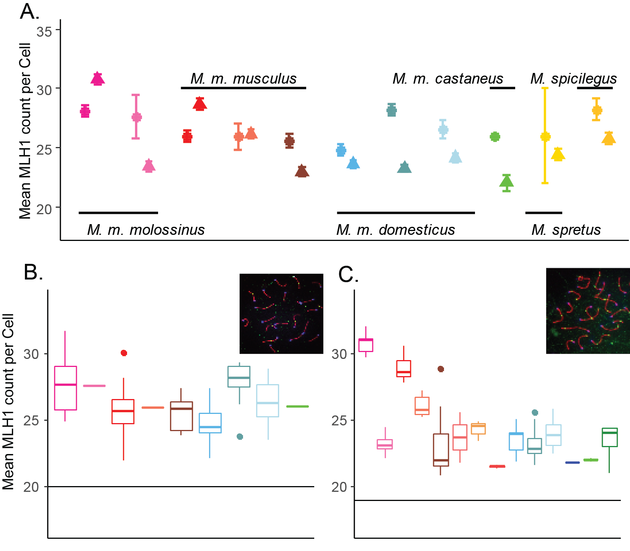

*Figure 1 Mean MLH1 count distributions by strain.*

A) Strain averages of MLH1 counts per cell, circles represent female measures and triangles represent male measures.

B) Female specific MLH1 count distributions for house mouse strains. Inset example oocyte, SYCP3 stained in red, CREST (centromeres) stained in blue and MLH1 foci stained in green. Horizontal line at 20 indicates the expected minimum of foci per cell.

C) Male specific MLH1 counts per cell for house mouse strains. Color themes are the same as A) – Additional strains with just male observations (are included – values represent the data in Table 2.

than in a which have only male observations. Horizontal line at 19 indicates the expected minimum number of foci per cell

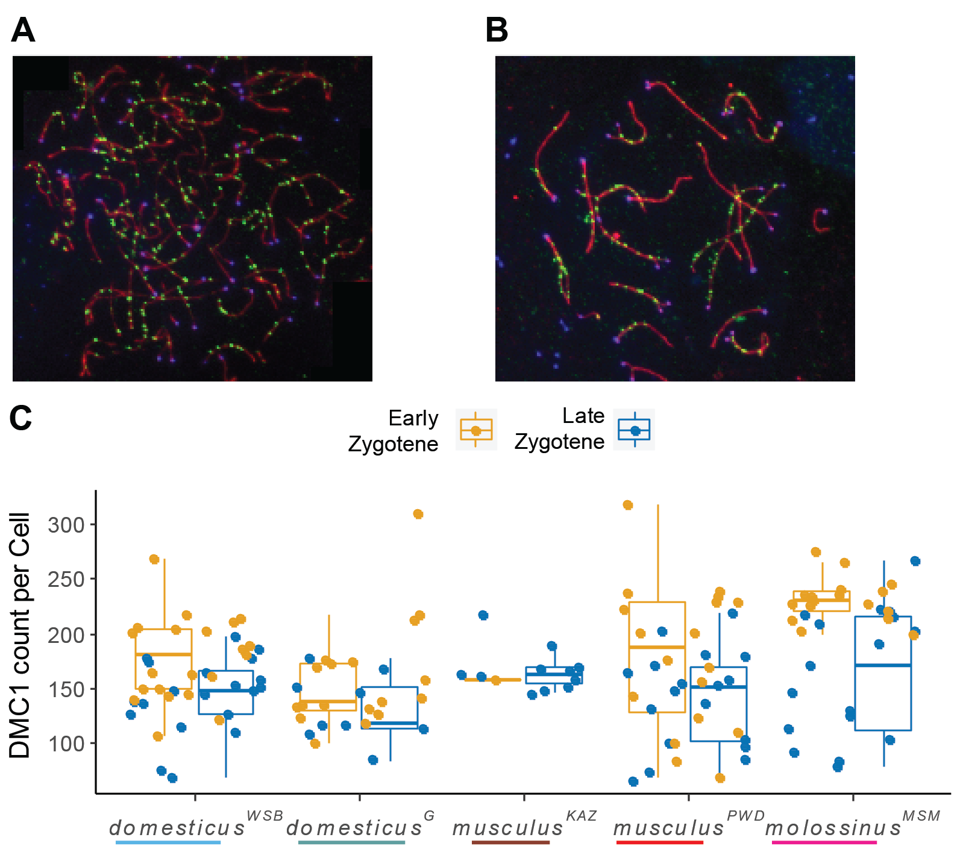

*Figure 2 Male DSB estimates*

A) Example early zygotene spermatocyte spread. SYCP3 stained in red, CREST (centromeres) stained in blue and DMC1 stained in green. B) Example late zygotene spermatocyte spread. Staining the same as a). C) Distribution of DMC1 counts per cell by strain.

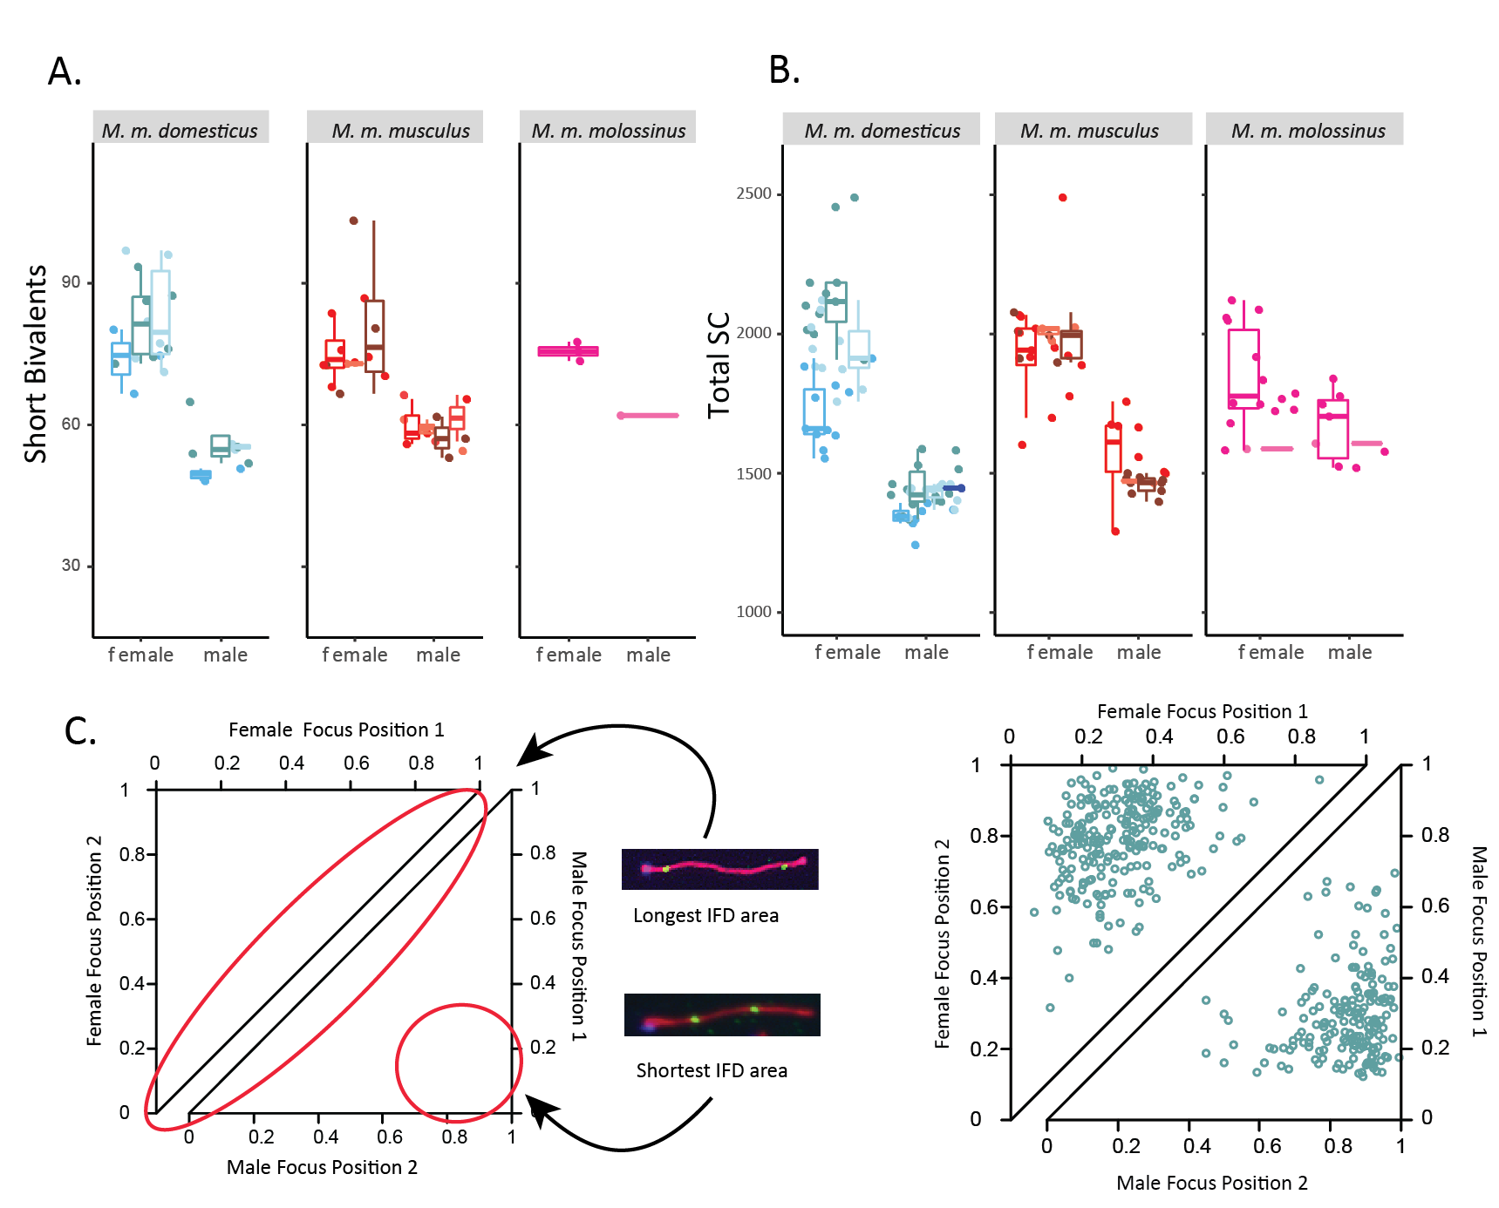

*Figure 3 Sex Differences in meiotic traits*

A) Mouse averages of short bivalents. B) Mouse averages of total SC area per cell. C) Example of sex differences in inter-focal distances and foci locations on 2CO bivalents. Female observations shown in top triangle, male plots shown in bottom triangle. Empirical data from domesticusG.

**Supplemental figures**

