Google Ads & Meta Ads Management Proposal
Creekside Marketing

Overview
Thank you for considering Creekside Marketing as your paid advertising partner. This proposal outlines our comprehensive approach to Google Ads and Meta Ads management, designed to drive measurable results for your business.
Our service includes complete onboarding, strategic campaign development, and ongoing optimization to ensure your advertising investment delivers maximum return.

Why Choose Creekside Marketing
- Contract Structure: 3-month minimum contract. Month one is non-cancellable. A $250 cancellation fee applies if you cancel during months 2 or 3. After the initial 3 months, service converts to month-to-month with 30-day cancellation notice.
- Direct Access to Your Ad Managers: You'll communicate directly with the specialists running your campaigns via Google Chat, not a support inbox or account coordinator.
- Growth-Focused Optimization: We optimize for business growth and revenue, not just vanity metrics like low cost-per-acquisition.
- Real-Time Communication: Message your team anytime in Google Chat for quick questions or updates between scheduled calls.

Onboarding Services
Our comprehensive onboarding process ensures your advertising campaigns launch on a solid foundation:

Conversion Tracking Setup
- Complete conversion tracking implementation across Google Ads and Meta Ads platforms
- CRM integration to ensure seamless data flow and accurate performance measurement
- Server-side conversion tracking implementation when required for enhanced accuracy and privacy compliance

Comprehensive Account Audits
- Thorough review of existing Google Ads account structure, campaigns, and performance
- Complete Meta Ads account audit including campaign analysis and audience evaluation
- Identification of optimization opportunities and strategic recommendations

90-Day Strategic Plan
- Detailed 90-day roadmap outlining campaign priorities, testing strategies, and growth initiatives
- Clear milestones and performance targets aligned with your business objectives
- Strategic framework for scaling successful campaigns and optimizing underperformers

Creative & Technical Support
- Landing page setup and optimization for improved conversion rates
- Creative design services including ad copy, imagery, and visual assets

Ongoing Management & Optimization
Once your campaigns are live, we provide continuous hands-on management with systematic optimization across all critical performance areas:

Communication & Reporting
- Bi-Weekly Performance Reports: Comprehensive written reports with data analysis, insights, and strategic recommendations delivered every two weeks.
- Monthly Strategy Calls: Dedicated time to review performance, discuss results, and align on strategic priorities for the month ahead.
- Direct Google Chat Access: Real-time communication with your ad specialists for quick questions, updates, or urgent issues between scheduled calls.

Google Ads Optimization Activities
Our team performs systematic optimization checks and adjustments on your Google Ads campaigns:
- Search Term Exclusions: Regular review and addition of negative keywords to prevent wasted spend on irrelevant searches
- Notification Monitoring: Daily review of Google Ads notifications for policy changes, account issues, or optimization recommendations
- Ad Placement Analysis: Review of where ads appear to exclude underperforming placements and websites
- Disapproved Ads & Policy Violations: Immediate resolution of any disapproved ads or policy issues to maintain campaign performance
- Budget Management: Regular monitoring and adjustment of campaign budgets to maximize results within your spending targets
- Conversion Tracking: Ongoing verification that all conversion events are firing correctly and data is accurate
- Search Keyword Performance: Analysis of individual keyword performance with adjustments to bids, match types, and keyword additions
- Campaign Comparisons: Cross-campaign analysis to identify winners and redistribute budget to highest performers
- Ad Group Optimization: Regular review and optimization of ad group structure, targeting, and performance

Meta Ads Optimization Activities
Our team performs systematic optimization checks and adjustments on your Meta Ads campaigns:
- Keyword & Ads Library Research: Competitive analysis using Meta's Ads Library to identify successful creative approaches and messaging strategies
- Optimization Score Monitoring: Regular review of Meta's optimization recommendations with strategic implementation of applicable suggestions
- Ad Strength Improvement: Continuous enhancement of ad creative quality scores through copy and visual optimization
- Budget Management: Daily monitoring and strategic reallocation of campaign budgets based on performance
- Conversion Tracking: Ongoing verification that Pixel events are firing correctly and attribution is working properly
- Ad Schedule Optimization: Use of automated rules and scheduling to optimize delivery timing based on performance patterns
- Placement Analysis: Review of ad placements across Facebook, Instagram, Messenger, and Audience Network to exclude underperformers
- Campaign Performance Comparison: Cross-campaign analysis focusing on target CPA achievement and budget optimization opportunities
- Pixel Health Monitoring: Regular checks to ensure Meta Pixel has no errors and all conversion events are tracking properly

Strategic Campaign Development
- New Campaign Launches: Development and launch of new campaign structures, audiences, and targeting strategies based on performance insights.
- A/B Testing: Systematic testing of ad creative, copy, audiences, bidding strategies, and landing pages to continuously improve performance.

Platform Coverage
Your campaigns will reach your target audience across multiple high-value placements:

Google Ads Placements
- Google Search: Capture high-intent users actively searching for your products or services
- YouTube: Engage audiences with video content on the world's second-largest search engine
- Google Display Network: Build brand awareness across millions of websites and apps
- Gmail: Reach potential customers in their inbox with targeted sponsored promotions
- Google Shopping: (For e-commerce businesses) Showcase products directly in search results with images, pricing, and merchant information

Meta Ads Placements
- Facebook: Connect with your audience across feeds, stories, and in-stream video
- Instagram: Engage visually-driven audiences through feed, stories, reels, and explore placements
- WhatsApp: Drive direct conversations and customer engagement
- Advantage+ Placements: Leverage Meta's automated placement optimization across Messenger, Audience Network, and other high-performing positions

Investment & Terms
We believe in transparent pricing that aligns with your business goals and risk tolerance. We offer three distinct management plans, allowing you to choose the structure that best fits your needs.

1. The Three Pricing Plans
Feature | Plan A: Growth | Plan B: Shared | Plan C: Retainer
Best For | Lower initial cost; fee scales directly with ad spend | Predictable base fee with a lower percentage as you scale | Total cost certainty — one flat fee regardless of ad spend
Base Fee | $0 base fee  ($1,500 minimum per platform  applies until ad spend exceeds $7,500/mo) | $3,000 flat base  (covers all platforms) | $10,000 flat retainer  (covers all platforms)
Variable Fee | 20% up to $30k spend  15% from $30k–$60k  10% over $60k  (Calculated per platform, $1,500 minimum) | 10% of total combined  ad spend across all platforms | None
Monthly Cap | $15,000 / month | $12,000 / month | N/A — always $10,000
Onboarding Fee | $1,500 per platform | $1,500 per platform | $1,500 per platform

2. Visual Fee Comparison
The chart below shows how your monthly agency fee changes with ad spend under each plan, including the exact crossover points where one plan becomes more cost-effective than another.
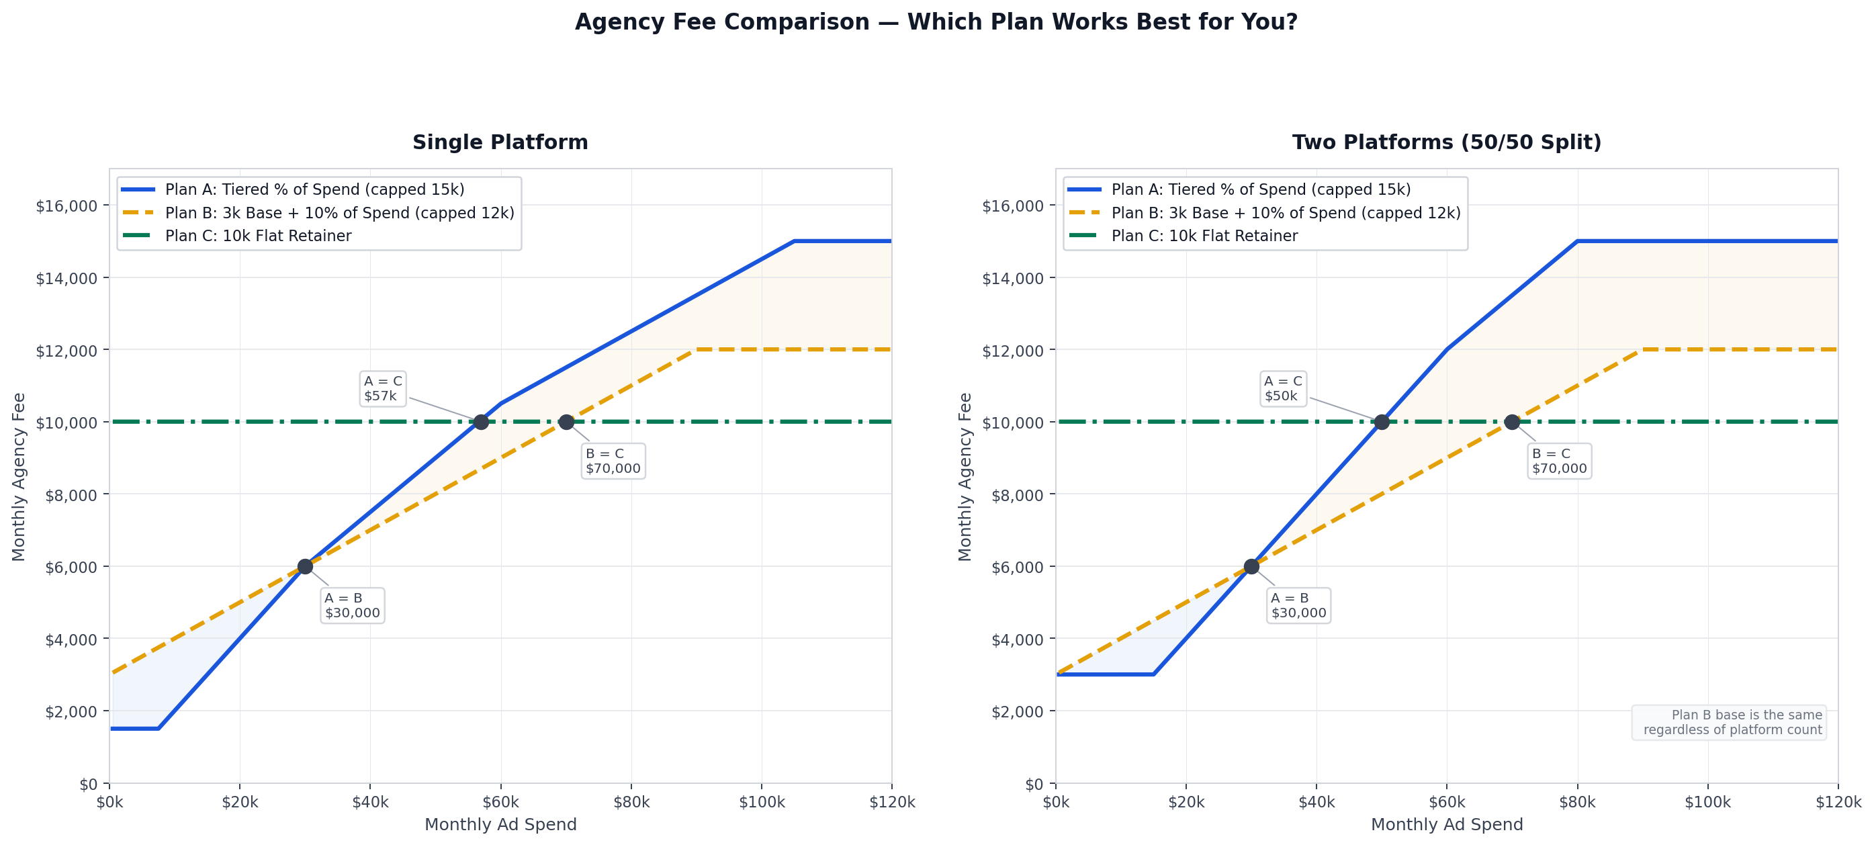
Figure 1 — Agency fee vs. monthly ad spend for single-platform (left) and two-platform 50/50 split (right) clients.

3. Payment & Contract Terms
- Ad Spend: You pay Google and Meta directly for all advertising costs. We never touch your ad spend budget.
- Management Fees: Billed separately and paid directly to Creekside Marketing.
- Contract Terms: 3-month minimum contract. Month one is non-cancellable. A $250 cancellation fee applies for cancellations in months 2 or 3. After the initial 3 months, service converts to month-to-month with 30-day cancellation notice.
- Account Ownership: All ad accounts, audiences, and creative assets remain your property. Upon cancellation, everything transfers back to you with full access.

Next Steps
We're excited about the opportunity to partner with you and drive meaningful results for your business.
- Review this proposal and reach out with any questions.
- Ready to move forward? Let us know which pricing plan you prefer, and we'll send over your onboarding invoice, service agreement, and onboarding instructions with everything we need to get started.

We look forward to helping you achieve your advertising goals.

Best regards,
The Creekside Marketing Team

