Induction Proof

MATH 189: Discrete Mathematics

Section 2

Rob Peterson

# Problem Description

The problem under consideration for this proof consists of a series of steps, described as follows:

1. A stack of 7 disks sits on a surface.
2. One disk is added to the top of the existing stack(s), and a set of disks is added to form a perimeter around the existing stack(s).
3. Step 2 is repeated ad Infinium.

Diagrams showing the steps involved are shown below:



Figure 1: Stage 0



Figure 2: Stage 1

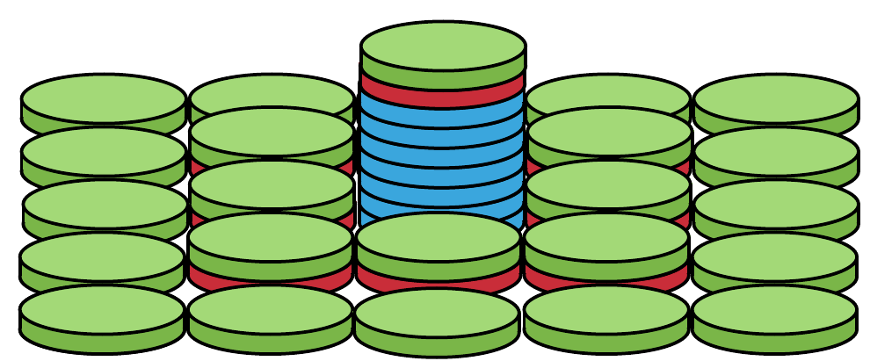

Figure 3: Stage 2

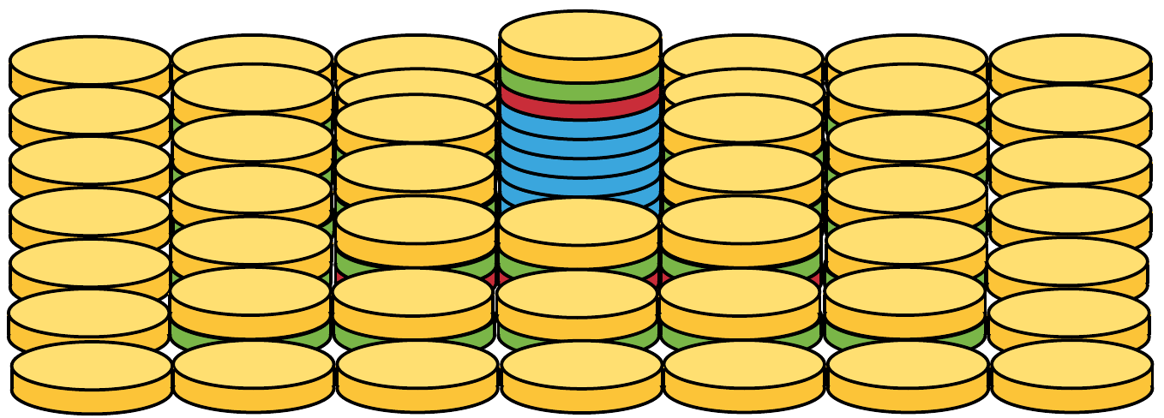

Figure 4: Stage 3

The problem statement regarding these series of stages is to determine a closed for expression for determining the total number of disks depending on what stage the process is in. A good practice in developing a model like this is to develop some data. The following table has been generated from inspection of the problem, and covers the first six stages. It shows the “dimension” of a stage, which denotes the length of a side of the stage, the stages form squares, where is the dimension of a stage. The number of stacks in a stage is also important information to track, as will be shown in the following portions of this proof.

|  |  |  |  |
| --- | --- | --- | --- |
| ***Stage (n)*** | ***Dimension*** | ***# stacks*** | ***# disks*** |
| 0 | 1 | 1 | 7 |
| 1 | 3 | 9 | 16 |
| 2 | 5 | 25 | 41 |
| 3 | 7 | 49 | 91 |
| 4 | 9 | 81 | 171 |
| 5 | 11 | 121 | 292 |

Table 1: First six stages of problem

If we create an expression for the number of disks in a particular stage, we can split it up into parts as shown:

We can build up an expression for the number of disks in a particular stage by breaking the expression into different parts and adding them together to get a total:

Latex:

\frac{1}{2\pi}\int_{0}^{2\pi}\frac{d\theta}{a+b\sin{\theta}}=\frac{1}{\sqrt{a^2-b^2}}