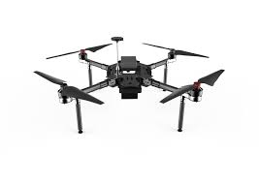

**Have you ever wanted to test pilot a drone?**

We are looking for potential users to test our

Inquire with Peter at [petersurlina@lewisu.edu](mailto:petersurlina@lewisu.edu), for more information!

Drone project. Feedback would be based

off areas such as automation, utility, convenience,

etc. This a great opportunity for people interested in

drones to get their feet wet and learn about the process

of assembling a drone and working with robot operating systems.

* Paula G. (Aidan)
* Katelyn Correa (QuizMaster)
* Paula G.
* Katelyn Correa

Classmates Helping us Test…

Classmates I will help Test…

**\*Meetings take Place Tuesdays, starting around 3:30pm-4:00pm**