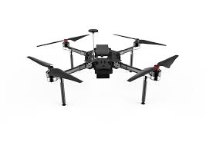

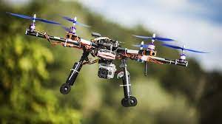
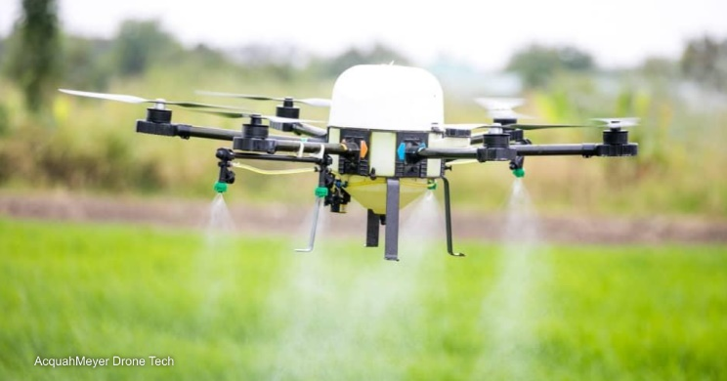
Have you ever wanted to test pilot a drone?

We are looking for potential users to test our
Inquire with Peter at petersurlina@lewisu.edu, for more information!
Drone project. Feedback would be based
off areas such as automation, utility, convenience,
etc. This a great opportunity for people interested in
drones to get their feet wet and learn about the process
of assembling a drone and working with robot operating systems.
*Meetings take Place Tuesdays, starting around 3:30pm-4:00pm
Come see and talk about new ideas and technologies like…
Agriculture
Surveillance

