Master’s Workshop: Chlamydia trachomatis  Used for PCR diagnostics

# Background:

AFTER AN ALMOST STEADY increase for 10 years in reported Chlamydia trachomatis (Ct) genital infections in Sweden, there was a levelling out in 2005 to 2006. In some areas of the country, like the county of Holland (290,000 inhabitants), we noted a decrease in diagnosed infections of 25% in the beginning of 2006.

In Holland they have used nucleic acid amplification tests (NAAT) to diagnose Ct infections since 1995, beginning with Abbott LCx (Abbott Laboratories, Abbott Park, IL), October 2002 to March 2006, Roche Amplicor PCR (Roche Molecular Systems, Branchburg, NJ), and then Abbott m200 real-time PCR, all with target areas on the **cryptic plasmid**.

The unexplained decrease in infection rate raised a suspicion. Was it a success story of public health? Impairment of kit quality or a change in the target area in the microbe?

* <https://journals.lww.com/stdjournal/fulltext/2007/05000/a_chlamydia_trachomatis_strain_with_a_377_bp.1.aspx>
* Ripa, T. and Nilsson, P.A., 2007. A Chlamydia trachomatis strain with a 377-bp deletion in the cryptic plasmid causing false-negative nucleic acid amplification tests. *Sexually transmitted diseases*, *34*(5), pp.255-256.

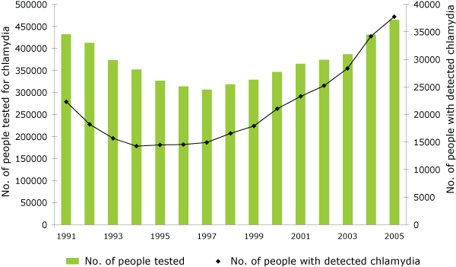

* <https://www.eurosurveillance.org/content/10.2807/esw.11.49.03090-en?crawler=true>

## The variant – where to find the sequence:

<https://www.ncbi.nlm.nih.gov/nuccore/EF121757>

# PCR strain variant not detected - back ground reading:

<https://bmcgenomics.biomedcentral.com/articles/10.1186/1471-2164-10-239>

* In Sweden, four commercially available nucleic acid amplification assays are used for chlamydia routine diagnostics, although in most counties, only one assay is used.
* Three of the detection systems (two from Roche and one from Abbott) use the same PCR primer target region. Is that a good idea?
* In summary: The chlamydia genetic variant recently identified has a deletion in this PCR amplification region, therefore these tests cannot detect it. OOOPs!

## Reason

In October 2006 a new variant of *C. trachomatis* was described in Sweden that evaded several of the then current commercial molecular diagnostic tests for detecting the microorganism, which were based on the presence of specific plasmid sequences. A 377bp deletion in the plasmid DNA, specifically in the region used for PCR diagnosis was responsible. Selection pressure?



Swedish counties 20 – 64% of current infections are caused by this mutant strain of *C. trachomatis*

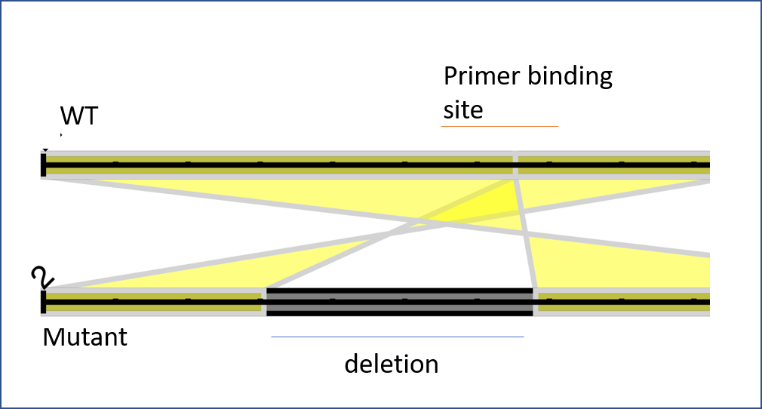

**Deletion can be seen here = no amplification**