Database design exercises, Question 4

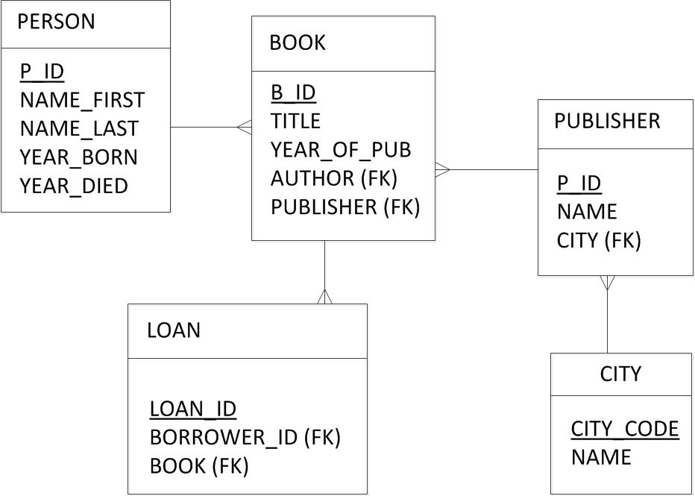

<https://github.com/peterverhaar/dmt-2020/blob/master/Zwiers/Homework_W9_Zwiers.txt>

No primary keys

Author and Visitor may be merged

<https://github.com/peterverhaar/dmt-2020/blob/master/Stiglmayer/Homework-W9-Stiglmayer.txt>

Borrower and Author have the same attributes; tables may be merged

<https://github.com/peterverhaar/dmt-2020/blob/master/SousaFernandesdeN%C3%B3bregaMen/Homework-W9-Exercise4_%5BSousa%20Fernandes%20de%20N%C3%B3brega%20Mendon%C3%A7a%5D.txt>

BOOK has a FK connected to LOAN AND LOAN has a KF connected to BOOK

PLACE has a place_of_birth and place_of_death?

DATE entity is not connected to any of the other entities

<https://github.com/peterverhaar/dmt-2020/blob/master/Shalev/Homework-W9-Shalev.txt>

VISITOR and AUTHOR may be merged

<https://github.com/peterverhaar/dmt-2020/blob/master/Sastrosoedjono/Homework_Wk9_Sastrosoedjono.pdf>

AUTHOR has FK Book: Implies that one book can have many authors and that one author can only write one book

LOANS entity should not have an FK AUTHOR

AUTHOR should not havea FK loans

<https://github.com/peterverhaar/dmt-2020/blob/master/R%C3%B6rsch/Homework-W9-DataModelling4_Roersch.pdf>

Loans should have a FK Book

<https://github.com/peterverhaar/dmt-2020/blob/master/Rui/Homework-W9-Exercise-04_Rui.txt>

<https://github.com/peterverhaar/dmt-2020/blob/master/Rui/Homework-W9-Exercise-04-entity-relationship-diagram-Rui.png>

AUTHOR and VISITOR may be merged

<https://github.com/peterverhaar/dmt-2020/blob/master/Hoogenboom/Homework_W9_Hoogenboom.txt>

BOOK has FK borrowed_by; this implies that a book can only be borrowed b one person

LIBRARY has FK Book; this implies that a library can only own own book and that one book may be owned by multiple libraries

<https://github.com/peterverhaar/dmt-2020/blob/master/Heijna/Homework_W9_Heijna.txt>

<https://github.com/peterverhaar/dmt-2020/blob/master/Evarts/Homework-W9-Evarts.txt>

AUTHOR and VISITOR may be merged

Author FK does not need to be in LOAN; this information is already captured in BOOK

<https://github.com/peterverhaar/dmt-2020/blob/master/Boreel/Homework-W9_Boreel.txt>

No need to distinguish between VISITOR and BORROWER

Borrow history and Borrowed Book may be merged

<https://github.com/peterverhaar/dmt-2020/blob/master/Baarslag/Homework-W9-Baarslag.txt>

AUTHOR and VISITOR may be merged