Introduction:

This RPI TVHeadEnd Server is a platform based on Raspberry PI hardware, which creates a headless DVB-S2 Tuner and streams the video to any network client. This platform enables conditional access via “oscam” server.

You can either recreate this to have similar platform or rip out three “goodies” for your own Raspberry Pi projects. Respective two github repositories provide you:

Python “Rotary Encoder Knob” class based on interrupts (to preserve processor's power and save energy). Example of simple pygame interface using above rotary class encoder and cheap SainSmart 1.8" TFT LCD display. All this together gives you a lean system with as little as possible components and GPIO lines to leverage your projects with powerful user control.

Local control is good, remote control via mobile, tablet or computer is even better. There are plenty of projects connecting processes on RPI with mobile apps. Here you will be given a plain piece of python code to create an interactive HTML5 page you can open in any modern browser and control your RPI remotely.

Quick links:
Go to local control via rotary and LCD
Go to web based RPI app
Screenshots :)

Steps to prepare the hardware platform

- Download and install raspbian (jessie)

scan for ip on your network to find newly booted rpi
nmap -sn 192.168.0.0/24 and ssh to rpi
run raspi-config
enable SPI – will be needed by the display

do not forget to:
sudo apt-get update
sudo apt-get upgrade

Change default name of the server from raspberry to any thing you want by modifying the file /etc/hostname
/etc/hosts

and run:
sudo /etc/init.d/hostname.sh

- Change dhcp to fixed ip (or do this on your router, servers should have fixed ip:
in file /etc/dhcpcd.conf at the bottom add:

interface eth0
static ip_address=192.168.0.10/24
static routers=192.168.0.1
static domain_name_servers=192.168.0.1
interface wlan0
static ip_address=192.168.0.11/24
static routers=192.168.0.1
static domain_name_servers=192.168.0.1

Make the network settings corresponding to your home network

- “install” if desired a passwordless ssh (it accelerate the work)
https://www.raspberrypi.org/documentation/remote-access/ssh/passwordless.md

- Install display SainSmart 1.8" TFT LCD
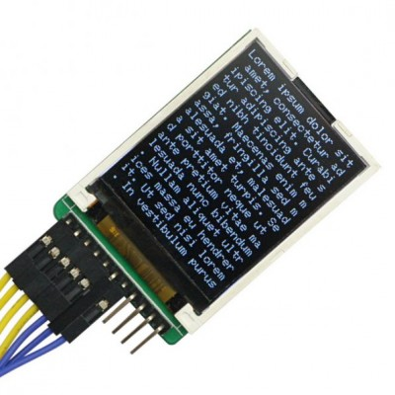

https://github.com/notro/fbtft/wiki#install

Add to file /etc/modules-load.d/fbtft.conf
spi-bcm2835
fbtft_device

Add to file /etc/modprobe.d/fbtft.conf
options fbtft_device name=sainsmart18 rotate=270

Consider the rotate parameter according to your own hardware setup or think twice before you glue it.

It is always good to see, on a headless device some booting or shutdown messages. As we have now a LCD head, let's enable it as a console device:
To use the display as a console, add this to the end of the line in /boot/cmdline.txt
fbcon=map:10

Make the console font smaller
sudo apt-get install kbd

sudo dpkg-reconfigure console-setup

Encoding to use on the console: <UTF-8>
Character set to support: <Guess optimal character set>
Font for the console: Terminus (default is VGA)
Font size: 6x12 (framebuffer only)

Switch off Console blanking
This is set in /etc/kbd/config:
BLANK_TIME=0
and to the /etc/rc.local
setterm --blank 0

and add to the file /etc/modules
i2c-dev
spi_bcm2708
fbtft
fbtft_device name=sainsmart18 rotate=270 verbose=0

- Prepare power pin for usb dvb tuner – at boot time we need “1” to enable modules loading
https://www.raspberrypi.org/documentation/configuration/pin-configuration.md

GPIO initialization at the boot time for power relay steering done via GPIO 1 (BCM GPIO 18) requires changing the default settings described in the blob file /boot/dt-blob.bin. Get the compiler
sudo apt-get install device-tree-compiler

Download the file dt-blob.dts for example from the above link, look at the bottom of the article:
https://www.raspberrypi.org/documentation/configuration/images/dt-blob.dts
or the better way is to create your won *.dts file out of your current hardware installation by:
on RPI in the local directory ~/dts call:
dtc -I dtb -O dts -o dt-blob.dts /boot/dt-blob.bin

In the file dt-blob.dts depending on your hardware revision modify section of
pins_2b1 { // Pi 2 Model B rev 1.0
for the entry of pin@p18 (GPIO 1) such as:
pin@p18 { function = "output"; termination = "pull_down"; drive_strength_mA = < 8 >; startup_state = "active"; }; // My relay active at start
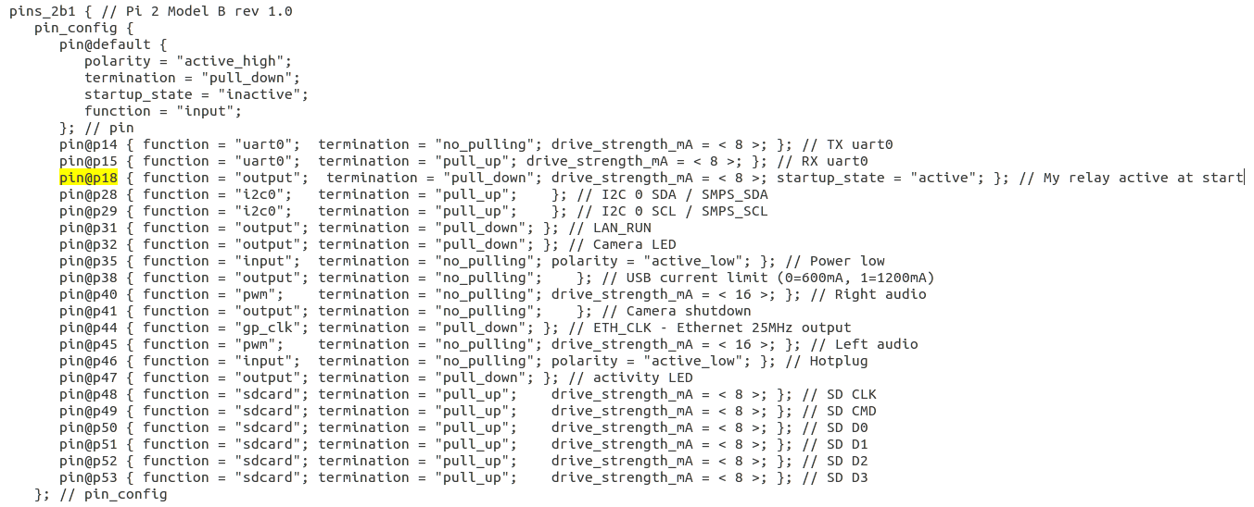
I added this also for the definition of pins_2b2 { // Pi 2 Model B rev 1.1
Eventually compile ZZ compile the new blob file:
sudo dtc -I dtb -O dts -o dt-blob.dts /boot/dt-blob.bin

- Install DVBSky S960 USB tuner

Check the link https://www.linuxtv.org/wiki/index.php/DVBSKY_S960 for details
S960 is supported out of te box by RPI on Jessie, we need only to download firmware file from:
http://www.dvbsky.net/Support_linux.html
extract all files to local folder
dvb-fe-ds3103.fw
dvb-demod-m88ds3103.fw
dvb-demod-m88ds3103.fw
and move all of them to /lib/firmware/
sudo mv *.fw /lib/firmware

- Install tvheadend
sudo apt-get install apt-transport-https
compile or instal from repo – here how to with repo:
https://tvheadend.org/projects/tvheadend/wiki/AptRepository
First install bintray's GPG key:
sudo apt-key adv --keyserver hkp://keyserver.ubuntu.com:80 --recv-keys 379CE192D401AB61
echo "deb https://dl.bintray.com/tvheadend/deb jessie release" | sudo tee -a /etc/apt/sources.list
where
This is for “jessie” Raspian version. In the tvheadend official repo there is only a “release” version no unstable or stable options.
Install tvheadend
sudo apt-get install tvheadend

Disable tvheadend service at the boot time – we start it only if necessary via local menu or via web in order to save energy when not used
sudo update-rc.d -f tvheadend remove

Tvheadend configuration requires several steps – google for it. It aso takes time to scan all multiplexers – be patient.

- Install oscam server
Download the oscam binary file from http://download.oscam.cc/index.php?direction=1&order=mod&directory=1.20_TRUNK/Raspberry
Extract oscam binary file and copy it to /usr/local/bin
Check the permision:
sudo chown root:root /usr/local/bin/oscam
sudo chmod 755 /usr/local/bin/oscam

Modify all necessary files according to your pay-tv provider. I'm not providing any help on this and I'd like to remind that watching pay-tv without required contract is illegal (at least in most of the countries). Eventually copy the files to /usr/local/etc

You have to configure the oscam server, which is independent from pay-tv. For the Easymouse 2 USB Smart Card reader, which I used in my project following settings are fine:
protocol = mouse
device = /dev/ttyUSB0
detect = dc

Jessie is ready to provide all USB libraries, just setup your Easymouse 2 USB Smart Card according to your card requirements plug and check if it is visible (lsusb).
Create oscam startup script in /etc/init.d folder
I use following file as an oscam startscript

#! /bin/sh
### BEGIN INIT INFO
# Provides: Oscam
# Required-Start: $remote_fs $syslog
# Required-Stop: $remote_fs $syslog
# Default-Start: 2 3 4 5
# Default-Stop: 0 1 6
# Short-Description: Oscam init script
# Description: Launch oscam at startup
### END INIT INFO

DAEMON=/usr/local/bin/oscam
DEAMON_OPTS="-b -r 2 -c /usr/local/etc"
PIDFILE=/var/run/oscam.pid

test -x ${DAEMON} || exit 0

. /lib/lsb/init-functions

case "$1" in
start)
log_daemon_msg "Starting OScam"
start-stop-daemon --start --quiet --background --pidfile ${PIDFILE} --make-pidfile --exec ${DAEMON} -- ${DAEMON_OPTS}
log_end_msg $?
;;
stop)
log_daemon_msg "Stopping OScam"
start-stop-daemon --stop --exec ${DAEMON}
log_end_msg $?
sleep 10
;;
force-reload|restart)
$0 stop
$0 start
;;
*)
echo "Usage: /etc/init.d/oscam {start|stop|restart|force-reload}"
exit 1
;;
esac

exit 0

and here we add this service to the default startup procedure (as this does not consume too much energy)
sudo update-rc.d oscam defaults

- Install required python libraries

- transitions, a lightweight, object-oriented finite state machine implementation in Python
- psutil
- gevent

sudo apt-get install build-essential python-dev python-pip
sudo pip install transitions
sudo pip instal psutil
sudo pip instal gevent

- Install python software to manage services on RPI including graphic interface, rotary knob and web

Create graphical menu with rotary knob:
git clone https://github.com/petervflocke/rotaryencoder_rpi menu

Create web interface
git clone https://github.com/petervflocke/flasksse_rpi web

Start both programs after the boot, add some log cleaning
sleep 3
gpio mode 1 output
gpio write 1 0
python /home/pi/menu/main.py&
python /home/pi/web/sse.py&

Explanation:
gpio action – the tuner starts always with power on – it secures loading respective modules etc. If it is not used (no dvb streaming) it satys plug in into usb but the 12V power supply can be switched off to decrease energy consumption. It works fine with the DVB S960 USB Tuner
finaly starts two programs one for display and rotary knob and the other for web interface. I want to have both to be able quickly access system menu.

- Housekeeping
Disable swaping:
sudo dphys-swapfile swapoff
consider of moving log files to ramdrive and or read on clean logs, which consumes space on sd drive.

- Hardware

Prepare the power supply.

Let's power the RPI using dedicated pads instead via micro USB. This let us avoid cables sticking out of the box, all issues with too thin USB power cables, etc.

Following the RPI forum: https://www.raspberrypi.org/forums/viewtopic.php?f=28&t=137305

You can solder the +5V wire to the points marked PP1 or PP2 and ground wire to PP3, PP$, PP5 or PP6. That will be the same as if the power has been supplied through the micro USB.

Add a switch for 5V for RPI for your convienience.

USB tuner requires external 12V, this will be switched on/off by a dedicated relay module, which I have laying around from “Arduino time”. The better way would be a switch based on mosfet transistor.

The USB Tuner shell be switched off in case of no use/no streaming to save energy.

Easymouse 2 is powered via USB from RPI.

Remark:

For your reference I used as a housing an old D-Link Di-624 Wlan Router.
Power socket is cut out from DVD Player board to get a nice stable 4 pin molex connector. Just cut out the size you need. De-solder unwanted elements (I left some capacitors) track down the paths from the molex socket and solder 12V and 5V power cables.

Display:

I used cheap SainSmart 1.8″ Color TFT LCD Display. This 1.8″ display has 128 x 160 pixels resolution and is capable of displaying 18-bit colors.
Measure: 5 cm x 3.5 cm x 0,6 cm thick.

My display has fixed back-light (there are version with PWN backlight). The Micro-SD-Card reader is left unused.

The display is driven by a ST7735R controller and is well supported by new linux kernel. Refer to the software installation part.

For display wiring refer to the picture

Note: When the screen is not used I can switching the power line – it still displays (magic or powering via data lines) dark screen – still testing.

High level wiring of the complete hardware below:

