PROGRAMMING TECHNIQUES
Assignment Five Stream Processing using Lambda Expressions

Student: Peter Ioan Vlad Group: 30421

Table of Contents

1) Problem Specification . . . . . . . . . . . . . . . . . . . . . . . . . . . . . . . . . . . . . . . . . . . . . . . . . . . . . . . . . . . .
1.a) Objective. . . . . . . . . . . . . . . . . . . . . . . . . . . . . . . . . . . . . . . . . . . . . . . . . . . . . . . . . . . . . . . . . . . . . . . .
1.b) Description. . . . . . . . . . . . . . . . . . . . . . . . . . . . . . . . . . . . . . . . . . . . . . . . . . . . . . . . . . . . . . . . . . . . .
2)Analysis of the problem. . . . . . . . . . . . . . . . . . . . . . . . . . . . . . . . . . . . . . . . . . . . . . . . . . . . . . . . .
3)Modelling. . . . . . . . . . . . . . . . . . . . . . . . . . . . . . . . . . . . . . . . . . . . . . . . . . . . . . . . . . . . . . . . . . . . . . . .
4)Use cases / Scenarios. . . . . . . . . . . . . . . . . . . . . . . . . . . . . . . . . . . . . . . . . . . . . . . . . . . . . . . . . . . .
5)Problem Design. . . . . . . . . . . . . . . . . . . . . . . . . . . . . . . . . . . . . . . . . . . . . . . . . . . . . . . . . . . . . . .
5.a) Class Diagram. . . . . . . . . . . . . . . . . . . . . . . . . . . . . . . . . . . . . . . . . . . . . . . . . . . . . . . . . . . . . . . . . .
5.b) Monitored Data. . . . . . . . . . . . . . . . . . . . . . . . . . . . . . . . . . . . . . . . . . . . . . . . . . . . . . . . . . . . . . . . .
5.c) Data Processing. . . . . . . . . . . . . . . . . . . . . . . . . . . . . . . . . . . . . . . . . . . . . . . . . . . . . . . . . . . . . . . .
5.d) Interface. . . . . . . . . . . . . . . . . . . . . . . . . . . . . . . . . . . . . . . . . . . . . . . . . . . . . . . . . . . . . . . . . . . . . . .
5.e) The main class. . . . . . . . . . . . . . . . . . . . . . . . . . . . . . . . . . . . . . . . . . . . . . . . . . . . . . . . . . . . . . . . . .
6) GUI. . . . . . . . . . . . . . . . . . . . . . . . . . . . . . . . . . . . . . . . . . . . . . . . . . . . . . . . . . . . . . . . . . . . . . . . . . .
7) Implementation / testing. . . . . . . . . . . . . . . . . . . . . . . . . . . . . . . . . . . . . . . . . . . . . . . . . . . . . . . . .
8) Results. . . . . . . . . . . . . . . . . . . . . . . . . . . . . . . . . . . . . . . . . . . . . . . . . . . . . . . . . . . . . . . . . . . . . . . .
9) Conclusions. . . . . . . . . . . . . . . . . . . . . . . . . . . . . . . . . . . . . . . . . . . . . . . . . . . . . . . . . . . . . . . . . . . .
10)What I have learned . . . . . . . . . . . . . . . . . . . . . . . . . . . . . . . . . . . . . . . . . . . . . . . . . . . . . . . . . . . .
11)Future Improvements. . . . . . . . . . . . . . . . . . . . . . . . . . . . . . . . . . . . . . . . . . . . . . . . . . . . . . . . . . . .
12)Bibliography. . . . . . . . . . . . . . . . . . . . . . . . . . . . . . . . . . . . . . . . . . . . . . . . . . . . . . . . . . . . . . . . . . . . .

Problem Specification
Objective

Designing and implementing an application aiming to use lambda expressions in order to process a stream input that consist in the time that an action starts and ends. The time consist in the date, the hour minutes and seconds("yyyy-MM-dd HH:mm:ss").
A stream input is a sequence of data and it is also a pipeline of functions that can be evaluated. A stream is not a data structure. A stream can be composed of multiple fuctons that can be composed of multiple functions that create a pipeline that that data flows through.

Lambda expression is a new and important feature of Java which was included in Java SE 8. It provides a clear and concise way to represent one method interface using an expression. It is very useful in collection library. It helps to iterate, filter and extract data from collection. Before lambda expression, anonymous inner class was the only option to implement the method.

Description

A smart house features a set of sensors that may be used to record the behavior of a person living in the house. The historical log of the person’s activity is stored as tuples (startTime, endTime, activityLabel), where startTime and endTime represent the date and time when each activity has started and ended while the activity label represents the type of activity performed by the person: Leaving, Toileting, Showering, Sleeping, Breakfast, Lunch, Dinner, Snack, Spare_Time/TV, Grooming. The attached log file Activities.txt contains a set of activity records over a certain period of time. Define a class MonitoredData having startTime, endTime and activityLabel as instance variables and read the input file data into the data structure monitoredData of type List. Using stream processing techniques and lambda expressions introduced by Java 8, write the following set of short programs for processing the monitoredData.

1. Count the distinct days that appear in the monitoring data.

2. Determine a map of type that maps to each distinct action type the number of occurrences in the log. Write the resulting map into a text file.

3. Generates a data structure of type Map> that contains the activity count for each day of the log (task number 2 applied for each day of the log) and writes the result in a text file.

4. Determine a data structure of the form Map that maps for each activity the total duration computed over the monitoring period. Filter the activities with total duration larger than 10 hours. Write the result in a text file.

5. Filter the activities that have 90% of the monitoring samples with duration less than 5 minutes, collect the results in a List containing only the distinct activity names and write the result in a text file.

Analysis of the problem
The newest release of Java, Java 8, has new features and enhancements with the target in mind to help the programmer developing different sorts of applications. Such in improvements that Java 8 provides is lambda expressions which is an anonymous expression that the programmer can use to create expression trees types. If you use lambda expressions, one can write local functions that can be passed as argumentsor returned as the value of a function calls.
Just like lambda expressions processing Streams are a new feature that Java 8 has brought to the programmer. Nearly every Java application makes and processes collections. They are fundamental to many programming tasks: they let you group and process data. For example, you might want to create a collection of banking transactions to represent a customer’s statement. Then, you might want to process the whole collection to find out how much money the customer spent. Despite their importance, processing collections is far from perfect in Java.
First, typical processing patterns on collections are similar to SQL-like operations such as “finding” (for example, find the transaction with highest value) or “grouping” (for example, group all transactions related to grocery shopping). Most databases let you specify such operations declaratively. For example, the following SQL query lets you find the transaction ID with the highest value: "SELECT id, MAX(value) from transactions".

Modelling

The modelling process for this project is quite simple. It is required to have have a class named MonitoredData that will have three parammeter : startTime (that represents the time that an activity starts), endTime (that represent the time that an activity ends) and activity label (that represents the activity, such as Leaving, Snack etc.)
All the data processing happens in the main clas that is called Test.Java, here we read the data from the files, we use lambda expressions and stream file processing and we erite the results of the requirements in files as the task said.
In the class GUI we the code for the grapfical user interface.
Use cases / Scenarios
This application could pe use by a AI programm that has the task to learn the behaviour of a person based on the frequency of the persons activities and duration.

Conclusions
The modelling process for this project is quite simple. It is required to have have a class named MonitoredData that will have three parammeter : startTime (that represents the time that an activity starts), endTime (that represent the time that an activity ends) and activity label (that represents the activity, such as Leaving, Snack etc.)
All the data processing happens in the main clas that is called Test.Java, here we read the data from the files, we use lambda expressions and stream file processing and we erite the results of the requirements in files as the task said.
In the class GUI we the code for the grapfical user interface.
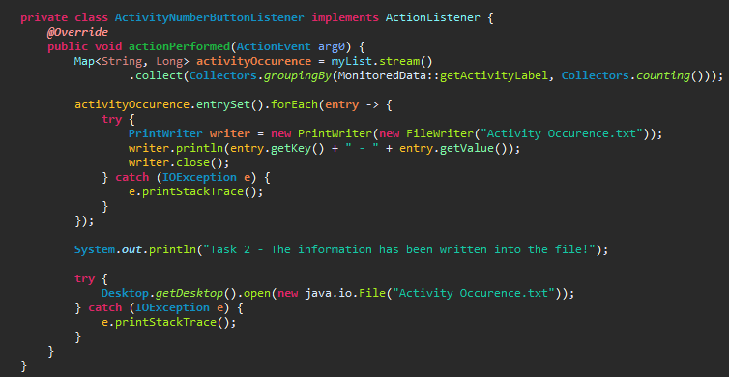
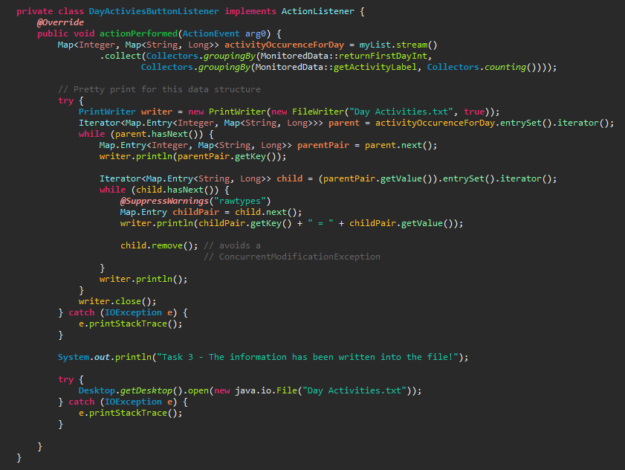
The next method computed the total number of occurrences of each activity in the provided text file. We do this by creating a map which has as key the activity label and then, for each key, we count how many times it appears in the file.
The following method was a more tricky one to implement. Here we were required to place a map inside another map so this was a more laborious task but with a bit of perseverance it was implemented. We need to compute the occurrences for each activity for each day – in essence, we have to do what we did in the previous method, only for each day present in the file.
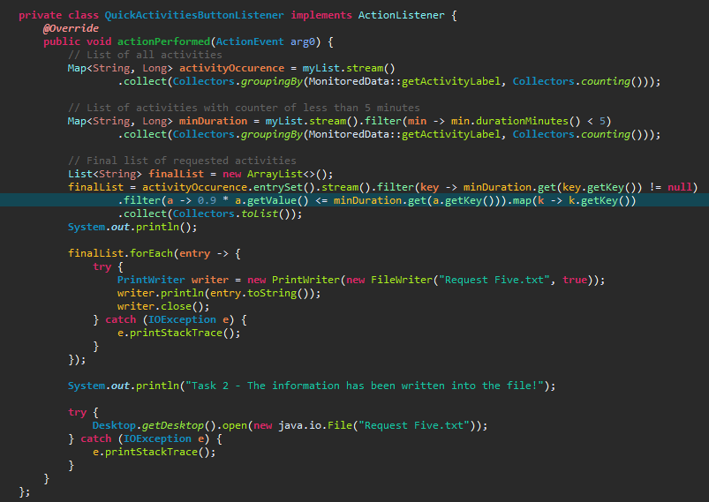

The last method that I implemented for this assignment, since the task number 4 is not done, is the ore regarding filtering the activities that have 90% of the durations smaller than five minutes. I implemented this using two maps and a list containing the final answer. First of all in those two maps we will place the total number of activities and the number of activities that have the duration smaller than 5 minutes. After that, using stream processing tools we place two filters – one that checks that the entry of the second map is not empty, and another filter to check if that activity indeed has 90% of the occurrences with duration smaller than 5 minutes, and we map the activity label into a list. Finally, we print that list in the text file and we add a block of code such that the text file will open automatically when the button is pressed.

Interface
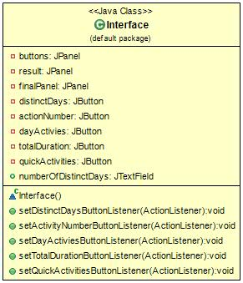
This class is a self explanatory one: it contains all the logic necessary such that the user will have a nice and simple way of running and interacting with the application. The interface contains five buttons each corresponding to the desired action of the user, and also a JTextField where the result of one of the requirements is displayed.
Also, in order to make the application a little easier for the user, after each press of the button in the interface, a text file containing the result will be opened.

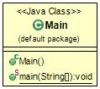
Main
Another easy to explain class is the main class of the application. Here we simply instantiate a DataProcessing object which contains all the logic of the application and the interface will start up.

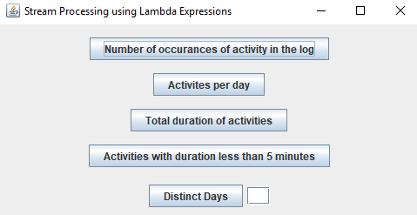
User interface
This is the way I chose to implement the user interface for this application. As I said earlier, there is no need to have a too complicated graphical user interface for this particular application because that would be an overkill. So I went with a model that has 5 buttons and a text field where I show the result of the first task.

Implementation and testing
The implementation of this application was a rather straight forward one, providing one had understood the concepts of lambda expressions and stream processing beforehand. I found that the most challenging part was computing the total duration of the activities hence it is not present in my application. The user interface was easy to design since a complex version of a graphical user interface is not needed.
The testing part was relatively easy since we have the input data. I put the expected result on a paper and verified that my program gives the same output.
Result
The result is an application that is easy to use featuring a very simplistic and easy to use graphical user interface. The user has the ability to choose the task he wants to compute on the respective input via the present buttons. The program will display the output in a text file(which will be created automatically in the folder of the program), file which will also be opened automatically after that button is pressed.
Conclusions
What I learned
First of all I have to note that I have never worked with streams and lambda expressions before so this project assignment provided the perfect opportunity to cover this area of Java programming. I can say that out of all the assignments this one was the most fun, because I really enjoyed learning about these concepts. As a programmer it’s important to stay up to date with all modifications in the job area because thing are changing at such a fast pace that it becomes easy to get stuck in the past. So, to learn these Java 8 programming tools is a really good addition to my programming arsenal that I can’t wait to use in the future.
Further improvements
It is easy to see that the application could benefit from some improvements down the path of its existence. First of all, the task of computing the total duration of each activity has to be implemented. That is an obvious upgrade of the application.
Next could be the graphical user interface which is very simple, almost too simple, and it could be unappealing to some of its user so that is in dire need of an upgrade. Maybe even change the logic of the application such that the results will be displayed in a text field inside the application, also with the option of storing those results in a text file.

