# Appendix A1. Glossaries.

This appendix briefly explains some acronyms, terminology and mathematical symbols

|  |  |
| --- | --- |
| **A1.1** | **Acronyms and Terminology** |
| AIC and BIC | Akaike and Bayesian information coefficients |
| AIDER | Analytically-defined IDER |
| Baseline MIXDER | A Mixture Dose-Effect Relationship which defines absence of synergy or antagonism. |
| CA | Chromosome aberration(s) |
| Concave | The opposite of convex, with which it is frequently confused. See Fig. 1 of the main text |
| Convex | A standard mathematical term that can be used to describe curve shapes. Fig. 1 of the main text gives a description adequate for present purposes |
| Default synergy hypothesis | A hypothesis consisting of a baseline no-synergy/no-antagonism MIXDER and also a way to calculate baseline mixture effect uncertainties when IDER uncertainties are known |
| Explicit function | Roughly, a function *f*(*x*) built from the standard functions used in introductory calculus – e.g. . Specifically, an ‘elementary’ function, as defined in math texts |
| IDER | Individual Dose Effect Relationship for a single ion. See sub-section 3.2 for examples. |
| Incremental  effect additivity | ODE method of calculating a MIXDER *I*(*d*) from the component IDERs, with *I*(*d*) then used as the definition of no synergy or antagonism |
| *I*(*d*) | Abbreviation both for the incremental effect additivity default hypothesis and for the corresponding baseline MIXDER |
| Inverse function | For a continuous monotonically increasing function *F*(*x*)*, D*(*F*(*x*))*=x* for all *x* in the domain of *F* defines the inverse function *D*(*F*)*.* For example exp and ln are inverses of each other |
| *L* | Stopping power, LET∞. |
| LNT | Linear-No-Threshold. A straight line through the origin dose=0, effect=0 |
| LQ | Linear-Quadratic; Appendix A3 |
| MIXDER | Mixture Dose-Effect Relationship |
| NTE | Non-Targeted Effects due to inter-cellular interactions. ‘Bystander effects’ |
| NT1, NTE2 | IDERs used in [Cacao et al. 2016] |
| ODE | Ordinary Differential Equation(s) |
| Sham mixture principle | The mixture of an agent with itself should have as a baseline MIXDER the agent’s own IDER. See Fig. 1 of the main text |
| Slope extrapolator | A function of a complex variable that specifies a particular AIDER |
| TE | Targeted Effects. Early effects on a cell that are not due to nearby cells being irradiated |
| Very low dose | 0 ≤ dose < 5 mGy |
| Ultra-low dose | 0 ≤ dose < 0.5 mGy |
| WGE | Whole Genome Equivalent (sub-section 2.1.2) |

|  |  |
| --- | --- |
| **A1.2** | **Symbols and Equations** |
| *αλ* | Linear coefficient of the LQ approximation to CA induced by gamma radiation |
| *α* | Usually the linear coefficient of LQ approximation; used in Appendix A3 |
| *β\** | The velocity of an ion divided by the velocity of light |
| *β* | Usually the quadratic coefficient of LQ approximation; used in Appendix A3 |
| *d0* | A nominal dose where the IDER slope due to NTE has already become substantially smaller than the initial slope at the origin |
| d*Ej*/d*dj* | The slope of an IDER |
| *Dj*(*Ej*) | The compositional inverse function of an IDER *Ej*(*dj*). Discussed in sub-section ssss |
|  | dose of a mixture component as a fraction *rj* of total mixture dose *d* . See sub-section 3.3.1 |
| *Ej*(*dj*) | IDER for the jth component of a mixture. See sub-section 2.2.2 |
| *E*(*d*) | IDER |
| *G*(*E*) | An inverse function in sub-section A3.4.2 |
| *G*(*z*) | A slope extrapolator, described in sub-section A5.1 |
| *η0, η1* | Adjustable parameters that control the height of NTE effects. See sub-section 3.2 |
| *η*(*L*) | NTE effect maximum height, a function of LET *L*. See sub-section 3.2 |
| *I*(*d*) | Incremental effect additivity MIXDER and default hypothesis, Eq. (3) |
| κ | An adjustable parameter. See sub-section 3.2 |
| *rj* | Fixed ratio of component dose to total mixture dose, |
| *S*(*d*) | Simple effect additivity MIXDER and default hypothesis, Eq. (10) |
| *Zeff* | Effective ion charge. Used in Table 1 and in Eq. (5) |

# Appendix A2. CA IDERs

The CA data considered in the Results section of the main text was modeled previously in [Cacao et al. 2016], with three kinds of models, Linear, NTE1, and NTE2. The Linear model does not incorporate NTE; the other two incorporate both TE and NTE. All three models modify Katz’ parametric track structure approach which relates heavy ion action to the action of gamma rays via analyzing delta-ray tracks [reviewed, e.g., in [Katz 1988; Cucinotta et al. 1999; Goodhead 2006; Cucinotta, Kim, Chappell, et al. 2013; Hada et al. 2014; Cacao et al. 2016]. More details on, motivations for, and intuitive or biophysical explanations of the models are in the above references. The models used the biophysical parameters in Table 1 of the main text, repeated here as Table A2.1.

|  |  |  |  |  |  |  |
| --- | --- | --- | --- | --- | --- | --- |
| **ion** | **16O** | **28Si** | **48Ti** | **56Fe** | | |
| *Z* | 8 | 14 | 22 | 26 | | |
| *E/u* (MeV) | 55 | 170 | 600 | 600 | 450 | 300 |
| *L* (keV/μm) | 75 | 100 | 125 | 175 | 195 | 240 |
| *Zeff2/β*2* | 595 | 690 | 770 | 1075 | 1245 | 1585 |
| *dmax* (Gy) | 0.4 | 1.2 | 0.6 | 0.8 | 0.4 | 0.8 |

**Table A2.1. Dose and Track Parameters.**

*Z* is atomic number. *E/u* is kinetic energy per atomic mass unit. *L* isstopping power *LET∞*, *Zeff* is the effective ion charge, almost equal to Z for the ions and *E/u* values shown. *β\** is ion speed relative to the speed of light. Values given here, rounded to be divisible by 5, are from GERMcode (reviewed in [Kim et al. 2015]), from [Hada et al. 2014], from the supplement to [Cacao et al. 2016], and from the standard formula for *Zeff* [Kraft et al. 1992]. *dmax* is the maximum dose for that ion in the data set.

Fig. A2.1 shows how slopes behave in the NTE2 model.

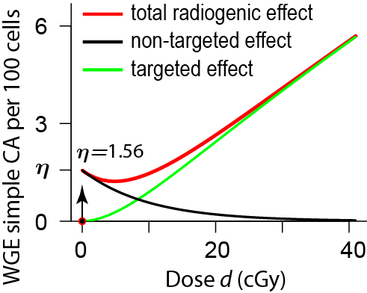**Fig. A2.1. Shape of a Typical NTE2 Model Curve*.*** In the NTE2 Model the total radiogenic effect is the sum of NTE and TE contributions (black and green curves). The two properties most relevant for the discussion of IDERs in our main text are the following. First, NTE are modeled as jumping, at an ultra-low dose smaller than 1 mGy, from 0 to *η* with infinite slope (arrow) and then decaying back to 0 (black curve). As a result the total radiogenic effect is decreasing rather than increasing at doses between the ultra-low dose and ~5 cGy. The second relevant property is that at doses larger than about 10 cGy, where the NTE2 model predicts TE are starting to dominate NTE, the TE curve (green) has a positive slope that is almost constant.

Eqs. (10) and (11) of the main text specify the smooth monotonically increasing IDERs that used the same data for illustrating mathematical synergy analysis. The resulting adjustable parameters and the significance level of their difference from zero are shown in Table A2.2.

**Table A2.2. Values and Statistical Significance Levels of the Parameters**

|  |  |  |  |  |
| --- | --- | --- | --- | --- |
| Model | *η0* | *η1* (*μ*/keV) | σ0 (micron2) | *κ* |
| IDER | 1.5e-4±2.2e-5 (<1e-3)*** | 3.5e-3±9.0e-4 (<1e-3)*** | 4.2±1.4 (<0.01)** | 469±247 (0.064)* |
| NTE1 | 1.1e-4±9.0e-5 (<0.299) | 7.0e-3±5.6e-3 (<0.256) | 6.12±1.66 (<0.021)* | 796±287 (<1e-4)*** |
| NTE2 | 4.7e-4±2.6e-4 (<0.152) | 1.1e-2±3.5e-3 (<0.036)* | 6.75±1.67 (<0.016)* | 590±236 (<1e-4)*** |

In the table the following conventions and abbreviations are used. (a) Powers of 10 are indicated by ‘e’; for example 1.5e-4=0.00015. (b) Standard errors are indicated by ±. (c) Asterisks indicate statistically significant difference from 0 at respective levels * ≤ 0.1; ** ≤0.01; *** ≤10-3.

A comparison at ultra low doses is shown in Fig A2.2

|  |
| --- |
| **Fig. A2.2. Smooth Concavity vs. Infinite Slope.** The figure shows modeled NTE contributions to total effect for Si ions (*L=*100). Red lines are for the NTE2 model used in [Cacao et al. 2016], where the slope at dose=0+ was taken to be infinite. The subsequent decrease at higher doses, shown in Fig. A2.1, is here barely visible at 1 mGy where the red line has dipped slightly below the horizontal line at height *η*(*L*). The three black curves are for NTE contribution in our corresponding IDER, Eqs. (10) and (11) , with the respective *d0* values, from left to right, of 0.02, 0.1, and 0.5 mGy. Our final results are essentially unchanged if any value of *d0* ≤0.1 mGy is used. The black curves are monotonic increasing at all doses; they approach *η*(*L*) and zero slope as dose increases*.* The value for *η*(*L*) after model parameter calibration is different for the red and black curves, but the y-axis has here been linearly re-scaled to facilitate comparison of the curve shapes. |

In addition to thus replacing the discontinuous function *I* by a smooth function*,* the monotonic increase in our model is based on the following reasoning. Even at doses above a few mGy intercellular signaling still occurs and produces some effect, which at doses where TE dominate is just a small perturbation that cannot be disentangled experimentally from the overall effect. The NTE1 model in [Cacao et al. 2016], which they consider their preferred model according to their information criteria, also does not assume a decrease in NTE as dose increases.

We calculated the Akaike information criterion (AIC) [Shuryak 2016] and the Bayesian information criterion (BIC) [Cacao et al. 2016] for our IDER. The results were compared with the AIC and BIC for the NTE1 and NTE2 models in [Cacao et al. 2016]. Our calculations of AIC and BIC for the NTE1 and NTE2 equations used the models and parameters in [Cacao et al. 2016] but were re-calculated to take into account our way of calibrating models, emphasizing radiogenic IDERs, with background subtracted out. Results are shown in Table A2.3.

|  |  |  |
| --- | --- | --- |
| Model\IC | AIC | BIC |
| NTE1 | 229.69 | 239.45 |
| NTE2 | 277.24 | 287.00 |
| IDER | 200.99 | 210.75 |

**Table A2.3. Akaike and Bayesian Information Criteria.**

Smaller values, here those in the last row, are preferred. Only differences between the rows are relevant. As in [Cacao et al. 2016], our calculations indicate that the NTE1 model is preferred over the NTE2 model. For details on the calculations see the scripts GCRfibroCA2GH.Rmd and CAsynergyAnalysisGH.R available on GitHub. Make all like this

In order to check visually that our insistence on monotonic increasing IDERs is acceptable, we compared our calibrated IDERs graphically with corresponding NTE2 IDERs from [Cacao et al. 2016]. The results are shown in Figs. A2.3 and A2.4.

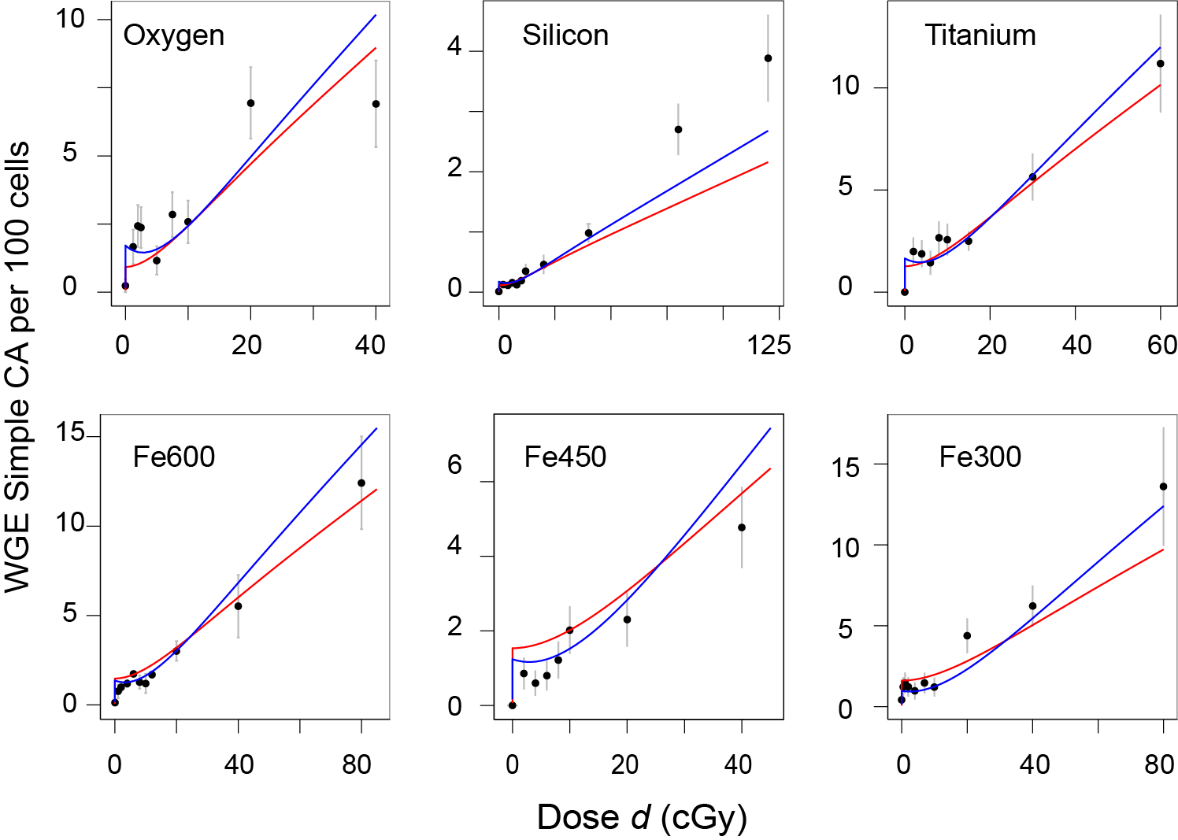**Fig. A2.3 Monotonically increasing IDERs.**

The figure compares our IDERs (red curves) with the NTE2 model curves of [Cacao et al. 2016] (shown as dashed blue curves), which are decreasing in the dose range from ultra-low doses to about 5 cGy. Visually, the monotonically increasing IDERs are not inferior, a result expected from Table A.2.3.

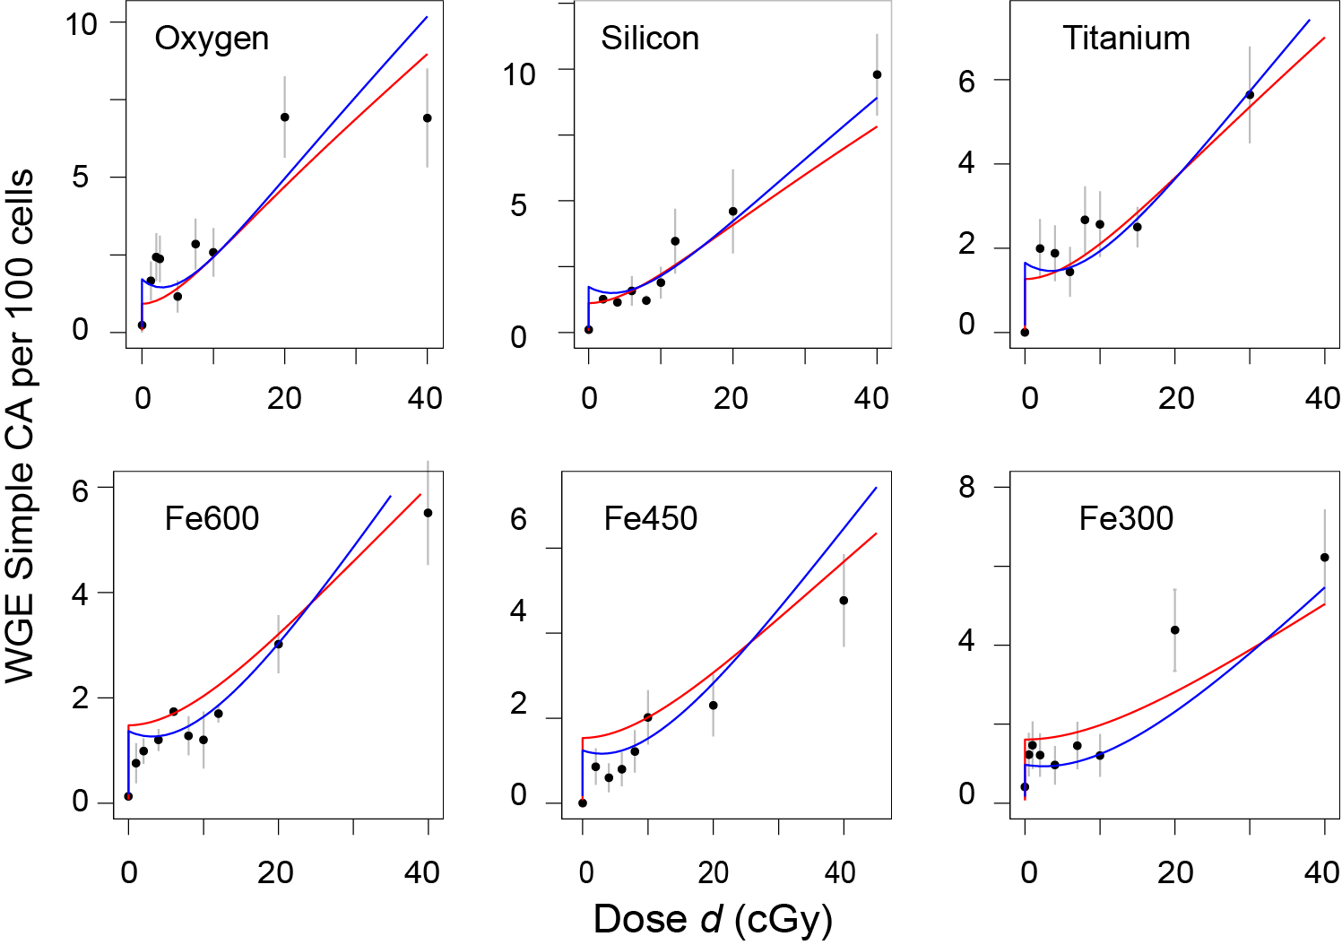**Fig. A2.4. Zooming in on Smaller Doses**

The figure zooms in on doses ≤ 40 cGy, so that the region between 0 and 5 cGy can be seen more clearly. It again compares our IDERs (solid red curves) for the main-example data set with the NTE2 model curves of [Cacao et al. 2016] (shown as dashed blue curves).

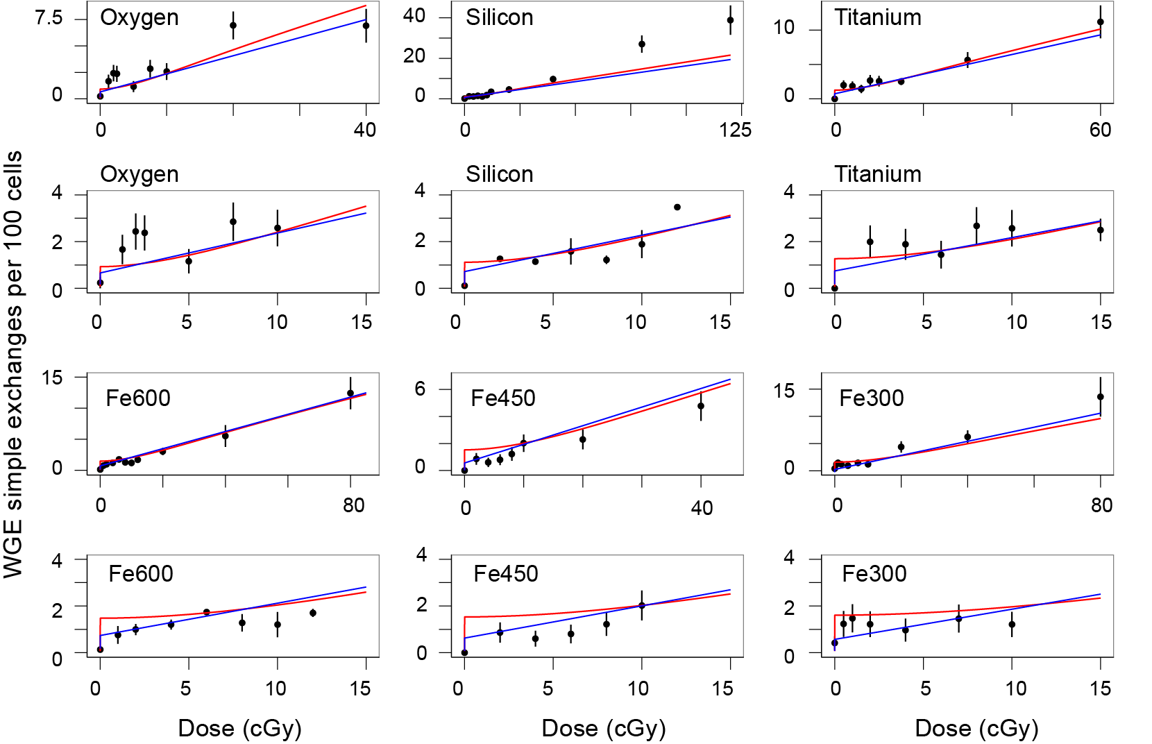Visual comparisons to the NTE1 model preferred in [Cacao et al. 2016] are shown in Fig. A2.5.

**Fig. A2.5. Comparing with a Previous Model.**

The IDERs for our calibrated model (red curves) are compared with the IDERs (blue curves) that were found to result from the NTE1 model identified as the preferred NTE model in [Cacao et al. 2016]. Points are the observed values. Rows 2 and 4 zoom in on the low dose range, 0-15 cGy, of the rows above them. It is seen that overall the NTE1 model and our IDER model are comparable visually. The silicon data at doses of 1 Gy or more show evidence of convexity, presumably due to 2-track action, neglected in the IDER. Other data at lower doses show no distinct upward curvature.

# Appendix A3. Synergy Analysis for Monotonically Increasing IDERs

## A3.1. Precise Quantification vs. Generality

As qualitative, general concepts ‘synergy’ and ‘antagonism’ are used heavily in radiobiology; this usage will no doubt continue for a long time to come. However, no quantitative, precisely defined synergy analysis theory applicable to a substantial fraction of situations where the vague qualitative concept of synergy is used are available or will become available in the foreseeable future [Ashford 1981; Geary 2013; Piggott et al. 2015]. For example, most current synergy analysis theories concern a scalar endpoint, not more complicated endpoints such as a dose-dependent function of time to tumor, so they only produce a baseline no-synergy-antagonism MIXDER, not more complicated outputs.

Even when only a scalar endpoint is involved, no specific synergy analysis theory sufficiently general to handle all mixed radiation fields of interest is known. The simple effect additivity theory *S*(*d*) should not be used unless all the mixture components have IDERs that are at least approximately LNT. Replacements for *S*(*d*) have substantial limitations.

As far as we are aware, every previously published systematic replacement explicitly or implicitly assumes that mixture components have IDERs which are all monotonically increasing (or are all monotonically decreasing; this case is so similar to the case where all are monotonically increasing it need not be described separately). In addition to this monotonicity limitation, each replacement has additional limitations of its own.

In Appendix 3 we now assume monotonicity; we discuss and compare these replacements. In Appendix 5 we will show a way to improve on them substantially.

## 

## A3.2. Barenbaum’s Approach

A famous pharmacology paper [Berenbaum 1989] reviews, extends, and advocates a general approach to synergy analysis theory applicable to mixtures each of whose IDER is monotonically increasing. The approach is based on the following considerations.

### A3.2.1. Some Assumptions and Motivations

Assuming that each IDER for the components of a mixture is known and essentially no further information is available, one can define a reasonable baseline MIXDER, characterizing absence of synergy or antagonism. Such baseline MIXDERs are useful first steps in understanding mixture effects (Fig. 2 of the main text). They are less reliable than predictions based on biophysical understanding of agent interactions but typically much faster, simpler, and cheaper [Berenbaum 1989; Greco et al. 1995; Geary 2013; Norbury et al. 2016].

The baseline MIXDERs, in the Berenbaum approach, are typically not mechanistic: they use mathematical manipulations of IDERs, not additional biophysical insights specific to the endpoint being analyzed [Berenbaum 1989; Greco et al. 1995]. The reasoning is that biophysical insights should be used in devising IDERs, but that subsequently intermingling the temporary synergy-analysis shortcut (Fig. 2, main text) and the long biophysical-understanding path (main text Fig. 2, blue arrows) would merely undermine the shortcut’s practical advantages without adequately replacing the long path. As we illustrated in the main text, a baseline MIXDER can be extended to a default hypothesis by estimating uncertainties for the baseline MIXDER from corresponding IDER information.

A3.2.2. The Sham Mixture Principle

The sham mixture principle, that the mixture of an agent with itself always has as a baseline no synergy/antagonism MIXDER the agent’s own IDER, is required in Barenbaum’s general approach (other researchers disagree, as discussed in A3.3.4 below). Incremental effect additivity *I*(*d*), defined by Eq. (3) of the main text, does always obey the sham mixture principle, as proved at the end of Appendix A3.4.2. below. Simple effect additivity *S*(*d*)does not obey the sham mixture principle (Fig. 1A of the main text). Therefore, in the Barenbaum approach, *S*(*d*) cannot be used for mathematical synergy analysis. An obvious exception occurs if, in some special situation, *S*(*d*) gives essentially the same answer as using a synergy definition that obeys the principle. For example, when all *N* IDERs for a mixture have the LNT form, *Ej*(*dj*)*=Ajdj* with *Aj* a positive constant, all synergy definitions, including *S*(*d*) and *I*(*d*)*,* have baseline MIXDERs  whether or not they violate the sham mixture principle when applied to curvilinear IDERs. When all theories give essentially the same answer, there can be no objection to using the simplest, namely *S*(*d*). Less trivial examples were given in [Siranart et al. 2016]. These were mixtures with some component IDERs being concave and others being convex, where accidental cancellations between *S*(*d*) under- and over-estimates resulted in *S*(*d*)being almost equal to *I*(*d*)*.*

## A3.3. Examples of Synergy/Antagonism Definitions

### A3.3.1. Isobole Synergy Analysis

By far the most commonly used synergy analysis theory based on the ideas in A3.2 is the linear isobole method (reviewed in [Chou 2006; Brun and Greco 2010; Lee 2010; Tallarida 2012; Geary 2013; Foucquier and Guedj 2015]). This method requires monotonically increasing IDERs for the components of a mixture. It computes from IDERs a default total mixture dosefor any given mixture effect *E*. If a mixture experiment shows that using a dose smaller than the default dose is sufficient to produce *E* then there is by definition synergy. Intuitively the idea is that there must have been some kind of extra cooperation between components that enables a small dose to produce an unexpectedly large effect *E*. Similarly if a dose larger than the default dose is needed to produce *E* then by definitionantagonism is present.

In the notation of the main text, the default total mixture dose *d* is calculated by the following equation:

(A3.3) 

For sufficiently small mixture effect *E* there is always a unique solution *d*(*E*)of Eq. (A3.3). The proof is the following. For *d* very small, the left hand side of Eq. 1 is larger than the sum on the right, which is independent of *d*. The right hand side is greater than zero; it remains fixed as *d* is gradually increased, while the left side decreases continuously and monotonically, eventually approaching 0. So there must be exactly one solution *d*.

An important ‘minimax’ limitation of linear isobole synergy analysis theories occurs in the following kind of situation, which is common in practice. Suppose some of the IDERs have finite maxima which they can never exceed for any dose of interest. Among these IDERs there must be at least one, which we can take to be *EN*(*dN*) without essential loss of generality, whose maximum is no larger than any of the other maxima. Call that minimum maximum *Eminimax*. Suppose there is at least one other IDER in the mixture which either has no maximum at all or has a maximum larger than *Eminimax*. Then values *E* of the total mixture effect greater than *Eminimax* are of interest but *DN*(*E*) is undefined for such *E* and thus Eq. (A3.3) cannot be used to calculate *d.* The *N*th IDER not only refuses to play linear isobole but also spoils the game for everybody else. In practice this minimax limitations sometimes limits the range of *d* to such small values that linear isobole synergy analysis theory becomes virtually useless.

In addition to this practical limitation of the linear isobole default hypothesis there is a conceptual issue. Barenbaum attempted to prove Eq. (A3.3) from the sham mixture principle. However his proof is now known to be incorrect ([Grabovsky and Tallarida 2004; Bosgra et al. 2009], reviewed in [Tallarida 2012; Foucquier and Guedj 2015]).

Curvilinear isobole synergy analysis theories (reviewed in [Tallarida 2012]) take into account Berenbaum’s error. However they also have drawbacks [Geary 2013], which preclude their application to complex mixtures of HZE ions [Siranart et al. 2016].

### A3.3.2. Two Other Approaches to Synergy Analysis

In radiobiology synergy is often analyzed by dual radiation action theory [Zaider and Rossi 1980]. The theory uses linear-quadratic (LQ) dose-effect relations. For one acute dose an LQ IDER is the sum of a term linear in dose and another quadratic in dose:

(A3.2) 

where *α* and *β* are non-negative constants at least one of which is non-zero. A generalization of Eq. (A3.2) to protracted dosing, such as fractionation or chronic low dose rate exposures, is discussed in Appendix section A4 below but for the time being we consider only the acute dosing case.

The dual radiation action theory applies only to mixtures each of whose components has an LQ IDER. For such mixtures it predicts the baseline MIXDER is LQ. The theory differs from Barenbaum’s general approach, described in Appendix sub-section 2.2 above, in many ways, including the following:

(a) Mechanistic biophysical arguments are used to obtain the parameters *α* and *β* for the baseline no-synergy/no-antagonism LQ MIXDER.

(b) This baseline MIXDER does not obey the sham mixture principle unless *β*=0.

(c) It is assumed, explicitly or implicitly, that synergy or antagonism must always be defined as deviations from the simple effect additivity baseline that Barenbaum deprecates.

(d) The terminology used differs strongly from that of Barenbaum. For example, a single radiation field having an LQ IDER with *β*>0 is said to be synergistic with itself whereas Barenbaum’s definitions imply self-synergy can never occur. The various terminological discrepancies are merely verbal differences arising from comparing different fields such as radiobiology and pharmacology. They are not in themselves actual scientific disagreements; but they are extraordinarily confusing.

LQ IDERs do not incorporate NTE, so the dual radiation action synergy analysis theory was not used in the main text. Details on and examples of the theory are given, e.g., in [Zaider and Rossi 1980; Bird et al. 1983; Zaider 1990; Berenbaum 1991; Furusawa et al. 2002; Suzuki et al. 2002].

Independent action [Lam 1994] is another theory that also allows self-synergy. In general its usefulness is restricted not only by the condition of IDER monotonic increase but also by the minimax restriction: if one mixture component, acting on its own, can never exceed some finite upper limit no matter how large the dose, then the same must hold for all the other components, with the same upper limit.

*A3.3.3. Asymmetrical Synergy Analysis Theories*

A number of synergy analysis theories, including some variants of curved isobole theories, are asymmetrical: the baseline MIXDER for combining *r1* of agent 1 with *r2* of agent 2 can be different than that for combining *r2* of agent 2 with *r1* of agent 1. This makes sense when one of the two agents is somehow clearly subordinate to the other agent, as can occur in adjuvant therapy. However, asymmetrical theories cannot be used for mixed radiation fields with many different components, all of which are on essentially the same footing.

## A3.4. Some Properties of Incremental Effect Additivity *I*(*d*)

Incremental effect additivity *I*(*d*), previously defined by Eq. (3) of the main text, was originally suggested by, and designed to improve on, the linear isobole theory of Appendix sub-section A3.3.1 above. Essentially, Eq. (3), like the linear isobole theory, is considering effect, rather than dose, as the basic independent variable, as is also often done [Durante 2014a], for different reasons and with different equations, in radiobiological discussions of relative biological effectiveness (RBE).

Incremental effect additivity *I*(*d*)*,* like some other replacements for simple effect additivity *S*(*d*)in the literature, always obeys the sham mixture principle [Siranart et al. 2016], in contrast to *S*(*d*) itself. Unlike most other replacements, *I*(*d*) is in principle applicable to mixtures with very heterogeneous IDERs. For example, one could in principle use Eq. (3) for a single mixture where some IDERs of each of three qualitatively different shapes are involved.

1. IDERs having a concave shape, as shown in Fig. 1B of the main text.
2. LQ IDERs, Eq. (A3.2), where the quadratic component obeys *β*>0. These IDERs are convex.
3. Hill function IDERs with Hill coefficient <1 [Greco et al. 1995; Chou 2006; Foucquier and Guedj 2015]. These functions are sigmoidal (‘S-shaped’). They are often used for agent mixtures in pharmacometrics, toxicology, evolutionary ecology and other fields

We will now discuss some mathematical properties of incremental effect additivity. We start with an existence and uniqueness theorem for *I*(*d*)*.* Then we review mixtures whose component IDERs are so similar that the ODE initial value problem (3) for *I*(*d*) can be solved without resort to computer numerical integration. Then we prove that *I*(*d*)always obeys the sham mixture principle. Finally we characterize the difference between *I*(*d*)and simple effect additivity in terms of baseline MIXDER slopes.

### A3.4.1. Solutions of Eq. (3): Existence, Uniqueness and Properties

The right hand side of the ODE in Eq. (3) is the sum of a finite number *N* of terms. Each term comes from one component of the mixture. In the relevant computations, each component of the mixture has an IDER that obeys the requirements of sub-section 2.2.2 as regards smoothness, finiteness of slope, and monotonic increase.

Picard’s theorem [Coddington and Levinson 1955] guarantees existence and uniqueness for the initial value problem (3). Specifically there is some number A>0 such that in the interval [0,A) there is one and only one solution and that solution is smooth. In our cases, the interval can be extended to an interval [0, *Eminimax*), where *Eminimax* is defined in Appendix sub-sections A3.3.1 and A3.3.2.

### A3.4.2. Mixtures Whose Component IDERs Have Constant Relative Potency

Two agents with respective IDERs *E1*(*d1*) and *E2*(*d2*) are said to have ‘constant relative potency’ (or said to be ‘similar’) if there is some relative potency constant *P>0* such that *E2*(*d2*) = *E1*(*Pd2*). Then *E1*(*d1*)= *E2*(*P-1d1*). The intuitive interpretation is that for all relevant doses, agent 2 is *P* times as potent in producing the effect as agent 1. For example if both IDERs are LQ, they have constant potency ratio if *α2d2*+*β2d22*= *α1Pd2*+*β1P2d22* for all *d2*, which implies *α2* =*Pα1* and *β2*= *P2β1.* For mathematical, historical, and practical reasons IDERs with constant relative potency are important in synergy (and other) analyses [Berenbaum 1989]. Mathematically, the case of a mixture all of whose IDERs have constant relative potency covers almost all situations where incremental effect additivity *I*(*d*)can be evaluated as an explicit function of mixture dose *d* instead of needing to use numerical ODE integration.

Specifically, suppose the following: g(*d*)is a smooth function for 0≤d<∞ with *g*(*0*)*=0*; *g*(*d*) has limit Emax for *d* approaching infinity, where 0 < Emax ≤ ∞; and the derivative g*′* is greater than 0for all *d.* Suppose in a mixture of *N* components each IDER obeys *Ej*(*d*) *=g*(*Pjd*)for some ‘potency constant’ *Pj* > 0. Then all the IDERs are pairwise similar and the following holds.

*Theorem. I*(*d*)*=g*(*w*)*,* where *w* = [Σ*rjPj*]*d*

*Interpretation.* The intuitive interpretation is that *M=*Σ*rjPj* can be regarded as an average potency *M* using the discrete probability distribution *rj*, and thus *w* is average potency times total mixture dose.

*Proof of the Theorem.* All pairs of IDERs are similar since *Ej*(*d*)*= g*(*Pjd*)*=g*((*Pjd/Pi*)*Pi*)*=Ei*(*Pjd*/*Pi*). The compositional inverse *G*(*E*) of *g* is defined for any *E* in the interval [0,Emax) and the compositional inverse *Dj* of *Ej* is given by *Dj*(*E*) *=* (1/*Pj*)*G*(*E*). For *I*(*d*) we therefore have, denoting the derivative function for *Ej* by *Ej*′,

(A3.3) 

Using Eq. (3) now gives

(A3.4) 

Here the last implication follows from Picard’s theorem on the uniqueness of the solution of the initial value problem for an ordinary differential equation [Coddington and Levinson 1955]. The reader may wish to trace the steps of the theorem’s proof using toy examples so simple that all the individual steps can also be carried out explicitly, such as *g=x2, g=2x+x2, g=x/*(*1+x*)*,* or *g=ln*(*x+1*).

Forlinear isobole synergy analysis a corresponding theorem has been known for a long time. It is discussed, e.g., in [Berenbaum 1989], which gives more details on the intuitive interpretation of the weighted sum *P.*

Any sham mixture, where all the IDERs are identical, is an example of constant relative potency, with *Pj*=1*=M*. Therefore the theorem above implies that *I*(*d*) always obeys the sham mixture principle.

### A3.4.3. Simple Effect Additivity Defined Incrementally

Suppose we have a mixture each of whose components has an IDER *Ej*(*dj*)that is “standard” as defined in the main text: it is zero at dose=0, smooth, and has positive slope for some half open dose interval [0, *Aj*) with *Aj*>0. Recall that the simple effect additivity baseline MIXDER is defined by

(A3.5) 

Then we can define *S*(*d*) by a slope equation equivalent to (A3.5) in some half open dose interval [0, *A*) with *A*>0, and this slope equation can be compared to the baseline incremental effect additivity *I*(*d*) MIXDER defined in the Methods section of the main text by

(A3.6) 

In fact, differentiating Eq. (A3.5), using *Ej*(*0*)=*0,* using *dj=rjd* and using the inverse function definition *dj=Dj*(*Ej*)gives

(A3.7) 

Eq. (A3.7) is equivalent to Eq. (A3.5) on some interval [0, *A*) with *A*>0 by Picard’s theorem and the fact that the number of summands is finite. In Eq. (A3.7) the subscript on the square brackets could have been omitted, since the derivative function is by definition a function of *dj* but the comparison of Eq. (A3.6) and (A3.7) pinpoints the fact that the sole difference between *S*(*d*)and *I*(*d*) comes from the fact that for *I*(*d*)the incremental contributions are determined by the biophysical system variable *I,* rather than by the control variable *d* which the system has no way to sense directly.

## A3.5. Summary

As useful qualitative concepts synergy and antagonism are very general. They indicate that a mixture effect seems different than the effect one might have expected from looking at the component IDERs. The only quantification that has comparable generality is simple effect additivity *S*(*d*), which is usually inappropriate unless all mixture components have LNT IDERs. To look for other quantitative versions of synergy/antagonism that are as general as the qualitative concepts or simple effect additivity is quite hopeless [Ashford 1981; Foucquier and Guedj 2015]. To get useful quantifications one has to impose extra conditions on the IDERs. Appendix A3 discussed some of the most commonly used extra conditions, emphasizing monotonic increase of all mixture component IDERs. We described some of the synergy quantifications most commonly used as alternatives to simple effect additivity, e.g. the linear isobole theory.

# 

# Appendix A4. Synergy Analysis for Chronic Low Dose Rate Radiation Fields

## A4.1. General Comments.

Dose protraction consists of a series of acute dose fractions, or of a chronic non-zero low dose rate which need not be constant in time, or of any combination of the two. In interplanetary space astronauts will experience chronic GCR irradiation protracted over several years (reviewed, e.g., in [Durante 2014b; Kim et al. 2015; Norbury et al. 2016]), whereas the acute irradiation considered up to this point is so rapid compared to other relevant processes such as radiation damage repair that it can be considered instantaneous. The chronic GCR dose rate in the absence of shielding and excluding solar particle events is, very roughly, 0.2 Gy per year, but this number depends on the solar cycle stage and other factors; current shielding configurations have a drastic effect on the HZE charge and energy spectra but are not effective in reducing estimated carcinogenesis risks from HZE.

Thus radiobiological synergy analyses will eventually have to be extended to mixtures whose components have IDERs appropriate for highly protracted dosing. We are a long way from understanding such IDERs for GCR radiations. We do not know the relevant radiation target sizes or relaxation times or the importance of NTE. We do not even know if we should consider IDERs or consider instead a function of dose and dose rate as co-equal variables, as can occur in a dynamic steady state [Lubin et al. 1995]. We do not know if protracting a given dose over a long time will decrease damage, as is often found in radiobiology, or actually increase it, as is sometimes found, especially for high LET radiations (reviewed, e.g., in [Stevens et al. 2014]). There are also discrepancies between accelerator experiments and interplanetary exposures. Exposure above low earth orbit is chronic in the absence of a solar particle event; experiments often involve fractionation instead of chronic irradiation and even the dose rate averaged over the entire experiment may be much higher than the chronic interplanetary GCR dose rates. Until these factors are better understood we do not know what kind of IDERs to assign to mixture components in a protracted dosing situation, let alone what default hypotheses should be used in mathematical synergy analyses.

In Appendix A4 we will now give one proof of principle example to show that synergy analysis can sometimes be carried out for protracted dosing mixtures. The example does not attempt to answer the above questions. It assumes an answer to the questions and shows how synergy analysis works under that assumption. We will review known IDERs that assume protraction decreases effects in a specific way and discuss the mathematical properties of these IDERs. Then we will specialize to the case of a constant dose rate. We will conclude by giving examples of baseline no-synergy/no-antagonism MIXDERs for a mixture whose components have such IDERs.

## A4.2. LQ IDERs with Generalized Lea-Catcheside Dependence on Dose Timing

### A4.2.1. The G function

Radiobiologists often use a standard dose-protraction LQ (linear-quadratic) formula for the effect accumulated by time *t*>0 due to an irradiation that started at time *t=0.* The formula, which can be used to incorporate the influence of repair and of damage-damage interactions during dose protraction, is the following:

(A4.1) 

Here *α*, *β*, and λ are non-negative constants with all 3 positive unless explicitly stated to the contrary. *R*(*t*)is the dose-rate at time *t* and

(A4.2) **

is the dose accumulated by time *t. G* is the generalized Lea-Catcheside functional. This functional *G*, and various special cases of *G*, have been introduced by many different research groups using many different arguments (reviewed, e.g., in [Sachs et al. 1997]).

### A4.2.2. Intuitive Interpretations of the Generalized Lea-Catcheside Functional

A sometimes useful intuitive interpretation of *G* in Eq. (A4.1) in terms of dual radiation action is the following. Assume the part of the total effect contributed by the *β* term comes from potentially damaging lesions that are, in competing processes, be repaired or interact bilinearly to make irreparable lesions. We have three different times: *t* > *w > s* > 0. The intuitive interpretation of the double integral is the following, reading from right to left. A small increment *R*(*s*)*ds* of dose arrives at an early time *s*. This increment *R*(*s*)*ds* makes some potentially damaging lesions. The increment of these potentially damaging lesions is proportional to *R*(*s*)*ds* with a fixed proportionality constant, say *C*. Some of these potentially damaging lesions are repaired during the time between *s* and *w*, so that only a fraction exp[*-λ*(*w-s*)] remains at later time *w*; here the factor exp[*-λ*(*w-s*)] results from a simple repair model called linear repair with per-capita rate constant *λ*. The potentially damaging lesions remaining at time *w* can then interact bilinearly with potentially damaging lesions due to the later arriving dose increment *R*(*w*)*dw* to make an irreparable effect. Adding all the contributions from all intermediate times *s* and *w* by double integrationwe get a value proportional to irreparable effect added by time *t*. The constant *β* is given by *β*=*C*2*B*, where *B* is the proportionality factor for the production of irreparably harmful lesions per pair of potentially harmful ones.

### A4.2.3. Properties of G

*G* in Eq. (A4.1) does not depend on the magnitude of the dose, just its time course. Specifically, if *R\**(*t*)*=CR*(*t*)for some constant scaling factor *C*>0, then *d\**(*t*)*=Cd*(*t*)but a short calculation shows *G\**(*t*)*=G*(*t*)*.* For a single acute exposure the term exp[*-λ*(*w-s*)] in Eq. (A4.1) is exp[*-λ*(*w-s*)]=1 since *t* > *w > s* > 0. Integration then shows *G=1* so *E*(*t*) has the LQ form (A3.2) with time dependent dose *d*(*t*) that jumps up from 0 at some specific time.

(A4.3) 

For finite dose rate instead of the Dirac delta function dose rate corresponding to a single acute dose, it can be shown that *G* obeys 0< *G* <1, so that spreading a given dose over a finite time interval always does decrease the effect, as expected from the intuitive interpretation of the previous sub-section, rather than increasing the effect.

## A4.3. Constant Chronic Dose Rate

For time *T*>0, consider irradiation with a constant dose rate *R>0* during the interval (0,*T*), with *R=0* otherwise. Thus *T* could represent the duration of a space voyage beyond low earth orbit, where GCR dose rate is approximately constant during transit, or represent irradiation time during a chronic dosing experiment. In the case of HZE irradiation, at a rate of about 0.2 Gy/year, during a prolonged interplanetary space voyage, one might have *T=* 1 yr. *Tλ* is a ‘dimensionless duration’; it is *ln*2 times the duration *T* of irradiation divided by the half-life of repairable lesions subjected to linear repair.

In the case of constant dose rate the LQ equation with dose protraction functional *G*, Eq. (A4.1),simplifies to

(A4.4) 

so going back and forth between dose and time is very easy here. Moreover, the double integral for *G* can be carried out explicitly to get results we will need for synergy analyses, as follows:



which implies

(A4.5) 

Also, taking the time derivative of *E*(*t*)in Eq. (A4.5) gives

(A4.6) 

For *t*≪1/*λ*, Eq. (A4.6) appropriately reduces to the acute irradiation limit, namely

(A4.7) 

Eq. (A4.6) shows that *dE/dt* is positive everywhere in the interval (0,*T*)*,* so *E*(*t*) increases monotonically, which implies there must exist some inverse function τ such that *t= τ*(*E*)*.* The inverse function *τ*(*E*) has a vivid intuitive interpretation as a biodosimetry function which estimates how long an astronaut has been in orbit by counting his or her chromosome aberrations [Sigurdson et al. 2008; Maalouf et al. 2011; Beinke et al. 2013; George et al. 2013].

## A4.4. Dose Rate Sparing

We next give a graph, Fig. A4.1 that summarizes some implications of the results in sub-section A4.3 above. Like the lung cancer relative risk graphs in [Lubin et al. 1995] for underground miners exposed for years to chronic levels of radiation from radon daughters, our graph here shows the effect *E* for the entire irradiation duration *T* at various total dose levels *d=RT*. It takes advantageof the fact that in Eq. A4.5.5 with *d* fixed, *T* and *λ* do not appear separately, only their product, the dimensionless duration *Tλ*

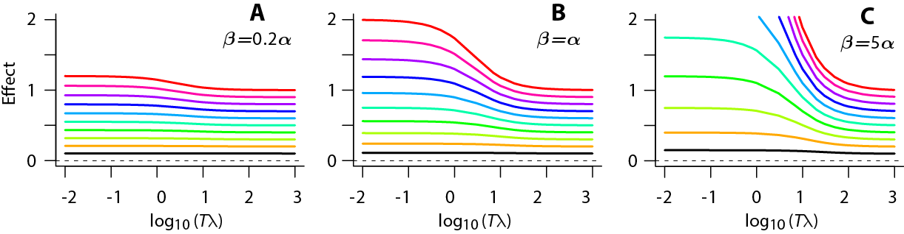**Fig. A4.1. Dose rate sparing.** The panels show total effect for total doses that run from d=0.1 Gy (black lowest curve in each panel) in equal steps to 1 Gy (red uppermost curve). The scale of the vertical axis is governed by the value of *α* and the curves shown assume that for this endpoint *α*=1 per Gy. The following properties of Eqs. (A.3.1) and (A.3.5) can be seen from the graphs.

* For *Tλ* ≤10-2 the slope is almost zero and the effect is at its largest for that dose and that parameter set. This is the acute (short duration) limit. Since the Lea-Catcheside *G* factor approaches 1 in that limit, one must have *E=αd*+*βd2.* For example if *α=1, β= 1, d=1* (red topmost line in panel B) one sees that to good approximation the height is *αd*+*βd2*=2.
* For *Tλ* ≥103, the curves are decreasing toward a lower limit of about *αd*. Manipulation of Eq. (A4.3.5) shows that in fact this is the exact value for *Tλ* approaching infinity. In terms of section A4.2, the intuitive explanation is that if the dose rate is small enough a repairable lesions is always repaired before it can interact with a later-arriving repairable lesion to make irreparable damage, so the entire *β* term in the LQ equation drops out leaving only the dose-rate independent term *αd*. The decrease, when going from left to right along a curve, from *E*=*αd*+*βd2* to *E*=*αd* is called ‘dose rate sparing’ or ‘the direct dose-rate factor’.

Frequently used standard LQ models for many endpoints, when applied to HZE radiations, often give results similar to panel A in Fig. A4.1: the curves are so nearly horizontal one may as well ignore the beta term entirely. However, for low LET radiation induction of leukemias one can instead have, in the dose range 0-2 Gy, *α/β* ≪ 1 Gy [Little 2009] so that dose rate sparing is pronounced, as in panel C.

In contrast to the dose rate sparing there is theoretical and experimental evidence (reviewed, e.g. in [Lubin et al. 1995; Brenner and Sachs 2003; Stevens et al. 2014]) that HZE action may (for many endpoints, dose rates and doses of interest) give qualitatively different results whereby effect increases as radiation duration increases for a given fixed dose, corresponding to an ‘inverse’ dose-rate factor instead of a direct one. In such cases Eq. (A4.1), for LQ IDERs with generalized Lea-Catcheside *G* factor, cannot be used*.* And mathematical models quite different from LQ models, e.g. models incorporating NTE such as those in [Cacao et al. 2016] and [Shuryak et al. 2017], are often now being used . Here our interest is mainly in producing proof of principle calculations illustrating how synergy can be analyzed even when dosing is protracted and dose-effect relations are highly curvilinear. These calculations are given in the next sub-section.

## A4.5. Examples of Baseline no-Synergy/no-Antagonism MIXDERs

We now can calculate and compare baseline MIXDERs for mixed radiation fields each of whose components has an IDER of the form (A4.5). For the incremental approach we assume that for a small increment of time *dt*, each component contributes an incremental effect *dEj=rj*(*dEj/dt*)*dt,* where *dEj/dt* is given by Eq. (A4.6) evaluated at that time when that component acting by itself would have produced the total effect *I* that both components acting together have already produced. This definition just transfers the arguments used to motivate incremental effect additivity synergy analyses to the case where small increments of time, rather than small increments of total mixture dose are considered. Formally the compositional inverse functions *τj* discussed below Eq. (A4.6) are used to find the appropriate time for each component.No explicit forms for *τj* are available. However, in computer calculations a 1-dimensional root finder can readily give high precision numerical versions of *τj*: the complications sometimes attendant on finding roots are not present because *E*(*t*) and thus its inverse *τ*(*E*) are always monotonically increasing in our case. We will assume the repair rates of the two radiations are the same, mainly for simplicily but also on the grounds that probably these rates are primarily a property of the biological target.

As an example, suppose in an NSRL experiment we have a mixture of low LET ion radiation 1 (e.g. high energy protons) with high LET radiation 2 and the endpoint is a surrogate for radiogenic excess relative risk for leukemia. As in mixture guidelines for recent NASA calls we will take 80% of the total dose to be due to the low LET radiation, i.e. *r1=0.8* and *r2=0.2*.We will assume chronic irradiation at constant dose rate for one week. For the dose rate *R* we will assume 0.5 Gy per week, i.e. 40 cGy total of low LET radiation mixed with 10 cGy total of high LET radiation over the course of the week.

For the low LET radiation a possible choice of *α* and *β* in Eq. (A4.7), judging from leukemias in the atom-bomb victims, is *α1=0*, *β1*=2 Gy-2 [Little 2009; Hsu et al. 2013]. The scale of the y axis in the figures we shall show is essentially arbitrary. One might calculate effect, or effect in %, or effect divided by some reference effect so a uniform re-scaling of all four LQ coefficients (*α1, β1, α2, β2*) makes no essential difference to the baseline MIXDERs or their relation to the IDERs in the figures we shall show. Thus a numerical value of one non-zero LQ coefficient, e.g. *β1* here can be chosen arbitrarily without essential loss of generality.

For the high LET radiation, on the usual argument that for such radiation irreparable one-track action probably dominates, we will choose *β2*=0; for *α2* we choose a nominal value *α2=*5 Gy-1; then the values of *λ2* and *R2* become irrelevant and need not be specified. Fig. A4.2 shows baseline no-synergy/no-antagonism curves for this mixture assuming various values of the repair rate *λ* = *λ1*.

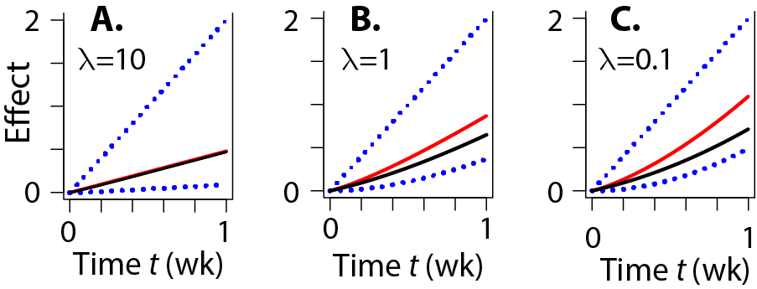**Fig. A4.2. Baseline MIXDERs.** The figure shows incremental effect additivity curves (red lines) and simple effect additivity curves (black lines) for a mixture of a high LET ion component and a low LET component. The IDERs, i.e. the curves that would have resulted were the total dose given entirely to one or the other component, are shown as dotted blue lines.

Even for this very simple choice of the two IDERs, no explicit analytic expression is available, so the calculation was done with the customized script Lea.R that is available on GitHub. This script was first tested by applying it to a mixture which happened to be explicitly soluble. Then it was applied to the high-LET low-LET mixture.

Panel A shows a typical result for a repair rate that is not much smaller than those normally assumed. It is trivial from the point of view of illustrating differences between *I*(*d*)and *S*(*d*) because both mixture components are effectively LNT: the high LET component IDER is exactly LNT and the low LET IDER might as well be LNT because the dose rate is so low compared to the repair rate that the quadratic term is negligible. Panels B and C show cases of unusually slow repair rate, as could perhaps occur due to some cause – e.g. a state of chronic irritation by ROS or RNS [Cucinotta, Kim and Chappell 2013], reviewed in [Shuryak 2017]. These panels show differences between *I*(*d*)and *S*(*d*).

In trying to decide what further figures to use to illustrate our mixture results we again found too many possibilities. Even when concentrating on 2-component mixtures to avoid the previously discussed confounding factor of having too many possible sets *rj* for dividing total mixture dose *d* into component doses *dj=rjd*, the fact that there are essentially4 other relevant parameters (*α1, β1, λ1*=*λ2, α2,* and *β2*, where only 3 of the 4 LQ coefficients count because of possible y-axis rescaling mentioned above) prevented any systematic choice of a few ‘representative’ mixtures. Indeed, even for acute dosing, trying to compare *S*(*d*) and *I*(*d*) over the entire relevant parameter space leads to unsolved mathematical/computational problems [Siranart et al. 2016]. The script Lea.R therefore did not attempt to consider the even more numerous possibilities that would arise for mixtures with more than 2 different ions entering the beam upstream of shielding.

Fig. A4.3 shows two more examples; its caption gives some intuitive interpretations.

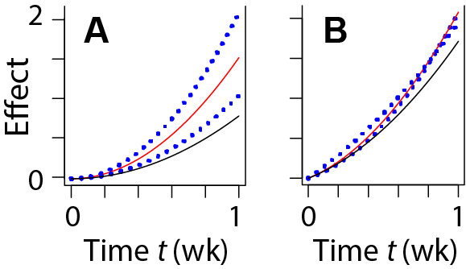**Fig. A4.3. Other Mixtures.** The figure gives results for two components having the parameters shown in the table: It shows the time-incremental effect additivity baseline no-synergy/no-antagonism MIXDERs (red lines) and the simple effect additivity no-synergy/no-antagonism MIXDER (black lines). The IDERs, i.e. the curves that would have resulted were the total dose given entirely to one or the other component, are shown as dotted blue lines.

|  |  |  |  |  |  |
| --- | --- | --- | --- | --- | --- |
| panel | ion | *α* | *β* | *λ* | *rj* |
|  |  | Gy-1 | Gy-2 | week-1 |  |
| **A** | 1 | 0 | 8.4 | 0.05 | 0.5 |
|  | 2 | 0 | 4.2 | 0.05 | 0.5 |
| **B** | 1 | 1.2 | 6 | 0.05 | 0.8 |
|  | 2 | 2.6 | 2.6 | 0.05 | 0.2 |

The fact that the simple effect additivity baseline MIXDER falls below both component IDERs is due to the fact that when all mixture components are convex, as is the case for the mixture here, the simple effect additivity baseline is an underestimate. Fig. 1A of the main text shows that such underestimates can be traced back to the failure of simple effect additivity to obey the sham mixture principle. Panel B shows a case where the two component IDERs cross.

## A4.6 Summary of Low Dose-Rate, Time-Incremental Effect Additivity Synergy Analysis

We have given explicit, reasonably realistic examples of how one can do synergy analyses for protracted mixture exposures. Our examples only apply to one very specific kind of component IDERs, which all had to be LQ with linear repair of potentially damaging lesions. We emphasized chronic irradiation at constant dose rate. Our treatment also involved a number of implicit assumptions. For example the time constant for resolution of potentially damaging lesions by either repair or transformation into irreparable lesions was assumed to be so short that one such lesion does not ever suffer a second hit. Conceptually it is clear that it should be possible to generalize the LQ example at least somewhat, but that has not been done and thus may involve unexpected difficulties.

# A5. Incremental Effect Additivity Synergy Theory

## A5.1. Analytically-characterized IDERs

Prior to the availability of computers which can rapidly provide accurate numerical solutions to non-linear ODE, it was natural to specify IDERs by giving effect as an appropriate explicit function *E=E*(*d*) of dose, as in our main text here, in [Cacao et al. 2016], in [Cucinotta and Cacao 2017], and in very many other papers. We suggest that nowadays it is often preferable to specify IDERs via their slope as a function of *E* itself, by solving an ODE initial value problem of the form

(A5.1) 

with the slope function *F*(*E*) sufficiently well behaved that there is one and only one solution for all sufficiently small non-negative doses.

One motivation for taking *F* as a function of *E* rather than a function of *d* is that *E,* unlike *d,* is a state variable, determined by the changing biophysical state of the target system as dose and effect accumulate [Lam 1994]. Moreover, mechanistically analyzing how a small increment of effect interacts with effects caused by earlier dose increments is sometimes easier than mechanistically analyzing the entire effect of the entire dose [Lam 1987].

Eq. (18) of the main text gave a toy example of a 2-ion mixture where using Eq. (A5.1) for one component had the important advantage of circumventing the minimax limitation discussed in sub-sections A3.3.1 and A3.3.2. That limitation sometimes renders linear isobole and other synergy analysis theories virtually useless [Siranart et al. 2016]. Circumventing the limitation is the most important practical advantage of Eq. (A5.1).

To decide on candidate slope functions *F*(*E*) for useful IDERs we reasoned that the toy example involved an extrapolation and, mathematically speaking, extrapolations often use analyticity. In Eq. (A5.1) *F*(*E*) is a real function of a real variable, but instead of choosing *F*(*E*) directly we will assume *F*(*E*) is specified using a complex-analytic function *G* of a complex variable, with *G* chosen to approximate whatever is known or mechanistically inferred about the IDER slope. We will call *G* a “slope extrapolator”.

Specifically, we assume that *F*(*E*) is the restriction of *G*(*z*), with *z* the complex variable *z=E+iy*, to the non-negative *E* axis in the complex plane, where *G* is holomorphic in some open neighborhood of the origin *E*=0=*y* and *G*(0) is non-negative. For example this slope extrapolator *G* could be any polynomial having real coefficients *aj* with *a0* non-negative. We call an IDER defined by Eq. (A5.1) and a specific function *G* an “Analytically-characterized” IDER (AIDER). We will next state the equation of incremental additivity, in its general form for mixtures some of whose components’ IDERs may be AIDERs.

## A5.2. The Equation of Incremental Effect Additivity in General

Consider a mixture consisting of *N* *≥*0 agents whose IDER are in the form *Ej*(*dj*) together with *M*≥0 agents whose IDER are AIDERs obeying Eq. (5.1), where *N+M ≥* 2. Let *r1, r2, ..., rN+M* be the corresponding proportions. Then the equation of incremental effect additivity is

(A5.2) 

The theorems of Picard and others [Coddington and Levinson 1955] guarantee the existence and uniqueness of *I*(*d*)on some half-open interval [0, A) of the dose axis.

**Incremental effect additivity synergy analysis of a given mixture consists of analyzing the solution *I*(*d*) of Eq. (A5.2). The corresponding default assumption, denoted by *I*(*d*) for brevity, consists of this synergy analysis plus carrying out uncertainty analyses of *I*(*d*).**

We will analyze motivations, examples, theorems, interpretations, advantages, disadvantages, and applications, related to AIDERs, and to the role of AIDERs in incremental effect additivity synergy theory.

## A5.3. AIDERs: Examples with Explicit Solutions

Over the years, radiobiologists have developed IDER equations given by explicit equations to fit various biophysically motivated and/or experimentally observed curve shapes. Examples include multi-target, multi-hit equations, amorphous track structure equations, LQ equations, many generalizations of LQ equations, equations incorporating NTE, etc. For AIDERs one instead starts with the slope *F*(*E*). Often no explicit equation for *E*(*d*) itself can be found. Finding *E*(*d*)then involves using a standard ODE integrator such as the function ode() in the package deSolve of the computer language R and results in a numerical version of *E*(*d*)*.* Subsequent calculations then either just use this numerical form to get further numerical results or use the qualitative theory of ODE [Brauer and Nohel 1989], which involves analyzing slopes to determine solution properties without attempting to actually integrate an ODE.

Sub-section A5.3.1 will show by examples that there are, however, many cases where the AIDER initial value problem (A5.1) can be solved explicitly. Explicit AIDERs, and methods for generating them, are often useful, in helping understand numerical AIDERs, when debugging customized software, and to supplement results obtained from the qualitative theory of ODE.

*A5.2.1. Examples of Explicit AIDERs*

In Eq. (A5.1) suppose *F*(*E*)is an *Nth* degree polynomial with *N* real roots, all non-zero and distinct from each other. Then:

(A5.3) 

where *c* is a real constant>0 so the roots are –*ak*. In this case one can always use the method of partial fractions to integrate the ODE (A5.1) and obtain *d* as a function of *E.* Sometimes the inverse function *E*(*d*)can be expressed explicitly. For example when *N=1* and *a*>0 the solution *E*(*d*)obtained by integrating and using an inverse function involves an exponential:

(A5.4) 

*E*(*d*) is then similar to an LQ curve with both *α* and *β* positive in the following respects: for doses so small terms cubic or higher in dose can be neglected, *E*(*d*) is LQ with α=*ca* and β=(*c*/2)α; *E*(*d*) is strictly convex, with positive second derivative, for all doses (Fig. A5.1 below); *E*(*d*) does not approach ∞ as some finite value is approached by *d*; and *E*(*d*)is unbounded, approaching ∞ as *d* approaches *∞.*

As another example, for *N=2* with *a, b, c>0* one has:

(A5.5) 

In this case *E*(*d*) approaches *b* as *d* approaches *∞* and, depending on the choice of parameters, the curve can be concave or sigmoidal (Fig. A5.1).

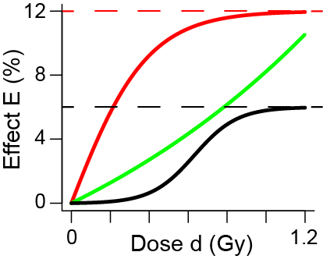**Fig. A5.1. AIDER curve shapes.** All three curves are monotonically increasing with finite positive slope at all doses. The green curve is described explicitly by Eq. (A5.4) with *a=*10and *c=*0.6. It has properties similar to an LQ curve; at low doses it is LQ, with α= 6% per Gy and α/β=10/3 Gy. The black curve and red curves are described by Eq. (A5.5) with upper limits *b*=6% or 12% respectively. The black curve has *a*=0.02 and has *c=*1.5; it is sigmoidal, with a point of inflection. The red curve has *a*=13 and has *c=*0.2. It is concave. The criterion for concavity vs. sigmoidicity is *a>b* vs. *a<b.* It is seen that one can readily find AIDERs with explicit *E*(*d*)functions and various qualitatively specified shapes.

## A5.4. AIDERs: Suitable and Unsuitable Slope Functions *F*(*E*)

### A5.4.1. Preview

Some AIDERs approach infinity as dose approaches some finite value from below. This sub-section gives an example. We suspect such AIDERs can never be useful in radiobiology; moreover, we will argue that if a mixture component is assumed to have such an IDER then incremental effect additivity synergy theory makes unreasonable predictions. Such AIDERs are unsuitable. In practice such AIDERs are easily avoided. However, the fact that not all AIDERs are suitable raises a question of principle.

Until/unless one finds simple necessary and sufficient conditions for AIDERs to be suitable, incremental effect additivity must remain somewhat unsatisfactory in principle as a mathematical theory. This sub-section discusses the mathematical aspects of that problem and suggests the solution may lie in studying where in the complex plane the singularities and roots of the slope extrapolator *G*(*E*+*iy*) are located.

### A5.4.2. Examples of AIDERs that become infinite

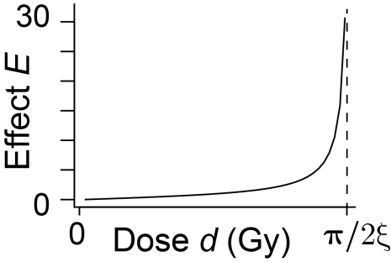For example, with *ξ* a real constant > 0 and *z*=*E*+*iy*, suppose the slope extrapolator *G*(*z*)*=ξ*(*1+z2*) so that *F*(*E*) in Eq. (A5.1) is *F*= *1+E2*. Integrating *dE/*(*1+E2*)shows the AIDER *E*=tangent(*ξd*). In the interval [0, π/2*ξ*) the AIDER is smooth. However, as *d* approaches π/2*ξ* from below, *E* approaches infinity, as shown in Fig. A5.2. An IDER that approaches ∞ at finite dose is not useful in any radiobiology analysis we know of, and attempts to use differential synergy analysis on a mixture one of whose components has IDER tangent(*ξd*)give strange results, with that component completely dominating mixture behavior. We therefore consider the AIDER tangent(*ξd*) unsuitable.

**Fig. A5.2. The AIDER *E*=tan(*ξd*).**

More generally, suppose throughout the rest of this sub-section that with *z=E+iy* the slope extrapolator *G*(*z*) is a polynomial of (finite) degree *M* greater than 0 with real coefficients *aj* and with *a0* > 0. Thus *G*(*z*) has no singularities in the complex plane (i.e. on the finite part of the extended complex plane). Suppose first the only zeros of *G*(*z*) lie on the imaginary axis. Then it follows that *M* is even, that *aM*>0, and, since *aMEM* increases at least as fast as *E2* for large *E*, that *E*(*d*) is unsuitable because it approaches infinity for some finite *d*. On the other hand suppose all zeros of *G*(*z*) lie on the real line with at least one zero for *E*>0. Then the qualitative theory of ODE [Brauer and Nohel 1989] shows that *E*(*d*) approaches the zero on the positive real axis closest to the origin; Fig A5.1 shows specific examples; it happens that *E*(*d*) can be found explicitly in these specific examples, but that is not a major consideration in the present argument. The AIDERs shown in Fig. A5.1 are suitable; AIDERs with qualitatively similar shapes are used frequently in radiobiology.

To summarize, by placing restrictions on the location in the complex plane of the slope extrapolator’s singular points and zeros we have been able to generalize somewhat, obtaining examples of suitable and unsuitable AIDERs. The calculations were rendered mathematically very simple by starting with the assumption that *G* is a polynomial, an assumption far too strong to be used as a general restriction. We suspect that analogous restrictions on zeros and singular points, for meremorphic slope extrapolators rather than just polynomials, may turn out to be the necessary and sufficient suitability conditions we would like to find.

## A5.5. AIDERs: Non-Linearity

The IDERs we used in the main text to reanalyze the CA data set involved adding two terms, for NTE and TE respectively. A corresponding approach when using AIDERs is to add two slopes, but one must then take into account non-linearities. Specifically, suppose the slope *F*(*E*)in Eq. (A5.1) is modeled as a sum of two terms:

(A5.6) 

Then *E*(*d*) is in general not merely the sum of the two AIDERs defined by



Intuitively speaking, *F1*(*E*)and *F2*(*E*) ‘interact’ with each other. For example consider the following case.

(A5.7)*….*

Using the methods of the preceding sub-section we find

(A5.8) 

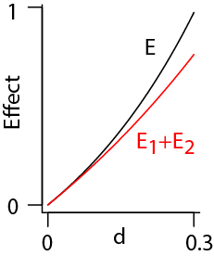So *E*(*d*)*>E1*(*d*)*+E2*(*d*), as shown in the Figure.

In fact, this inequality holds whenever both *F1*(*E*)and *F2*(*E*)are positive monotonic increasing functions for all relevant *E.* The intuitive reason is roughly the following.For *E* the slope at each dose is larger than for either of the two components so it leads the solution to larger values of *E* faster than for either component. Because all the slopes are monotonic increasing functions of effect, this leads to an ever increasing lead of *E* over *E1+E2.*

The result *E*(*d*)*>E1*(*d*)*+E2*(*d*) contrasts with the result where a slope is determined by functions of dose. For any integrable functions *F1*(*d*) and *F2*(*d*) we have

(A5.9) 

Here the second implication follows from the fact that all 3 effects are 0 at d=0.

## A5.6. MIXDER *I*(*d*): Additional Examples

### A5.6.1. Exemplifying Qualitative ODE Theory and also Sophisticated Slope-Extrapolators

We now, as another example, analyze mixtures of three agents, as follows. Two of the agents have conventional IDERs of the form *E=f(d)*, with *f(d)* explicit, smooth and monotonically increasing; the third agent’s IDER is an AIDER that has negative slope at large effect values. As in Eq. (18) of the main text, *I(d)* can be calculated for large doses, even when the third agent starts to contribute negative slope, which tends to counterbalance (but cannot override) the other two agents’ tendency to increase the effect.

In the example, all effects of interest are in the interval [0,1) so, as in Eq. (12) of the main text, we can and will define smooth monotonically increasing IDERs in terms of corresponding hazard functions *Hj*(*d*j), which are themselves smooth monotonically increasing IDERs, as follows:

(A5.10) 

Eq. (A5.10) implies slope equations, which will be needed to calculate *I(d)*:

(A5.11) 

With *α, β,* and *k* adjustable constants greater than zero, our example uses two IDERs defined by Eq. (A.5.10) and the following explicit equations.

(A5.12) 

The third IDER *E*3 is an AIDER. With *c* and *a* real, positive numbers and with *z=E*3+*iy* it is defined by the following slope extrapolator, more sophisticated than just a polynomial:

(A5.13) 

There is an open neighborhood of the origin on an appropriate Riemann sheet where *G*(*z*) is holomorphic and its restriction to the real axis is real and is positive for *E*3 ≥ 0.

The motivation for this choice of *G*(*z*) was to illustrate behavior similar to that in Eq. (18) of the main text, by defining an AIDER which approaches but never quite reaches some level less than 1. This can be achieved by starting with the ODE initial value problem

(A5.14) 

The slope of *H*3 is thus positive when *H*3< 0.5. The qualitative theory of ODE [Brauer and Nohel 1989] shows that *H*3 approaches but never quite reaches 0.5 (its slope approaches 0 as *H*3 approaches 0.5). The corresponding limit for *E*3=1-exp(-*H*3), shown as the dashed line in panel A of Fig. A5.3 below, is 1-exp(-0.5) ≈ 0.39347. Using Eq. (A5.10) to rewrite the slope in Eq. (A5.14) in terms of *E*3 gives for the slope

(A5.15) 

Eq. (A5.13) extrapolates Eq. (A5.15) to a function of a complex variable and thereby to values of *E*3 between 1-exp(-0.5) and 1 where the slope becomes negative.

Fig. A5.3 shows the result of calculating *I*(*d*) for two different mixtures of our three agents.

We used three parameters that differ between panels as shown in Table 5.1 and the following parameters common to both panels: *r*1 = *r*2 = (1-*r*3)/2; *a* = 0.2; *c* = 10; *k* = 4.

|  |  |  |  |
| --- | --- | --- | --- |
| Panel | *r3* | *α* | *β* |
| A | 35 | 1 | 2 |
| B | 50 | 3 | 0 |

**Table A5.1.**

Three of the eight parameters used in Fig. A5.3.

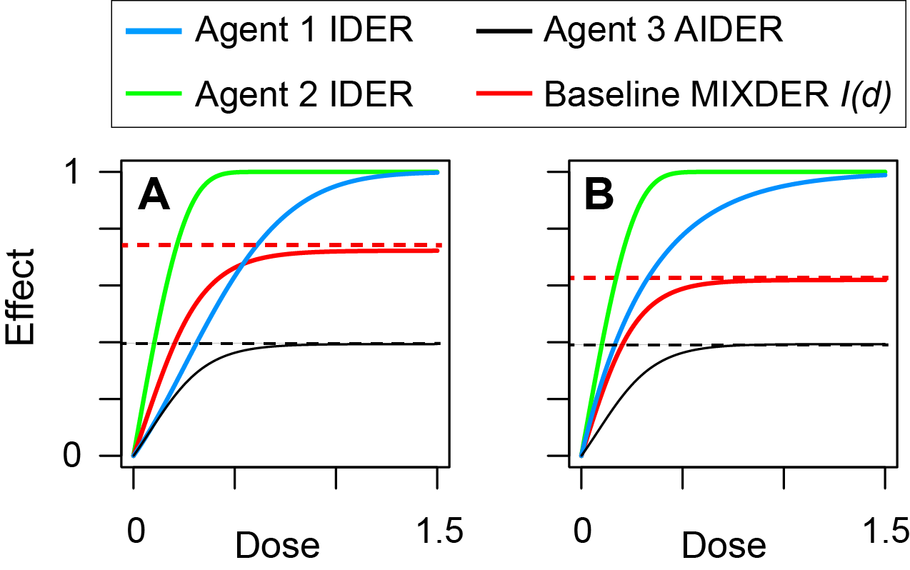**Fig. A5.3. *I*(*d*) for two 3-component mixtures.**

Agent 3 acting on its own cannot exceed 1-exp(-0.5) as shown by the black dashed lines. Initially all three IDER slopes are positive so *I*(*d*) increases. However, when the other two agents pull *I*(*d*) above 1-exp(-0.5) by their positive slopes, the extrapolated negative slope of agent 3 starts a battle of slopes which results in *I* approaching a compromise asymptote at indefinitely large doses, shown as the dashed red lines. In panel A the initial slope of agent 1 is smaller than in panel B but the main difference between the two panels is that in panel B agent 3 contributes a larger fraction of the total dose so that it is able to pull the compromise asymptote down more effectively, as shown.

One interesting aspect is that to get the dashed red lines one need not first integrate the equation of incremental effect additivity for *I*(*d*), then eyball a line which *I*(*d*) approaches. The qualitative theory of ODE, though mainly developed for systems of ODE rather just one ODE as here, states here that to find the asymptotic dashed red lines one only needs to find the first effect value *I* such that the sum of the three slopes =0. In panel B we used a 1-dimensional root finder to get the value Effect = 0.61936. Characteristically, the qualitative theory of ODE gives only partial information -- not the full red curve, just its asymptote -- but involves far less calculation. For a single ODE the qualitative theory is not very powerful but for ODE systems it is.

There are routine extensions of the above results to more than two conventional explicit IDERs and/or to more than one AIDER and/or to IDERs given directly rather than in the hazard function form of Eq. (A4.33).

### A5.6.2. A Mixture of an Effector and an Inhibitor

Consider some effect, e.g. an excess of reactive oxygen species, and two agents. Suppose both agents’ IDERs are AIDERs, with respective slope generators

(A5.16) 

Here: *zk* = *Ek* + *iy*, *k* ϵ {1,2}; and both *c* and λ are real and positive constants. Restricting *Gk* to the non negative real axis gives

(A5.17) 

As for all IDER the initial conditions are *E1*(0)=0 and *E2*(0)=0. The initial value problems are readily solved:

(A5.18) 

Here Eq. (A5.18A) is fully equivalent to Eq. (A5.17A) with its implied initial condition, but Eq. (5.18B) contains no information on the strength *λ* of the inhibitor while Eq. (A5.17B) does.

The interpretation of Eq. (A5.17A) is that a small increment in *d1* causes a positive effect increment proportional to *c*(*1+E1*)*.* Thus agent 1 is an effector, e.g. an HZE beam. The interpretation of Eq. (A5.17B) is that if any positive effect is present a small increment in *d2* causes a small decrease in effect. Thus agent 2 is an inhibitor, e.g. an anti-oxidant. The interpretation of Eq. (A5.18B) is that if no effect is present, a small increment in *d2* does nothing at all. This could be the case if background effect *Y*0 is negligible, so that agent 2 acting by itself cannot drive total effect *Y*0 + *E*2 below*Y*0.

We now consider a mixture of the two agents with proportions *r1* and *r2* that are both positive and add up to 1. As before, we hold *r1* and *r2* fixed as total mixture dose varies, As before this is just a convenient way to summarize results, not essential to the argument or to the overall conclusions drawn. The initial value problem for incremental effect additivity, (A5.2), reads

(A5.19) 

Intuitively, this equation says that the effector tends to make more and more effect, and the inhibitor, as soon as it has some effect to inhibit, acts in the opposite direction. The qualitative theory of ODE [Brauer and Nohel 1989] shows that there are two main types of solutions of Eq.

(A5.19), characterized respectively by *r2λ/r*1*c* ≥1(e.g. a large admixture of a strong inhibitor) and by *r2* *λ/r*1*c <* 1 (e.g. a small admixture of a weak inhibitor). Fig. A5.4 shows the pattern.

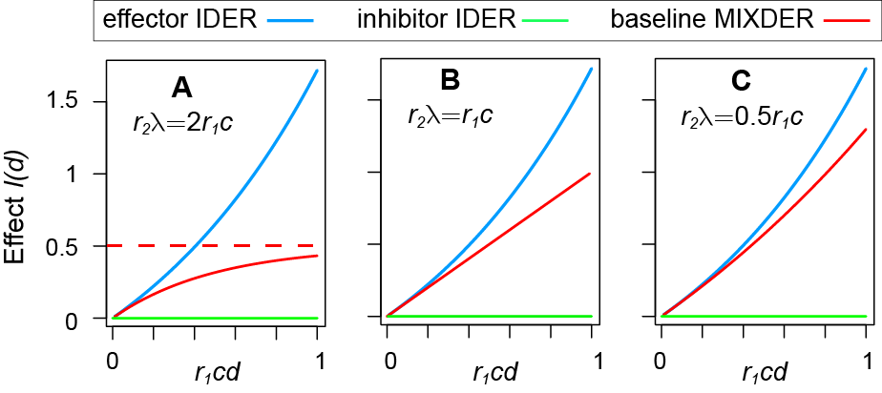**Fig A5.4. Stabilizing or Only Partial Inhibition.**

In all 3 panels the inhibitor IDER is the horizontal straight line at effect 0, but the inhibitor AIDER (not shown) is non-trivial. In panel A, inhibition is so strong the baseline no-synergy/antagonism MIXDER *I*(*d*) approaches a finite limit (dashed line) as dose increases. In panels B and C the baseline MIXDER grows indefinitely, at a slower rate than if no inhibitor were present.

If one has many effectors and many inhibitors *I*(*d*)can be calculated similarly. In the equation of incremental effect additivity, each effector contributes a positive amount to the slope and each inhibitor a negative amount. Recently [Piggott et al. 2015] reviewed known attempts to determine whether, when many effectors and inhibitors are in a mixture, the observed MIXDER is higher than, lower than, or approximately equal to the MIXDER one would have expected from the component IDERs. It was concluded that no known synergy analysis theory was adequate to answer the question and that probably no acceptable systematic quantitative method could be devised. However, the incremental approach here in fact gives the baseline MIXDER quantitatively and systematically.

### A5.6.3. A Major Generalization.

We have repeatedly emphasized that essentially all known replacements for simple effect additivity synergy theory *S*(*d*) are tormented by the unwelcome restriction that for small doses all components of a mixture have monotonic increasing IDERs (or all have monotonic decreasing IDERs). But the preceding sub-section shows the torment may be avoidable: Fig. A5.4 made us (belatedly) realize that the key restriction is that incremental effect additivity *I*(*d*) for a mixture be itself monotonic at low doses, and that can easily occur even if at low doses some component AIDERs are monotonically increasing, others are identically zero like the inhibitor AIDER in Fig. A5.4, and some others are monotonically decreasing.

Specifically suppose all components of a mixture have AIDERs given by slope extrapolators which are polynomials with real coefficients. Then one can integrate the equation of incremental additivity, Eq. (A5.3), and the slope of *I*(*d*) will not change sign. Denote the zeroth order coefficient of the *k*th AIDER polynomial by *a*0*k*. Then *I*(*d*) will be monotonic increasing, identically zero, or monotonic decreasing respectively according as  is positive, 0, or negative respectively. In other words one can freely mix AIDERs of many shapes and *I*(*d*) will nonetheless be well defined.

This is a major generalization. It is not fully satisfactory because: (a) one will sometimes need AIDERs more sophisticated than polynomials, e.g. the AIDER with slope generator given by Eq. (A5.13); and (b) we have not given simple necessary and sufficient conditions to exclude unsuitable behavior such as *I*(*d*) shooting up or down to ± infinity at finite doses, as exemplified in Fig. A5.2. But ameliorating both these problems is quite clearly possible and perhaps both can be eliminated entirely to develop a synergy theory which is as general as simple effect additivity but is capable of handling highly curvilinear IDERs.

A5.7. The Mixtures of Mixtures Principle

*A5.7.1. Mixtures of Mixtures*

An advantage of incremental effect additivity theory is that it obeys what we shall call the mixture of mixtures principle. In NASA studies, mixtures whose components are themselves mixtures by the time they hit the biological target are important (reviewed in [Norbury et al. 2016]). Pharmacological practice indicates that synergy analysis theory is then still applicable. A drug whose active ingredient is a single chemically pure compound can nonetheless act in complicated ways: on various organs in various locations at various concentrations by various mechanisms after transformation in the body to various other compounds [Ashford 1981]. So it is essentially already a mixture as far as its physiological effects are concerned. But if an IDER for such a chemically pure compound is known, and the compound is one component of a mixture, then pharmacometric mathematical synergy analyses routinely treat the component on the same footing as a different compound which has essentially just one simple physiological effect; indeed in many cases one does not even know if the action of a chemically pure compound is very complex or very simple.

So if a drug is some standard mixture of various active compounds and its IDER is known the drug can also be considered as single agent which can become one component of a mixture. This then implies a constraint on synergy theories. For a single acute treatment, a mixture of agents, some of which are themselves mixtures, must have the same baseline MIXDER defining absence of synergy and antagonism, as any other regrouping of the same components in the same amounts. As with the sham mixture principle, imposing the mixture of mixture principle excludes a number of synergy theories in the literature. Some theories always obey the mixture of mixtures principle. We will show that differential synergy analysis is an example. Other theories sometimes violate the mixture of mixtures principle. We will show that simple effect additivity is an example.

*A5.7.2.*  *I*(*d*) *Always Obeys the Mixture of Mixtures Principle.*

Note from Eq. (A5.2) that the slope of the baseline MIXDER *I*(*d*) is just a sum

(A5.20) ,

which can be grouped, regrouped and shuffled like any other sum. This remark and Picard’s existence/uniqueness theorem for ODE initial value problems are enough to show that the *I*(*d*) baseline MIXDERs are well defined in some, perhaps small, half open dose interval including the origin, and to show that such MIXDERs obey the mixture of mixtures principle for appropriately restricted dose and effect intervals.

*A5.7.3. Simple Effect Additivity: An Example of a Mixture Theory Failing to Obey the Principle.*

In this section we will show by an example that using the baseline simple effect additivity MIXDER *S*(*d*)instead of differential synergy analysis can violate the mixture of mixtures principle. Consider again the example given by Eqs. (A5.18)-(A5.20). For our next calculation we do not need inverse functions or slopes, only the three AIDERs in their *E*(*d*)form:

(A5.21) 

Denote the baseline MIXDER for mixture *M1* by *I1*(*d*)and that for *M3* by *I3*(*d*).A straightforward calculation using the definition, Eq. (10) for simple effect additivity shows that

(A5.22) 

Since *E1* and *E2* are strictly convex the difference in Eq. (A5.22) is positive for all doses > 0, as can be checked by using Eq. (A5.21). Thus simple effect additivity sometimes violates the mixture of mixtures principle. Additional calculations, not shown here, lead to two further conclusions: the violation of the principle by simple effect additivity is the generic case for that synergy definition; and there are other synergy analysis theories in use that also typically violate the principle. As far as we know, all synergy analysis theories that obey the sham mixture principle also obey the mixture of mixtures principle and vice-versa. Whether there is a theorem that states this equivalence must always hold, or instead there is a counter example, is an open question.

A5.8. Evaluating Substitutes for Simple Effect Additivity *S*(*d*)

### A5.8. Advantages of the Incremental Effect Additivity Synergy Theory I(d)

Simple effect additivity is always available for synergy analyses; in practice it is always used to help plan for mixture experiments and to interpret mixture data. But the simple effect additivity synergy theory has important known limitations for analyzing mixtures whose component IDERs are highly curvilinear, so that a supplement or replacement for *S*(*d*)is often needed. *I*(*d*) appears preferable to other known alternatives. Some of the main reasons are the following.

* *I*(*d*)can be used for mixtures whose component IDERs have quite heterogeneous shapes.
* *I*(*d*) obeys the sham mixture and the mixture of mixtures principles.
* Eq. (A5.2) for *I*(*d*) does not require AIDERs to be monotonic increasing at large doses. It circumvents the *Eminimax*complication, occurring at high effect values. It thereby often allows synergy analysis over larger dose and/or effect ranges, than linear isobole synergy analysis can handle. In some applications this dose and effect range extension is essential.
* Importantly, for some kinds of AIDERs Eq. (A5.2) can be used for mixtures where some component AIDERs are monotonically increasing at all sufficiently small doses while others are monotonically decreasing at all sufficiently small doses. Together with the ability to circumvent the large-dose/effect *Eminimax*complication this is a major generalization whose possibilities are just beginning to be explored.
* *I*(*d*) emphasizes the possibility of using effect as predictor variable and dose as response variable instead of vice-versa. This emphasis makes sense: effect is a state variable, i.e. a property of the biological system. On the other hand a biological system can sense the various doses delivered by various agents in a mixture only indirectly by the effects the combined dosing induces.
* As the graphs in this paper attest, *I*(*d*)tends to lie nested within the band formed by the various component IDERs of a mixture, as would be expected of a MIXDER that is supposed to indicate absence of synergy and absence of antagonism.
* Using *I*(*d*) and AIDER together in incremental effect additivity synergy theory can incorporate additional biophysical information on the incremental action of an agent’s incremental dose when an effect larger than the agent can induce when acting by itself has already been induced by other agents in a mixture.

*A5.8.2. Problems with the Incremental Effect Additivity Synergy Theory*

Although *I*(*d*) is the preferred substitute for simple effect additivity its limitations should not be underestimated. We next review some of the main limitations.

*I*(*d*)shares the limitations of all reasonably general mathematical synergy analyses theories such as those summarized in Fig. 2 of the main text and in Section A3 above. For example it emphasizes mathematical curve manipulation rather than biophysical insights, and it is usually just a real-valued function of dose, not a more complicated mathematical object that could take into account more complex endpoints such as probability distributions of time to tumor. Computing *I*(*d*) usually involves heavy use of computer calculations. The heavy emphasis on numerical methods instead of explicit functions is somewhat unfamiliar; it makes global results that hold for all relevant values of parameters hard to find. There is, at least as yet, no standardized, critically tested consensus protocol for using and interpreting *I*(*d*). The advantages of *I*(*d*) should be balanced against these problems.

The following strategy seems indicated. Whenever at least one component of a mixture has a highly curvilinear IDER, the incremental effect additivity synergy theory should be used to supplement or replace the simple effect additivity theory. Some other synergy theory such as the LQ mixture equation should be used as an additional supplement when there are biophysical reasons for doing so.

**Bibliography**

1. Ashford JR. "General models for the joint action of mixtures of drugs." Biometrics **37**(3): 457-474. (1981).

2. Beinke C, S Barnard, H Boulay-Greene, A De Amicis, S De Sanctis, F Herodin, . . . M Abend. "Laboratory intercomparison of the dicentric chromosome analysis assay." Radiat Res **180**(2): 129-137. (2013).

3. Berenbaum MC. "What is synergy?" Pharmacol Rev **41**(2): 93-141. (1989).

4. Berenbaum MC. "Concepts for describing the interaction of two agents." Radiat Res **126**(2): 264-268. (1991).

5. Bird RP, M Zaider, HH Rossi, EJ Hall, SA Marino and N Rohrig. "The sequential irradiation of mammalian cells with X rays and charged particles of high LET." Radiat Res **93**(3): 444-452. (1983).

6. Bosgra S, JC van Eijkeren and W Slob. "Dose addition and the isobole method as approaches for predicting the cumulative effect of non-interacting chemicals: a critical evaluation." Crit Rev Toxicol **39**(5): 418-426. (2009).

7. Brauer F and J Nohel. The Qualitative Theory of Ordinary Differential Equations. New York, Dover. (1989)

8. Brenner DJ and RK Sachs. "Domestic radon risks may be dominated by bystander effects--but the risks are unlikely to be greater than we thought." Health Phys **85**(1): 103-108. (2003).

9. Brun YF and WR Greco. "Characterization of a three-drug nonlinear mixture response model." Front Biosci (Schol Ed) **2**: 454-467. (2010).

10. Cacao E, M Hada, PB Saganti, KA George and FA Cucinotta. "Relative Biological Effectiveness of HZE Particles for Chromosomal Exchanges and Other Surrogate Cancer Risk Endpoints." PLoS One **11**(4): e0153998. (2016).

11. Chou TC. "Theoretical basis, experimental design, and computerized simulation of synergism and antagonism in drug combination studies." Pharmacol Rev **58**(3): 621-681. (2006).

12. Coddington EA and N Levinson. Theory of ordinary differential equations. NY, McGraw-Hill. (1955)

13. Cucinotta FA and E Cacao. "Non-Targeted Effects Models Predict Significantly Higher Mars Mission Cancer Risk than Targeted Effects Models." Sci Rep **7**(1): 1832. (2017). ***PMC5431989***

14. Cucinotta FA, MH Kim and LJ Chappell. Space Radiation Cancer Risk Projections and Uncertainties – 2012. Hanover, MD; <http://ston.jsc.nasa.gov/collections/TRS>, NASA Center for AeroSpace Information. (2013)

15. Cucinotta FA, MH Kim, LJ Chappell and JL Huff. "How safe is safe enough? Radiation risk for a human mission to Mars." PLoS One **8**(10): e74988. (2013). ***PMC3797711***

16. Cucinotta FA, H Nikjoo and DT Goodhead. "Applications of amorphous track models in radiation biology." Radiat Environ Biophys **38**(2): 81-92. (1999).

17. Durante M. "New challenges in high-energy particle radiobiology." Br J Radiol **87**(1035): 20130626. (2014a). ***PMC4064605***

18. Durante M. "Space radiation protection: Destination Mars." Life Sci Space Res (Amst) **1**: 2-9. (2014b).

19. Foucquier J and M Guedj. "Analysis of drug combinations: current methodological landscape." Pharmacol Res Perspect **3**(3): e00149. (2015). ***PMC4492765***

20. Furusawa Y, M Aoki and M Durante. "Simultaneous exposure of mammalian cells to heavy ions and X-rays." Adv Space Res **30**(4): 877-884. (2002).

21. Geary N. "Understanding synergy." Am J Physiol Endocrinol Metab **304**(3): E237-253. (2013).

22. George K, J Rhone, A Beitman and FA Cucinotta. "Cytogenetic damage in the blood lymphocytes of astronauts: effects of repeat long-duration space missions." Mutat Res **756**(1-2): 165-169. (2013).

23. Goodhead DT. "Energy deposition stochastics and track structure: what about the target?" Radiat Prot Dosimetry **122**(1-4): 3-15. (2006).

24. Grabovsky Y and RJ Tallarida. "Isobolographic analysis for combinations of a full and partial agonist: curved isoboles." J Pharmacol Exp Ther **310**(3): 981-986. (2004).

25. Greco WR, G Bravo and JC Parsons. "The search for synergy: a critical review from a response surface perspective." Pharmacol Rev **47**(2): 331-385. (1995).

26. Hada M, LJ Chappell, M Wang, KA George and FA Cucinotta. "Induction of chromosomal aberrations at fluences of less than one HZE particle per cell nucleus." Radiat Res **182**(4): 368-379. (2014).

27. Hsu WL, DL Preston, M Soda, H Sugiyama, S Funamoto, K Kodama, . . . K Mabuchi. "The incidence of leukemia, lymphoma and multiple myeloma among atomic bomb survivors: 1950-2001." Radiat Res **179**(3): 361-382. (2013).

28. Katz R. (1988). "Radiobiological Modeling Based On Track Structure. Quantitative Mathematical Models in Radiation Biology, ed. J. Kiefer." Retrieved December, 2016, from <http://digitalcommons.unl.edu/physicskatz/60>.

29. Kim MH, A Rusek and FA Cucinotta. "Issues for Simulation of Galactic Cosmic Ray Exposures for Radiobiological Research at Ground-Based Accelerators." Front Oncol **5**: 122. (2015). ***PMC4455530***

30. Kraft G, M Kramer and M Scholz. "LET, track structure and models. A review." Radiat Environ Biophys **31**(3): 161-180. (1992).

31. Lam GK. "The interaction of radiations of different LET." Phys Med Biol **32**(10): 1291-1309. (1987).

32. Lam GK. "A general formulation of the concept of independent action for the combined effects of agents." Bull Math Biol **56**(5): 959-980. (1994).

33. Lee SI. "Drug interaction: focusing on response surface models." Korean J Anesthesiol **58**(5): 421-434. (2010). ***PMC2881515***

34. Little MP. "Cancer and non-cancer effects in Japanese atomic bomb survivors." J Radiol Prot **29**(2A): A43-59. (2009).

35. Lubin JH, JD Boice, Jr., C Edling, RW Hornung, G Howe, E Kunz, . . . et al. "Radon-exposed underground miners and inverse dose-rate (protraction enhancement) effects." Health Phys **69**(4): 494-500. (1995).

36. Maalouf M, M Durante and N Foray. "Biological effects of space radiation on human cells: history, advances and outcomes." J Radiat Res **52**(2): 126-146. (2011).

37. Norbury JW, W Schimmerling, TC Slaba, EI Azzam, FF Badavi, G Baiocco, . . . CJ Zeitlin. "Galactic cosmic ray simulation at the NASA Space Radiation Laboratory." Life Sci Space Res (Amst) **8**: 38-51. (2016).

38. Piggott JJ, CR Townsend and CD Matthaei. "Reconceptualizing synergism and antagonism among multiple stressors." Ecology and Evolution: **5**(7): 1538–1547. (2015).

39. Sachs RK, P Hahnfeldt and DJ Brenner. "The link between low-LET dose-response relations and the underlying kinetics of damage production/repair/misrepair." Int J Rad Bio **72**(4): 351-374. (1997).

40. Shuryak I. "Mechanistic Modeling of Dose and Dose Rate Dependences of Radiation-Induced DNA Double Strand Break Rejoining Kinetics in Saccharomyces cerevisiae." PLoS One **11**(1): e0146407. (2016). ***PMC4711806***

41. Shuryak I. "Quantitative modeling of responses to chronic ionizing radiation exposure using targeted and non-targeted effects." PLoS One **12**(4): e0176476. (2017). ***PMC5404850***

42. Shuryak I, AJJ Fornace, Jr., K Datta, S Suman, S Kumar, RK Sachs and DJ Brenner. "Scaling Human Cancer Risks from Low LET to High LET when Dose-Effect Relationships are Complex." Radiat Res **187**(4): 476-482. (2017). ***PMID: 28218889***

43. Sigurdson AJ, M Ha, M Hauptmann, P Bhatti, RJ Sram, O Beskid, . . . JD Tucker. "International study of factors affecting human chromosome translocations." Mutat Res **652**(2): 112-121. (2008). ***PMC2696320***

44. Siranart N, EA Blakely, A Cheng, N Handa and RK Sachs. "Mixed Beam Murine Harderian Gland Tumorigenesis: Predicted Dose-Effect Relationships if neither Synergism nor Antagonism Occurs." Radiat Res **186**(6): 577-591. (2016).

45. Stevens DL, S Bradley, DT Goodhead and MA Hill. "The influence of dose rate on the induction of chromosome aberrations and gene mutation after exposure of plateau phase V79-4 cells with high-LET alpha particles." Radiat Res **182**(3): 331-337. (2014).

46. Suzuki S, Y Miura, S Mizuno and Y Furusawa. "Models for mixed irradiation with a 'reciprocal-time' pattern of the repair function." J Radiat Res **43**(3): 257-267. (2002).

47. Tallarida RJ. "Revisiting the isobole and related quantitative methods for assessing drug synergism." J Pharmacol Exp Ther **342**(1): 2-8. (2012). ***PMC3383036***

48. Zaider M. "Concepts for describing the interaction of two agents." Radiat Res **123**(3): 257-262. (1990).

49. Zaider M and HH Rossi. "The synergistic effects of different radiations." Radiat Res **83**(3): 732-739. (1980).