Revised Alert Notice Application

Peter Higgins, PhD

April 16, 2022

Introduction
This work is the latest revision of previous versions that implements changes requested by the project specialist, Elizabeth Waagen, AAVSO, including:

- Add forum links to notice staff edit forms and html document.
- Automate handling of include graphic in original and edited submittals.
- Reorder star table columns, vertically.
- Cosmetic changes, fix errors.

Staff menu
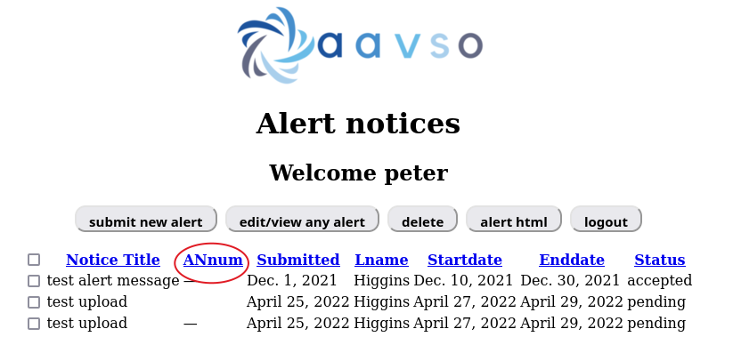
Figure 1

Annum has been changed to ANnum, shown circled in red.

Changes in staff edit/view of a notice
Several changes have been made including:
- This form still allows staff to enter a new notice because often a notice is entered by staff from email information from PIs. This probably will still be the case even when PI's can use this app to enter notices directly.
- The form is now 30 margin pixels from left side of page, not centered. Title of the form has been, and the home button is replace by menu. This is consistent with Sara's specification for sun spot entry.
- An entry box has been added for staff entry only of the AAVSO relevant forums (red ellipse). Staff can cut and paste forum string data giving title and html link, but the leading character before title and link must be a \# charater instead of a dash character as shown by blue ellipse.
- Entry of an optional graphic uses a forms.FileField control, shown here within a green ellipse, and a model.CharField in models.py The handling of this entry has been changed. When a new notice is created, including an optional graphic is optional, and the notice can be generated and saved to the database without it. No error is thrown if no graphic is chosen. But if a graphic is entered, several things happen: the graphic is now saved in the table field in the database AND it is now automatically uploaded into the project so it is found by the html writer. When selected, the file name appears alongside the control on the entry form. But unlike all other fields, it does not appear on the form in an edit of this notice even though it is in the database and has been uploaded. Because of this, previous versions of this app required the user to reselect it even when it doesn't change in the edit. This is a problem because the person editing may not remember what was originally selected, and it doesn't show on the form to remind them. This revision includes a work-around to this problem. Now when a notice record is selected by the checkbox, the included file (if there is one) is captured using REQUEST.POST and stored in a session variable. When the edit is saved if no new selection is discovered, the previous selection is recalled from the session variable and the revised notice record is updated with the previous selection (so the user now does nothing to restore the original choice). The code for this complication is in the edit function shown in the code below.
- Figure 3 shows the bottom of the new or edit form. It is moved to the left and the entries are not centered as highlighted by green ellipse. As requested the star columns now are arranged vertically not horizontally so that s2 is below s1 in the left column, not beside s1 in the right column (black ellipse).

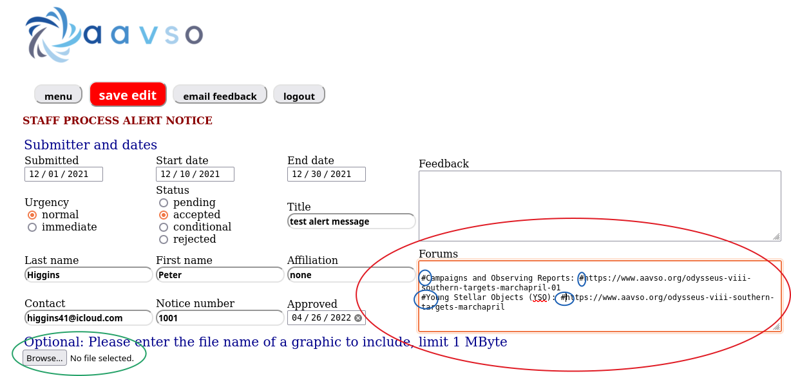
Figure 2

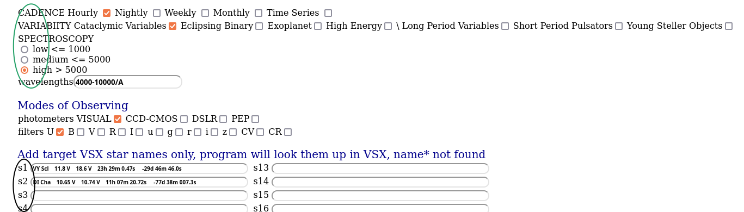
Figure 3

Code for included graphic handler
The comment lines explain functionality.
if "edit" in request.POST:
#get the include graphic in original posting by first getting the orininal record
pid = request.session['editrec']
idd = int(pid[0])
print("edit",idd)
# make query dictionary from this record using the session stored id key
tb=submittal.objects.get(id=idd)
print("tb",tb.table)
# get fields needed for success message
rqp = request.POST
sid = rqp.get('ld')
title = rqp.get('title')
# get new graphic if the user chose another
tblblank = rqp.get('table')
print("sform table",tblblank)
#make an edit form of the edited record
sform = EditForm(request.POST,request.FILES)
if sform.is_valid():
print("sform is valid")
#if the user chose another, try will work and the form is saved and new include uploaded
try:
handle_uploaded_file(request.FILES['table'])
sform.save()
poststars(request, 0)
submittal.objects.filter(id=pid).delete()
submitmsg = "Thank you for your edited submission of the Alert Notice \
entitled %s.<br> Your edited submission is now being reviewed. \
If you have any further questions,<br> \
please email eowaagen@aavso.org." % title
messages.success(request, mark_safe(submitmsg))
#but if the user didn't chose another, and if original had an include
except:
sform.save()
poststars(request, 0)
print("point A")
#since the form is saved without any include the last id is the record
lastid = submittal.objects.order_by('pk').last().id
print("lastid",lastid)
#make a recordset of the record just saved and update it with previous include
r = submittal.objects.get(id=lastid)
setattr(r, 'table', tb.table)
print('last table', tb.table)
r.save()
#but don't delete the original, let staff do it after checking
"""
submittal.objects.filter(id=pid).delete()
"""
#submit success record
submitmsg = "Thank you for your edited submission of the Alert Notice \
entitled %s.<br> Your edited submission is now being reviewed. \
If you have any further questions,<br> \
please email eowaagen@aavso.org." % title
messages.success(request, mark_safe(submitmsg))

Note that the original of a edited record is commented out, so that staff can check or reedit if needed before manually deleting it.

The new html document with forum links

The forum information entered in the staff edit form is detected and entered on the generated html document as shown by the red ellipse in Figure 4. A new graphic entered in the same edit is enclosed by the blue ellipse.
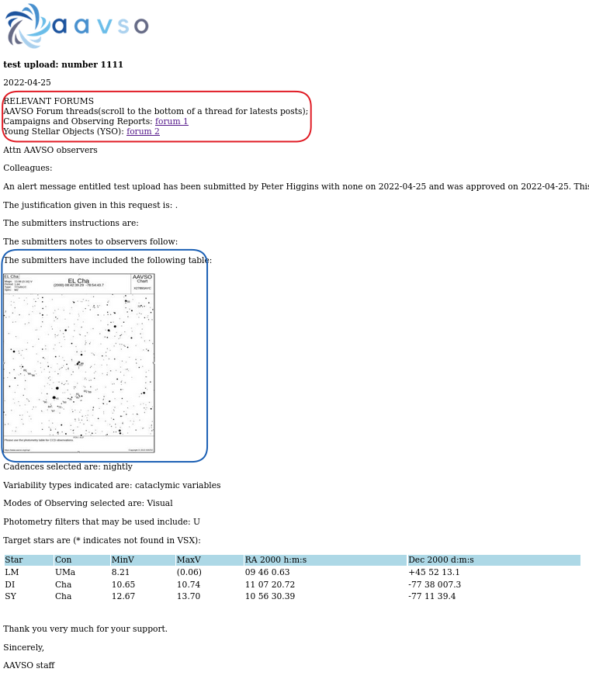
Figure 4

