Test Case for Converters from LATEX to Word Processor Format

1 Introduction
Mathematical formulae are the nemesis of converters. This is a simple inline equation: x=2. This one contains a fraction: . The following one has a subscript: . Here goes a summation: .
The following is a simple equation:
(1)
This equation includes the identity operator from amssymb:
(2)
Whereas the following one includes a pmatrix from amsmath:

[Sorry. Ignored \begin{pmatrix} ... \end{pmatrix}]
. (3)
The same column vector is expressed as an array in math mode:
(4)
This is a cross reference to the next section: Section 2
This is a citation without parenthesis: dummy2013least. The citation after this sentence should have parenthesis if natbib works correctly (dummy2013least)

2 Figures and tables

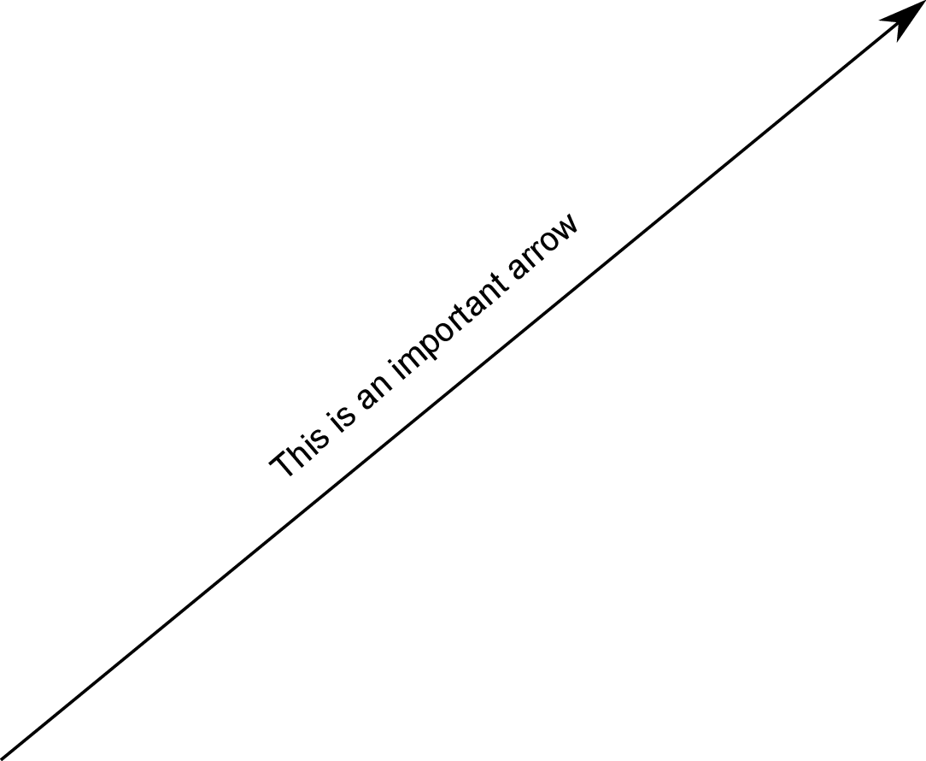
Figure 1: Arrow included in PDF format.

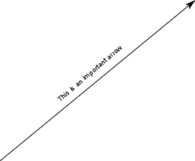
Figure 2: Arrow included in PNG format.

(a) PDF
(b) PNG
Figure 3: Images combined in subfigure environment.
Figure 1 includes an arrow in PDF format. Figure 2 includes the same image bitmapped in PNG format. Figure 3 combined the two images in a subfigure environment.

Column 1 | Column 2 | Column 3
1 | 2

Table 1: Simple table.

2*Multirow | Multicolumn
 | I | II
1 | 2

Table 2: Complicated table.
Table 1 is a simple table without requiring special packages. Table 2 is more complicated: it includes multiple rows and multiple columns.
References
[Dummy and Foo, 2013]Dummy, J. and Foo, J. (2013). The least important paper ever written. In Proceedings of IRR-10, 24th International Conference on Irrelevance., pages 45–50.

