WATERWATCH SL

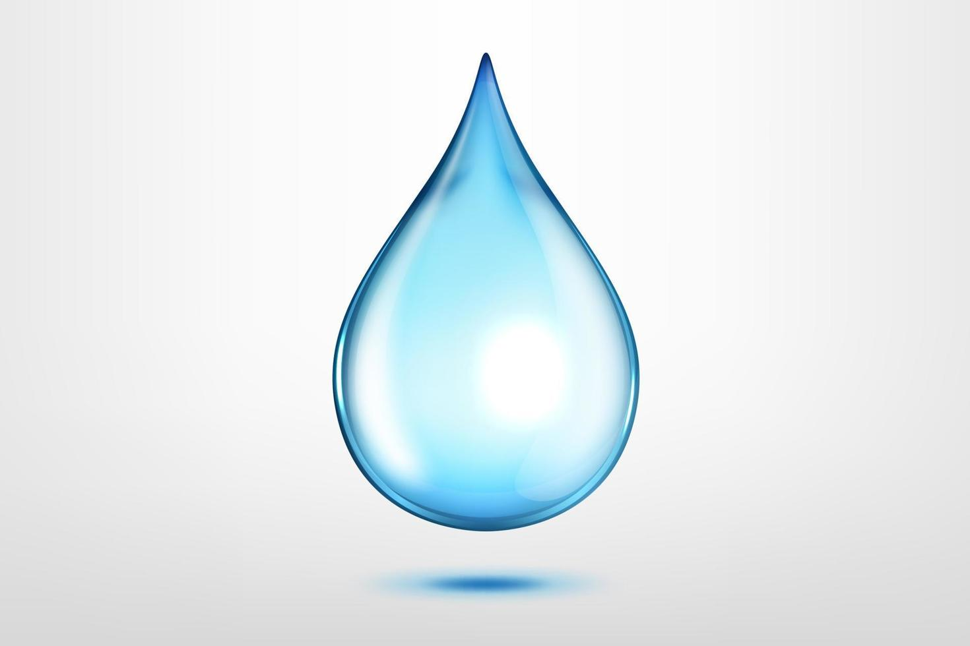

TABLE OF CONTENTS
1. Summary | 2
2. Rationale and Problem Context | 2
2.1 Problem Description | 2
2.2 Background | 2
2.3 Who Is Affected? | 2
2.4 Why the Problem Exists | 3
2.5 Community Impact | 3
3. Proposed Solution and Requirements | 3
4. Computational Thinking and Problem Decomposition | 5
5. Algorithm Design | 6
5.1 Step-by-Step Algorithm | 6
5.2 Pseudocode | 6
5.3 Flowchart | 8
6. Logical Design | 9
6.1 Input, Processing and Output | 9
6.2 Decision Structures and Boolean Logic | 9
6.3 Repetition Structures | 9
6.4 Variables, Constants and Data Types | 9
6.5 Functional Modules | 10
7. Data Design and Expected Outputs | 10
8. Open Source, Digital Public Goods and SDGs | 12
9. Test Scenarios | 13
10. Risks, Limitations and Sustainability | 14
11. Conclusion | 14
12. References | 14
 | 15

1. EXECUTIVE SUMMARY
This assignment proposes WaterWatch SL, a simple community water point fault reporting and maintenance tracking system for Sierra Leone. The system is designed to help residents, community water committees and responsible maintenance officers record problems at public water points, prioritise urgent cases, prevent duplicate records and track whether a reported problem has been reviewed or resolved. The assignment focuses on the logical design rather than executable source code, in line with the assignment brief.
The problem is practical and locally relevant. Sierra Leone’s National Water Compact describes a gap between the country’s water resources and the availability of safe, reliable water services, and identifies weak infrastructure maintenance, limited monitoring and coordination challenges as concerns for the sector (Ministry of Water Resources and Sanitation, 2026). UNICEF also reports that rural communities may rely on unsafe and unprotected water sources where reliable supplies are not available (UNICEF Sierra Leone, 2026). WaterWatch SL does not construct water infrastructure or test water quality. It is a proposed information and coordination tool to make reports visible, traceable and easier to prioritise.
The logical solution uses validated input, a duplicate check, decision structures for priority classification, repetition for processing reports, and modular functions for saving, referring and updating cases. Its intended benefits include faster awareness of faults, clearer responsibility, better records for planning and improved community participation. Its primary Sustainable Development Goal link is SDG 6: Clean Water and Sanitation, especially access to safe drinking water and community participation in water and sanitation management (United Nations, n.d.).

2. RATIONALE AND PROBLEM CONTEXT

2.1 Problem Description
The selected community problem is the difficulty of reporting, tracking and following up faults at shared water points such as hand pumps, public taps, boreholes and community water systems. When a water point stops working, leaks, becomes visibly damaged or is suspected of having a water-quality problem, residents need a clear way to notify the responsible committee or service provider and learn what action has been taken. Where reports are made only by word of mouth, phone calls or scattered paper notes, information may be incomplete, duplicated or lost. Residents may also be uncertain about whom to contact and whether a reported fault has been assigned to anyone.

2.2 Background
The National Water Compact for Sierra Leone 2026-2030 notes that abundant water resources have not automatically resulted in widespread access to safe and reliable Water, Sanitation and Hygiene (WASH) services. It identifies inadequate operation and maintenance as a factor that contributes to water infrastructure failure, and points to limited monitoring and fragmented coordination as wider sector challenges (Ministry of Water Resources and Sanitation, 2026). These observations support the need for better operational information, although this assignment does not claim that reporting software by itself can solve infrastructure or financing constraints.
UNICEF Sierra Leone has also documented water and sanitation programmes in underserved rural fishing communities, including work to construct and rehabilitate water points and strengthen community-based WASH structures (UNICEF Sierra Leone, 2026). This shows the importance of both physical infrastructure and community-level service arrangements. WaterWatch SL is designed as a small supporting mechanism that can sit alongside those arrangements.

2.3 Who Is Affected?
- Households that depend on community boreholes, hand pumps or shared taps for drinking water and domestic use.
- Women and girls, who may bear a disproportionate share of household water collection and the time costs caused by service interruption.
- Schools and health facilities that need dependable water for learning, hygiene and basic service delivery.
- Community water committees and volunteer caretakers who receive reports and coordinate local responses.
- Water service providers, district authorities, non-governmental organisations and development partners that need consistent records to plan inspections, repairs and investments.

2.4 Why the Problem Exists
- Reporting channels may be informal and inconsistent, with no standard set of details to capture the location, type and urgency of a fault.
- The same fault can be reported by several residents, creating duplicated follow-up and making totals unreliable.
- Responsibility for reviewing and repairing a water point may not be clear to residents, particularly where several organisations operate in the same area.
- Paper records and disconnected messages make it difficult to see the current status of a case or to identify repeat faults.
- Limited connectivity, device access and digital literacy may prevent some residents from using an online-only solution.

2.5 Community Impact
The expected impact of unresolved water-point faults can include longer journeys to alternative sources, lost time for households, disruption to schools and health facilities, and greater reliance on sources whose safety is uncertain. The project will not assume that every fault creates the same health risk: an ordinary broken tap and a suspected contamination incident must be handled differently. The system therefore records the type of fault and its urgency, flags suspected contamination for prompt referral, and leaves decisions about water testing, public health advice and repairs to authorised personnel.
The main beneficiaries are communities that depend on shared water points and the people responsible for maintaining them. Long-term benefits would depend on local institutions responding to the reports, assigning staff or resources, and keeping status information accurate. The technology is a coordination aid, not a replacement for infrastructure investment, inspection, water-quality testing or accountable service delivery.

3. PROPOSED SOLUTION AND REQUIREMENTS

3.1 Proposed Solution
WaterWatch SL is a proposed, low-bandwidth reporting and case-tracking service. A resident can submit a fault report through a simple mobile-friendly form or through an assisted reporting point operated by a community focal person. If the community has no reliable internet access, the initial deployment can accept a standard paper or telephone report and allow an authorised focal person to enter it later. SMS or USSD integration may be considered in a future phase; it is not assumed to exist in the current logical design.
Each accepted report receives a unique case ID. The system validates mandatory details, checks whether a similar unresolved report already exists for the same water point, assigns an initial priority, stores a timestamp and displays the status. A suspected contamination report or a report marked as critical is flagged for prompt referral to the responsible water or public-health authority. A case can later be marked Under Review, Assigned, In Progress, Resolved or Closed by an authorised user. Users receive a case reference so they can ask for an update.

3.2 Objectives
- Provide a standard way to record water-point faults and the location where they occur.
- Validate reports so that essential information is captured before a case is created.
- Detect likely duplicates and link additional information to an existing open case.
- Use transparent rules to flag urgent reports and support a prioritised maintenance queue.
- Track case status, assigned responsibility and update dates.
- Produce simple summaries of faults by community, fault type, priority and status.
- Support assisted and low-bandwidth reporting so that the service does not depend entirely on smartphones or continuous connectivity.

3.3 Users and Scope
User type | Main responsibilities
Community member / reporter | Submit a fault report; provide accurate location and fault details; keep the case ID for follow-up.
Community focal person | Help residents submit reports; enter offline or paper reports; confirm the water-point location.
Water committee / maintenance officer | Review the queue; assign responsibility; update progress; record resolution or refer a case to the relevant authority.
System administrator | Manage authorised users, community and water-point lists, categories, configurable thresholds, backups and exports.
District / programme reviewer | Review aggregate trends and unresolved cases for planning and coordination.

3.4 Functional Requirements
- FR1 - The system shall capture community, water-point name or identifier, fault type, date/time, urgency and estimated number of affected users or households.
- FR2 - The system shall reject a submission with missing mandatory fields and show which fields need correction.
- FR3 - The system shall check for a similar open case for the same water point and fault type within a configurable duplicate window (48 hours in this design).
- FR4 - The system shall create a unique case ID for each new accepted case and timestamp the report.
- FR5 - The system shall assign an initial priority using published decision rules.
- FR6 - The system shall allow authorised users to update case status, assigned team and notes.
- FR7 - The system shall provide a receipt with the case ID and current status, without promising a repair time that has not been confirmed.
- FR8 - The system shall generate aggregate summaries and allow authorised export in a common format such as CSV.
- FR9 - The system shall avoid collecting unnecessary personal information; reporter contact details are optional unless a local operating procedure requires them.

3.5 Non-Functional Requirements and Assumptions
Requirement | Design response
Usability | Plain language, short forms, clear error messages and locally tested translations where available.
Accessibility | Mobile-friendly layout and assisted reporting for users without smartphones or literacy support.
Reliability | Timestamped records, regular backups, case-status history and an offline paper/phone fallback.
Privacy and security | Role-based access; optional contact details; secure storage; no public display of personal information.
Interoperability | Export summary data using common formats and document any data fields and categories.
Operational assumption | Local authorities or water committees must identify a focal point and response pathway before a pilot begins.

4. COMPUTATIONAL THINKING AND PROBLEM DECOMPOSITION
Computational thinking breaks a broad problem into manageable parts and creates a repeatable set of steps. For WaterWatch SL, the process is applied as follows:

4.1 Decomposition
Subproblem | Logical task
Capture | Collect the location, water-point details, fault category, urgency and optional contact information.
Validation | Check mandatory fields, accepted category values and reasonable numeric inputs.
Duplicate management | Search for an open report that appears to describe the same problem at the same water point.
Classification | Apply decision rules to assign an initial priority.
Routing and tracking | Create the case record, refer it to the responsible person and record later status changes.
Reporting | Summarise open cases, repeated problems, priority levels and resolution times.

4.2 Pattern Recognition
Common patterns include repeated faults at the same water point, multiple reports about one event, contamination concerns that require special attention, and unresolved cases that have not been updated for a long period. Recognising these patterns helps the system avoid duplicate counts and helps a reviewer identify water points that may need inspection or stronger maintenance support.

4.3 Algorithmic Thinking
The process is organised into consistent steps: collect data, validate it, check for a duplicate, generate or reuse a case ID, calculate priority, save and route the case, and return a receipt. This order prevents the system from creating incomplete records and allows the priority rules to be tested independently.

5. ALGORITHM DESIGN

5.1 Step-by-Step Algorithm: Submit a Water-Point Fault
- Start the report process.
- Ask for the community, water-point name or identifier, fault category, urgency and estimated number of affected users. Accept reporter contact information only if provided and needed.
- Validate all mandatory fields and confirm that numeric values, such as affected users, are zero or greater.
- If any mandatory field is missing or invalid, display a clear error and return to the form for correction.
- Search for a similar unresolved report for the same water point and fault category within the configured 48-hour duplicate window.
- If a matching case exists, attach the additional information to that case and retain its original case ID.
- If no matching case exists, generate a unique case ID, record the submission timestamp and save the report.
- If the fault is suspected contamination or urgency is marked critical, set priority to HIGH and flag the case for prompt referral to the responsible authority.
- Otherwise, assign MEDIUM priority if the water point serves a school or health facility, or if the configurable affected-user threshold is met; assign LOW priority in other cases.
- Set the initial status to NEW or AWAITING REVIEW, depending on the local workflow.
- Display the case ID, current status and route for requesting an update. Do not promise a repair time unless the responsible officer confirms one.
- End the submission process.

5.2 Pseudocode
The following pseudocode expresses the main logic in a language-independent form. It is not executable source code.

CONSTANT DUPLICATE_WINDOW_HOURS = 48
CONSTANT AFFECTED_USER_THRESHOLD = 100 // configurable pilot value

PROCEDURE SubmitWaterFaultReport()
INPUT community, waterPointID, faultType, urgency
INPUT facilityType, affectedUsers, reporterContact

validReport = ValidateRequiredFields(community, waterPointID,
faultType, urgency,
affectedUsers)
WHILE validReport = FALSE
DISPLAY "Please complete or correct the required fields."
INPUT community, waterPointID, faultType, urgency
INPUT facilityType, affectedUsers, reporterContact
validReport = ValidateRequiredFields(community, waterPointID,
faultType, urgency, affectedUsers)
END WHILE

existingCaseID = FindMatchingOpenCase(
waterPointID, faultType,
DUPLICATE_WINDOW_HOURS)

IF existingCaseID IS NOT EMPTY THEN
AppendUpdate(existingCaseID, "Additional report received")
caseID = existingCaseID
priority = CalculatePriority(faultType, urgency, facilityType, affectedUsers)
UpdatePriorityIfMoreUrgent(caseID, priority)
IF priority = "HIGH" THEN
NotifyResponsibleOfficer(caseID, priority)
END IF
DISPLAY "Your information has been added to an existing case."
ELSE
caseID = GenerateUniqueCaseID()
priority = CalculatePriority(faultType, urgency,
facilityType, affectedUsers)
SaveNewCase(caseID, community, waterPointID, faultType,
urgency, affectedUsers, priority, CURRENT_DATETIME)
SetStatus(caseID, "NEW")
NotifyResponsibleOfficer(caseID, priority)
END IF

DISPLAY "Case ID: ", caseID
DISPLAY "Use this case ID to request an update."
END PROCEDURE

FUNCTION CalculatePriority(faultType, urgency, facilityType, affectedUsers)
IF faultType = "SUSPECTED CONTAMINATION" OR urgency = "CRITICAL" THEN
RETURN "HIGH"
ELSE IF facilityType = "SCHOOL" OR facilityType = "HEALTH FACILITY"
OR affectedUsers >= AFFECTED_USER_THRESHOLD THEN
RETURN "MEDIUM"
ELSE
RETURN "LOW"
END IF
END FUNCTION

PROCEDURE ReviewOpenCases()
FOR EACH case IN OpenCaseQueue
IF case.priority = "HIGH" AND case.status = "NEW" THEN
FlagForPromptReview(case.caseID)
END IF
IF case.lastUpdated exceeds the local follow-up interval THEN
AddToFollowUpList(case.caseID)
END IF
END FOR
END PROCEDURE

PROCEDURE UpdateCaseStatus(caseID, newStatus, authorisedUser)
IF authorisedUser = TRUE AND StatusTransitionIsAllowed(newStatus) THEN
SaveStatusChange(caseID, newStatus, CURRENT_DATETIME)
DISPLAY "Case status updated."
ELSE
DISPLAY "Update not accepted. Check permissions and status."
END IF
END PROCEDURE

Design note: the value of 100 affected users is an illustrative pilot threshold, not an official national standard. The responsible water-sector team should set and periodically review thresholds based on local operating capacity. The 48-hour duplicate window should also be configurable.

5.3 Flowchart
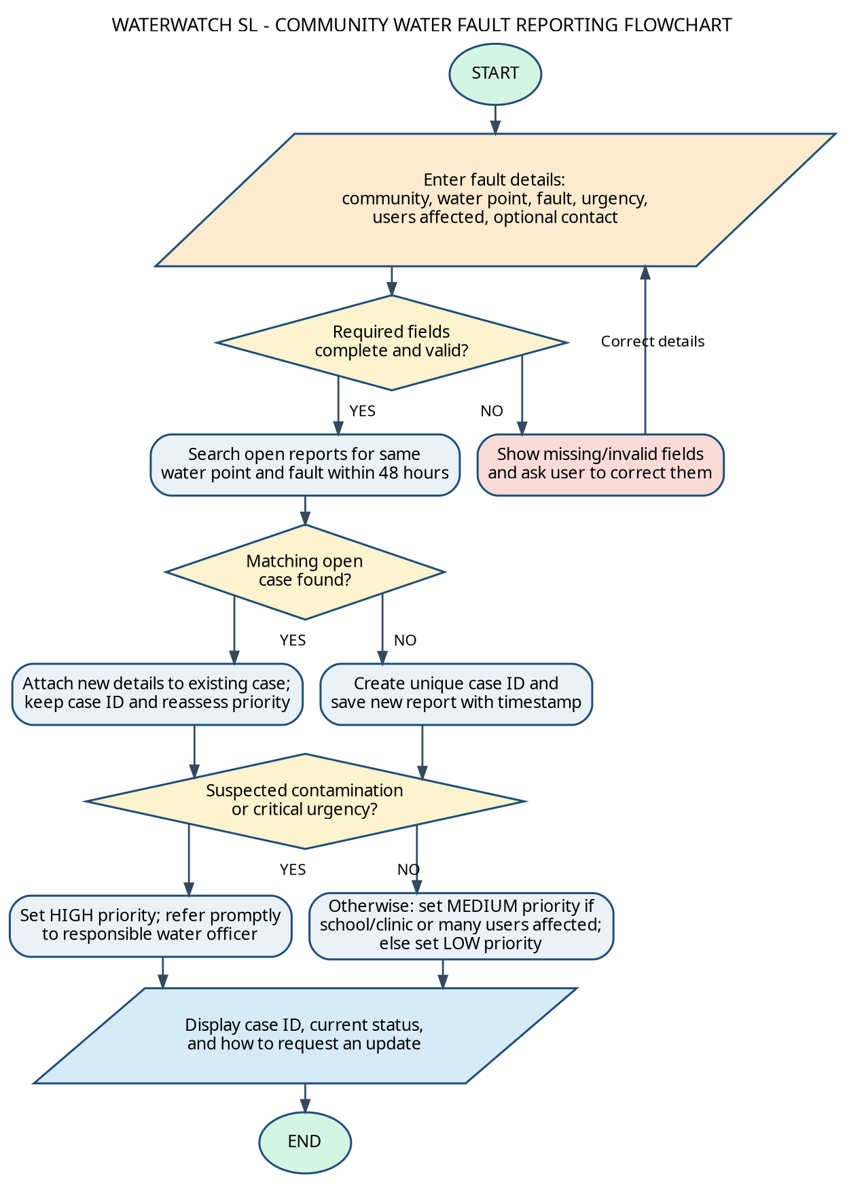

6. LOGICAL DESIGN

6.1 Input, Processing and Output
Stage | Details
Input | Community and district; water-point ID/name; facility type; fault type; urgency; estimated affected users; submission time; optional reporter contact and consent for follow-up.
Processing | Validate data; check category values; detect likely duplicate cases; create or reuse a case ID; calculate priority; save timestamps; refer to an authorised officer; record later status changes.
Output | Case receipt and ID; current status; high-priority referral flag; list of open cases; follow-up list; summary reports by community, fault category, priority and status.

6.2 Decision Structures and Boolean Logic
Condition | Result | Reason
Required fields are not valid | Reject submission temporarily and show errors | Prevents incomplete records.
A similar open case exists for the same water point and fault within 48 hours | Reuse its case ID and append an update | Reduces duplicate work and over-counting.
Fault is suspected contamination OR urgency is critical | Set HIGH priority and flag for prompt referral | Makes urgent safety concerns visible.
Otherwise, school/health facility OR affected users meet threshold | Set MEDIUM priority | Recognises key services or wider impact.
None of the above conditions apply | Set LOW priority | Keeps routine faults in the maintenance queue.

Example Boolean expression: highPriority = (faultType = SUSPECTED_CONTAMINATION) OR (urgency = CRITICAL). The system should not automatically declare water unsafe. It should flag the report for a qualified authority to assess and provide advice.

6.3 Repetition Structures
- WHILE loop: repeats form validation until required details are corrected or the user cancels the submission.
- FOR EACH loop: processes records in the open-case queue to identify urgent cases and cases due for follow-up.
- Repeated menu cycle: allows an authorised officer to submit, review, update or export records until the user selects Exit.
Iteration is suitable for queues and lists because the system must check each relevant record. Recursion is unnecessary for this design; a loop is easier to follow and avoids needless function calls.

6.4 Variables, Constants and Data Types
Name | Suggested type | Purpose
caseID | String | Unique human-readable case reference.
community, waterPointID | String | Identify location and water point.
faultType, facilityType, status | Enumerated string | Restrict values to approved categories.
urgency, priority | Enumerated string | Record severity and calculated priority.
affectedUsers | Integer | Estimate the number of users affected; must be zero or greater.
reportDateTime, lastUpdated | Date/time | Support ordering and follow-up.
reporterContact | String / optional | Enable follow-up where appropriate.
validReport, duplicateFound | Boolean | Store TRUE/FALSE results of validation and duplicate checks.
DUPLICATE_WINDOW_HOURS | Integer constant | Initial design value of 48 hours.
AFFECTED_USER_THRESHOLD | Integer constant | Illustrative value of 100; must be reviewed by local operators.

6.5 Functional Modules and Functions
Module / function | Inputs | Main action and output
CaptureReport() | User-entered report fields | Collects and returns a draft report.
ValidateRequiredFields(report) | Draft report | Returns TRUE if required fields and values are valid; otherwise returns FALSE and a list of errors.
FindMatchingOpenCase(pointID, faultType, hours) | Water-point ID, fault type, duplicate window | Returns existing case ID or EMPTY.
GenerateUniqueCaseID() | Current date/time and sequence | Returns a unique case reference.
CalculatePriority(...) | Fault type, urgency, facility type, affected users | Returns HIGH, MEDIUM or LOW using the rules in Section 6.2.
SaveNewCase(caseData) | Validated report and priority | Stores the new record and timestamps.
NotifyResponsibleOfficer(caseID, priority) | Case ID and priority | Adds the case to an authorised review/notification queue.
UpdateCaseStatus(caseID, status, user) | Case ID, new status, user permission | Checks permission, records status history and returns success or failure.
GenerateSummary(filters) | Date/community/status filters | Returns aggregate counts and an exportable summary.

7. DATA DESIGN AND EXPECTED OUTPUTS

7.1 Suggested Case Record
Field | Example | Rule
Case ID | WWSL-2026-0042 | Generated by system; never reused.
Community | Makeni - Example Community | Must identify where the point is located.
Water-point ID/name | WP-014 / Community Hand Pump | Use a register or readable local name.
Fault type | Broken pump handle | Select from the approved list.
Facility type | Community water point | May be school, health facility or other.
Urgency | Normal | Reporter-supplied indication, not the final priority.
Affected users | 75 | Integer estimate; validation rejects negative numbers.
Priority | LOW | Calculated by the decision rules.
Status | NEW | Updated by an authorised user.
Date reported | 2026-10-29 10:15 | Automatically recorded on submission.
Assigned team | Community maintenance committee | Filled by an authorised reviewer.
Contact | Not supplied | Optional; access limited to authorised users.

7.2 Expected Outputs Using Sample Scenarios
Scenario / input | Expected processing | Illustrative output
A resident reports a broken hand pump in a community; 75 users affected; no matching open case. | Validate; create case ID; no high-priority condition; affected users below illustrative threshold. | Case ID: WWSL-2026-0042; Priority: LOW; Status: NEW; action: added to routine review queue.
A report says water from a school water point may be contaminated. | Validate; create or link case; suspected contamination condition is TRUE. | Priority: HIGH; status: NEW / AWAITING REVIEW; action: prompt referral to responsible water/public-health officer. The system does not determine whether the water is unsafe.
The community field is blank. | Required-field check returns FALSE. | No new case ID is generated; message asks the reporter to enter the community/location.
A second person reports the same unresolved broken pump within 48 hours. | Duplicate search finds a likely match. | Additional note is attached to the original case ID; duplicate case is not counted as a new fault.
An authorised officer records that repair work has started. | Permission and allowed status transition are checked; timestamp is saved. | Status changes from ASSIGNED to IN PROGRESS; status history records the change.
A case has not been updated within the local follow-up interval. | Queue review checks lastUpdated. | Case is added to the follow-up list for review; no automatic claim is made that a repair is overdue unless the service standard defines it.

7.3 Example Dashboard Outputs
- Open reports by community and water-point ID.
- Cases grouped by HIGH, MEDIUM and LOW priority.
- Reports by fault category, such as broken pump, leakage, no water or suspected contamination.
- Status totals: New, Under Review, Assigned, In Progress, Resolved and Closed.
- Average elapsed time between report submission and first recorded review, provided the timestamps are complete.
- Repeat faults at the same water point to help maintenance teams plan inspections.

8. OPEN SOURCE, DIGITAL PUBLIC GOODS AND SDGs

8.1 Sustainable Development Goal Alignment
The primary SDG is SDG 6: Clean Water and Sanitation. Target 6.1 calls for universal and equitable access to safe and affordable drinking water, while Target 6.b calls for community participation in improving water and sanitation management (United Nations, n.d.). WaterWatch SL supports these aims indirectly by improving the visibility and follow-up of reported faults. It does not itself deliver drinking water or guarantee SDG outcomes.
The project can also contribute to SDG 3 (Good Health and Well-Being) by directing suspected water-quality incidents to responsible authorities, and SDG 10 (Reduced Inequalities) if assisted reporting and accessible design make it easier for underserved users to report problems. These are intended contributions and should be assessed during a pilot rather than treated as proven outcomes.

8.2 Why the Proposed Solution Should Be Open Source
- Transparency: the public and technical reviewers can inspect how case IDs, duplicate checks and priority decisions are designed.
- Affordability: community organisations and institutions can use and adapt the design without depending entirely on a proprietary vendor.
- Local adaptation: developers and students can translate labels, change locally approved categories and adapt the system to different districts.
- Continuity: readable documentation and open standards reduce dependence on one person or contractor.
- Learning and collaboration: students, local developers, civic technology groups, universities and water-sector partners can suggest improvements through issues and reviewed changes.

8.3 Potential Community Contributions
- Community water committees can review the reporting categories and validate the local water-point list.
- Students and local developers can improve usability, translations, accessibility and import/export tools.
- Water-sector institutions can propose priority rules and status definitions suited to their official response procedures.
- Civil society organisations can test whether assisted reporting reaches people with limited connectivity or digital literacy.
- Contributions should follow a documented process, with maintainers reviewing changes before they are included in the shared version.

8.4 How It Could Become a Digital Public Good
The Digital Public Goods Alliance explains that its Digital Public Goods Standard assesses factors including SDG relevance, open licensing, clear ownership, platform independence, documentation, data extraction, privacy and applicable laws, standards, and security (Digital Public Goods Alliance, n.d.). WaterWatch SL is a proposed design and should not be described as an officially recognised Digital Public Good. To move towards that status, a future implementation would need to meet the relevant requirements and undergo the appropriate assessment.

8.5 Sierra Leone Community Impact and Long-Term Sustainability
In a pilot, the project should be co-designed with a small number of communities and the organisations responsible for maintaining their water points. Before launch, the pilot team should confirm who receives reports, what counts as an urgent case, how privacy is protected, and how status updates reach residents. Training and assisted reporting are important because an online form alone could exclude residents without reliable data access or digital skills.

9. TEST SCENARIOS
The logical design should be tested with normal, boundary and error cases before any real community data is used. The following test plan gives the expected result for the proposed rules.
Test ID | Test input | Expected result | Pass condition
T01 | All required fields valid; no matching open case; ordinary fault; 20 affected users. | New case ID; LOW priority; NEW status. | Case saved once and receipt displayed.
T02 | Suspected contamination; no matching open case. | HIGH priority and prompt referral flag. | Priority rule takes precedence and case is visible in urgent queue.
T03 | Urgency = CRITICAL; ordinary fault type. | HIGH priority. | Boolean OR condition evaluates TRUE.
T04 | Blank community field. | Validation error; no case ID. | Invalid report is not saved as a new case.
T05 | Affected-user count = -5. | Validation error. | Negative count is rejected.
T06 | Same water point and fault reported again within 48 hours while first case remains open. | Existing case ID is reused; update appended. | No second duplicate case is created.
T07 | Same fault reported after duplicate window or after original case is closed. | New case may be created after checking local rules. | Duplicate logic follows configured window and status rules.
T08 | Unauthorised user attempts to close a case. | Update rejected with permission message. | Status remains unchanged and attempt is logged if auditing is enabled.
T09 | Officer changes status from ASSIGNED to IN PROGRESS. | Update accepted with timestamp and user recorded. | Case history shows the new status.
T10 | Connection unavailable during field reporting. | Use approved paper/phone fallback or offline queue, then synchronise. | No report is silently lost; the date/time and source are retained.

10. RISKS, LIMITATIONS AND SUSTAINABILITY
Risk or limitation | Mitigation
No response capacity | Agree on responsible officers and realistic escalation rules before accepting community reports.
Incorrect or misleading reports | Validate required details, let authorised staff review reports and retain status history.
Weak connectivity / low digital literacy | Provide assisted reporting, paper/phone fallback, simple interface and optional future SMS/USSD support.
Exposure of personal information | Collect only necessary data, make contact optional, restrict access and publish aggregate reports only.
Duplicate detection misses or wrongly links reports | Use water-point identifiers and fault categories; allow staff to unlink or correct cases with an audit trail.
Priority threshold does not fit local needs | Make threshold configurable and review it with responsible local water-sector institutions.
Software is mistaken for a repair or water-safety service | Clearly state that the system tracks reports; qualified authorities must test water and determine public-health advice.
Project becomes unsupported | Identify an owner, document the system, use open standards, train maintainers and plan hosting/backup costs.

GITHUB REPROSITERY LINK
https://github.com/peterwurie000-beep/PROG101_Assignment1_Peter-C-Wurie_905006243.git

GITHUB EVIDENCE

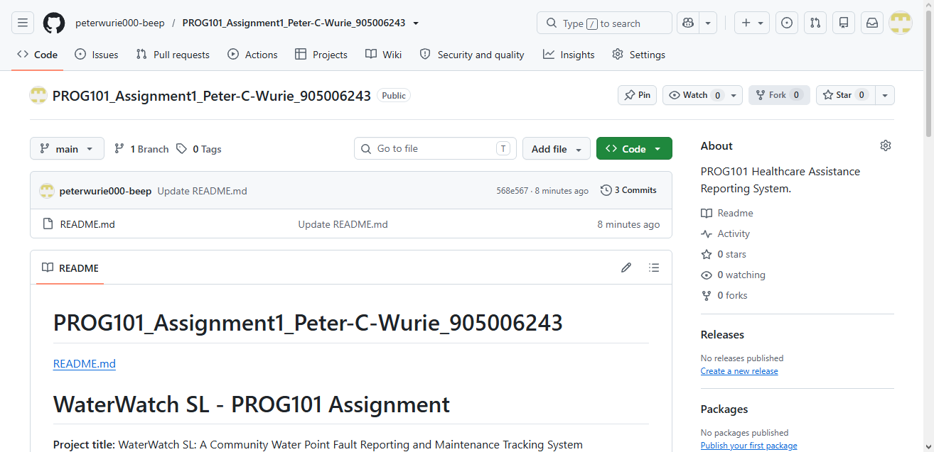

README.md

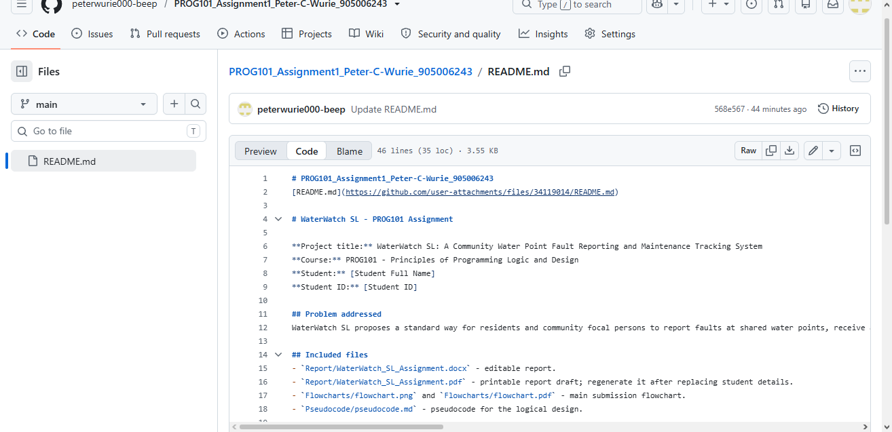

11. CONCLUSION
Water Watch SL presents a logical and locally relevant response to the challenge of reporting and following up faults at community water points in Sierra Leone. It translates an everyday service problem into a clear process that can be expressed using an algorithm, pseudocode, a flowchart, variables, decision structures, repetition and modular functions. Validation protects record quality, duplicate detection improves the reliability of case counts, and explicit priority rules help draw attention to urgent reports.
The solution supports SDG 6 by improving information and community participation related to water services, and its open-source approach could encourage local adaptation and shared learning. However, it is only a proposed coordination tool. Results depend on responsible institutions receiving reports and acting on them, a realistic maintenance pathway, privacy protection and sustained operational support. A small, community-led pilot with measurable indicators is recommended before a wider rollout.

- REFERENCES

- Digital Public Goods Alliance. (n.d.). Digital Public Goods Standard. Retrieved October 29, 2026, from https://www.digitalpublicgoods.net/standard
- Ministry of Water Resources and Sanitation. (2026). National Water Compact for Sierra Leone 2026-2030:A water-secure Sierra Leone. Government of Sierra Leone. https://www.worldbank.org/content/dam/theworldbankgroupasset/document/2026/water-forward-compacts/Water%20Compact%20Sierra%20Leone%202026.pdf
- UNICEF Sierra Leone. (2026, February 5). Access to clean water could improve children’s health and education. https://www.unicef.org/sierraleone/stories/access-clean-water-could-improve-childrens-health-and-education
- UNICEF Sierra Leone. (2026, May). Joint evaluation of improving access to water, sanitation, and hygiene in rural fishing communities. https://www.unicef.org/sierraleone/reports/joint-evaluation-improving-access-water-sanitation-and-hygiene-rural-fishing-communities
- United Nations, Department of Economic and Social Affairs. (n.d.). Goal 6: Ensure availability and sustainable management of water and sanitation for all. Retrieved October 29, 2026, from https://sdgs.un.org/goals/goal6

