Rev 0 Tx Circuit
MD1213 + TC6320
Revised Technical Note
  - Prepared for design review and early prototyping
Peter Yazdi
This revision corrects the half-bridge connection description in the earlier draft and clarifies OE behavior, AC-coupled gate drive, capacitor pre-charge, and the purpose of the integrated gate-source zener clamps.
Scope of this note
This document is a first-pass engineering note for a ±100 V pulser stage using the MD1213 gate driver and the TC6320 complementary MOSFET pair. It is intended to support bench bring-up, schematic capture, and initial component selection. It is not a substitute for final validation on real hardware.

1. Executive summary
• The MD1213 is the low-voltage, fast gate driver. The TC6320 is the high-voltage switching pair that actually applies the output pulse to the transducer.
• In the TC6320 pulser connection, SP ties to +100 V, SN ties to -100 V, and the P-channel and N-channel drain nodes join at the output node.
• The 10 nF capacitors are AC-coupling capacitors. They do not power the transducer; they inject a fast gate step into a floating high-voltage gate node.
• OE has a dual role: it enables the outputs and also establishes a known precharged bias across the coupling capacitors before a pulse burst starts.
• The integrated gate-source zener clamps are protection elements. They limit excessive |VGS| caused by overshoot, ringing, and Miller coupling; they are not precision bias references.

2. Corrected system topology
At the system level, the signal flow is MCU -> MD1213 -> 10 nF coupling capacitors -> TC6320 -> transducer. The MD1213 works from a small bipolar or single-supply gate-drive rail, while the TC6320 sits on the high-voltage output stage and commutates the transducer node between the positive and negative pulser rails.
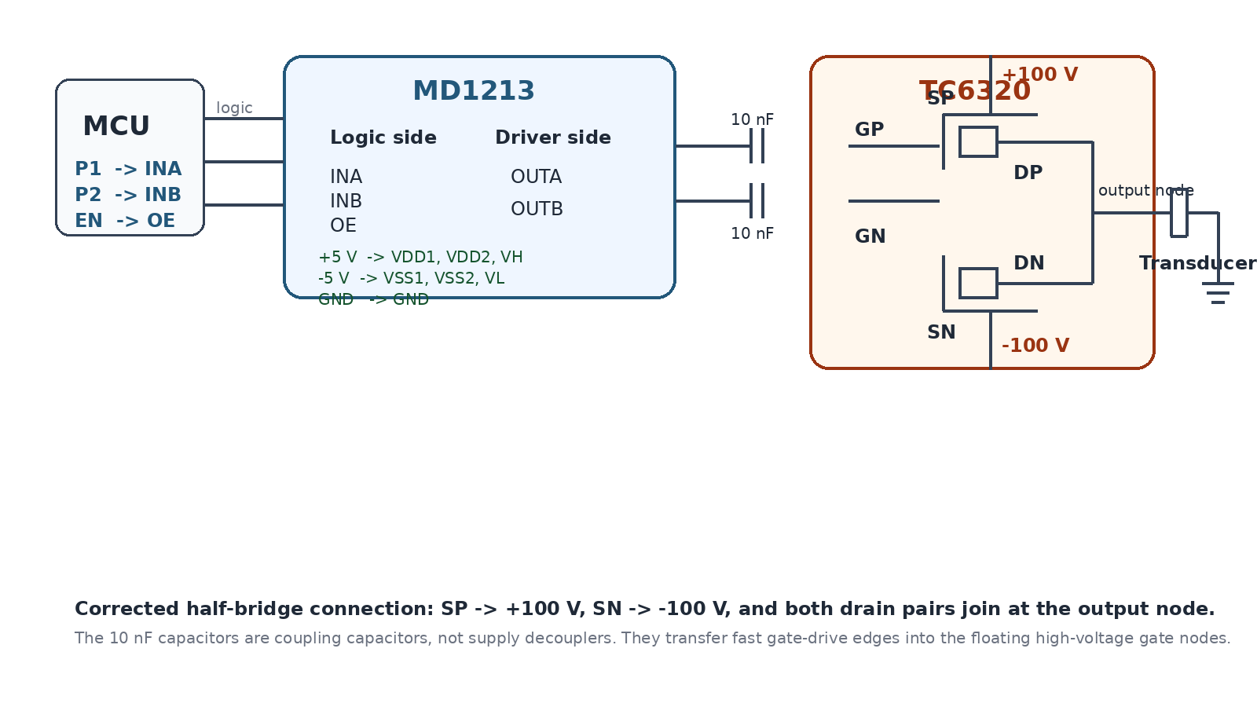
  - Figure 1. Simplified one-channel pulser connection with corrected TC6320 topology.

Why the earlier draft needed correction
The main connection error in the earlier draft was the location of the TC6320 source and drain nodes. For a high-side P-channel device, the source sits at the positive rail. For the low-side N-channel device, the source sits at the negative rail. The switching node is formed by tying the drain nodes together externally. This matches the Microchip typical application circuit and the TC6320 pin/function description.

3. MD1213 supplies and OE behavior

Meaning of the supply pins
Pin | Role in the driver
VDD1 | High-side analog / level-shifter supply. Should be at the same DC potential as VDD2.
VDD2 | High-side gate-drive supply.
VSS1 | Lowest potential on the chip for the low-side analog / level-shifter section. Pin 5 and the thermal pad must be connected externally.
VSS2 | Low-side gate-drive supply. Should sit at the same potential as VSS1.
VH | Output high rail for OUTA and OUTB.
VL | Output low rail for OUTA and OUTB.
GND | Logic input ground reference for INA, INB, and OE.
OE | Output enable. When high, INA and INB control the outputs. When low, OUTA is forced to VH and OUTB is forced to VL.

For the Microchip reference pulser, the usual starting point is VDD1 = VDD2 = VH = +5 V and VSS1 = VSS2 = VL = -5 V. That gives a 10 V output swing at OUTA / OUTB, which is enough to strongly enhance the TC6320 while remaining below the integrated gate-clamp region under normal operation.

What OE actually does
OE is not just an enable pin. It serves two practical functions in this pulser architecture:
• When OE is high, INA and INB actively control OUTA and OUTB.
• When OE is low, OUTA is forced high to VH and OUTB is forced low to VL. That establishes a known voltage across the two series coupling capacitors before the pulse sequence begins.
Practical precharge state
With VH = +5 V, VL = -5 V, SP near +100 V, and SN near -100 V, the upper coupling capacitor will settle to roughly 95 V of bias magnitude and the lower coupling capacitor will also settle to roughly 95 V of bias magnitude. The exact sign depends on which plate is treated as the reference. The important point is that both capacitors start from a known stored voltage before the next edge arrives.

4. Why the AC-coupling capacitors are essential
A capacitor stores voltage between its two plates, not relative to ground. That is the key reason the right-hand side of each 10 nF capacitor does not need to be tied to ground. The gate node is allowed to float at a high DC potential, while the capacitor still transfers the fast edge coming from the MD1213 output.

What AC coupling means in this circuit
• The capacitor blocks a direct DC connection between the MD1213 output and the TC6320 gate.
• Fast changes at OUTA or OUTB are coupled through the capacitor and appear as a temporary change in gate voltage.
• The TC6320 integrated gate-to-source resistor then slowly pulls the gate back toward the source potential, so the MOSFET returns to its off state unless another edge arrives.

Where the return path comes from
The gate node is not left floating forever. The TC6320 provides an internal gate-to-source shunt resistor on each device. That resistor gives the gate a DC return path to its own source. For the upper device, the gate relaxes back toward +100 V. For the lower device, the gate relaxes back toward -100 V. In other words, the gate is referenced to the source, not to ground.

Why a ±5 V driver can still switch a ±100 V stage
The driver does not need to generate +100 V or -100 V directly. It only has to create a fast differential gate step. To first order, the gate step is approximately
Delta V_gate ~= Delta V_driver * C_couple / (C_couple + C_iss + parasitics)
With a 10 nF coupling capacitor and a TC6320 input capacitance on the order of 110 pF to 200 pF, almost the full 10 V driver step appears at the gate. That is why a +5 V to -5 V output transition can momentarily create roughly -10 V VGS on the P-channel device, while a -5 V to +5 V transition can create roughly +10 V VGS on the N-channel device.

5. Function of the integrated gate-source zener clamps
The TC6320 includes an internal zener clamp from gate to source on both MOSFETs. This is useful because the gate oxide of a MOSFET is vulnerable to excessive |VGS|, especially in a fast pulser where ringing, layout inductance, and Miller coupling can create spikes that are significantly larger than the intended command signal.
• During a strong edge, the output node can ring. That ring couples back into the gate through the Miller capacitance.
• If the gate were left unprotected, a transient could push VGS high enough to stress or puncture the oxide over time.
• The integrated zener provides a last line of defense by clamping large gate-source excursions before they grow without bound.
Important limitation
The zener clamp is a protection feature, not a precision operating point. The datasheet clamp range is broad, so it should not be used as a normal bias target. Good layout, controlled edge rates, and appropriate dead-time are still required.

6. One bipolar pulse sequence
A safe one-cycle bipolar event is easiest to understand as a sequence of edges rather than a sequence of static logic levels. Because the TC6320 gates are AC-coupled, the edge at OUTA or OUTB is what creates the temporary VGS that turns a device on.
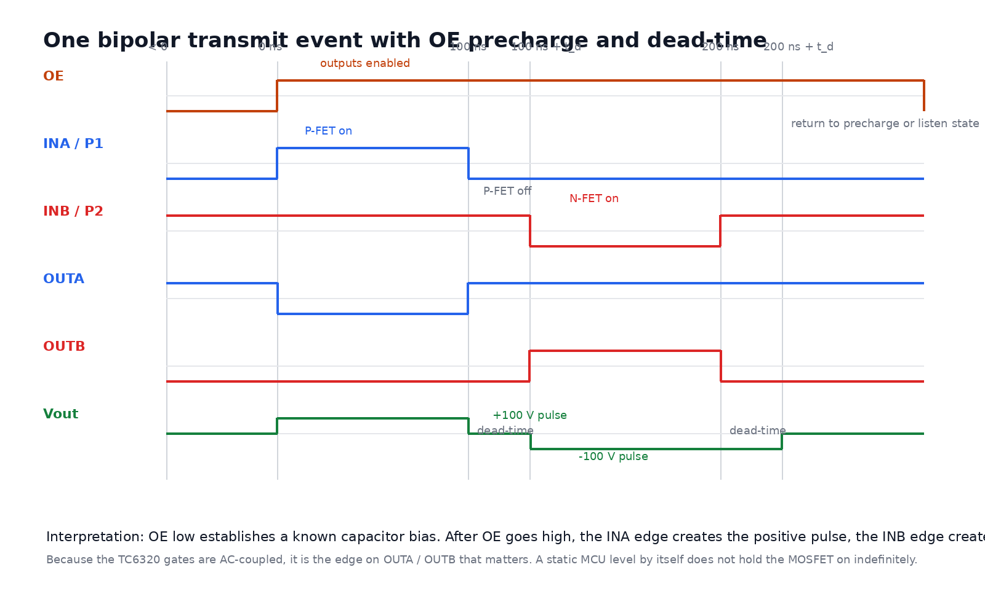
  - Figure 2. Conceptual timing for OE, the MCU drive inputs, and the output pulse.
Phase | Command | Physical result
Idle / precharge | OE low | OUTA is at VH and OUTB is at VL. The coupling capacitors settle to known stored voltages. Both MOSFETs are off.
Arm state | OE high | INA and INB are now active. No pulse is applied yet.
Positive pulse | INA edge drives OUTA from VH to VL | The upper gate is pulled negative relative to SP, the P-channel device turns on, and the output node is driven toward +100 V.
Dead-time | Both devices commanded off | A short gap prevents direct shoot-through from +100 V to -100 V.
Negative pulse | INB edge drives OUTB from VL to VH | The lower gate is pulled positive relative to SN, the N-channel device turns on, and the output node is driven toward -100 V.
Return to listen state | Both devices off again | The gate-source resistors discharge the coupled gate step and the output node is no longer actively forced.

7. Corrected pin map for the TC6320 SOIC package
Pin(s) | Name | Correct connection
1 | SN | N-channel source. Connect to the negative pulser rail (-100 V in the example).
2 | GN | N-channel gate. Driven from OUTB through the 10 nF coupling capacitor.
3 | SP | P-channel source. Connect to the positive pulser rail (+100 V in the example).
4 | GP | P-channel gate. Driven from OUTA through the 10 nF coupling capacitor.
5, 6 | DP | P-channel drain pins. Tie together and connect to the output switching node.
7, 8 | DN | N-channel drain pins. Tie together and connect to the same output switching node.

The duplicate drain pins exist to lower package resistance and inductance and to improve thermal spreading. They are not separate functions; they are parallel pins for the same internal node on each MOSFET.

8. Capacitor roles and first-pass sizing guidance

Do not confuse the two capacitor jobs
Part | Main job | Primary concern
10 nF coupling capacitors | Transfer fast gate-drive edges into the floating TC6320 gate nodes. | Need sufficient voltage rating for the standing DC bias plus pulse excursion and ringing.
HV storage / decoupling capacitors | Source the instantaneous pulse current locally at the +100 V and -100 V rails. | Need enough capacitance, voltage rating, and low-inductance placement near the TC6320.

Coupling capacitor rating
• Nominal value: 10 nF is reasonable because it is much larger than the TC6320 input capacitance, so most of the driver step is transferred to the gate.
• Voltage rating: a 200 V part is a sensible minimum for a ±100 V pulser because the capacitor can sit with roughly 95 V of DC bias magnitude plus ringing.
• Dielectric: prefer a stable dielectric when practical. If a high-k ceramic is used, verify its capacitance under real DC bias.

Local HV storage capacitor sizing
A useful first-pass relation for one edge is
C_local >= (C_T * Delta V_out) / Delta V_rail
where C_T is the transducer capacitance, Delta V_out is the output swing imposed during the edge, and Delta V_rail is the maximum rail droop you are willing to tolerate locally.
Example: if the transducer is about 1 nF and you want a 200 V differential swing with less than 1 V droop on a local reservoir, the capacitor estimate is about 200 nF. That is why the 1 uF local rail capacitors shown in the reference pulser are a comfortable starting point rather than an arbitrary choice.

9. Practical cautions before scaling to eight channels
• Measure the real transducer capacitance and impedance near the operating frequency before finalizing the pulser. That number drives current, rise time, and storage-cap sizing.
• Keep the loop formed by the rail capacitor, TC6320, and output node extremely tight. Layout inductance will dominate overshoot and ringing if the loop is long.
• Add deliberate dead-time in firmware or logic. Do not rely on idealized simultaneous switching.
• Use a proper high-voltage probe for output measurements and treat the ±100 V stage as hazardous hardware during bring-up.
• Bleed resistors are still recommended even if the average energy is modest, because the local capacitors can hold charge after power-down and can still produce unpleasant or damaging transient events.
Recommended next bench measurements
1) transducer capacitance and ESR, 2) unloaded output pulse shape, 3) gate waveform at GP and GN with a differential probe, 4) rail droop at the local ±100 V reservoirs, and 5) drain-node ringing with different dead-time values.

10. References used for this revision
• Microchip MD1213 High-Speed Dual-MOSFET Driver datasheet, including the typical application circuit and pin / truth-function information.
• Microchip TC6320 N-Channel and P-Channel Enhancement-Mode MOSFET Pair datasheet, including package pinout, application circuit, electrical characteristics, and integrated gate-protection features.
• Original working draft supplied by Peter Yazdi and revised into this document.

