N-body Simulation

By Pete Siharath

Abstract

This report describes a simulation of the behaviour of argon atoms inside an enclosed box. The simulation investigates two hypotheses. The first hypothesis is that there is a negative linear relationship between the volume of the gas and the pressure of the gas. The second hypothesis is that there is a positive relationship between the temperature of the gas and the pressure of the enclosed box.  
The results of this investigation can be shown to prove these hypotheses partially correct.

Methodology

This simulation was created using Python and Jupyter Notebook. Python provides clear syntax for readable and understandable code and libraries namely NumPy and Matplotlib. Jupyter Notebook allows for quick prototyping and experimentation due to its ability to split up segments of code.

To provide ease, object-oriented programming was used as it helps with varying number of particles and measuring attributes. In a separate module, a “Particle” class and a “System” class were created. The particle class monitored the positions and velocities for particle objects and the system class monitored every particle involved in the simulation.

Each particle’s positions, velocities and accelerations were stored in NumPy arrays of length 3 where each element in the array represents an axis. This allowed for calculations to be performed for each axis. The choice of a NumPy array allows for vectorisation and capitalises on parallel processing, speeding up computation.

To simulate the movement, time steps were used to calculate the position of each particle in the system. Each timestep, the position of each particle was calculated using a series of equations:

* The force exerted between two particles were calculated using the Lennard-Jones potential, which depends on the relative positions between the particles. The net force on a particle was found by summing all the forces experienced from other particles.
* By using Newton’s second law, the accelerations for each particle were calculated.
* The velocity of a particle was increased by the acceleration multiplied by half the timestep.
* The position of a particle was increased by the velocity multiplied by the timestep.
* Acceleration is recalculated based off the new positions of the particles.
* The velocity was increased again by the acceleration multiplied by half the timestep.

A more typical approach would be to increase the velocity based off the full timestep, but due to the steep changes of acceleration in relation to relative position, the integration scheme above allows for a more precise simulation.

For a given box length, adding a cubic box to the simulation was performed by checking every timestep whether one of the particle’s position components was outside the box. If so, the particle’s position component would be corrected to the box edge and its corresponding velocity component reversed. This simulated elastic rebounds.

To investigate the behaviour of the gas, the temperature and pressure was measured. Using the average translational kinetic energy equation for ideal gases, the temperature could be calculated from the speeds of the particles and by measuring the perpendicular velocity through a cross-section, the pressure could be calculated. Since the temperature and pressure measured can be very stochastic, the calculations were averaged over the whole time of the simulation. For temperature, total kinetic energy was recorded every timestep and the average was calculated and recorded.

For pressure, the assumption of pressure being isotropic was used. To find the perpendicular velocity through a cross section, an arbitrary cross section at the y-z plane was chosen. Particles which passed through were found by checking if the particle’s x position was less than zero. Then checking if it was bigger than zero for the next timestep assuming that velocity would also be unchanged. The particle’s x velocity was measured as the perpendicular velocity and this was used to calculate the pressure.

For experimentation, generating initial particle positions were done randomly. When the absolute distance between particles is less than 1, forces between them become massively high so conditions were made to ensure this does not happen.

To measure how box volume and temperature affected pressure, the values were varied and the simulations were ran and measured. To provide a satisfactorily accurate experiment, many particles had to be simulated. However, the number of particles being too large comes at the expense of computational power. 10 particles were chosen for this investigation. The timestep of 0.01 was chosen as it allows for precise calculations while it gave the chance to investigate a large amount of time.

To vary box volume, the box length was varied linearly between 5 and 10. Due to there being 10 particles, box volume could not be too low otherwise there would be too little space between particles.

To vary temperature, the initial velocities of the particles were varied. This was done by using a uniform distribution to create a wide range of initial velocities for each component then using these as the mean of a normal distribution to randomise each particle’s initial velocity. Finally, approximately half of the velocity components were multiplied by -1. This allowed for a very wide range of initial velocities and discouraged any potential patterns. The uniform distribution was bounded between 0.1 and 5 to lower the risk of initial particle velocities being too high and causing particles to be too close.

Testing

To test that the code worked for the movement of the particles, a known scenario was simulated. One particle was placed at the origin and another particle was placed close to the origin along the x-axis. The equations of motions were only dependent on three parameters so dimensionless units were defined by cancelling out these parameters. By placing the second particle at [1.1, 0, 0], the particles are expected to oscillate in place.

Figure 1: A graph showing the trajectories of two argon atoms

Then, to test the code for the elastic box, a single particle was initialised with a non-zero velocity. Using Matplotlib, a 3D graph was created to verify if the code worked as intended.

Figure 2: A 3D graph showing the trajectory of an argon atom inside an enclosed box.

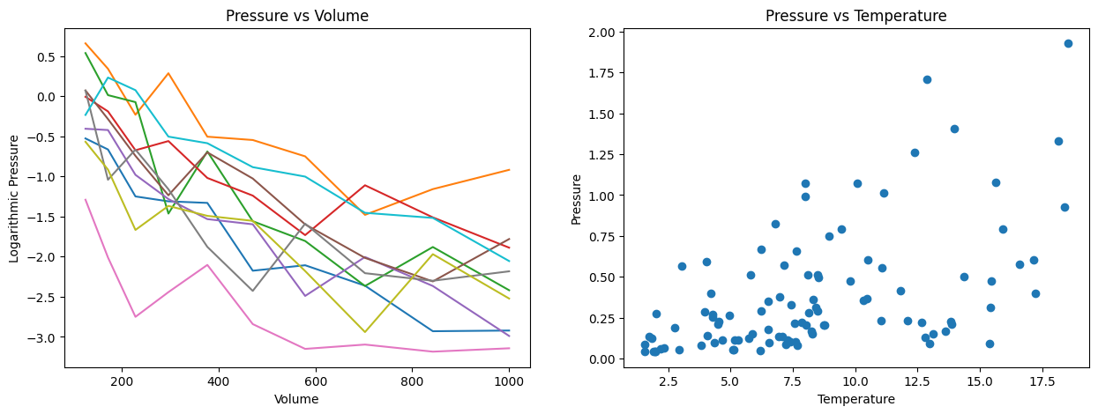Results

Figure 3: Two graphs showing the relationship between volume and logarithmic pressure and the relationship between temperature and pressure

Based on the left graph, we could see that there is a negative linear relationship between volume and logarithmic pressure. This implies the presence of an exponentially decaying relationship between volume and pressure. Therefore, this proves the existence of a negative relationship between volume and pressure but disproves the linear relationship. Thereby, partially proving our first hypothesis correct.

Based on the right graph, we could see that there is a positive linear relationship between temperature and pressure. Therefore, proving our second hypothesis correct

Improvements

Based on the assumptions made, there is room for improvement. If the particles were modelled as spherical objects that could physically interact with each other, then there would be no chance of a division by zero error when calculating forces.

With more time, there could be a larger allowance for computational power to be used and therefore more particles to model for the investigation.

With regards to the measurement of pressure, the assumption that velocity is unchanged for the next timestep is next to zero. However, the assumption is unlikely to make a large difference due to the small timesteps used.

Conclusion

Overall, the findings proved the hypotheses to be partially correct as the Figure 3 showcased how the first hypothesis was partially correct and the second hypothesis was fully correct. The simulation which was created to obtain our data helped us visualise a difficult problem in a digestible manner whilst not needing to compromise with too many assumptions. Furthermore, there is room for improvement and this research could be expanded upon by applying possibly different atom types.