**Final Examination**

**DATA ANALYTICS**

🎓Batangas State University - Main Campus

This document summarizes all the processed data from the session **Morning Session** that was analyzed by **Dr. John Doe** last **2025-03-19**. The data presented here is based on the findings and detections of the AI model developed and trained by our research group for the academic year 2024-2025.

Please note that this document does not contain any personal information of students, such as names, grades, or ages. It strictly presents **metrics and visualizations** of student behavior data as detected by the AI. This report is intended for research and analysis purposes only and **must not be used as the sole basis** for evaluating student performance or behavior. The AI system is a tool to assist in understanding behavioral patterns, but human judgment and contextual interpretation remain essential in any assessment.

**Document Details**

Analytics ID

A12345

Processed By

Dr. John Doe

Date Processed

2025-03-19, 10:30 AM

Date Downloaded

2025-03-19, 11:00 AM

File Name

exam_results.docx

File Size

2.3 MB

### **AI ANALYTICS DATA**

AI Analytics Data Title

Session Name

Morning Session

Date & Time Processed

,

Processed By

Front Video Directory/Path

**Front Video Details:**

File Name

File Size

Created Date

Video Length

Center Video Directory/Path

**Center Video Details:**

File Name

File Size

Created Date

Video Length

**Heatmap Graph Color Key:**

**—--Blue:** Sitting

**—--Orange:** Extending Right Arm

**—--Green:** Extending Left Arm

**—--Red:** Standing

**—--Purple:** Turning Around

*Diagram 1.1 Heatmap for All Actions*

*Diagram 1.2 Heatmap for Sitting Actions Only*

*Diagram 1.3 Heatmap for Extending Right Arm Actions Only*

*Diagram 1.4 Heatmap for Extending Left Arm Actions Only*

*Diagram 1.5 Heatmap for Standing Actions Only*

*Diagram 1.6 Heatmap for Turning Around Actions Only*

**Line Graph Color Key:**

**—--Blue:** Sitting

**—--Orange:** Extending Right Arm

**—--Green:** Extending Left Arm

**—--Red:** Standing

**—--Purple:** Turning Around

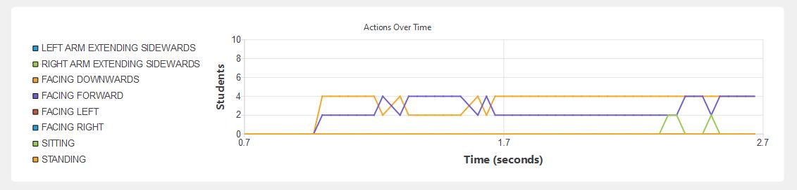  
*Diagram 2.1 Line Graph for All Actions*

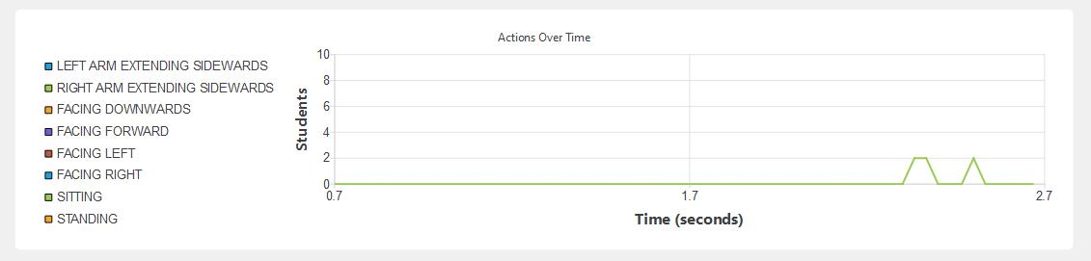  
*Diagram 2.2Line Graph for Sitting Actions Only*

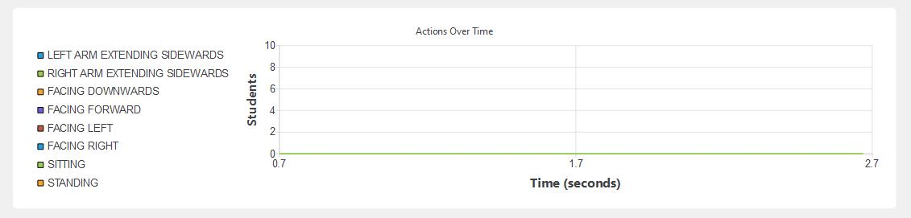  
*Diagram 2.3 Line Graph for Extending Right Arm Actions Only*

*Diagram 2.4Line Graph for Extending Left Arm Actions Only*

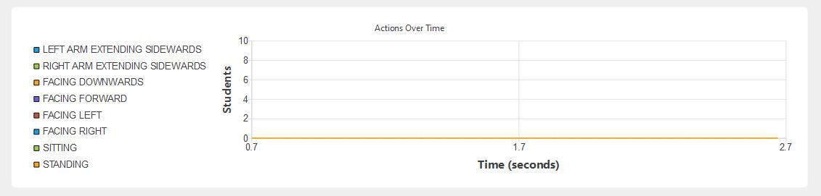  
*Diagram 2.5 Line Graph for Standing Actions Only*

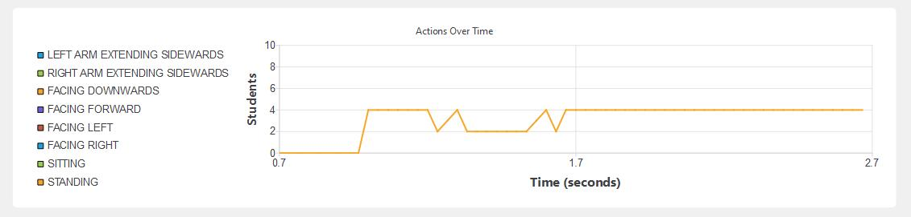  
*Diagram 2.6 Line Graph for Facing Downward Only*

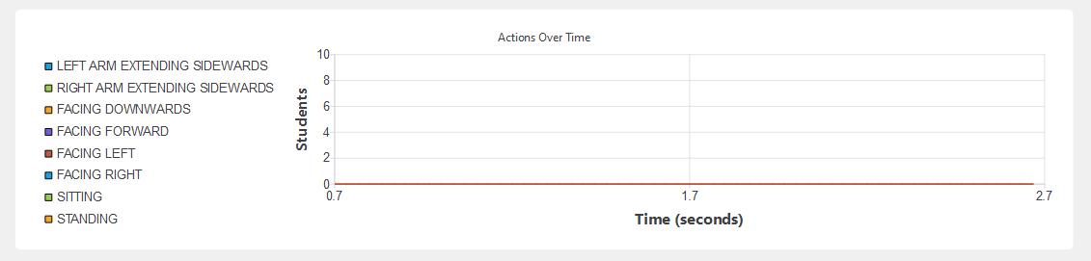  
*Diagram 2.7 Line Graph for Facing Left Only*

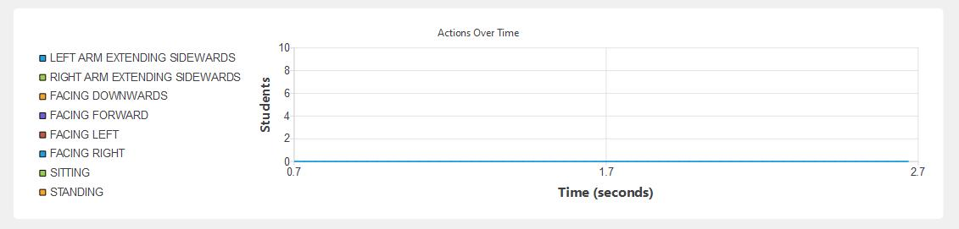  
*Diagram 2.8 Line Graph for Facing Right Only*

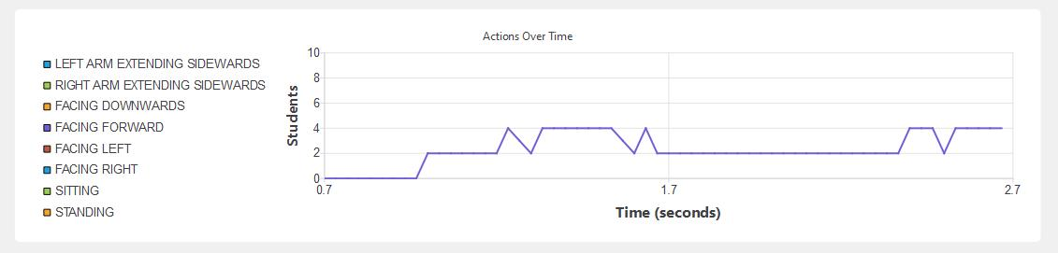  
*Diagram 2.9 Line Graph for Facing Forward Only*

**Table Image of Logs**

|  |  |  |
| --- | --- | --- |
|  |  |  |

|  |  |  |
| --- | --- | --- |
|  |  |  |

|  |  |  |
| --- | --- | --- |
|  |  |  |

**Conclusion:**

Insert generalizations and summary

### 

### **ADVANCED ANALYTICS DATA**

Advanced Analytics Data Title

Session Name

Date & Time Processed

,

Processed By

Front Video Directory/Path

**Front Video Details:**

File Name

File Size

Created Date

Video Length

Center Video Directory/Path

**Center Video Details:**

File Name

File Size

Created Date

Video Length

#### **Head Movement Analysis (Line Graph & Data Summary)**

**Line Graph Color Key:**

**—--Blue:** Looking Right (>90 degrees)

**—--Orange:** Looking Left (<80 degrees)

**—--Green:** Looking Down

**—--Red:** Facing Forward

**—--Purple:** Looking Up

**- - - Dash Line:** Total Students

*Diagram 1.1 Number of Students per Head Movement Over Time*

**Description:**

Total number of students detected

**Top 3 time frames with highest head movement actions:**

**—--**At ,  **students** looking right (>90 degrees)

**—--**At ,  **students** looking left (<80 degrees)

**—--**At ,  **students** looking down

#### **Arm Movement Analysis (Line Graph & Data Summary)**

**Line Graph Color Key:**

**—--Blue:**

**—--Orange:**

**—--Green:**

**—--Red:**

**—--Purple:**

**- - - Dash Line:** Total Students

*Diagram 1.2 Number of Students per Arm Movement Over Time*

**Description:**

Total number of students detected

**Top 3 time frames with highest arm movement actions:**

At ,  **students** extended their arms

At ,  **students** raised their arms

At ,  **students** crossed their arms

**Heatmap Graph Color Key:**

**—--Blue:** Sitting

**—--Orange:** Extending Right Arm

**—--Green:** Extending Left Arm

**—--Red:** Standing

**—--Purple:** Turning Around

*Diagram 3.1 Heatmap for All Actions*

*Diagram 3.2 Heatmap for Sitting Actions Only*

*Diagram 3.3 Heatmap for Extending Right Arm Actions Only*

*Diagram 3.4 Heatmap for Extending Left Arm Actions Only*

*Diagram 3.5 Heatmap for Standing Actions Only*

*Diagram 3.6 Heatmap for Turning Around Actions Only*

**Line Graph Color Key:**

**—--Blue:** Sitting

**—--Orange:** Extending Right Arm

**—--Green:** Extending Left Arm

**—--Red:** Standing

**—--Purple:** Turning Around

*Diagram 4.1 Line Graph for All Actions*

*Diagram 4.2Line Graph for Sitting Actions Only*

*Diagram 4.3 Line Graph for Extending Right Arm Actions Only*

*Diagram 4.4Line Graph for Extending Left Arm Actions Only*

*Diagram 4.5 Line Graph for Standing Actions Only*

*Diagram 4.6 Line Graph for Turning Around Actions Only*

**Table Image of Logs**

|  |  |  |
| --- | --- | --- |
|  |  |  |

|  |  |  |
| --- | --- | --- |
|  |  |  |

|  |  |  |
| --- | --- | --- |
|  |  |  |

**Conclusion:**

Insert generalizations and summary