**Final Examination**

**DATA ANALYTICS**

🎓Batangas State University - Main Campus

This document summarizes all the processed data from the session **Morning Session** that was analyzed by **Dr. John Doe** last **2025-03-19**. The data presented here is based on the findings and detections of the AI model developed and trained by our research group for the academic year 2024-2025.

Please note that this document does not contain any personal information of students, such as names, grades, or ages. It strictly presents **metrics and visualizations** of student behavior data as detected by the AI. This report is intended for research and analysis purposes only and **must not be used as the sole basis** for evaluating student performance or behavior. The AI system is a tool to assist in understanding behavioral patterns, but human judgment and contextual interpretation remain essential in any assessment.

**Document Details**

Analytics ID

A12345

Processed By

Dr. John Doe

Date Processed

2025-03-19, 10:30 AM

Date Downloaded

2025-03-19, 11:00 AM

File Name

exam_results.docx

File Size

2.3 MB

**Line Graph Color Key:**

**—--Blue:** Sitting

**—--Orange:** Extending Right Arm

**—--Green:** Extending Left Arm

**—--Red:** Standing

**—--Purple:** Turning Around

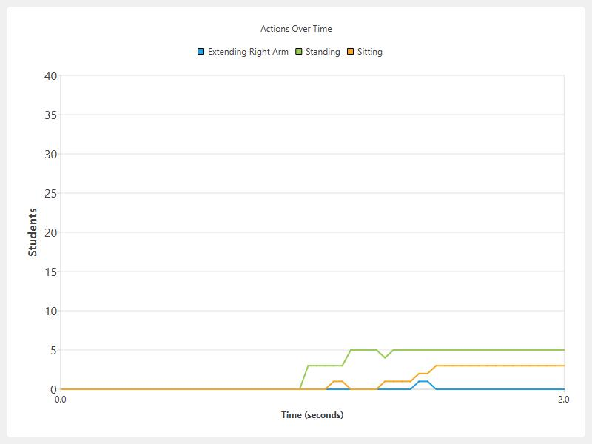  
*Diagram 2.1 Line Graph for All Actions*

  
*Diagram 2.2Line Graph for Sitting Actions Only*

  
*Diagram 2.3 Line Graph for Extending Right Arm Actions Only*

  
*Diagram 2.5 Line Graph for Standing Actions Only*